Supplementary materials for
“The Incidence and Prevalence of Cardiovascular Diseases in Gout: A Systematic Review and Meta-analysis”
Peter Cox¹, Sonal Gupta², Sizheng Steven Zhao³, David M Hughes⁴
1 Institute of Systems, Molecular and Integrative Biology,
University of Liverpool
Liverpool
UK

2 School of Medicine
University of Liverpool
Liverpool
UK

3 Musculoskeletal Biology, Institute of Life Course and Medical Sciences
University of Liverpool
Liverpool
UK

4 Department of Health Data Science
University of Liverpool
Liverpool
UK

Correspondence to:
Peter Cox
Institute of Systems, Molecular and Integrative Biology
University of Liverpool,
Biosciences Building,
Crown Street,
Liverpool,
L69 7BE
UK
hlpcox@liverpool.ac.uk
Supplementary Table S1 Quality assessment using a modified Newcastle-Ottawa Scale
Study | Representativeness | Sample size | Gout definition | Ascertainment of cardiovascular disease | Total
Abbott, R. D. 1988 | 2 | 0 | 0 | 1 | 3
Chang, K. 2017 | 1 | 0 | 1 | 1 | 3
Chen, S.Y. 2007 | 1 | 0 | 2 | 1 | 4
Chiu, C. C. 2016 | 1 | 0 | 1 | 1 | 3
Clarson, L.E. 2015 | 2 | 1 | 1 | 1 | 5
Colantonio, L. D. 2020 | 1 | 0 | 1 | 0 | 2
Disveld, I. J. M. 2019 | 1 | 0 | 2 | 1 | 4
Essex, M. N. 2017 | 1 | 0 | 1 | 1 | 3
Francis-Sedlak, M. 2020 | 1 | 0 | 1 | 1 | 3
Huang, C. C. 2015 | 2 | 0 | 1 | 1 | 4
Janssens, H.J.E.M. 2003 | 2 | 1 | 1 | 1 | 5
Janssens, H.J.E.M. 2017 | 2 | 0 | 1 | 1 | 4
Kim, S.C. 2016 | 2 | 0 | 1 | 1 | 4
Kubota, Y. 2016 | 2 | 0 | 0 | 1 | 3
Kuo, C.F. 2010 | 1 | 0 | 0 | 1 | 2
Kuo, C.F. 2013 | 1 | 0 | 1 | 1 | 3
Li, L. 2020 | 2 | 0 | 2 | 1 | 5
Lin, J.C. 2015 | 1 | 0 | 2 | 1 | 4
Meek, I.L. 2013 | 1 | 0 | 2 | 0 | 3
Pan, A. 2015 | 2 | 0 | 0 | 0 | 2
Raisch, D.W. 2009 ABSTRACT | 2 | 0 | 1 | 1 | 4
Seminog, O. O. 2013 | 1 | 0 | 1 | 1 | 3
Singh, J.A. 2018 AF | 1 | 0 | 1 | 1 | 3
Singh, J.A. 2018 MI | 1 | 0 | 1 | 1 | 3
Stack, A.G. 2013 | 2 | 0 | 0 | 1 | 3
Sultan, A. A. 2019 | 2 | 0 | 1 | 1 | 4
Representativeness: 2 for population or primary care level data, 1 hospital, 0 more selective. Sample size: 1 if justified, 0 if not. Gout definition: 2 for classification criteria or physician diagnosis; 1 for diagnostic codes; 0 if self-reported. Ascertainment of cardiovascular disease: 1 if diagnostic code; 0 if self-reported. 0 is given if unclear or unreported.

Supplementary Fig S1 Distribution of Newcastle-Ottawa Scale bias scores from Table S1

Supplementary Table S2 Complete data extraction of studies included in the systematic review
Study | Country | Data source | Sample Size | Gout diagnosis | Mean Age | Male% | Cardiovascular diagnosis | Prevalence | Incidence per 1000 years
Myocardial infarction
Abbott, R. D. 1988 | USA | Framingham Study | 113 | Self-reported | N/A | 83.2 | Physician diagnosed | 19.47
Chen, S.Y. 2007 | Taiwan | Ho-Ping Gout Database, inpatients | 22,572 | Wallace criteria | N/A | 91.2 | Cardiologist reviewed resting ECG for pathological Q-wave in 2 adjacent leads | 1.74
Essex, M. N. 2017 | USA | Humedica database | 65,329 | ICD code | 63.7 | 73.2 | ICD code | 1.71
Janssens, H.J.E.M. 2017 | Netherlands | GP Database | 1859 | International Classification of Primary Care (ICPC) | 62.5 | 66.9 | ICPC | 2.04
Kuo, C.F. 2013 | Taiwan | Taiwanese National Health Insurance database | 26,556 | ICD code | 55.4 | 70.3 | ICD code | 1.74 | 2.2
Seminog, O. O. 2013 (HES) | UK | Hospital Episode Statistics for England | 202,033 | ICD code | 70.3 | 74 | ICD code | 5.44
Seminog, O. O. 2013 (ORLS) | UK | Oxford Record Linkage Study | 3,174 | ICD code | 68.8 | 73 | ICD code | 2.8
Singh, J.A. 2018 MI | USA | Medicare 5% claims data | 94,809 | ICD code | N/A | N/A | ICD code | 1.32 | 4.1
Clarson, L.E. 2015 | UK | Clinical Practice Research Datalink | 8,386 | Diagnostic code | 66.3 | 69.4 | Medical code |  | M 9.27, F 6.11
Cerebrovascular accident
Janssens, H.J.E.M. 2017 | Netherlands | GP Database | 1859 | ICPC | 62.5 | 66.9 | ICPC | 1.56
Seminog, O. O. 2013 (HES) | UK | Hospital Episode Statistics for England | 202,033 | ICD code | 70.3 | 74 | ICD code | 4.93
Seminog, O. O. 2013 (ORLS) | UK | Oxford Record Linkage Study | 3,174 | ICD code | 68.8 | 73 | ICD code | 9.45
Clarson, L.E. 2015 | UK | Clinical Practice Research Datalink | 8,386 | Diagnostic code | 66.3 | 69.4 | Medical code |  | M 7.45, F 13.71
Colantonio, L. D. 2020 | USA | REGARDS cohort | 187 | ICD code | 73.8 | 65.8 | Physician diagnosed |  | 9.3
Heart failure
Essex, M. N. 2017 | USA | Humedica database | 65,329 | ICD code | 63.7 | 73.2 | ICD code | 5.41
Francis-Sedlak, M. 2020 | USA | Humanan Research Database | 6831 | ICD code | 71.8 | 67.4 | Diagnostic code | 22.82
Janssens, H.J.E.M. 2017 | Netherlands | GP Database | 1859 | ICPC | 62.5 | 66.9 | ICPC | 1.67
Lin, J.C. 2015 | Taiwan | N/A | 108 | Wallace and ACR criteria | 58.2 | 90 | Transthoracic echocardiogram | 23.15
Colantonio, L. D. 2020 | USA | REGARDS cohort | 187 | ICD code | 73.8 | 65.8 | Physician diagnosed |  | 13.1
Venous thromboembolism
Chiu, C. C. 2016 | Taiwan | Taiwanese National Health Insurance database | 35,959 | ICD code | 54.7 | 73.7 | ICD code | 1.02 | 1.348
Kubota, Y. 2016 | USA | Atherosclerosis Risk in Communities Study | 647 | Self-reported | N/A | N/A | ICD code | 6.18
Raisch, D.W. 2009 ABSTRACT | USA | Veterans Affairs national database | 156,809 | ICD code | N/A | N/A | ICD code | 1.62
Li, L. 2020 | Canada | Population Data BC Database | 130,708 | Physician diagnosed | 58.98 | 64.38 | ICD code and prescription of anticoagulation therapy | 1.58 | 2.63
Sultan, A. A. 2019 | UK | Primary Care and NHS Hospital databases | 62,234 | Medical code | 62.4 ± 15.1 | 73.8 | Medical code | 2.38 | 3.73
Huang, C. C. 2015 | Taiwan | National Health Insurance Research database | 57,981 | ICD code | 52.5 | 73.9 | ICD code |  | 0.526
Cardiovascular mortality
Disveld, I. J. M. 2019 | Netherlands | Gout Arnhem-Liemers Cohort | 700 | Crystal-proven joint fluid analysis | 62 | 81.9 | ICD code |  | 7.71
Kuo, C.F. 2010 | Taiwan | Health screening programme in Chang Gung Memorial Hospital | 1,311 | Medical code or self-report | N/A | N/A | ICD code |  | 2.09
Stack, A.G. 2013 | USA | Third National Health and Nutrition Examination Survey | 468 | Self-reported | N/A | N/A | ICD code |  | 23.1
Hypertension
Essex, M. N. 2017 | USA | Humedica database | 65,329 | ICD code | 63.7 | 73.2 | ICD code | 17.79
Francis-Sedlak, M. 2020 | USA | Humanan Research Database | 6831 | ICD code | 71.8 | 67.4 | Diagnostic code | 84.22
Meek, I.L. 2013 | Netherlands | Arthritis Center Twente (outpatients) and the Doetinchem Cohort | 129 | Attending rheumatic outpatients | N/A | 89.9 | Physical examination of BP>140/90 mmHg | 83
Pan, A. 2015 | China | Singapore Chinese Health Study | 573 | Self-reported | 58.5 | 60.4 | Self-reported |  | 52.54
Angina
Abbott, R. D. 1988 | USA | Framingham Study | 113 | Self-reported | N/A | 83.2 | Physician diagnosed | 20.35
Janssens, H.J.E.M. 2017 | Netherlands | GP Database | 1859 | ICPC | 62.5 | 66.9 | ICPC | 0.97
Clarson, L.E. 2015 | UK | Clinical Practice Research Datalink | 8,386 | Diagnostic code | 66.3 | 69.4 | Medical code |  | M 11.80, F 12.32
Transient Ischaemic Attack
Janssens, H.J.E.M. 2017 | Netherlands | GP Database | 1859 | ICPC | 62.5 | 66.9 | ICPC | 0.81
Clarson, L.E. 2015 | UK | Clinical Practice Research Datalink | 8,386 | Diagnostic code | 66.3 | 69.4 | Medical code |  | M 6.04, F 9.34
Atrial Fibrillation
Francis-Sedlak, M. 2020 | USA | Humanan Research Database | 6831 | ICD code | 71.8 | 67.4 | Diagnostic code | 21.48
Kim, S.C. 2016 | USA | United HealthCare database | 70,015 | ICD code | 56.8 | 81.4 | ICD code | 1.47 | 7.19
Singh, J.A. 2018 AF | USA | Medicare 5% claims data | N/A | ICD code | N/A | N/A | ICD code |  | 43.4
Peripheral Vascular disease
Janssens, H.J.E.M. 2017 | Netherlands | GP Database | 1859 | ICPC | 62.5 | 66.9 | ICPC | 1.51
Clarson, L.E. 2015 | UK | Clinical Practice Research Datalink | 8,386 | Diagnostic code | 66.3 | 69.4 | Medical code |  | M 5.60, F 7.09
Any Coronary Heart Disease
Clarson, L.E. 2015 | UK | Clinical Practice Research Datalink | 8,386 | Diagnostic code | 66.3 | 69.4 | Medical code |  | M 28.46, F 9.11
Colantonio, L. D. 2020 | USA | REGARDS cohort | 187 | ICD code | 73.8 | 65.8 | Physician diagnosed |  | 16.0
Aortic Stenosis
Chang, K. 2017 | USA | Outpatients | 112 | Medical Records | 80.1 | 99.1 | Transthoracic echocardiogram | 21.43
Aortic aneurysm
Janssens, H.J.E.M. 2017 | Netherlands | GP Database | 1859 | ICPC | 62.5 | 66.9 | ICPC | 0.91
Cardiovascular disease
Janssens, H.J.E.M. 2003 | Netherlands | Continuous Morbidity Registration | 170 | Medical code | N/A | 91 | Diagnostic code | 25.88
F, Female; HES, Hospital Episode Statistics; ICD, International Classification of Diseases; ICPC, International Classification of Primary Care; M, Male; ORLS, Oxford Record Linkage Study.

Funnel plots for each meta-analysis
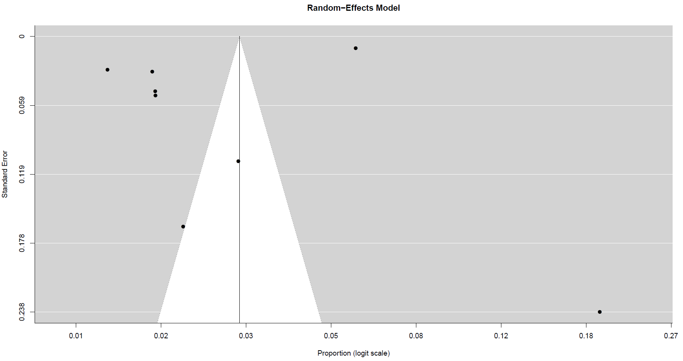
Supplementary Fig S2 Funnel plot for pooled prevalence of myocardial infarction

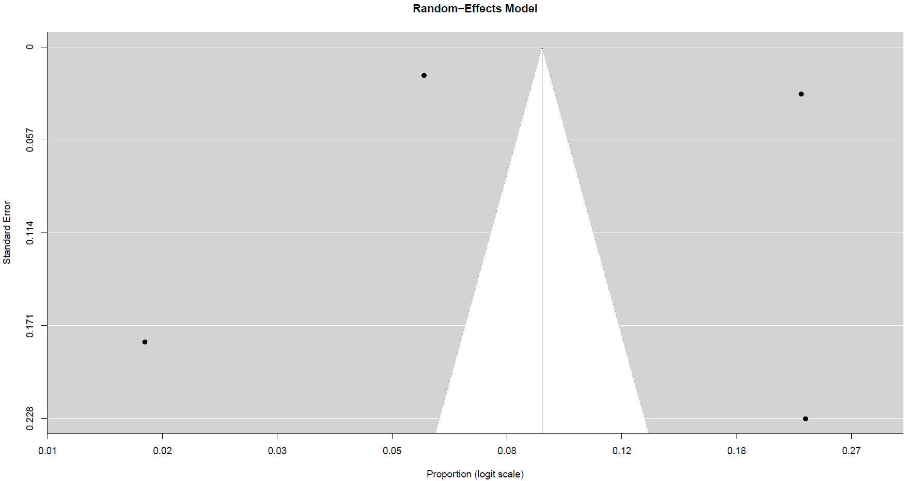
Supplementary Fig S3 Funnel plot for pooled prevalence of heart failure

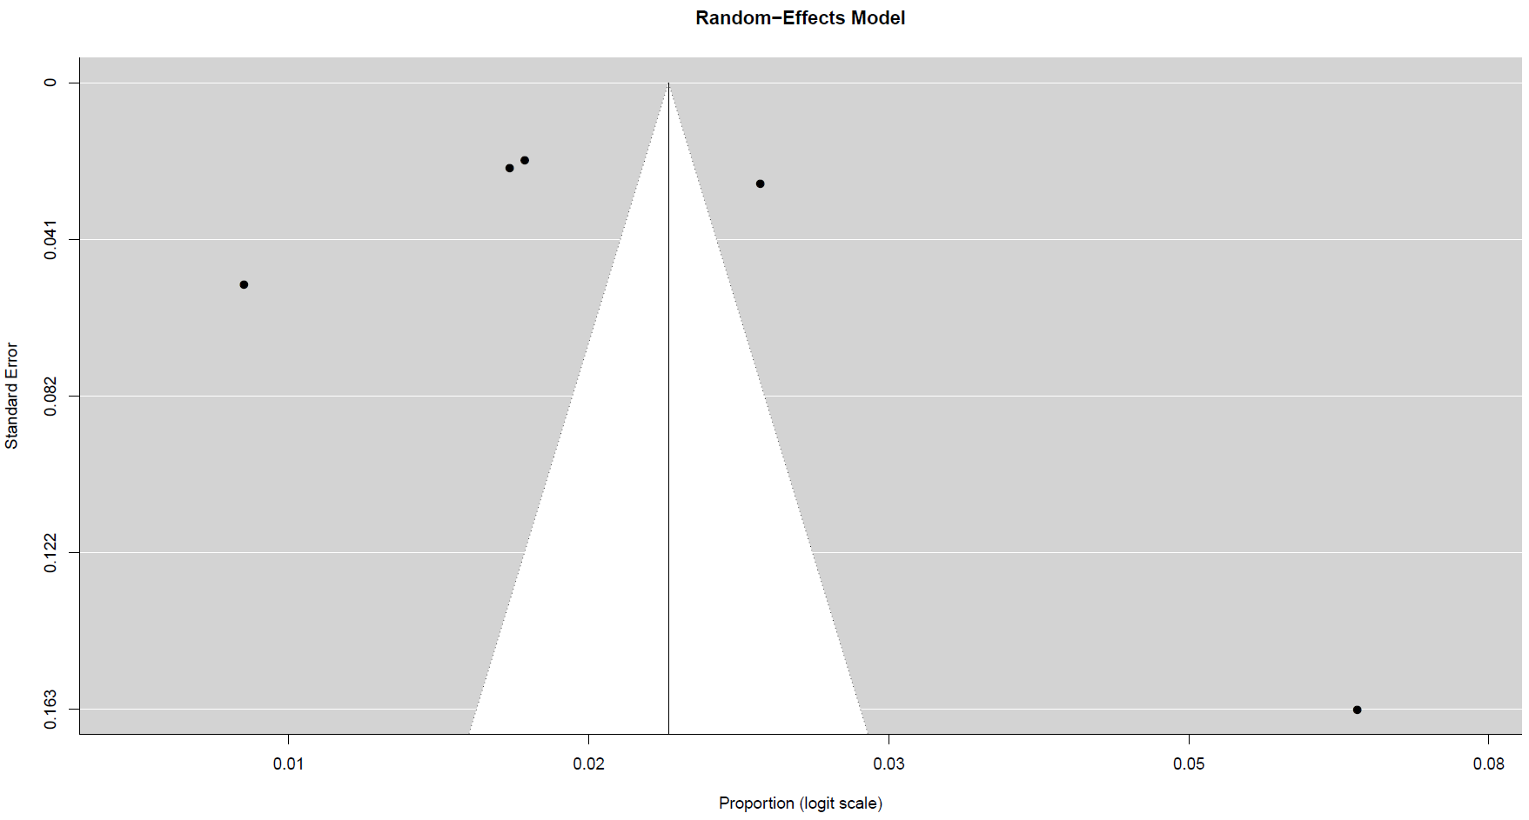
Supplementary Fig S4 Funnel plot for pooled prevalence of venous thromboembolism

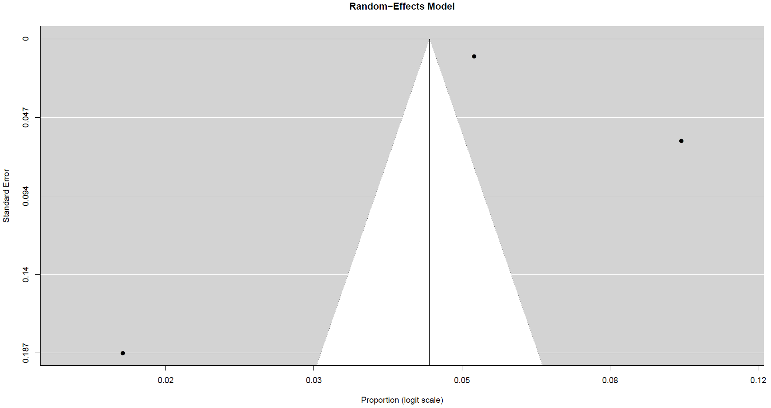
Supplementary Fig S5 Funnel plot for pooled prevalence for cerebrovascular accident

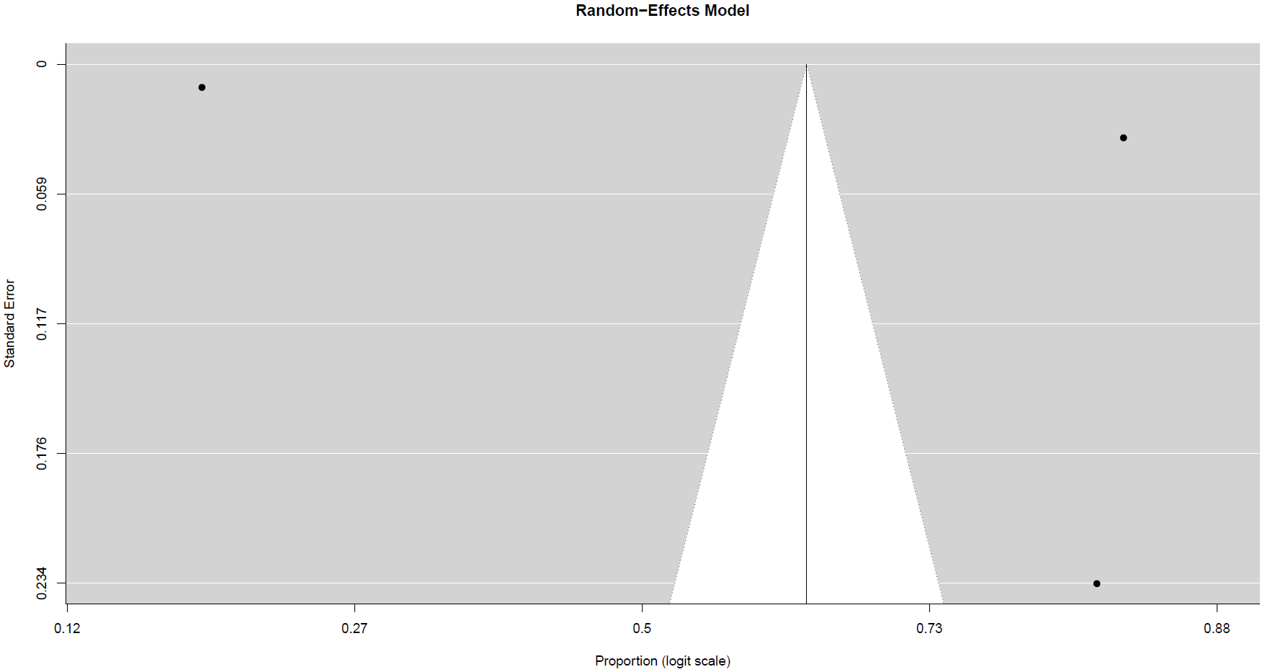
Supplementary Fig S6 Funnel plot for pooled prevalence for hypertension

