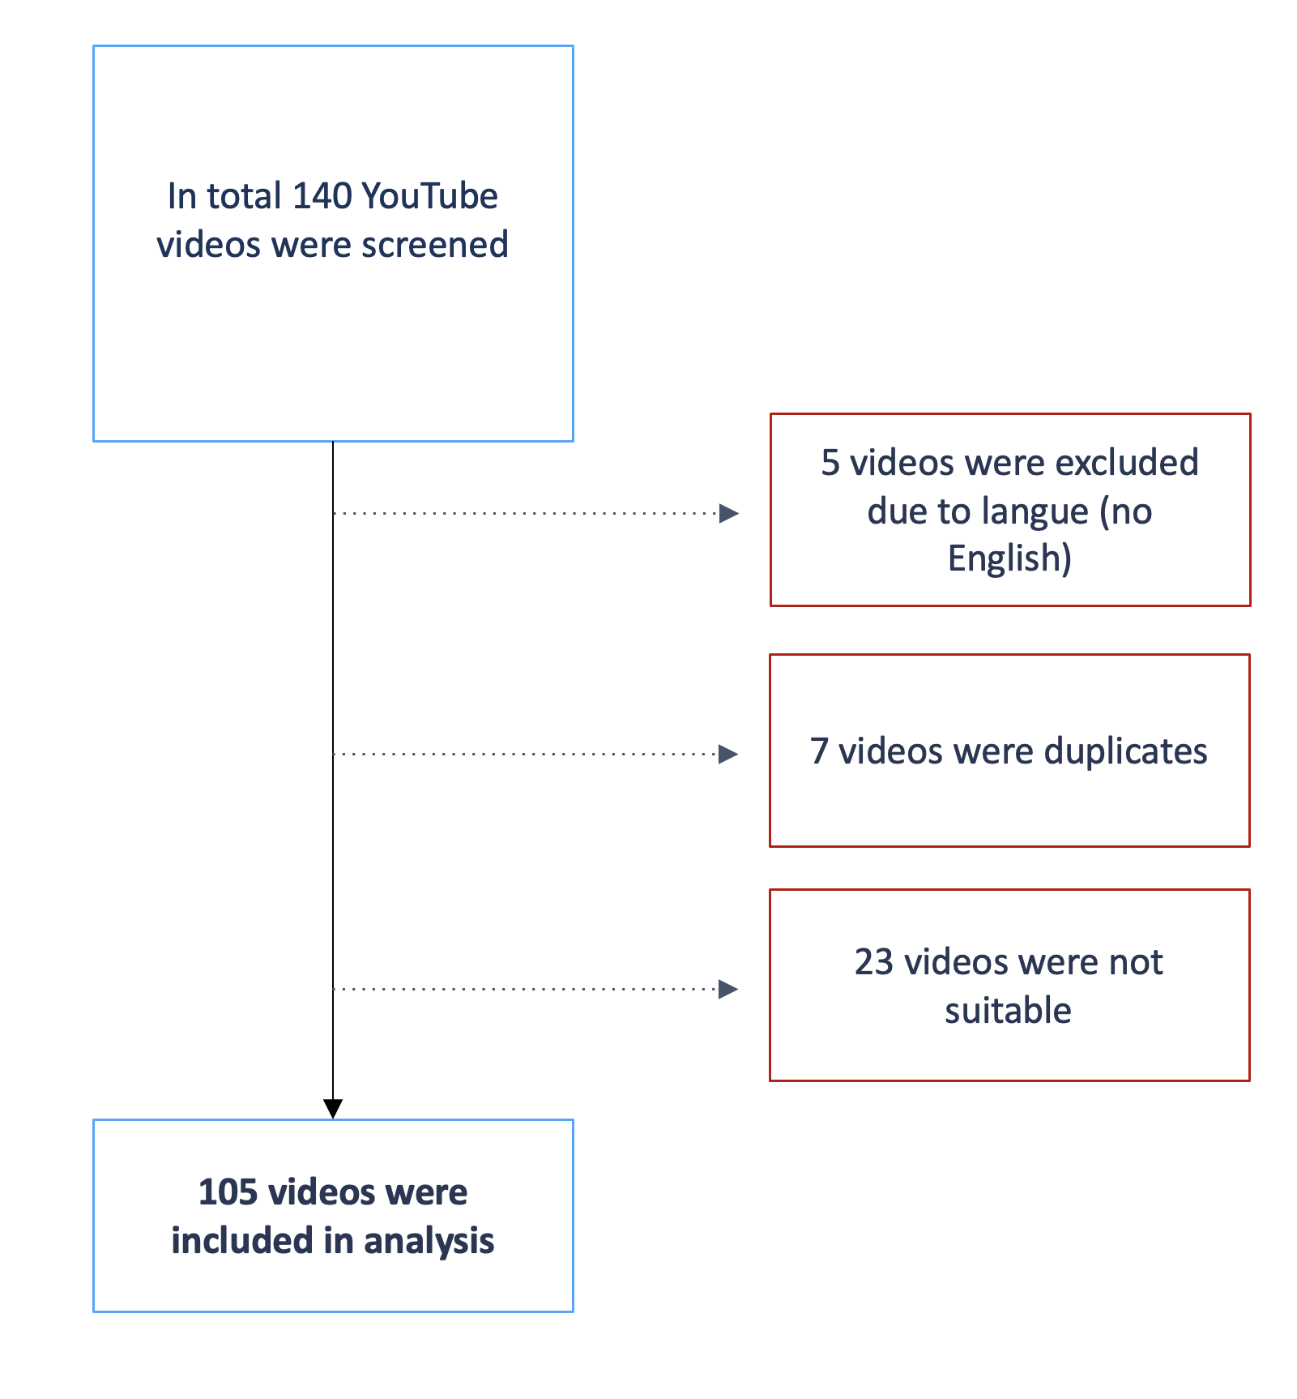
Figure SI 1: Flow chart of the selection process of YouTube videos
.

