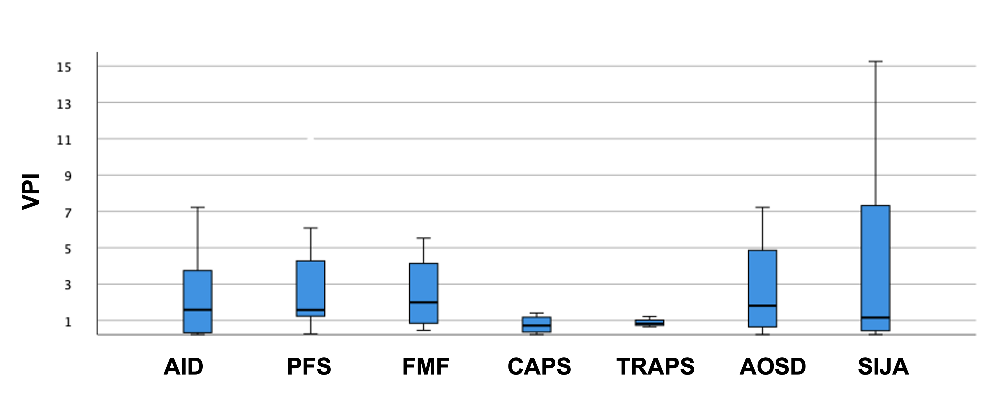
Figure SI 2: Boxplot showing the median and spread of the video power index (VPI). This graph does not present outliers and extreme values for a better overview.

