Supplementary material

Table A. Mean, standard deviation, correlation, and Cronbach coefficient alpha for B-IPQ items
B-IPQ Item sumscale | Total N  Mean (SD) | RA  Mean (SD) | PsA  Mean (SD) | axSpA  Mean (SD) | Correlation with total | Alpha
Item 1 – Consequences | 5.0 (2.9) | 4.7 (2.9) | 5.5 (2.9) | 5.8 (2.7) | 0.71 | 0.76
Item 2 – Timeline | 8.3 (2.6) | 8.2 (2.7) | 8.4 (2.5) | 8.5 (2.5) | 0.20 | 0.83
Item 3 – Personal control | 5.5 (2.9) | 5.8 (2.9) | 5.0 (3.0) | 4.6 (3.1) | 0.64 | 0.77
Item 4 – Treatment control | 7.4 (2.5) | 7.7 (2.3) | 6.9 (2.7) | 6.9 (2.6) | 0.36 | 0.81
Item 5 – Illness identity | 5.2 (2.7) | 4.9 (2.7) | 5.7 (2.5) | 5.6 (2.6) | 0.65 | 0.77
Item 6 – Concern | 5.6 (2.9) | 5.4 (2.9) | 6.0 (2.7) | 6.1 (2.7) | 0.69 | 0.77
Item 7 – Coherence | 5.9 (2.9) | 6.1 (2.9) | 5.7 (2.7) | 5.7 (2.8) | 0.32 | 0.82
Item 8 – Emotional representation | 4.9 (3.1) | 4.6 (3.1) | 5.4 (2.9) | 5.4 (3.1) | 0.67 | 0.77
Total coefficient alpha |  |  |  |  |  | 0.811344

Table B. Correlation and Cronbach’s coefficient alpha of the consequence domain and control domain
B-IPQ item | Total domain  correlation | Cronbach’s alpha | RA correlation | Cronbach’s alpha | PsA correlation | Cronbach’s alpha | axSpA correlation | Cronbach’s alpha
Consequence domain
Item 1 – Consequences | 0.75 | 0.807 | 0.755 | 0.811 | 0.787 | 0.818 | 0.666 | 0.740
Item 5 – Illness identity | 0.69 | 0.836 | 0.679 | 0.842 | 0.712 | 0.849 | 0.632 | 0.758
Item 6 – Concern | 0.72 | 0.823 | 0.730 | 0.821 | 0.744 | 0.836 | 0.583 | 0.779
Item 8 – Emotional representation | 0.69 | 0.834 | 0.697 | 0.836 | 0.694 | 0.856 | 0.630 | 0.761
Total Cronbach’s alpha |  | 0.863 |  | 0.865 |  | 0.875 |  | 0.808
Control domain
Item 3 – Personal control | 0.54 | 0.495 | 0.543 | 0.532 | 0.527 | 0.471 | 0.466 | 0.297
Item 4 – Treatment control | 0.48 | 0.585 | 0.512 | 0.591 | 0.436 | 0.621 | 0.347 | 0.500
Item 7 – Coherence | 0.44 | 0.627 | 0.460 | 0.647 | 0.471 | 0.577 | 0.314 | 0.547
Total Cronbach’s alpha |  | 0.668 |  | 0.685 |  | 0.665 |  | 0.562

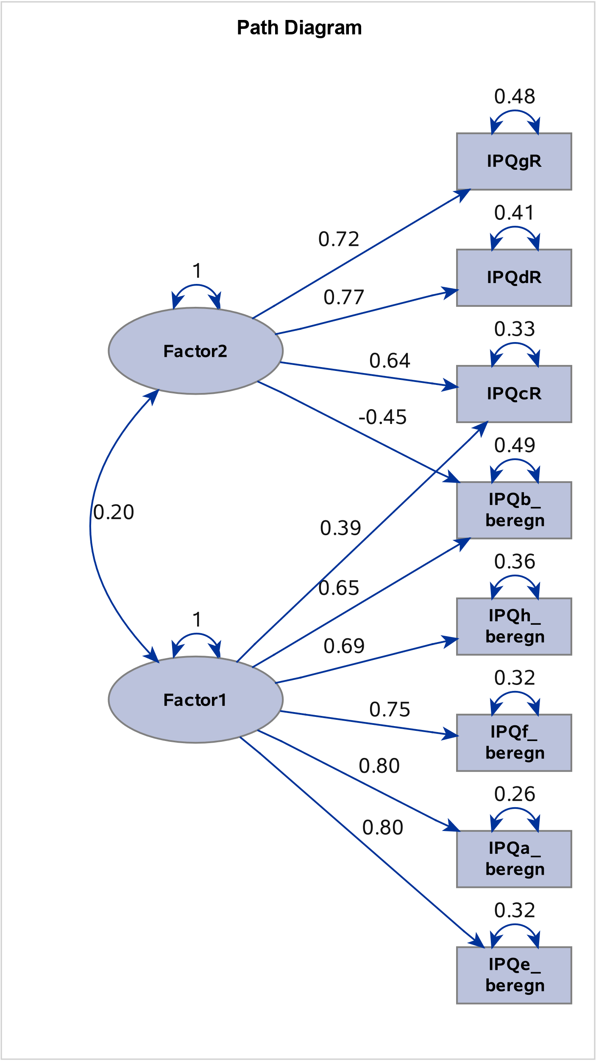
Fig 1. Results from exploratory factor analysis: Oblique rotation
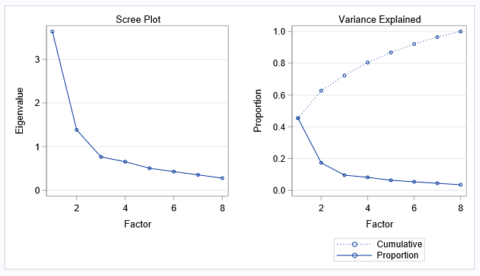
Fig 2. Results from exploratory factor analysis: Eigenvalue Scree plot and proportion of variance explained by factors.

Table C. Factor analysis and domains
The confirmatory factor analysis showed that a two-factor structure was acceptable. We analysed both with and without item 2 (the timeline question), and the standardised RMR, RMSEA estimate, Bentler Comparative Fit Index and Bentler-Bonett Non-Normed Index improved when this item was removed (data not shown). Therefore, we excluded item 2 and divided the IPQ scale into the following two domains:
The Consequence domain | The Control domain
Included question 1 (Consequences), 5 (Identity), 6 (Concern) and 8 (Emotional response) | Included question 3 (Personal control), 4 (Treatment control) and 7 (Understanding)
This compromises items that capture the patient’s perspective on the symptom burden (illness identity) and the impact of the disease on their health and life. It encompasses the level of concern and emotional impact experienced by the patient. Therefore, this domain reflects the patient’s thoughts and emotions regarding their current health status. | This compromises items that represent the extent to which the patient believes that they can recover from or control the illness, as well as their understanding of the disease. Thus, this domain reflects the patient’s thoughts and emotions regarding their capacity to influence their health status.

Table D1. Automated stepwise selection logistic regression with high consequence as response variable
Explanatory variable | Score chi-square | P-value chi-square
Pain | 147.2 | < 0.01
Age | 42.3 | < 0.01
Physical function | 27.9 | < 0.01
Available to the labour market | 10.9 | < 0.01
Fatigue | 10.4 | 0.01
Cohabitant status | 4.1 | 0.04
Diagnosis | 5.5 | 0.07
Disease activity | 5.1 | 0.08
Area under the curve |  | 0.75

Table D2. Automated stepwise selection logistic regression with low control as response variable
Explanatory variable | Score chi-square | P-value chi-square
Fatigue | 76.3 | < 0.01
Physical function | 30.9 | < 0.01
Age | 14.9 | < 0.01
Disease activity | 7.1 | 0.03
Diagnosis | 5.4 | 0.07
Household income | 5.4 | 0.07
Area under the curve |  | 0.70

