Supplementary Material

Figure S1. Flowchart of screening

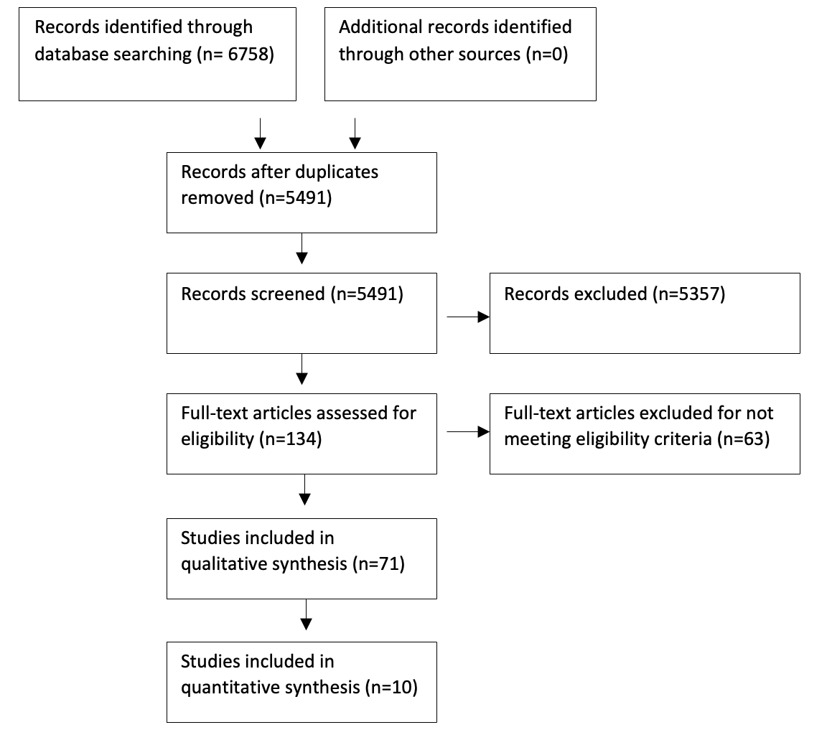

Table 1. Summary of studies
Author | Year | Cohort | Country | Study Design | Sample Size | Weeks Follow up | Mean age | % Female | Measure
Zhao [41] | 2015 |  | UK | Observational | 126 | 52 | Not reported | Not reported | DAS28, HAQ,
Matcham [42] | 2015 |  | UK | Observational | 385 | 52 | 59 | 81 | DAS28, HAQ, ESR, TJC, SJC, PGA
van den Hoek [43] | 2016 |  | Netherlands | Observational | 882 | 156 | 59 | 72 | HAQ, EGA, Mortality
Miwa [44] | 2015 |  | Japan | Intervention | 333 | 26 | Not reported | Not reported | SDAI
Brown [45] | 1990 |  | USA | Observational | 387 | 182 | 53 | 75 | VAS pain
Kronisch [46] | 2015 | SERA | UK | Observational | 578 | 52 | 61 | 65 | HAQ
Corominas [47] | 2014 |  | Spain | Observational | 120 | 104 | 52 | 87 | DAS28
Gwinnutt [48] | 2019 | RAMS | UK | Intervention | 463 | 52 | Not reported | 68 | Work disability (work leave, sick leave, presenteeism)
Rathbun [49] | 2016 | CORRONA | USA | Intervention | 1820 | 52 | 58 | 75 | CDAI
Matcham [33] | 2016 |  | UK | Observational | 56 | 52 | 54 | 79 | DAS28, ESR, TJC, SJC, PGA
Kronisch [50] | 2016 | SERA | UK | Observational | 1140 | 52 | 61 | 65 | HAQ
Miwa [51] | 2017 |  | Japan | Retrospective intervention | 232 | 26 | 55 | 71 | HAQ
Ang [52] | 2005 |  | USA | Observational | 1290 | 939 | 57 | 73 | Mortality
Parenti [53] | 2016 |  | USA | Retrospective intervention | 4064 | 26 | Not reported | Not reported | DAS 28, CDAI
Cui [54] | 2015 | OBRI | Canada | Observational | 2305 | 26 | Not reported | Not reported | DAS28, SDAI
Corominas [55] | 2019 |  | Spain | Intervention | 2305 | 26 | Not reported | Not reported | FACIT-F
Michelsen [56] | 2017 | NOR-DMARD | Norway | Intervention | 1326 | 26 | 54 | 75 | DAS28, CDAI, SDAI
Kleinert [57] | 2016 |  | Germany | Observational | 764 | 261 | 54 | 80 | Mortality
Hider [58] | 2009 |  | UK | Intervention | 160 | 52 | 56 | 72 | DAS28
Bode [59] | 2012 |  | USA | Observational | 530 | 255 | 60 | 84 | Mortality
Leblanc-Trudeau [60] | 2015 | EUPA | Canada | Intervention | 275 | 182 | 61 | 63 | SDAI
McFarlane [61] | 1988 |  | Australia | Observational | 30 | 156 | 53 | 66 | DAS28
Norton [62] | 2011 | ERAS | UK | Observational | 784 | 156 | 57 | 67 | DAS28, HAQ
Michelsen [63] | 2017 | NOR-DMARD | Norway | Intervention | 1326 | 26 | 54 | 75 | DAS28, CDAI, SDAI
Kuijper [27] | 2018 |  | Netherlands | Intervention | 281 | 65 | 53 | 68 | DAS28, ESR, SJC
Feldthusen [64] | 2016 |  | Sweden | Observational | 65 | 52 | 54 | 74 | VAS fatigue
Gonzalez-Lopez [38] | 2013 |  | Mexico | Observational | 123 | 52 | 44 | 73 | Sick leave
Tanaka [65] | 2019 |  | Japan | Intervention | 377 | 104 | Not reported | Not reported | WPAI
Doeglas [66] | 2004 |  | Netherlands | Observational | 264 | 156 | 53 | 65 | GARS
Verstappen [67] | 2007 |  | Netherlands | Intervention | 112 | 52 | 49 | 68 | HAQ
Hommel [68] | 1998 |  | USA | Observational | 42 | 52 | 53 | 81 | MHAQ
Fifield [69] | 2001 |  | USA | Observational | 415 | 417 | 58 | 83 | VAS fatigue
Looper [70] | 2011 | McEAR | Canada | Retrospective observational with history of depression | 104 | Medical History | 54 | 61 | HAQ
Nugaliyadde [71] | 2017 |  | UK | Intervention | 13 | 51 | 61 | 73 | DAS28
Chung [72] | 2013 |  | Australia | Observational | 114 | 261 | Not reported | Not reported | DAS28, HAQ
England [73] | 2015 | BRAGGS | UK | Intervention | 1847 | 26 | 58 | 76 | DAS28
Sergeant [74] | 2015 | RAMS | UK | Intervention | 460 | 26 | 60 | 73 | DAS28
Morris [75] | 2011 | UCSF RA panel | USA | Observational | 1115 | 939 | 55 | 80 | HAQ
Van Den Hoek [76] | 2013 |  | Netherlands | Observational | 882 | 574 | 59 | 72 | HAQ, SF-36
Bechman [11] | 2018 | OPTTIRA | UK | Intervention | 97 | 52 | 57 | 74 | DAS28
McFarlane [77] | 1987 |  | Australia | Observational | 40 | 156 | 53 | 80 | DAS-28
Odegard [36] | 2007 | EURIDISS | Norway | Observational | 238 | 521 | 52 | 74 | VAS pain
Vriezekolk [78] | 2010 |  | Netherlands | Intervention | 73 | 6 | 53 | 72 | AIMS, VAS pain
Sergeant [79] | 2016 | RAMS | UK | Intervention | 1050 | 26 | 59 | 70 | DAS28
Sergeant [80] | 2018 | RAMS | UK | Intervention | 1656 | 26 | 59 | 67 | DAS28
Casalla [81] | 2013 | CONAART | Argentina | Observational | 237 | 52 | 49 | 84 | DAS28
Cook [82] | 2016 | NOAR | UK | Observational | 868 | 261 | 56 | 66 | SJC
Treharne [83] | 2008 |  | UK | Observational | 189 | 52 | 56 | 74 | VAS fatigue
Dobkin [84] | 2013 |  | Canada | Observational | 248 | 52 | 59 | 63 | MPQ-SF
Leggett [85] | 2017 | RAMS | UK | Intervention | 308 | 52 | 52 | 66 | WPS-RA
Dyball [32] | 2018 | BRAGGSS | UK | Intervention | 2919 | 26 | 57 | 76 | DAS28, CRP, TJC, SJC
Schieir [86] | 2016 | ERA | Canada | Intervention | 1595 | 52 | 54 | 72 | DAS28
Parker [87] | 1992 |  | USA | Observational | 80 | 26 | 61 | 0 | SJC
Norton [62] | 2011 | ERAS | UK | Observational | 784 | 261 | 57 | 67 | HADS, ESR, VAS pain, TJC, SJC, Stiffness
Matcham [42] | 2015 | CARDERA | UK | Intervention | 467 | 104 | 54 | 68 | HAQ, ESR, SJC
Iannaccone [88] | 2016 |  | USA | Observational | 264 | 104 | 57 | 83 | DAS28, MHAQ, CRP
Schieir [89] | 2009 | McEAR | Canada | Observational | 320 | 26 | 57 | 69 | MPQ, SJC
Rathbun [90] | 2013 | CORRONA | USA | Observational | 4250 | 104 | Not reported | Not reported | CDAI, HAQ, CRP, ESR, VAS pain, TJC, SJC, EGA, PGA
Rathbun [91] | 2015 | CORRONA | USA | Observational | 12,445 | 104 | 58 | 73 | DAS28, CDAI, HAQ, CRP, ESR, TJC, SJC, EGA, PGA
El Miedany [92] | 2013 |  | Egypt or UK | Observational | 264 | 156 |  | 68 | DAS28, TJC,
Uhlig [93] | 2000 | EURIDISS | Norway | Observational | 238 | 261 | 51 | 74 | AIMS
Li [94] | 2019 | Truven Health Marketscan databse | USA | Observational | 46,700 | 52 | 52 | 78 | Short-term disability
Matcham [34] | 2014 | CARDERA | UK | Intervention | 467 | 104 | 54 | 68 | DAS28, HAQ, ESR, VAS pain, TJC, SJC, EGA
Van Den Hoek [95] | 2013 |  | Netherlands | Observational | 882 | 574 | 59 | Not reported | HAQ, SF-36
Matcham [96] | 2014 | CARDERA | UK | Intervention | 379 | 104 | 54 | 68 | SJC
Crotty [97] | 1994 |  | Australia | Observational | 75 | 191 | 42 | 100 | HAQ
Overman [30] | 2011 |  | Netherlands | Intervention | 545 | 26 | 56 | 69 | TJC
Matcham [28] | 2018 | BSRBR-RA | UK | Intervention | 18,421 | 52 | 56 | 76 | DAS28, ESR, SJC, EGA
Euesden [98] | 2017 | CARDERA | UK | Intervention | 520 | 104 | 55 | 69 | DAS28, HAQ, ESR, VAS pain, TJC, SJC, EGA
Smedstad [99] | 1997 | EURIDISS | Norway | Observational | 238 | 104 | 52 | 73 | HAQ, VAS pain
Karpouzas [100] | 2017 | UCLA RA cohort | USA | Observational | 156 | 52 | 52 | 89 | HAQ

Table 2. Vote counting
Outcome | Number of studies | Vote count for direction of effect of affective distress on outcomes
 |  | Negative effect | Positive effect | No effect/  unclear
Disease Activity  Disease Activity Score (DAS), including remission  Simple Disease Activity Index (SDAI)  Clinical Disease Activity Index (CDAI) | 34  26  4  4 | 1  0  0 | 12  3  3 | 13  1  1
Disability  Health Assessment Questionnaire (HAQ)  Arthritis Impact Measurement Scale (AIMS)  Activities of Daily Living (ADL)  Groningen Activity Restriction Scale (GARS)  Modified Health Assessment Questionnaire (MHAQ)  Short-term disability days | 23  16  2  1  1  2  1  1 | 0  0  0  0  0  0 | 7  1  0  0  1  1 | 9  1  1  1  1  0
Pain  Visual Analog Scale (VAS)  Arthritis Impact Measurement Scales (AIMS)  McGill Pain Questionnaire (MPQ) | 12  9  1  2 | 0  0  0 | 3  1  1 | 6  0  1
C-reactive protein (CRP) | 3 | 0 | 0 | 3
Erythrocyte Sedimentation Rate (ESR) | 8 | 0 | 0 | 8
Tender Joint Count (TJC) | 7 | 0 | 5 | 2
Swollen Joint Count (SJC) | 7 | 0 | 5 | 2
Physician Global Assessment (EGA) | 4 | 0 | 3 | 1
Patient Global Assessment (PGA) | 3 | 0 | 2 | 0
Work disability  Presenteeism (WPS-RA)  Sick leave  Work productivity (WPAI)  Left Work | 4  2  2  1  1 | 1  0  1  0 | 0  2  0  0 | 1  0  0  1
Mortality | 4 | 0 | 4 | 0
Stiffness | 1 | 0 | 0 | 1
Fatigue  Visual Analog Scale (VAS)  Functional Assessment of Chronic Illness Therapy (FACIT-F) | 4  3  1 | 0  0 | 1  1 | 2  0

Table 3. Quality Assessment using the Newcastle-Ottowa Scale
Study | Year | Selection |  |  |  | Comparability | Outcome |  |  | Quality Total
 |  | Representativeness | Non-exposed  cohort | Ascertainment of exposure | Outcome did not exist at start | Comparability of Design or Analysis  (2 stars) | Assessment of outcome | Follow up long enough | Adequacy of follow ups
Zhao | 2015 | 1 | 1 | 0 | 1 | 1 | 0 | 1 | 1 | 6
Matcham | 2015 | 1 | 1 | 1 | 1 | 1 | 1 | 1 | 0 | 7
van den Hoek | 2016 | 1 | 1 | 0 | 1 | 2 | 0 | 1 | 0 | 6
Miwa | 2015 | 1 | 1 | 1 | 1 | 0 | 1 | 1 | 0 | 6
Brown | 1990 | 1 | 1 | 0 | 1 | 0 | 0 | 1 | 1 | 5
Kronisch | 2015 | 1 | 1 | 1 | 1 | 1 | 1 | 1 | 1 | 8
Corominas | 2014 | 1 | 1 | 1 | 1 | 0 | 1 | 1 | 0 | 6
Gwinnutt | 2019 | 1 | 1 | 1 | 1 | 1 | 1 | 1 | 0 | 7
Rathbun | 2016 | 1 | 1 | 0 | 1 | 2 | 1 | 1 | 1 | 8
Matcham | 2016 | 1 | 1 | 0 | 1 | 1 | 0 | 1 | 1 | 6
Kronisch | 2016 | 1 | 1 | 1 | 1 | 1 | 1 | 1 | 1 | 8
Miwa | 2017 | 1 | 1 | 1 | 1 | 0 | 1 | 1 | 0 | 6
Ang | 2005 | 1 | 1 | 0 | 1 | 2 | 0 | 1 | 0 | 6
Parenti | 2016 | 1 | 1 | 1 | 1 | 0 | 1 | 1 | 0 | 6
Cui | 2015 | 1 | 1 | 0 | 1 | 1 | 1 | 1 | 0 | 6
Corominas | 2019 | 1 | 1 | 1 | 1 | 2 | 1 | 1 | 1 | 9
Michelsen | 2017 | 1 | 1 | 0 | 1 | 1 | 0 | 1 | 0 | 5
Kleinert | 2016 | 1 | 1 | 0 | 1 | 0 | 1 | 1 | 0 | 5
Hider | 2009 | 1 | 1 | 1 | 1 | 0 | 1 | 1 | 1 | 7
Bode | 2012 | 1 | 1 | 1 | 1 | 1 | 1 | 1 | 0 | 7
Leblanc-Trudeau | 2015 | 1 | 1 | 1 | 1 | 1 | 1 | 1 | 1 | 8
McFarlane | 1988 | 1 | 1 | 0 | 1 | 1 | 0 | 1 | 1 | 6
Norton | 2011 | 1 | 1 | 0 | 1 | 1 | 0 | 1 | 0 | 5
Michelsen | 2017 | 1 | 1 | 0 | 1 | 1 | 0 | 1 | 0 | 5
Kuijper | 2018 | 1 | 1 | 0 | 1 | 1 | 0 | 1 | 0 | 5
Feldthusen | 2016 | 1 | 1 | 0 | 1 | 1 | 0 | 1 | 0 | 5
Gonzalez-Lopez | 2013 | 1 | 1 | 1 | 1 | 1 | 1 | 1 | 1 | 8
Tanaka | 2019 | 1 | 1 | 0 | 1 | 0 | 0 | 1 | 1 | 5
Doeglas | 2004 | 1 | 1 | 1 | 1 | 1 | 1 | 1 | 1 | 8
Verstappen | 2007 | 1 | 1 | 0 | 1 | 1 | 0 | 1 | 0 | 5
Hommel | 1998 | 1 | 1 | 0 | 1 | 0 | 0 | 1 | 0 | 4
Fifield | 2001 | 1 | 1 | 0 | 1 | 0 | 0 | 1 | 1 | 5
Looper | 2011 | 1 | 1 | 1 | 1 | 1 | 1 | 1 | 0 | 7
Nugaliyadde | 2017 | 1 | 1 | 0 | 1 | 0 | 0 | 1 | 0 | 4
Chung | 2013 | 1 | 1 | 0 | 1 | 1 | 0 | 1 | 0 | 5
England | 2015 | 1 | 1 | 0 | 1 | 0 | 0 | 1 | 0 | 4
Sergeant | 2015 | 1 | 1 | 0 | 1 | 0 | 0 | 1 | 0 | 4
Morris | 2011 | 1 | 1 | 0 | 1 | 1 | 0 | 1 | 0 | 5
Van Den Hoek | 2013 | 1 | 1 | 0 | 1 | 0 | 0 | 1 | 0 | 4
Bechman | 2018 | 1 | 1 | 0 | 1 | 1 | 0 | 1 | 0 | 5
McFarlane | 1987 | 1 | 1 | 0 | 1 | 0 | 0 | 1 | 0 | 4
Odegard | 2007 | 1 | 1 | 0 | 1 | 1 | 0 | 1 | 1 | 6
Vriezekolk | 2010 | 1 | 1 | 0 | 1 | 0 | 0 | 1 | 1 | 5
Sergeant | 2016 | 1 | 1 | 0 | 1 | 1 | 0 | 1 | 0 | 5
Sergeant | 2018 | 1 | 1 | 1 | 1 | 1 | 1 | 1 | 1 | 8
Casalla | 2013 | 1 | 1 | 0 | 1 | 1 | 0 | 1 | 1 | 6
Cook | 2016 | 1 | 1 | 1 | 1 | 1 | 1 | 1 | 0 | 7
Treharne | 2008 | 1 | 1 | 1 | 1 | 1 | 1 | 1 | 0 | 7
Dobkin | 2013 | 1 | 1 | 0 | 1 | 1 | 0 | 1 | 1 | 6
Leggett | 2017 | 1 | 1 | 0 | 1 | 1 | 0 | 1 | 0 | 5
Dyball | 2018 | 1 | 1 | 0 | 1 | 1 | 0 | 1 | 0 | 5
Schieir | 2016 | 1 | 1 | 0 | 1 | 1 | 0 | 1 | 0 | 5
Parker | 1992 | 1 | 1 | 1 | 1 | 0 | 1 | 1 | 0 | 6
Norton | 2011 | 1 | 1 | 0 | 1 | 1 | 0 | 1 | 0 | 5
Matcham | 2015 | 1 | 1 | 0 | 1 | 1 | 0 | 1 | 1 | 6
Iannaccone | 2016 | 1 | 1 | 0 | 1 | 1 | 0 | 1 | 0 | 5
Schieir | 2009 | 1 | 1 | 0 | 1 | 0 | 0 | 1 | 0 | 4
Rathbun | 2013 | 1 | 1 | 0 | 1 | 0 | 0 | 1 | 0 | 4
Rathbun | 2015 | 1 | 1 | 1 | 1 | 2 | 1 | 1 | 0 | 8
El Miedany | 2013 | 1 | 1 | 0 | 1 | 0 | 0 | 1 | 0 | 4
Uhlig | 2000 | 1 | 1 | 0 | 1 | 0 | 0 | 1 | 1 | 5
Li | 2019 | 1 | 1 | 0 | 1 | 0 | 0 | 1 | 0 | 4
Matcham | 2014 | 1 | 1 | 0 | 1 | 1 | 0 | 1 | 0 | 5
Van Den Hoek | 2013 | 1 | 1 | 0 | 1 | 2 | 0 | 1 | 0 | 6
Matcham | 2014 | 1 | 1 | 0 | 1 | 1 | 0 | 1 | 0 | 5
Crotty | 1994 | 1 | 1 | 0 | 1 | 1 | 0 | 1 | 0 | 5
Overman | 2011 | 1 | 1 | 0 | 1 | 2 | 0 | 1 | 0 | 6
Matcham | 2018 | 1 | 1 | 1 | 1 | 1 | 1 | 1 | 0 | 7
Euesden | 2017 | 1 | 1 | 0 | 1 | 1 | 0 | 1 | 0 | 5
Smedstad | 1997 | 1 | 1 | 0 | 1 | 0 | 0 | 1 | 0 | 4
Karpouzas | 2017 | 1 | 1 | 0 | 1 | 0 | 0 | 1 | 0 | 4

