Supplementary Figure S1. Map showing the 94 Countries where the survey was distributed by the COVAD Study Group

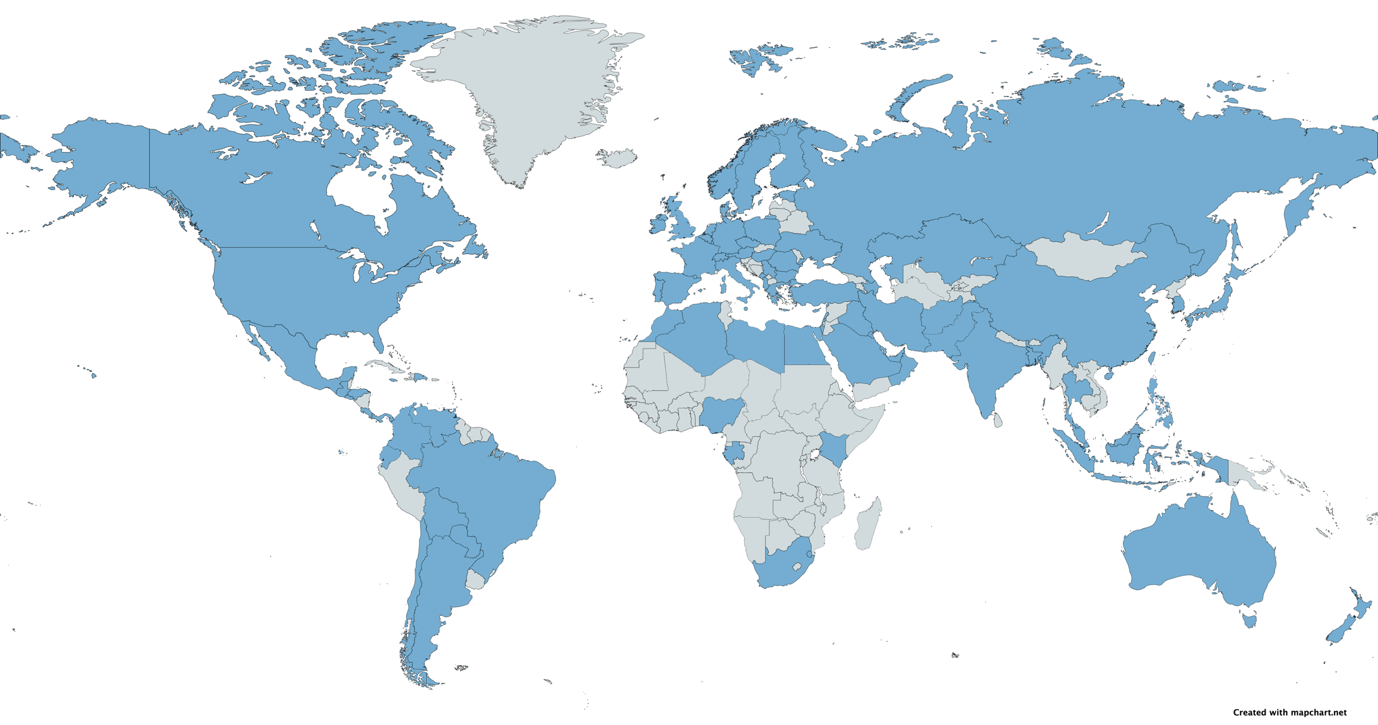

Supplementary Table S1 Number of survey respondents by Country (N=6010, 97 Countries)

Country | Number | % | Country | Number | %
Turkey | 1182 | 19.7 | Mauritius | 8 | 0.1
India | 877 | 14.6 | Austria | 7 | 0.1
Mexico | 817 | 13.6 | Bahrain | 7 | 0.1
Poland | 162 | 2.7 | China | 6 | 0.1
Philippines | 150 | 2.5 | Hungary | 6 | 0.1
Pakistan | 146 | 2.4 | Oman | 6 | 0.1
United Kingdom | 129 | 2.1 | Australia | 5 | 0.1
Italy | 125 | 2.1 | El Salvador | 5 | 0.1
Thailand | 124 | 2.1 | Kuwait | 5 | 0.1
Bulgaria | 118 | 2 | Algeria | 4 | 0.1
Brazil | 115 | 1.9 | Ethiopia | 4 | 0.1
Bangladesh | 114 | 1.9 | Qatar | 4 | 0.1
Peru | 110 | 1.8 | Ukraine | 4 | 0.1
Egypt | 105 | 1.7 | Afghanistan | 3 | 0.0
United States | 97 | 1.6 | Honduras | 3 | 0.0
Malaysia | 83 | 1.4 | Kazakhstan | 3 | 0.0
Lebanon | 81 | 1.3 | Netherlands | 3 | 0.0
United Kingdom | 79 | 1.3 | Nicaragua | 3 | 0.0
Saudi Arabia | 76 | 1.3 | Portugal | 3 | 0.0
Guatemala | 73 | 1.2 | Romania | 3 | 0.0
Indonesia | 73 | 1.2 | Belgium | 2 | 0.0
Colombia | 70 | 1.2 | Cyprus | 2 | 0.0
Russian Federation | 68 | 1.1 | Czech Republic | 2 | 0.0
United States of America | 63 | 1 | Haiti | 2 | 0.0
Ghana | 58 | 1 | Ireland {Republic} | 2 | 0.0
Sweden | 57 | 0.9 | Libya | 2 | 0.0
Switzerland | 57 | 0.9 | Liechtenstein | 2 | 0.0
Nepal | 56 | 0.9 | Serbia | 2 | 0.0
Germany | 53 | 0.9 | Albania | 1 | 0.0
Spain | 52 | 0.9 | Andorra | 1 | 0.0
Israel | 50 | 0.8 | Angola | 1 | 0.0
Nigeria | 47 | 0.8 | Armenia | 1 | 0.0
Japan | 43 | 0.7 | Azerbaijan | 1 | 0.0
Taiwan | 42 | 0.7 | Burkina Faso | 1 | 0.0
Venezuela | 36 | 0.6 | Cameroon | 1 | 0.0
United Arab Emirates | 34 | 0.6 | Gabon | 1 | 0.0
Argentina | 31 | 0.5 | Greece | 1 | 0.0
Ecuador | 31 | 0.5 | Grenada | 1 | 0.0
Morocco | 30 | 0.5 | Iran | 1 | 0.0
France | 24 | 0.4 | Jamaica | 1 | 0.0
Iraq | 21 | 0.3 | Kenya | 1 | 0.0
Chile | 19 | 0.3 | Korea South | 1 | 0.0
Costa Rica | 19 | 0.3 | Kyrgyzstan | 1 | 0.0
Canada | 17 | 0.3 | Malawi | 1 | 0.0
Panama | 16 | 0.3 | Montenegro | 1 | 0.0
Bolivia | 14 | 0.2 | Somalia | 1 | 0.0
Dominican Republic | 14 | 0.2 | Tuvalu | 1 | 0.0
Jordan | 12 | 0.2 | Uzbekistan | 1 | 0.0
Paraguay | 12 | 0.2

Supplementary Table S2 Frequency of early mild adverse events in the study subgroups

Early mild AE | RMDs N=1135 | nrADs N=308 | HC N=3150
 | Number (%) of individuals
Injection site (arm) pain and soreness | 516 (45) | 194 (63) | 1661 (53)
Muscle pain in all arms and legs | 125 (11) | 49 (16) | 410 (13)
Body ache | 199 (17) | 76 (25) | 555 (18)
Fever | 187 (16) | 69 (22) | 525 (17)
Chills | 117 (10) | 28 (19) | 319 (10)
Nausea/Vomiting | 47 (4) | 18 (6) | 130 (4)
Headache | 218 (19) | 81 (26) | 602 (19)
Rash | 13 (1) | 2 (1) | 21 (1)
Fatigue | 244 (21) | 95 (31) | 704 (22)
Diarrhoea | 21 (2) | 9 (3) | 74 (2)
Abdominal pain | 20 (2) | 8 (3) | 34 (1)
High pulse rate or palpitations | 27 (2) | 19 (6) | 66 (2)
Rise in blood pressure | 3 (0.3) | 6 (2) | 10 (0.6)
Fainting | 3 (0.3) | 1 (0.3) | 14 (0.4)
Difficulty in breathing | 14 (1.2) | 8 (2.6) | 23 (0.7)
Dizziness | 54 (5) | 19 (6) | 128 (4)
Chest pain | 10 (1) | 6 (2) | 29 (1)
RMD, rheumatic and musculoskeletal diseases; nrADs, non-rheumatic autoimmune diseases; HC, healthy controls

Supplementary Table S3 Comparison of the clinical picture of SARS-CoV-2 infection within the study subgroups

 | B-INF vs pre-vaccine infection
 | RMDs | nrADs | HC
 | Adjusted OR (95% CI)
Fever | 0.7 (0.4-1.2) | 0.9 (0.3-3.0) | 0.9 (0.6-1.3)
Fatigue | 1.2 (0.7-2.0) | 0.8 (0.2-2.6) | 1.1 (0.7-1.5)
Myalgia | 0.9 (0.6-1.5) | 0.6 (0.2-2.0) | 1.1 (0.7-1.5)
Arthralgia | 0.9 (0.5-1.4) | 1.2 (0.3-5.4) | 0.8 (0.6-1.3)
Cough | 1.5 (0.9-2.5) | 0.4 (0.1-1.4) | 1.9 (1.3-2.7)
Shortness of breath | 1.1 (0.6-2.0) | 0.4 (0.1-1.6) | 0.6 (0.4-0.9)
Loss of smell | 0.3 (0.2-0.5) | 0.4 (0.1-1.4) | 0.3 (0.2-0.5)
Loss of taste | 0.3 (0.2-0.5) | 0.4 (0.1-1.4) | 0.3 (0.2-0.4)
Running nose | 2.1 (1.2-3.5) | 0.8 (0.2-2.7) | 1.7 (1.2-2.6)
Congestion | 1.7 (0.9-3.0) | 0.7 (0.2-2.6) | 1.2 (0.8-1.8)
Throat pain | 1.7 (0.9-3.8) | 0.9 (0.3-3.0) | 1.7 (1.1-2.4)
Chest pain | 0.8 (0.4-1.5) | 0.3 (0.1-1.9) | 0.7 (0.4-1.2)
Diarrhoea | 0.6 (0.3-1.1) | 1.2 (0.2-7.0) | 1.0 (0.6-1.7)
Headache | 1.1 (0.7-1.8) | 0.3 (0.1-1.0) | 0.8 (0.6-1.2)
Oral ulcers | 1.0 (0.3-3.9) | 0.4 (0.02-6.5) | 2.3 (0.3-21.4)
Nausea/vomiting | 0.8 (0.4-1.6) | 1.2 (0.1-12.5) | 1.5 (0.7-3.4)
Abdominal pain | 1.3 (0.6-2.9) | 0.8 (0.1-9.3) | 1.8 (0.8-3.8)
Skin rashes | 0.8 (0.3-2.4) | 0.8 (0.1-9.3) | 0.2 (0.03-0.8)
RMD, rheumatic and musculoskeletal diseases; nrADs, non-rheumatic autoimmune diseases; HC, healthy controls; OR, odds ratio; CI, confidence interval; B-INF, breakthrough infections

Supplementary Table S4 Comparison of the clinical picture of SARS-CoV-2 pre vaccine and post vaccine infection between study subgroups

 | RMDs vs HC |  | nrADs vs HC
 | Adjusted OR (95% CI)
 | Pre vaccine infection | B-INFs | Pre vaccine infection | B-INFs
Fever | 1.3 (0.8-2.2) | 1.5 (0.9-2.0) | 0.6 (0.2-1.9) | 0.7 (0.3-1.3)
Fatigue | 0.9 (0.6-1.6) | 1.1 (0.8-1.6) | 0.9 (0.3-2.6) | 0.7 (0.3-1.3)
Myalgia | 1.0 (0.6-1.7) | 0.9 (0.6-1.2) | 1.6 (0.5-4.6) | 0.9 (0.5-1.8)
Arthralgia | 2.2 (1.2-3.6) | 2.2 (1.5-3.1) | 0.7 (0.2-2.5) | 1.0 (0.4-2.1)
Cough | 1.7 (1.1-2.9) | 1.4 (0.9-1.99) | 3.3 (1.1-10.2) | 0.7 (0.4-1.4)
Shortness of breath | 1.1 (0.6-2.0) | 1.5 (0.9-2.4) | 2.3 (0.8-7.0) | 1.8 (0.8-4.1)
Loss of smell | 1.0 (0.6-1.7) | 0.9 (0.6-1.4) | 0.9 (0.3-2.7) | 1.1 (0.5-2.3)
Loss of taste | 0.9 (0.5-1.5) | 1 (0.7-1.6) | 0.6 (0.2-1.9) | 0.9 (0.4-2.0)
Running nose | 1.2 (0.7-2.1) | 1.5 (1.0-2.0) | 2.0 (0.7-6.0) | 0.9 (0.5-1.9)
Congestion | 0.9 (0.5-1.7) | 1.4 (0.9-1.9) | 1.2 (0.4-3.9) | 0.7 (0.3-1.6)
Throat pain | 1.3 (0.8-2.3) | 1.4 (0.9-1.9) | 2.0 (0.7-5.9) | 1.1 (0.6-2.2)
Chest pain | 1.5 (0.8-3.1) | 1.6 (0.9-2.7) | 1.5 (0.4-5.9) | 0.8 (0.2-2.7)
Diarrhoea | 2.2 (1.2-4.3) | 1.4 (0.9-2.2) | 0.9 (0.2-4.7) | 1.2 (0.5-3.1)
Headache | 1.2 (0.7-1.9) | 1.6 (1.2-2.3) | 2.1 (0.7-6.3) | 0.7 (0.3-1.4)
Oral ulcers | 6.6 (0.7-64.0) | 2.8 (0.2-2.3) | 13.3 (0.8-224) | 2.1 (0.2-19.0)
Nausea/vomiting | 4.7 (2.0-11.1) | 2.5 (1.5-4.5) | 1.4 (0.2-12) | 1.1 (0.3-3.8)
Abdominal pain | 2.2 (0.9-5.9) | 1.7 (0.9-2.9) | 3.0 (0.6-11.5) | 0.3 (0.03-2.3)
Skin rashes | 1.5 (0.5-5.0) | 4.2 (0.8-21.0) | 1.8 (0.2-16.0) | 8.7 (1.2-64)
RMD, rheumatic and musculoskeletal diseases; nrADs, non-rheumatic autoimmune diseases; HC, healthy controls; AE, adverse events; OR, odds ratio; CI, confidence interval; B-INF, breakthrough infections

