The global prevalence of interstitial lung disease in patients with rheumatoid arthritis: A systematic review and meta-analysis

Hari Prasanna ^{1*}, Charles A Inderjeeth ^{1,3} Johannes C Nossent^{1,3}, Khalid B Almutairi1 ^{1,2}
Affiliations
1 School of Medicine, The University of Western Australia, Perth, Western Australia, Australia
2 Pharmacy Department, King Fahd Specialist Hospital, Burydah, Al Qassim, Saudi Arabia
3 Geronto-Rheumatology, Sir Charles Gairdner and Osborne Park Health Care Group, Perth, Western Australia, Australia

* First and corresponding author: Mr Hari Prasanna
* Corresponding author E-mail: 22981086@student.uwa.edu.au
Address:
Mr Hari Prasanna
School of Medicine
University of Western Australia
35 Stirling Highway
Perth WA 6009 Australia
Appendix 5
Table 11: Hoy et al. risk of bias assessment tool
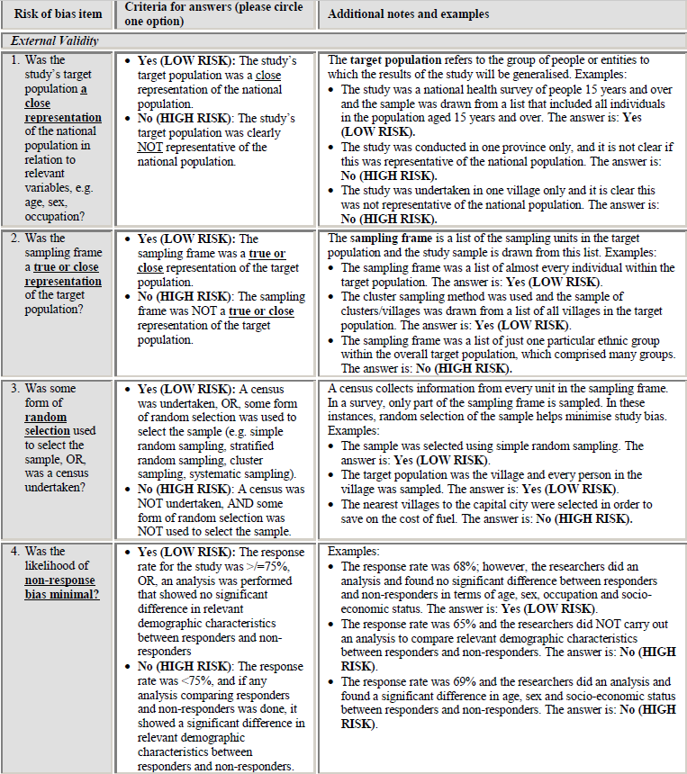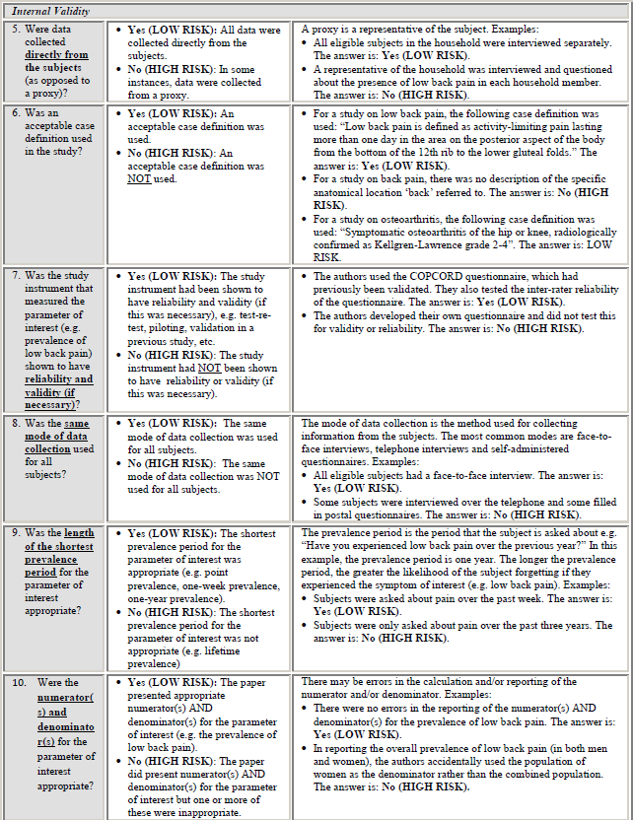
Note: If there is insufficient information in the article to answer a particular item, answer ‘NO’ for that item.
Each item that had a ‘NO’ as an answer is tallied up. If the total number of points are:
- 0 – 3 points = LOW RISK OF BIAS: Further research is very unlikely to change our confidence in the estimate.

- 4 – 6 points = MODERATE RISK OF BIAS: Further research is likely to have an important impact on our confidence in the estimate and may change the estimate.

- 7 – 10 points = HIGH RISK OF BIAS: Further research is very likely to have an important impact on our confidence in the estimate and is likely to change the estimate.
From: Hoy D, Brooks P, Woolf A, Blyth F, March L, Bain C, et al. Assessing risk of bias in prevalence studies: modification of an existing tool and evidence of interrater agreement. J Clin Epidemiol. 2012;65(9):934-9

