Supplementary material
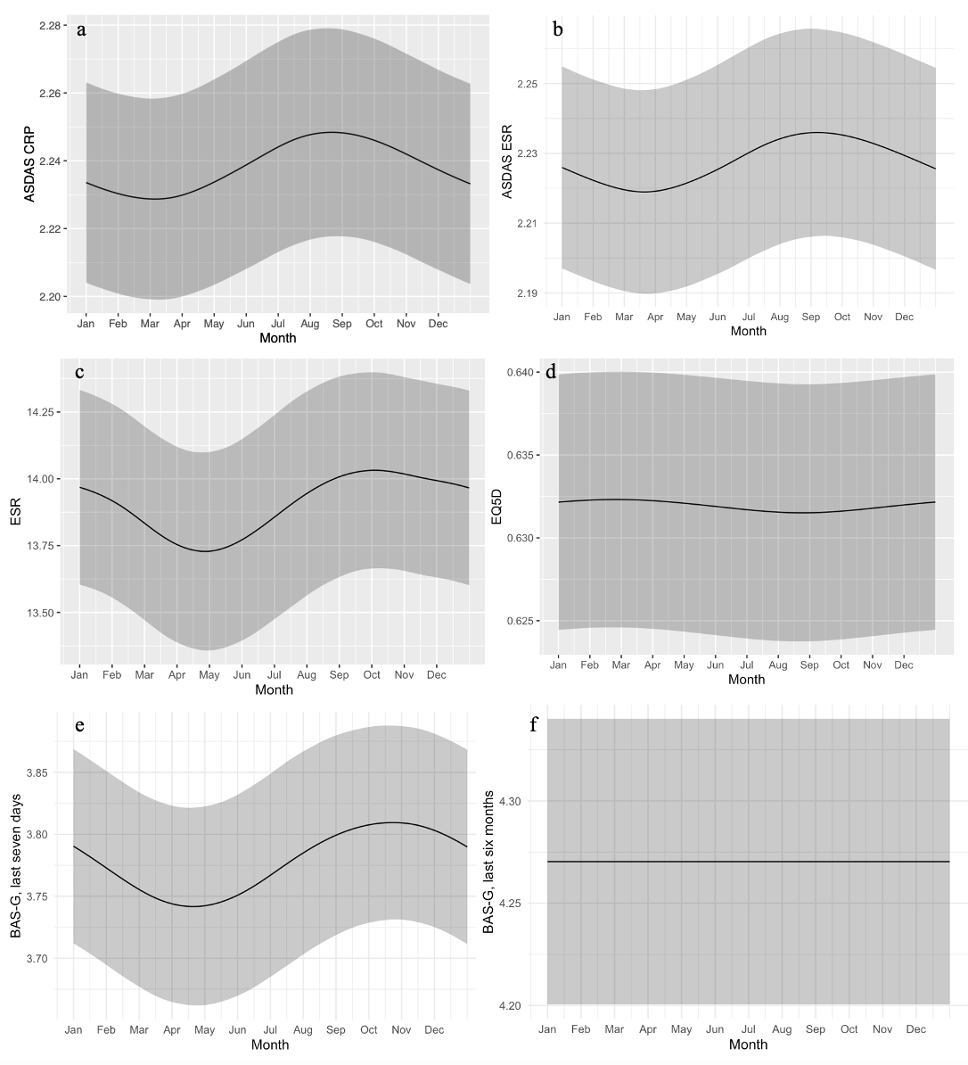Supplementary fig. 1 Temporal variation, for the entire country, in mean values with splines. Figure a displaying ASDAS CRP (p = 0.1), figure b displaying ASDAS SR (p = 0.1), figure c displaying ESR (p = 0.52), figure d displaying EQ5D (p = 0.3), figure e displaying BAS-G, last 7 days, (p = 0.06) and figure f displaying BAS-G, last 6 months, (p = 1). The main line represents the smoothed mean curve, while the ribbon signifies the 95% confidence interval

BASDAI: Bath Ankylosing Spondylitis Disease Activity Index. BASFI: Bath Ankylosing Spondylitis Functional Index. BASMI: Bath Ankylosing Spondylitis Metrology Index. BAS-G: Bath Ankylosing Spondylitis Global Score. CRP: C-reactive protein. ESR: Erythrocyte sedimentation rate. ASDAS: Ankylosing Spondylitis Disease Activity Score

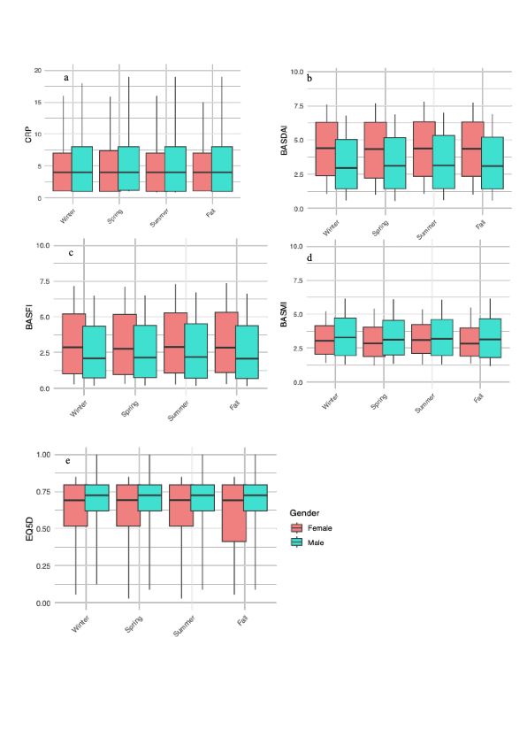
Supplementary fig. 2 Median values of CRP, BASFI, BASDAI, BASMI, and EQ5D split by seasons and gender. The boxes represent the interquartile range, with the line inside indicating the median. The whiskers extend to the 10th and 90th percentiles

BASDAI: Bath Ankylosing Spondylitis Disease Activity Index. BASFI: Bath Ankylosing Spondylitis Functional Index. BASMI: Bath Ankylosing Spondylitis Metrology Index. CRP: C-reactive protein

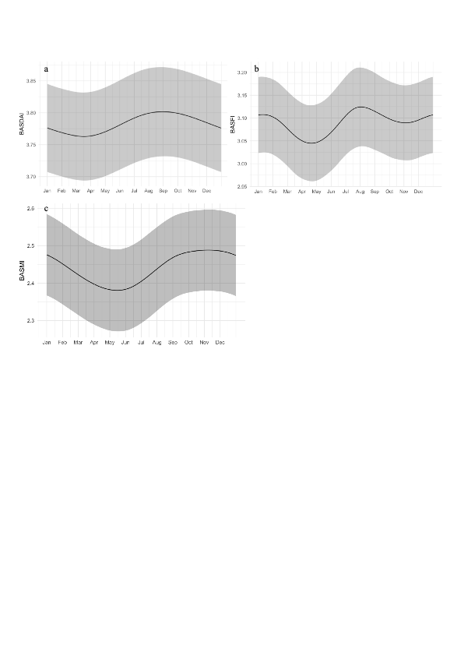
Supplementary fig. 3 Temporal variation, for individuals with a clinically relevant variation (i.e. >1 cm, >0.7 cm, >30%) between highest and lowest value in BASDAI (fig. a, n = 24 401), BASFI (fig. b, n = 21 545), and BASMI (fig. c, n = 2770) in mean values with splines (p 0.1). The main line represents the smoothed mean curve, while the ribbon signifies the 95% confidence interval

BASDAI: Bath Ankylosing Spondylitis Disease Activity Index. BASFI: Bath Ankylosing Spondylitis Functional Index. BASMI: Bath Ankylosing Spondylitis Metrology Index

