Table S1: Time course for pod collection (time from previous stage)

 | Flower Stage 1 (S0) | Flower Stage 2 (S1) | Pod Stage 1 (S2) | Pod Stage 2 (S3) | Pod Stage 3 (S4) | Pod Stage 4 (S5) | Pod Stage 5 (S6) | Pod Stage 6 (S7)
Days | 0 | 2 | 1.5-2 | 0.5-1 | 0.5 | 0.5-1 | 1 | 1-1.5

Table S2: Sequences of primers used in qPCR
Gene Name | Primer Sequences
MtWOX1-like | AACTGGCTACCATCTACAAATTCCA
MtWOX1-like | TCTTCTTTGCTGTAATTCTGCTTCA
MtWOX4-like | GTTTCATTAGACCCGAAACTGCTC
MtWOX4-like | TTGTTCTTGTGTTGGATTCCATCTT
MtWOX5 | TATGAATGCTTCAACACAAAGGTT
MtWOX5 | CCAAATGAGTTCAATGGAAAAAGC
MtWOX9-like | TCCCCATTATTGATCATCGACAT
MtWOX9-like | CAAAGGATGCACGAACGTTAAAG
MtWOX11-like | AAATTCAAGCAGGGCCACTAGAC
MtWOX11-like | GGTGCAAGCTCTGAATCAAGATG
MtWUS | CTTACAACATTTCATCTGCTGGGCT
MtWUS | CGACATGATGACCAATCCATCCTAT
MtLMI1-like | GCGATTAACGAGTGAACAGATGG
MtLMI1-like | GCTGTAGCCCTAACTCCTTGGAA
HD-ZIP2 (AtHB2-like) | GTCGAAGGAGCAGTCAATGTTGT
HD-ZIP2 (AtHB2-like) | CTTGGCTTCAGATTCAACTGCTT
HD-ZIP3 (HAT14-like) | TGCAACAAATTCTACAGCCACTTC
HD-ZIP3 (HAT14-like) | TTTGAGGTGGAATCATCACTGGT
HD-ZIP4 (AtHB13-like) | CAGAACCAAAAACTTCAAGCTGAGA
HD-ZIP4 (AtHB13-like) | TGATCCTTCTGTTTCTTTGTTCAGG
HD-ZIP5 (HAT9-like) | TCTAAGGCCACGACAAGTTGAAG
HD-ZIP5 (HAT9-like) | TTTTCAAGAACTCGCAATCCACCT
MtKNOX6 (STM-like) | GACAACAACTACTTGATTGGTGGAG
MtKNOX6 (STM-like) | CTTCAAATCTAGGCCTGTTGATTCT
MtKNOX4 (KNAT7-like) | CAAACTCATTCTCTTTCGCCTCAT
MtKNOX4 (KNAT7-like) | ACAGCTTCAACAGCATGAACTCTG
MtKNOX7 (KNAT4-like) | CGCATTATGTTCTCCTGCTCTGT
MtKNOX7 (KNAT4-like) | CGGTCAAGCTTTGTAGAGACTGC
MtSERF | TCATACGCCATCATCTCTTAGGT
MtSERF | AGGGGTTGTTTCCTTTGAAGAT
MtABI3-like | TGCAGACACAGAGTTCTCACCAG
MtABI3-like | GACTTCCGACATCACTTTGCTTC
MtFUS3-like | GCTTTCCTTCCTGTCCTTGAGTC
MtFUS3-like | GATCACAAGCTTTCTTTGCCTGA
MtBBM | GATCTCTACCTAGGAACTTTCAGCAC
MtBBM | TGTCAAAGTTTGTAACTGCACTCAG
MtDOF1 | ACCATAAGATCCATCATGAAGAAAG
MtDOF1 | AGAAGTGTTGTTATTTTGCTGAACC
MtGAPDH | GACTTTATTGGTGATACCAGGTCG
MtGAPDH | GGTCAACCACACGGGTACTGTAA

Table S3: Gene Loci, Arabidopsis homologues and Affymetrix Probesets
Gene Name | Medicago Locus¹  ^{Mt3.5} | Medicago Locus²  ^{Mt3.0 Phytozome 9.0} | Closest Matching Arabidopsis Locus; Name³; identity of amino acids | Affymetrix M. truncatula Probeset³ | Tissue-specific expression in M. truncatula gene atlas | Functional / developmental studies in M. truncatula
MtWOX1-like | Medtr4g154980 | Medtr8g107210 | At3g18010; WOX; 38.7% | Mtr.51678.1.S1_at | Flowers,vegetative buds and seed maturation | Blade outgrowth and leaf vascular patterning in Medicago (Tadege et al. 2011)
MtWOX4-like | Medtr1g024140 | Medtr1g019130 | At1g46480; WOX4; 55.3% | Mtr.23994.1.S1_at | Flowers, shoots and stems | In vitro root formation – low expression (Imin et al. 2007)
MtWOX5 | Medtr5g089330 | Medtr5g081990 | At3g11260; WOX5; 55.4% | Mtr.33304.1.S1_at | Leaf tissue culture during first two wks | Root meristem development (Chen et al. 2009)
MtWOX9-likeB⁶ | Medtr7g026130 | Medtr7g025010 | At2g33880; WOX9; 36.9% | Mtr.5935.1.S1_at | NA | NA
MtWOX11-like | Medtr7g103730 | Medtr7g086940 | At3g03660, WOX11; 45.9% | Mtr.28819.1.S1_at | Flowers, seed coat, seed development | NA
MtWUS | Medtr5g021830 | Medtr5g021930 | At2g17950, WUS; 39.0% | NA | NA | Somatic and zygotic embryogenesis (Chen et al. 2009)
MtLMI1-like | Medtr1g073710 | Medtr1g061660 | At5g03790; LMI1; 44.5% | Mtr.18411.1.S1_s_at | Vegetative bud and seed | NA
HD-ZIP2 (AtHB2-like) | NA (TC149707) | NA | At4g16780; ATHB2 | Mtr.11045.1.S1_at | Seed development | NA
HD-ZIP3 (HAT14-like) | Medtr2g071640 | Medtr2g061030 | At5g06710; HAT14; 45.0% | Mtr.12147.1.S1_at | Leaf tissue culture in first 2 wks | NA
HD-ZIP4 (AtHB13-like) | Medtr5g040020 | Medtr5g039000 | At1g69780; ATHB13; 61.7% | Mtr.10964.1.S1_at | Hypocotyl | NA
HD-ZIP5 (HAT9-like) | Medtr5g015030 | Medtr5g014890 | At2g22800; HAT9; 60.1% | Mtr.40459.1.S1_at | Stem | NA
MtKNOX6 (STM-like) | Medtr5g093180 | Medtr5g085860 | At1g62360; STM; 49.1% | Mtr.32410.1.S1_at | Most highly in stems, but also in seed filling | Shoot apical meristem (Giacomo et al. 2008)
MtKNOX4 (KNAT7-like) | Medtr5g011210 | Medtr5g011070 | At1g62990; KNAT7; 74.4% | Mtr.38132.1.S1_a_at⁵ | Highly in seed coat, roots, also seed maturation | Shoot apical meristem (Giacomo et al. 2008)
MtKNOX7 (KNAT4-like) | NA (TC149968 ) | NA | At5g11060; KNAT4 | Mtr.8750.1.S1_at | Expressed widely, but highest in nodules | Shoot apical meristem (Giacomo et al. 2008
MtSERF1 | Medtr1g059490 | Medtr1g040430 | AT5G61590; NA; 42.6% | Mtr.38122.1.S1_at | Embryo | Somatic and zygotic embryogenesis (Mantiri et al. 2008)
MtABI3-like | NA (TC162720) | NA | At3g24650; ABI3 | Mtr.44550.1.S1_at | Seed-specific | Seed filling (Verdier et al. 2008)
MtFUS3-like | Medtr7g096720 | Medtr7g083700 | At3g26790; FUS3; 47.3% | Mtr.25862.1.S1_at | Seed-specific | Seed filling (Verdier et al. 2008)
MtBBM | Medtr7g090100 | Medtr7g080460 | At5g17430; BBM; 45.0% | Mtr.21627.1.S1_at | Leaf tissue culture, seed and root | In vitro root formation – high expression (Imin et al. 2007)
MtDOF1 | NA (TC161263) | NA | At4g24060; DOF4.6 | Mtr.45367.1.S1_at | Expressed widely | NA
MtGAPDH | Medtr8g109660 | Medtr4g103920 | At3g04120; GAPC; 87.6% | Mtr.51186.1.S1_at | Expressed everywhere at a similar level | NA
¹Obtained from the Mt3.5 genome release (http://www.medicagohapmap.org) or, where no data exist, a corresponding TC sequence from the M. truncatula Gene Index is given (http://compbio.dfci.harvard.edu/tgi). ² Mt 3.0 genome release (http://www.medicagohapmap.org) used in Phytozome 9.0. ³Based on phylogenetic analysis of protein sequences or where no full length sequence was available by BLAST searches. ⁴Only the best matching probeset (E-value = 0) from the Affymetrix M. truncatula GeneChip shown. ⁵Probeset match has a large E-value (1x10⁻⁵⁶). ⁶ We obtained the full length coding sequence from cDNA to correctly annotate this gene locus on Phytozome. There are two WOX9-like genes (Medtr2g015000 and Medtr7g025010; MtWOX9-likeA and B respectively) and both with closer identity to AtWOX9 than AtWOX8. The amino acid identity between MtWOX9-likeB and AtWOX8 is less than between MtWOX9-likeA and AtWOX8). NA; no data available.

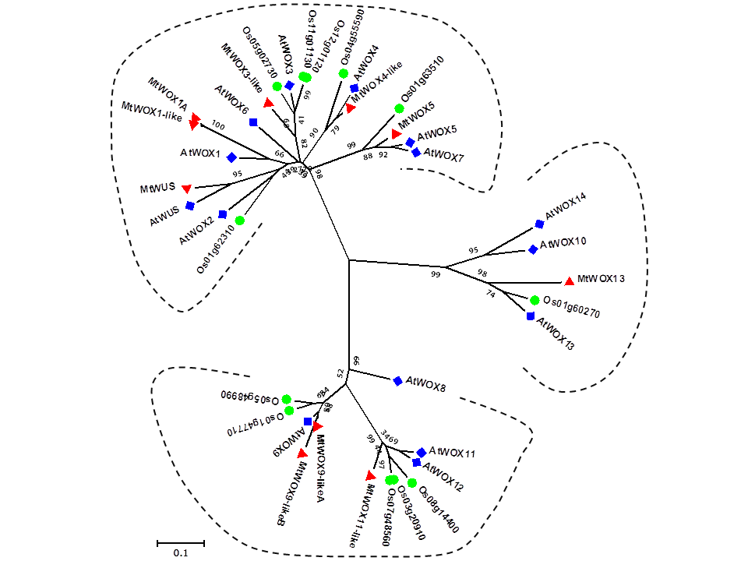

Supplementary Fig. 1A. Phylogenetic tree of WOX genes from Arabidopsis, Medicago and rice. Dendrogram is based on full-length amino acid sequences. Bootstrap values are expressed as percentage (1000 rounds). Putative M. truncatula orthologues to Arabidopsis proteins examined in this study are shown in red.

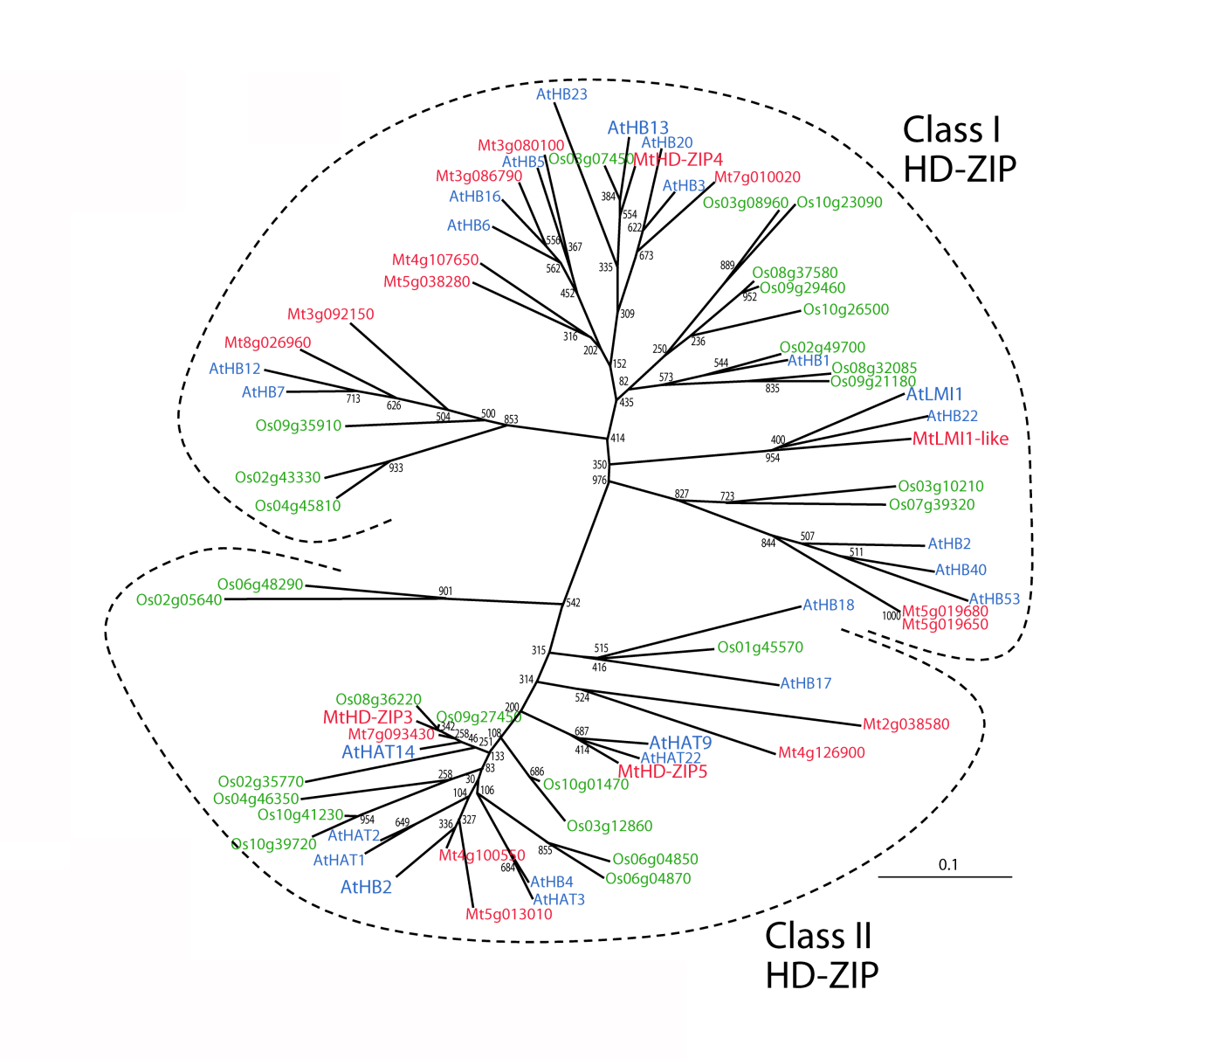
Supplementary Fig. 1B. Phylogenetic tree of HD-ZIP genes from Arabidopsis, Medicago and rice. Dendrogram is based on full-length amino acid sequences. Bootstrap values are for 1000 rounds. Putative M. truncatula orthologues to Arabidopsis proteins examined in this study are shown in red.

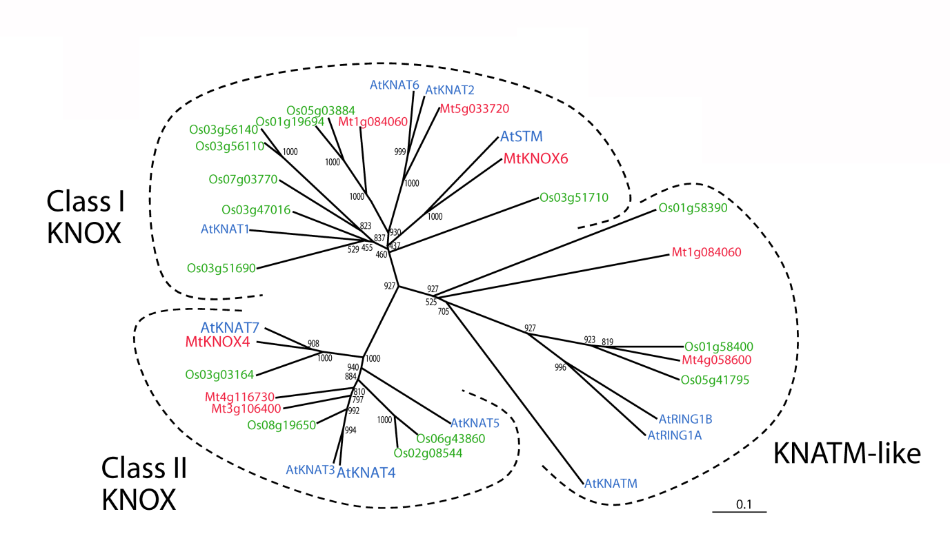

Supplementary Fig. 1C. Phylogenetic tree of HD-ZIP genes from Arabidopsis, Medicago and rice. Dendrogram is based on full-length amino acid sequences. Bootstrap values are for 1000 rounds. Putative M. truncatula orthologues to Arabidopsis proteins examined in this study are shown in red.

