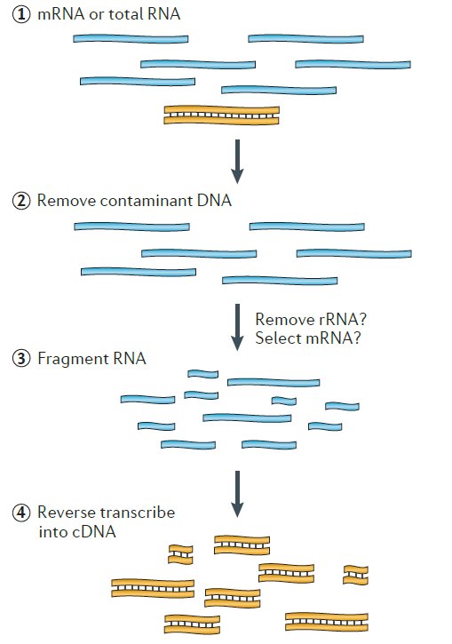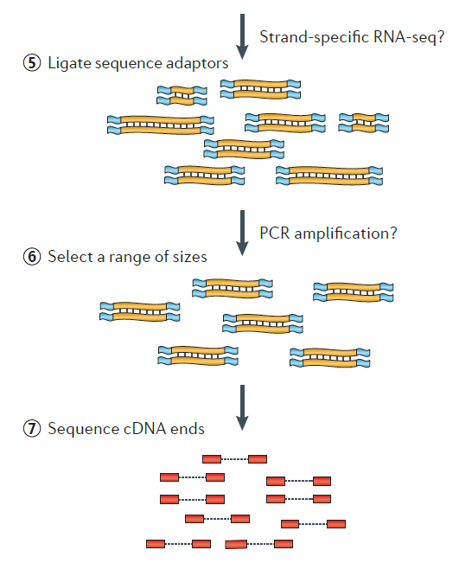

Fig S1. RNA-Seq Data Generation Workflow

Table: Reference Sequence Information

IRGSP 정보 | 파일명 | Total Sequence No. | Total Length (bp) | Min Length (bp) | Max Length (bp)
Genome | Gmax_275_v2.0.fa | 1,190 | 978,495,272 | 1,002 | 58,018,742
Transcript | Gmax_275_Wm82.a2.v1.transcript_primaryTranscriptOnly.fa | 56,044 | 92,028,847 | 87 | 16,968
CDS | Gmax_275_Wm82.a2.v1.cds_primaryTranscriptOnly.fa | 56,044 | 65,462,595 | 87 | 16,308
Protein | Gmax_275_Wm82.a2.v1.protein_primaryTranscriptOnly.fa | 56,044 | 21,820,865 | 29 | 5,436

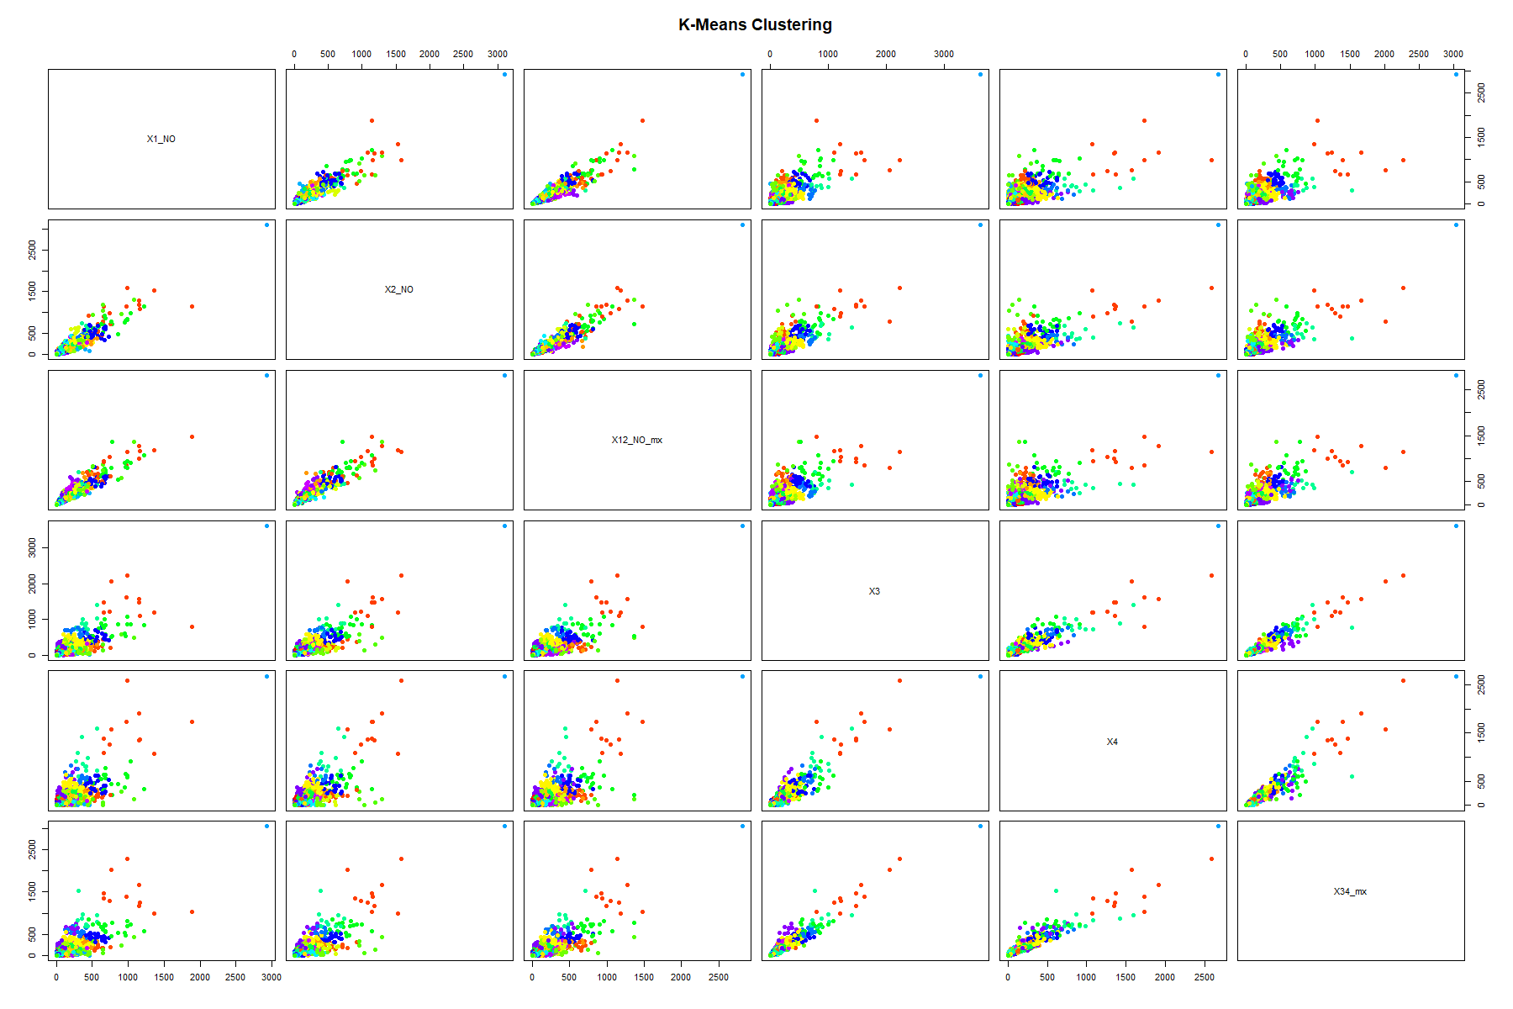
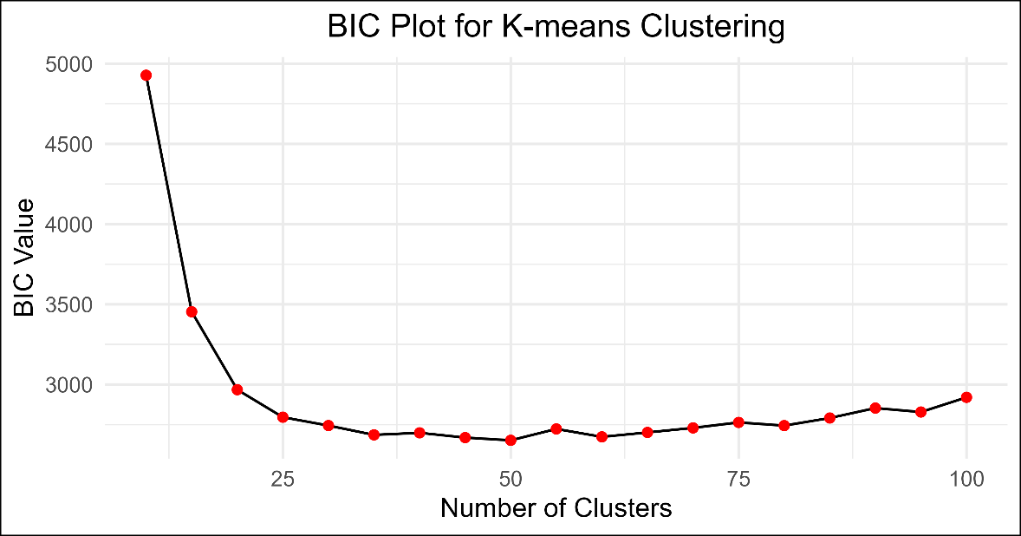
Figure: The data were subjected to k-means clustering analysis, and Bayesian Information Criterion (BIC) statistics were computed for different values of K. The plot illustrates the relationship between the number of clusters (K) and the corresponding BIC values. The minimum BIC, indicating the optimal number of clusters, was observed at K = 82.

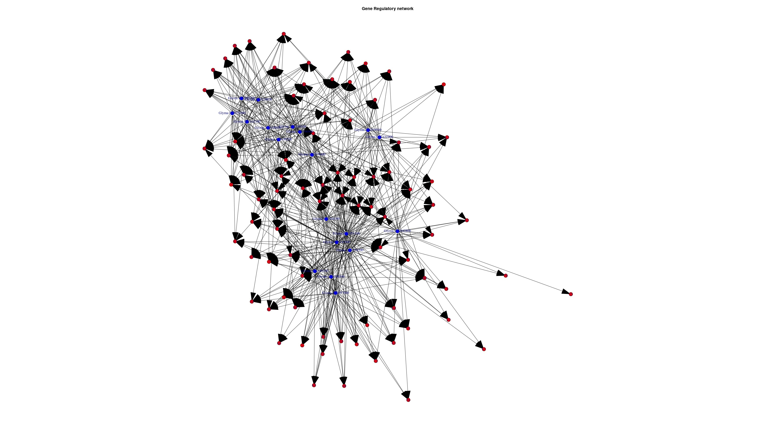
Fig: Gene Regulatory Network with edge

