Supplementary Figures
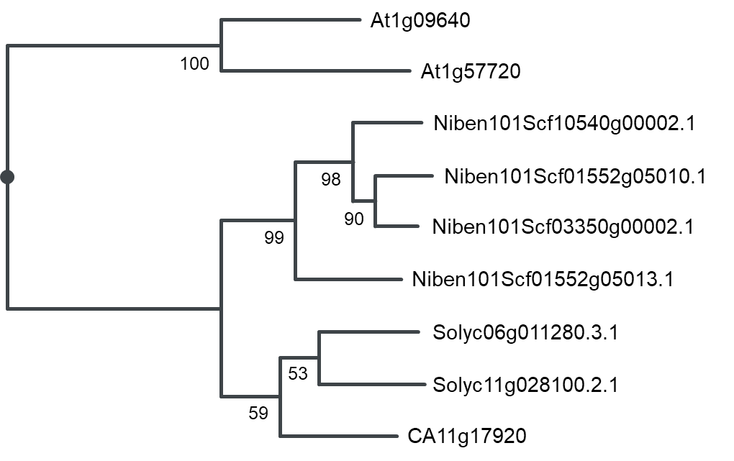
Fig. S1 Phylogenetic tree of eEF1Bγ proteins from four different plant species. The phylogenetic tree was constructed with the neighbor-joining method using PID in the Jalview program.

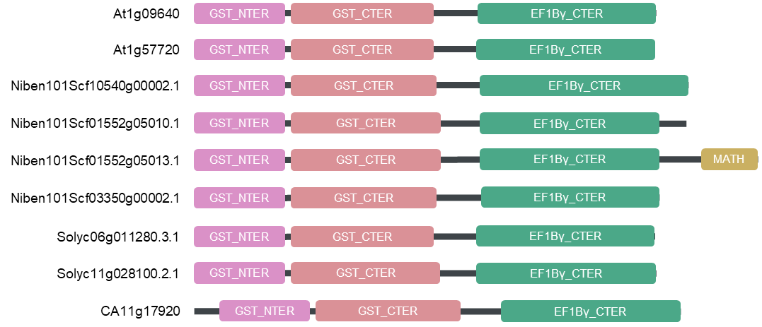
Fig. S2 Diagram of the eEF1Bγ domain structure. The domain structure of eEF1Bγ proteins was predicted by the InterPro program. GST_NTER, glutathione S-transferase N-terminal domain; GST_CTER, glutathione S-transferase C-terminal domain; EF1Bγ_CTER, Elongation factor 1B gamma C-terminal domain; MATH, meprin and TRAF homology domain.

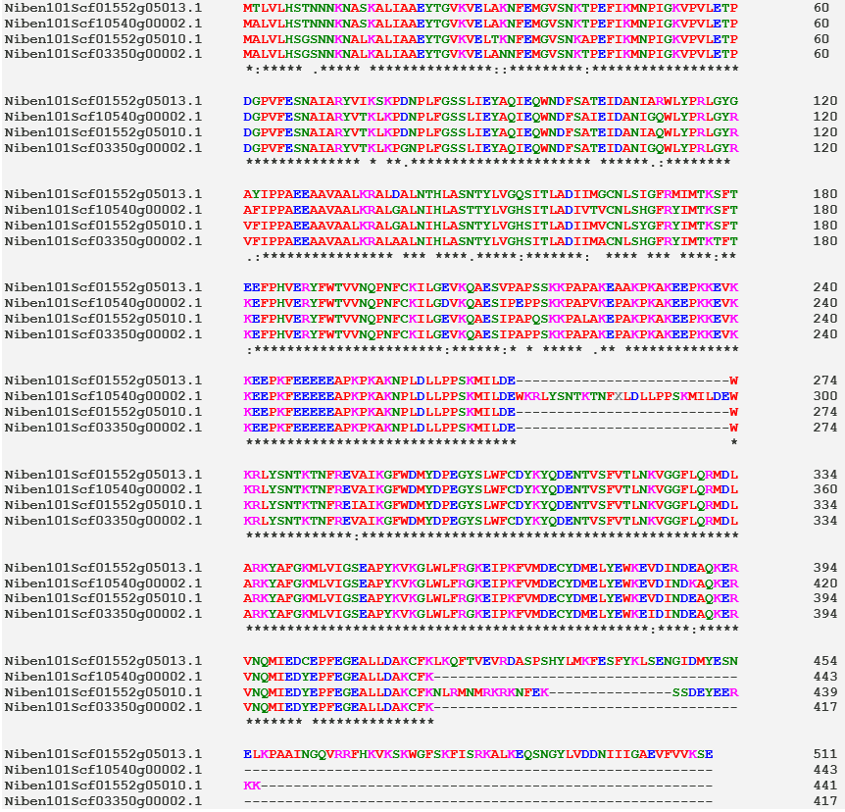
Fig. S3 Alignment of amino acid sequences of the eEF1Bγ proteins in N. benthamiana. The protein sequences of all four N. benthamiana eEF1Bγs were aligned using the Clustal Omega program.

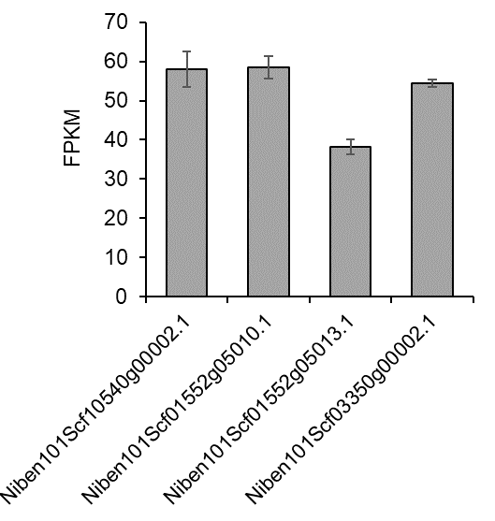
Fig. S4. Expression analysis of eEF1Bγ homologs in N. benthamiana. Transcriptome data from three SRA files (SRR11747765, SRR11747766, and SRR11747767) corresponding to N. benthamiana leaf samples were used. Fragments Per Kilobase per Million mapped fragments (FPKM) values were calculated for each of the four eEF1Bγ homologs. Data are presented as means ± SD. n = 3.

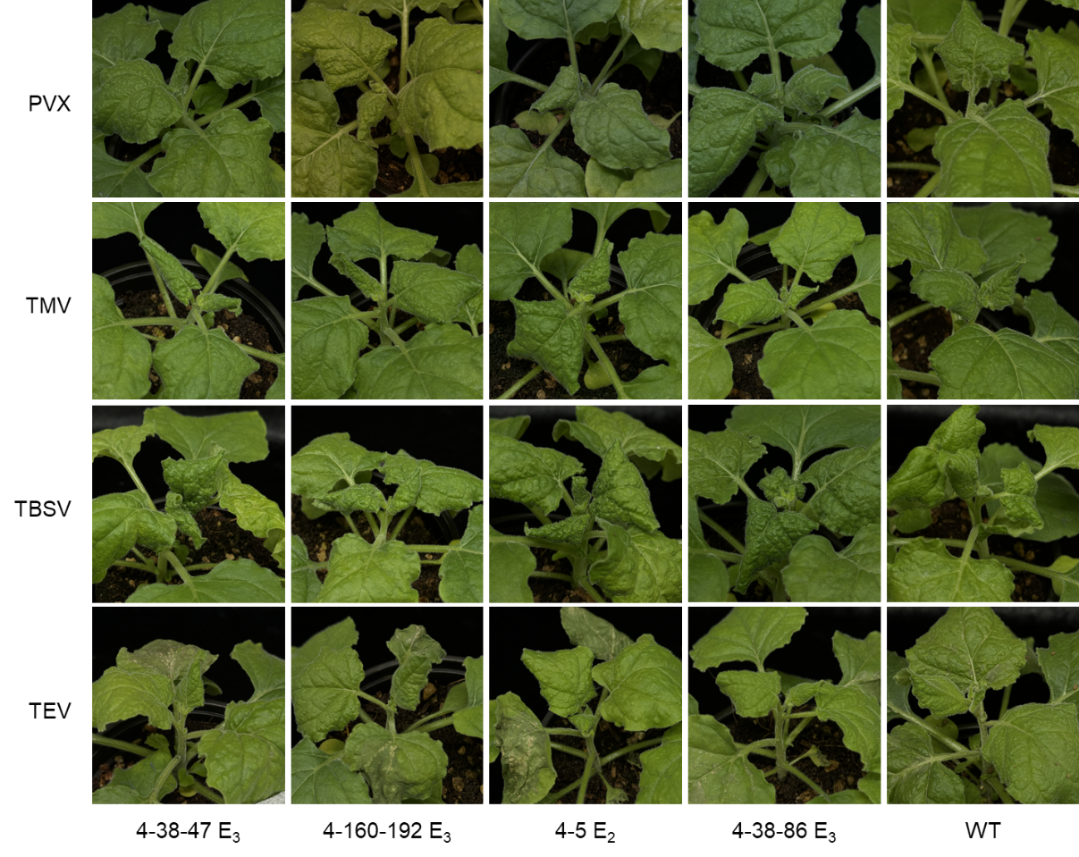
Fig. S5 Virus symptoms of eEF1Bγ-edited lines and WT plants inoculated with PVX, TMV, TBSV, and TEV. The photographs display virus symptoms observed at 5 DPI.

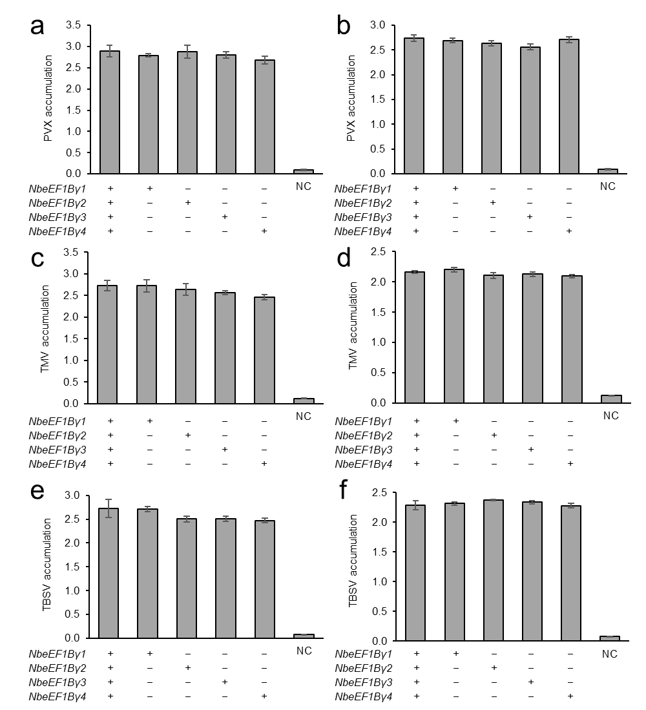
Fig. S6 Resistance analysis of eEF1Bγ-edited lines inoculated with PVX, TMV, or TBSV. Plants of the eEF1Bγ-edited lines 4-38-47 E₃, 4-160-192 E₃, 4-5 E₂, and 4-38-86 E₃ were inoculated with PVX (a and b), TMV (c and d), or TBSV (e and f), and ELISA was conducted using inoculated leaves (a, c, and e) and systemic leaves (b, d, and f) at 5 DPI. Data are presented as means ± SE (n = 4–8).
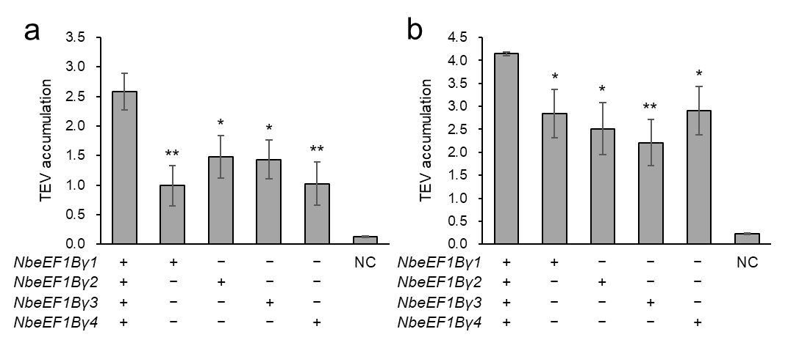
Fig. S7 Resistance analysis of eEF1Bγ-edited lines inoculated with TEV. Plants of the eEF1Bγ-edited lines, 4-38-47 E₃, 4-160-192 E₃, 4-5 E₂, and 4-38-86 E₃ were inoculated with TEV-HAT, and ELISA was conducted using inoculated leaves (a) and systemic leaves (b) at 5 DPI. Data are presented as means ± SE (n = 10–12 for eEF1Bγ-edited plants or wild-type plants; n = 4 for non-inoculated plants, negative control, NC). Statistical significance was determined by a two-tailed t-test in Microsoft Excel relative to WT: *, P < 0.05, **, P < 0.01, and ***, P < 0.001.

Supplementary Tables
Table S1 List of primers used in this study.
Primer name | Sequence (5' to 3') | Amplicon size (bp) | Purpose
eEF1Bγ-sgRNA-MfeI-F | GATACAATTGCTCATTGCTGCTGAGTACACGTTTTAGAGCTAGAAATA | 218 | pTRV2-sgRNA vector construction
tRNAIle-XmaI-R | GTACCCCGGGCTGCAGCCATGGAAAAAATGCTTCCGGCGGGGCTCG | 218 | pTRV2-sgRNA vector construction
eEF1Bγ1-PCR-RE-F | GATGAAATTTCTTGATGATATCCTCGC | 604 | Mutation detection
eEF1Bγ1-PCR-RE-R | ATTTGAGCCTGTCAAGGAAAAAGA | 604 | Mutation detection
eEF1Bγ2-PCR-RE-F | TGGGACATTTTGCATGAAGGCT | 650 | Mutation detection
eEF1Bγ2-PCR-RE-R | CCCGCCTGCCATTCCTACTA | 650 | Mutation detection
eEF1Bγ3-PCR-RE-F | GGGATAAAATTTCTTGAAGATATCCTCGT | 468 | Mutation detection
eEF1Bγ3-PCR-RE-R | AAAAGGGGATTGTCGGGCTT | 468 | Mutation detection
eEF1Bγ4-PCR-RE-F | TTTCTCTTGGGTAGGTAATTTCTTGATG | 478 | Mutation detection
eEF1Bγ4-PCR-RE-R | GGATTGCCGGGCTTCAATTT | 478 | Mutation detection
eEF1Bγ1 qRT-F | CAAGTTTCAACTGTGCAACCATGG | 158 | RT-qPCR
eEF1Bγ1 qRT-R | GATAAACTCAGGTGTCTTGTTTGATACC |  | RT-qPCR
eEF1Bγ2 qRT-F | GGCACCTGAGTTTATCAAGATGAAC | 122 | RT-qPCR
eEF1Bγ2 qRT-R | GATTGTCGGGCTTCAATTTAGTTACATAT |  | RT-qPCR
eEF1Bγ3 qRT-F | ACAAGACACCTGAGTTTATCAAGATGAAT | 167 | RT-qPCR
eEF1Bγ3 qRT-R | CTCGATTTGAGCATATTCAATCAATGATGAA |  | RT-qPCR
eEF1Bγ4 qRT-F | GCACGCTATGTAACTAAATTGAAGCCCGG | 138 | RT-qPCR
eEF1Bγ4 qRT-R | ACGTGGGTACAACCATTGCC |  | RT-qPCR
Nb-actin-F | CTGAGAGATTCCGCTGC | 143 | RT-qPCR
Nb-actin-R | GAGGACAATGTTTCCGTAC |  | RT-qPCR

Table S2 Similarity among eEF1Bγ proteins from four plant species.
Similarity (%) | At1g09640 | At1g57720 | Solyc06g011280.3.1 | Solyc11g028100.2.1 | CA11g17920 | Niben101Scf10540g00002.1 | Niben101Scf01552g05010.1 | Niben101Scf01552g05013.1 | Niben101Scf03350g00002.1
At1g09640 | – | 93 | 85 | 85 | 85 | 80 | 85 | 82 | 82
At1g57720 | – | – | 85 | 84 | 83 | 76 | 82 | 82 | 81
Solyc06g011280.3.1 | – | – | – | 96 | 93 | 86 | 93 | 92 | 91
Solyc11g028100.2.1 | – | – | – | – | 93 | 88 | 94 | 92 | 92
CA11g17920 | – | – | – | – | – | 82 | 91 | 91 | 89
Niben101Scf10540g00002.1 | – | – | – | – | – | – | 91 | 90 | 91
Niben101Scf01552g05010.1 | – | – | – | – | – | – | – | 95 | 98
Niben101Scf01552g05013.1 | – | – | – | – | – | – | – | – | 95
Niben101Scf03350g00002.1 | – | – | – | – | – | – | – | – | –

Table S3 List of primers used in off-target analysis.
Predicted off-target sequence | Primer name | Sequence (5' to 3') | Amplicon size (bp)
CTCAGTACTGCTGAAAACACAGG | eEF1Bγ-off1-F | GTGGTCCACGACTCTAAGCA | 502
CTCAGTACTGCTGAAAACACAGG | eEF1Bγ-off1-R | CCTGATTGCTCATCAGAGAATACTAAATCAG | 502
CCTATTGCTCCTAAGTACACAGG | eEF1Bγ-off2-F | CATTGTACCTTGTTGCCCAGCTA | 664
CCTATTGCTCCTAAGTACACAGG | eEF1Bγ-off2-R | TTCGGTGAAACGCTTACCCT | 664
AGCATTGCTGCTGACAACACTGG | eEF1Bγ-off3-F | AAAGAGTAGGAGATCTGCAGCC | 599
AGCATTGCTGCTGACAACACTGG | eEF1Bγ-off3-R | ACGGGAGAGGATCTACCAGTT | 599
TTCATTGCTGCTCAGAAAACAGG | eEF1Bγ-off4-F | TACCGCTGATAGGACAGAAGC | 562
TTCATTGCTGCTCAGAAAACAGG | eEF1Bγ-off4-R | GATAGTTGTTGTTGTTATTGTTGTTATGCCCA | 562
CTCATTGCCGCAGAGGACACAGG | eEF1Bγ-off5-F | GGAGTATTAGCCCCGCATG | 551
CTCATTGCCGCAGAGGACACAGG | eEF1Bγ-off5-R | ATCATACATCTTTGAAAGGTCGCTGAG | 551
CTCATAGATGGTGAGTACACGGG | eEF1Bγ-off6-F | CTTCATGTCCTAGGCGGCA | 731
CTCATAGATGGTGAGTACACGGG | eEF1Bγ-off6-R | GGAGCATCTATAGTTGGAGCCTGATA | 731
CTCATTGATGCTGAGTACACGAG | eEF1Bγ-off7-F | TACAAACTGTCAATATCTAGGCCAATGTCTAAT | 789
CTCATTGATGCTGAGTACACGAG | eEF1Bγ-off7-R | GGAGTCATCGAGGTAGCTGTAA | 789

