Supplementary data
Table S1. Expression of genes coding for enzymes modifying cell-wall polysaccharides in BS1 ovules compared to expression in revertant ovules. RNA was extracted from ovules, and libraries were prepared. All genes of cell-wall-modifying enzymes (n=3) in BS1 ovules exhibited significant expression (p<0.05) compared to revertant ovules and are expressed as log2 fold change.

Enzyme | Gene name/ transcript ID | Log2 fold change | Differentially expressed genes in BS1
Xyloglucan xyloglucosyl transferase [EC:2.4.1.207] | Ofi_XT1  Ofi_XT2  Ofi_XT3  Ofi_XT4  Ofi_XT5  Ofi_XT6  Ofi_XT7  Ofi_XT8  Ofi_XT9  Ofi_XT10  Ofi_XT11  Ofi_XT12 | +2.24  +2.04  +1.79  +1.28  +5.70  +0.98  +1.51  +2.26  +1.78  +2.51  +2.89  +1.78 | Up regulation
Pectinesterase [EC:3.1.1.11] | Ofi_PE1  Ofi_PE2  Ofi_PE3  Ofi_PE4 | +1.05  +0.89  +1.91  +0.67 | Up regulation
Cellulose synthase-like protein [EC:2.4.1.-] | Ofi_ CSLD1 | +1.89 | Up regulation
Polygalacturonase [EC:3.2.1.15] | Ofi_PG1 | +10.99 | Up regulation
Xyloglucan 6-xylosyltransferase [EC:2.4.2.39] | Ofi_XXT1 | +1.28 | Up regulation
Chitinase [EC:3.2.1.14] | Ofi_CHIT1  Ofi_CHIT2  Ofi_CHIT3  Ofi_ CHIT4 | +3.02  +1.62  +3.27  +1.37 | Up regulation
Endoglucanase [EC:3.2.1.4] | Ofi_EG1  Ofi_EG2  Ofi_EG3  Ofi_EG4 | -2.11  -1.54  -1.58  -1.49 | Down regulation
Galacturan 1,4-alpha-galacturonidase [EC:3.2.1.67] | Ofi_GAG1  Ofi_GAG2 | -6.02  +0.80 | Up/down regulation
β-galactosidase [EC:3.2.1.23] | Ofi_BGA1  Ofi_BGA2  Ofi_BGA3  Ofi_BGA4 | +0.63  +2.11  +1.02  +0.79 | Up regulation
Beta-glucosidase [EC:3.2.1.21] | Ofi_BGL1  Ofi_BGL2  Ofi_BGL3  Ofi_BGL4  Ofi_BGL5  Ofi_BGL6  Ofi_BGL7  Ofi_BGL8 | +1.07  +2.93  +2.86  +1.10  +1.78  +0.94  +0.85  +3.99 | Up regulation

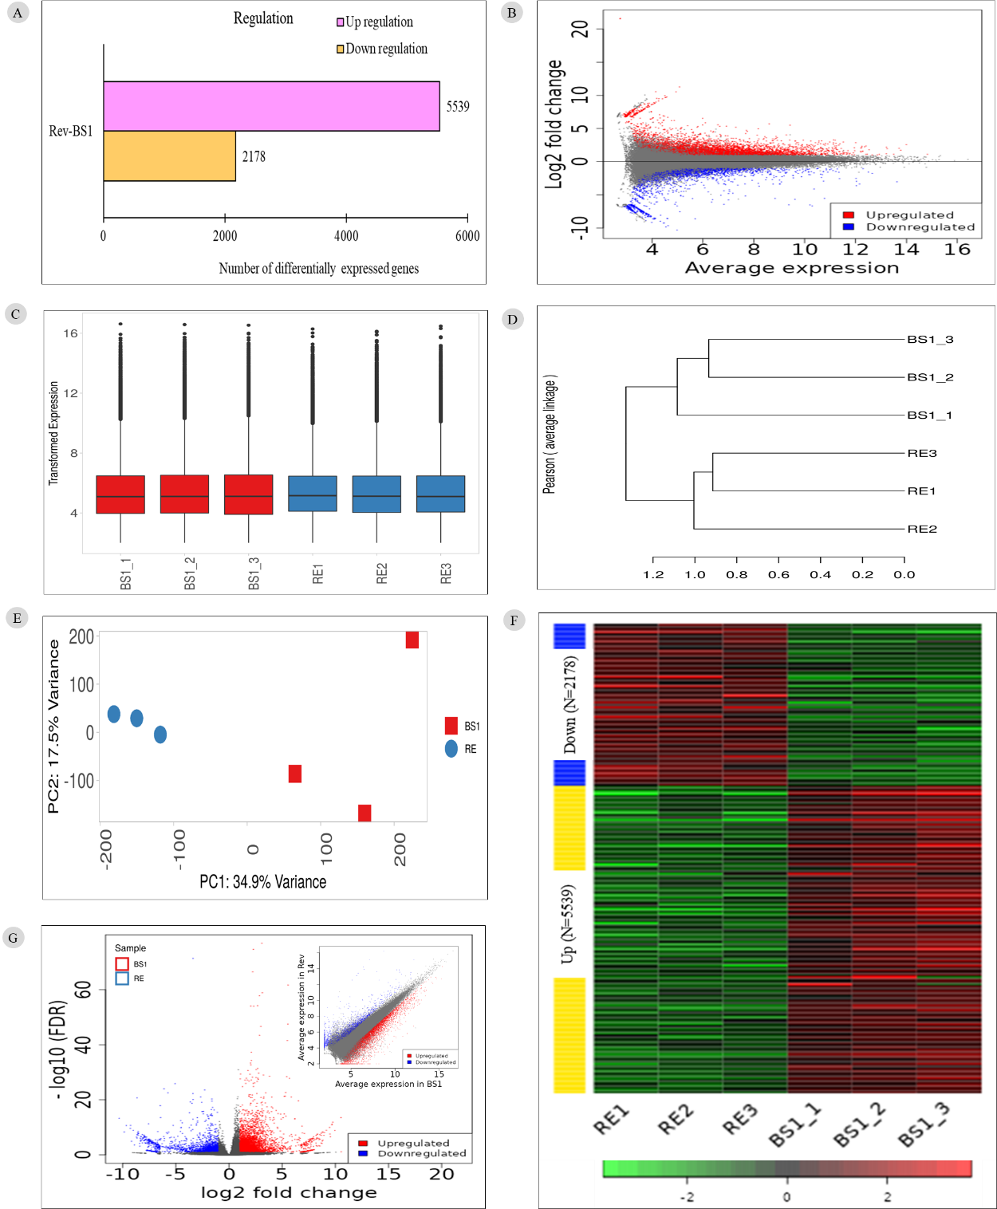

Fig. S1. Transcriptome analysis of BS1 and revertant (Rev). (A) Differential expression of genes in BS1 and Rev. (B) Scatter plot of transformed expression in BS1 and Rev, showing a strong positive relationship. (C) Box plot showing a comparative analysis of data dispersion within and between the BS1 and revertant groups for transformed data distribution. (D) Phylogenetic tree showing the genetic relationships between BS1 and Rev groups. (E) PCA analysis of BS1 versus revertant. (F) Hierarchical clustering. (G) Volcano plot of ddifferentially expressed genes (DEGs) (Inset: MA plot of DEGs).

