Supplementary Fig.1 Figure X. Flow cytometry histogram overlay of nuclear DNA content (FL4 channel). Blue trace: Carex rigescens, estimated genome size = 308.35 Mb, mean FL4 fluorescence intensity = 627.67; black trace: Carex breviculmis, estimated genome size = 344.03 Mb, mean FL4 fluorescence intensity = 807.19. The fluorescence intensity ratio of Carex rigescens to Carex breviculmis is ~1.2, consistent with their genome size difference.
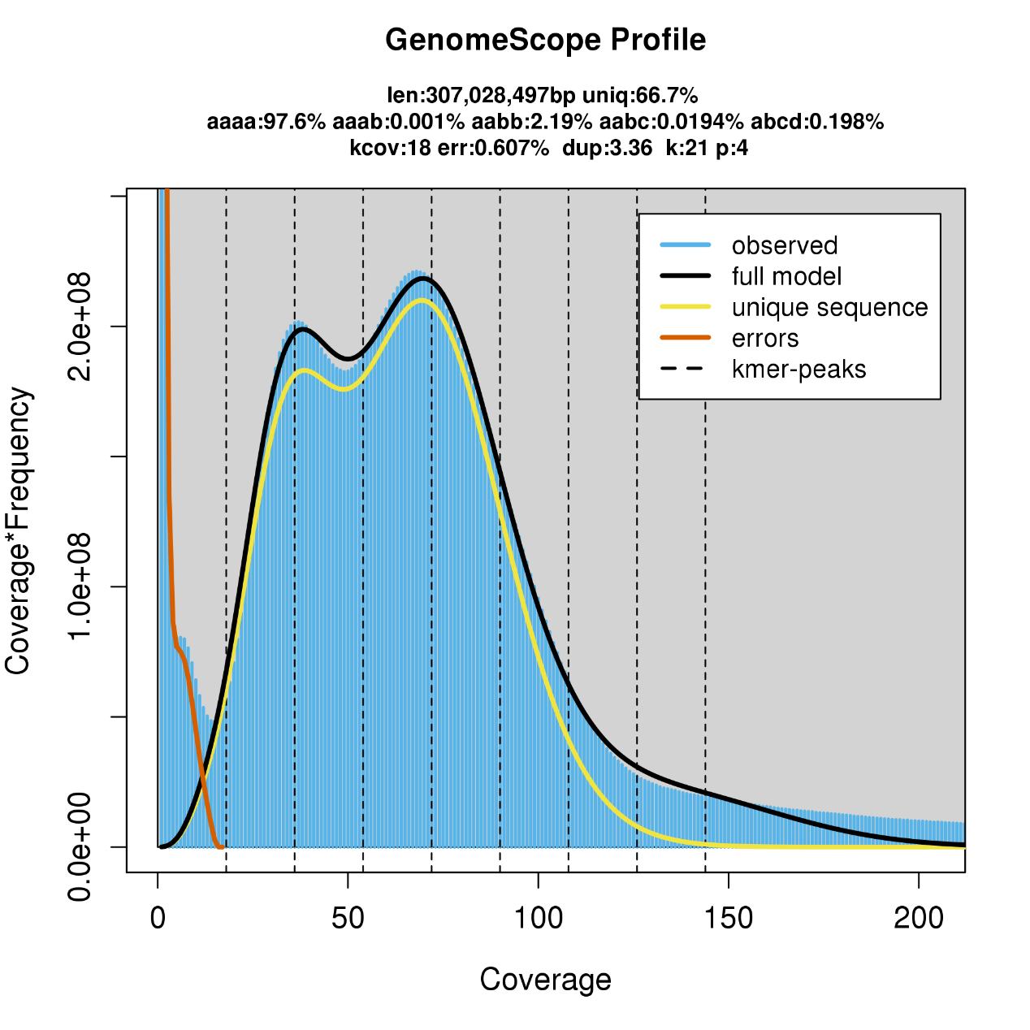
Supplementary Fig.2 Distribution of 21-mer frequency in the Carex rigescens genome.

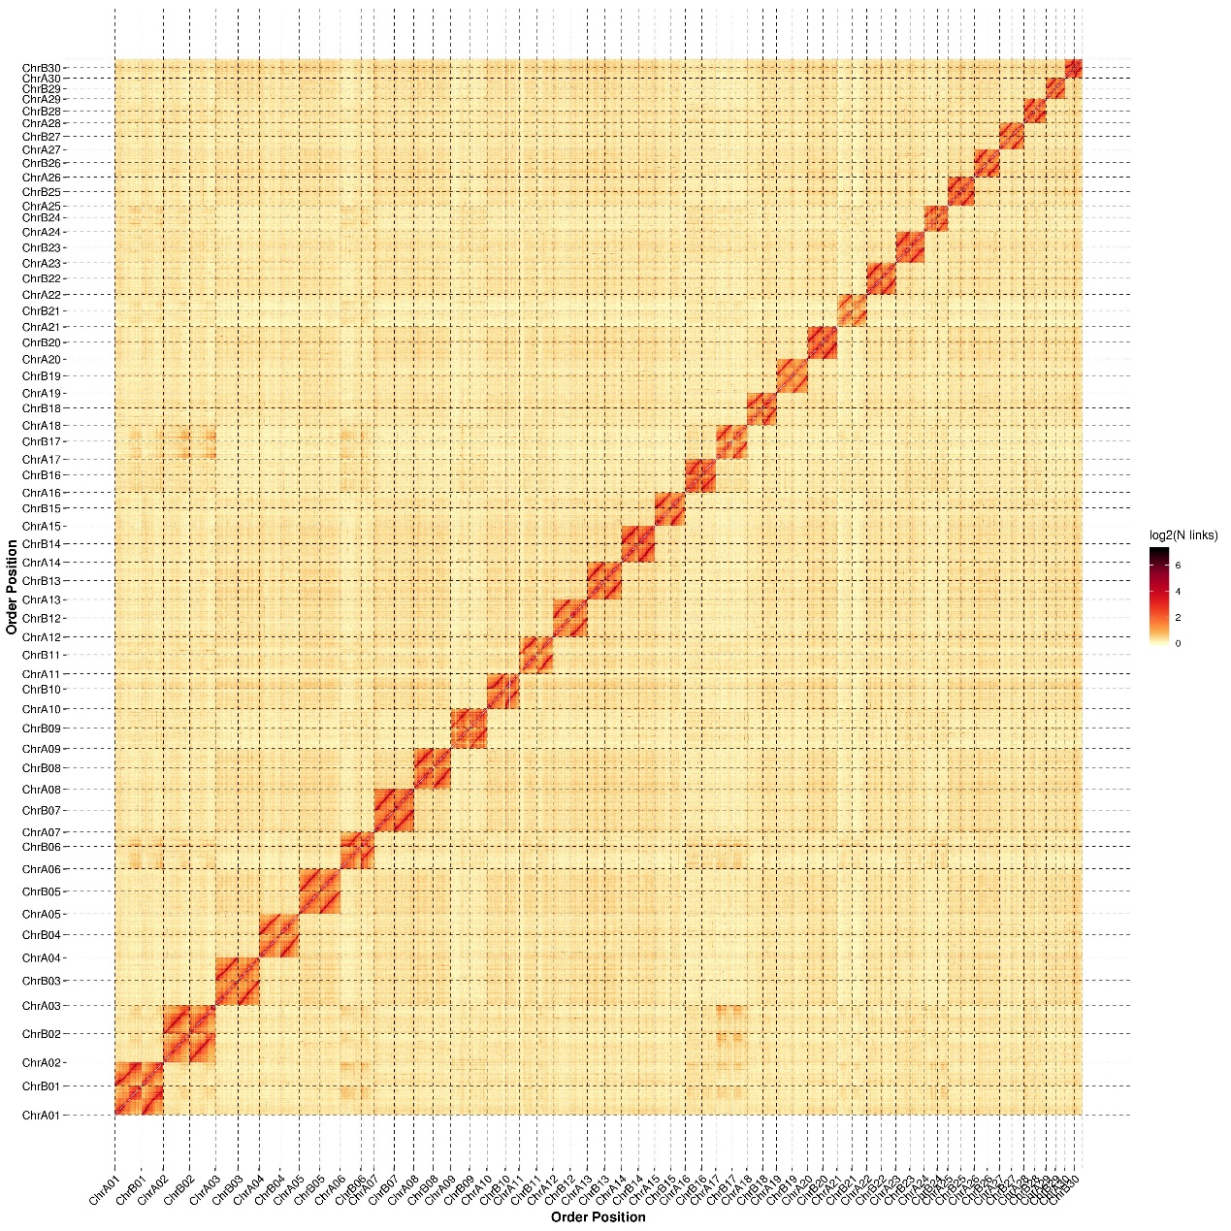
Supplementary Fig.3 DNA interactions in 60 Carex rigescens chromosomes. Each heat map represents a normalized contact matrix, with strong contacts in red.
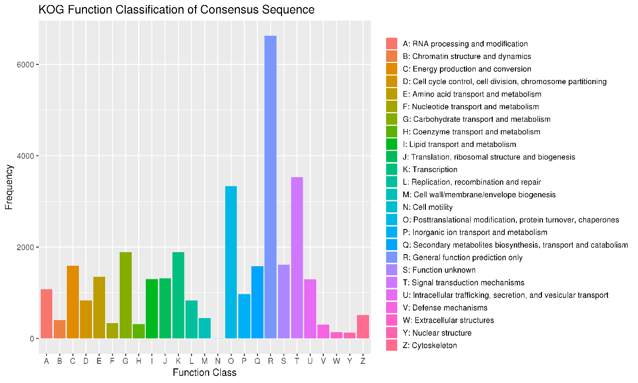
Supplementary Fig.4 KOG function classification.
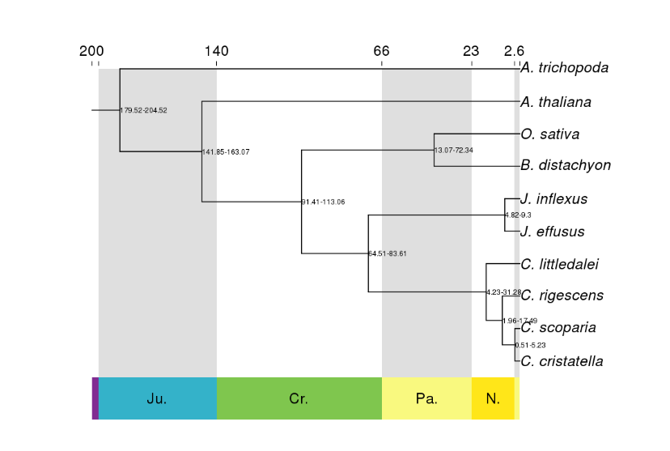
Supplementary Fig.5 Phylogenetic tree of Carex rigescens and 9 other species based on aconcatenated alignment of 103 single-copy ortholog gene sets. The tree is rooted with A. trichopoda as the out group.
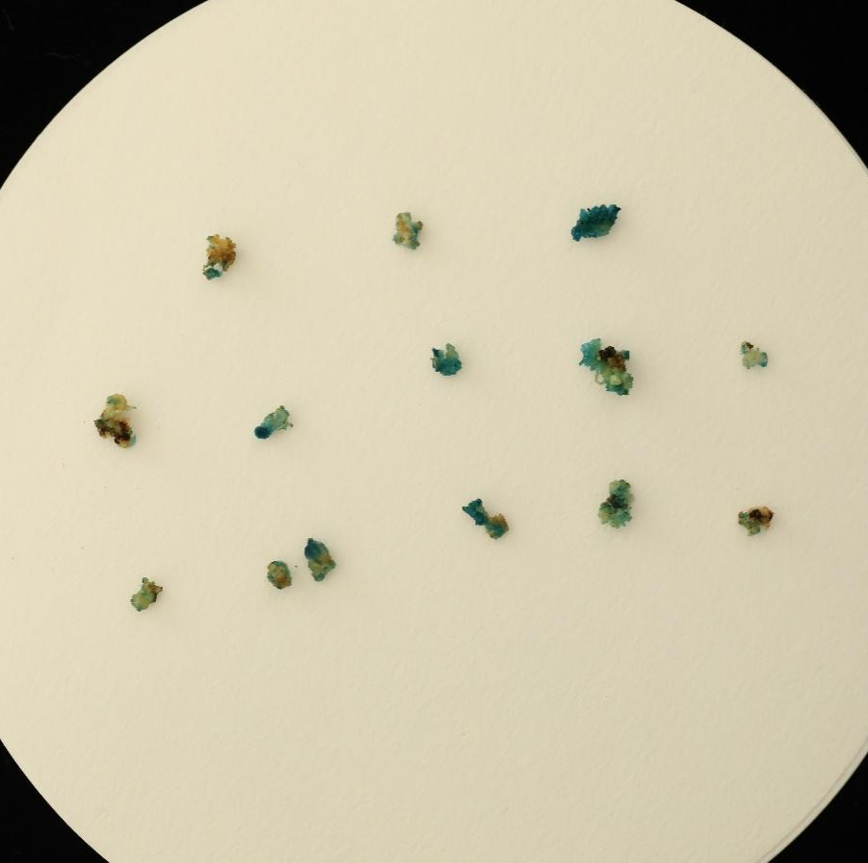
Supplementary Fig.6 Transient GUS staining of callus.
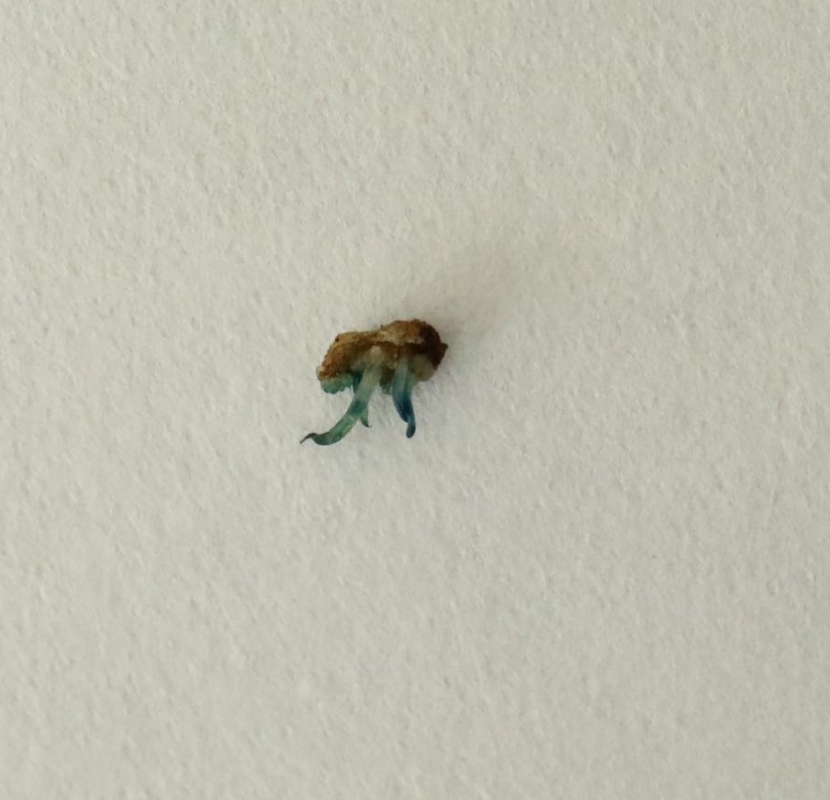
Supplementary Fig.7 GUS staining of Carex rigescens seedling.

Table S1 Top 5 BLAST hit species from contamination assessment of Hi-C reads.
NT_species | ratio(%)
[plant](taxid:432994)Carex laevissima | 0.53
[plant](taxid:544733)Carex parvula | 0.14
[plant](taxid:140873)Carex myosuroides | 0.1
[plant](taxid:418180)Carex siderosticta | 0.07
[plant](taxid:234464)Carex nigra | 0.05

Table S2 Callus induction rates under different hormone combinations in induction media
NO. | 2,4-D(mg/L) | 6-BA(mg/L) | NAA(mg/L) | Induction rate(%)
1 | 1 | 1 | 1.5 | 56±1.225g
2 | 1 | 2 | 1.5 | 63±1.581f
3 | 1.5 | 0.5 | 1.5 | 70±2.550e
4 | 1.5 | 1 | 1 | 78±2.550c
5 | 2 | 0.5 | 1.5 | 84±2.449b
6 | 2 | 1 | 1 | 87±0.020a
7 | 2.5 | 0.5 | 1.5 | 75±1.000d
8 | 2.5 | 1 | 1 | 71±0.787e
Note:Different lowercase letters in the table indicate significant differences at the p < 0.05 level.

Table S3 Transformation Efficiency Statistics for Carex rigescens Infected with Agrobacterium at Different OD₆₀₀ Conditions.
OD₆₀₀ | Conversion rate(%)
0.6 | 12±1.00d
0.7 | 18±1.58c
0.8 | 23±0.71a
0.9 | 20±1.00b
1.0 | 17±0.71c
Note:Different lowercase letters in the table indicate significant differences at the p < 0.05 level.

Table S4 Sequencing results
Library | Data (Gb) | Read_num | Read_base | Depth (X) | GC (%) | Q20 (%) | Q30 (%)
Illumina | 28.87 | 96783303 | 28,873,280,760 | 94.04 | 33.42 | 98.62 | 92.29
PacBio | 16.06 | 860,178 | 16,057,571,808 | 52
Hi-C | 53.44 | 178,972,551 | 53,440,095,456 |  | 34.89 | 98.97 | 95.51
Note: Library: sequencing library; Data(Gb): Clean data from library sequencing; Reads_num: Total reads number: Reads_bases(bp) : Total base number. Depth(x): sequencing depth; GC(%): GC content of the library; Q20(%): Proportion of bases with sequencing quality values above 20; Q30(%): Proportion of bases with sequencing quality values above 30

Table S5 BUSCO evaluation
Type | Complete BUSCOs(C) | Complete and single-copy BUSCOs(S) | Complete and duplicated BUSCOs(D) | Fragmented BUSCOs(F) | Missing BUSCOs(M) | Total Lineage BUSCOs
HiFi assembly | 1508 (93.43%) | 222 (13.75%) | 1286 (79.68%) | 7 (0.43%) | 99 (6.13%) | 1,614
Coding-gene prediction | 1539 (95.35%) | 203 (12.58%) | 1336 (82.78%) | 12 (0.74%) | 63 (3.90%) | 1,614
Note: Complete BUSCOs: the complete BUSCO number; Complete and single-copy BUSCOs: Complete and single-copy BUSCO number; Complete and duplicated BUSCOs: Complete and duplicated BUSCO number; Fragmented BUSCOs: Fragmented BUSCO number; Missing BUSCOs: the number of BUSCO not predicted.

Table S6 The assembled genome aligned with short reads and HiFi reads
Type | Total_reads | Mapped_reads | Mapped(%)
Short reads | 193,56606 | 192,174,500 | 99.28
HiFi reads | 860,178 | 857,629 | 99.7%
Note: Total_Reads: Clean Readsnumber; Mapped reads: Mapped reads number; Mapped(%): mapped reads number as a percentage of total clean reads number;

Table S7 Statistics of transposable elements(TE) sequences
Type | Number | Length | Rate(%)
ClassI:Retroelement | 290,937 | 77,466,550 | 12.31
ClassI/LINE | 57,713 | 12,485,114 | 1.98
ClassI/LTR/Caulimovirus | 62 | 235,750 | 0.04
ClassI/LTR/Copia | 55,428 | 21,362,350 | 3.39
ClassI/LTR/ERV | 3,027 | 191,747 | 0.03
ClassI/LTR/Gypsy | 12,468 | 6,789,962 | 1.08
ClassI/LTR/Ngaro | 477 | 29,805 | 0
ClassI/LTR/Pao | 382 | 88,236 | 0.01
ClassI/LTR/Unknown | 145,980 | 34,313,052 | 5.45
ClassI/SINE | 15,400 | 1,970,534 | 0.31
ClassII:DNA transposon | 474,050 | 113,269,726 | 17.99
ClassII/Academ | 3 | 107 | 0
ClassII/CACTA | 4,487 | 1,748,280 | 0.28
ClassII/Crypton | 58 | 2,605 | 0
ClassII/Dada | 289 | 15,132 | 0
ClassII/Ginger | 87 | 4,323 | 0
ClassII/Helitron | 3,829 | 1,682,602 | 0.27
ClassII/IS3EU | 179 | 10,004 | 0
ClassII/Kolobok | 492 | 44,583 | 0.01
ClassII/Maverick | 104 | 6,305 | 0
ClassII/Merlin | 214 | 10,754 | 0
ClassII/Mutator | 4,277 | 2,821,966 | 0.45
ClassII/P | 157 | 9,591 | 0
ClassII/PIF-Harbinger | 971 | 64,035 | 0.01
ClassII/PiggyBac | 69 | 3,347 | 0
ClassII/Tc1-Mariner | 322 | 19,323 | 0
ClassII/Unknown | 454,928 | 106,152,919 | 16.86
ClassII/Zisupton | 147 | 7,746 | 0
ClassII/hAT | 3,437 | 666,104 | 0.11
Unknown | 41 | 2,609 | 0
Total | 765,028 | 190,738,885 | 30.30
Note: Type: the type of TE; Number: TE number, respectively; Length: the prediction TE length; Rate(%): Proportion of TE sequences in the total genome.

Table S8 Gene function annotation
#AnnO_Database | Annotated_Number | Annotated_Ratio
GO_Annotation | 46,156 | 77.23
KEGG_ Annotation | 40,025 | 66.98
KOG_ Annotation | 29,513 | 49.39
Pafm_ Annotation | 47,434 | 79.37
Swissprot_ Annotation | 44,562 | 74.57
TrEMBL_ Annotation | 53,730 | 89.91
eggNOG_ Annotation | 46,177 | 77.27
Nr_ Annotation | 53,152 | 88.94
All_ Annotation | 54,551 | 91.28
Note: Annotation_database: Functional gene annotation; Annotation_number: Number of genes annotated to the corresponding database; Annotation_Ratio: Percentage of genes annotated to the database.

Table S9 Statistical information on gene family clustering
Item | Athal | Atric | Bdist | Ccris | Clitt | Crige | Cscop | Jeffu | Jinfl | Osati
Number of genes | 27316 | 16,599 | 33,062 | 25,507 | 22,441 | 59,758 | 24,921 | 18,932 | 24,537 | 55,975
Number of genes in orthogroups | 16,743 | 13,973 | 25,481 | 22,297 | 19,913 | 55,422 | 21,892 | 18,074 | 18,615 | 40,926
Number of unassigned genes | 10,573 | 2,626 | 7,581 | 3,210 | 2,528 | 4,336 | 3,029 | 858 | 5,922 | 15,049
Percentage of genes in orthogroups | 61.30 | 84.20 | 77.10 | 87.40 | 88.70 | 92.70 | 87.80 | 95.50 | 75.90 | 73.10
Percentage of unassigned genes | 38.70 | 15.80 | 22.90 | 12.60 | 11.30 | 7.30 | 12.20 | 4.50 | 24.10 | 26.90
Number of orthogroups containing species | 11,009 | 11,396 | 19,114 | 17,871 | 15,281 | 21,021 | 17,669 | 13,866 | 14,621 | 21,177
Percentage of orthogroups containing species | 27.30 | 28.20 | 47.40 | 44.30 | 37.90 | 52.10 | 43.80 | 34.40 | 36.20 | 52.50
Number of species-specific orthogroups | 2,763 | 418 | 768 | 103 | 273 | 1,505 | 113 | 131 | 406 | 2,627
Number of genes in species-specific orthogroups | 7,318 | 1,385 | 2,571 | 252 | 702 | 4,592 | 272 | 715 | 1,038 | 16,813
Percentage of genes in species-specific orthogroups | 26.80 | 8.30 | 7.80 | 1 | 3.10 | 7.70 | 1.10 | 3.80 | 4.20 | 30.00
Note: Genes containing code-shifting mutations in all species were excluded from the statistics. Number of genes: Number of genes per species; Number of genes in orthogroups: Number of genes involved in clustering; Number of unassigned genes: Number of genes not involved in clustering; Percentage of genes in orthogroups: Percentage of genes involved in clustering; Percentage of unassigned genes: Percentage of genes not involved in clustering; Number of orthogroups containing species: Number of gene families of the species; Percentage of orthogroups containing species: Proportion of gene families of the species to the total number of gene families; Number of species-specific orthogroups: Number of species-specific gene families; Number of genes in species-specific orthogroups: Number of genes contained in species-specific gene families; Percentage of genes in species-specific orthogroups: Percentage of genes contained in species-specific gene families

Table S10 Predicted WOX in Carex rigescens
Predicted WOX in Carex rigescens
CriA01G000030.1
CriA02G004570.1
CriA03G000550.1
CriA04G002320.1
CriA04G009380.1
CriA05G005440.1
CriA10G000400.1
CriA10G001620.1
CriA10G001800.1
CriA10G002120.1
CriA16G006270.1
CriA26G001240.1
CriB01G000030.1
CriB02G003890.1
CriB03G000540.1
CriB04G001860.1
CriB04G008240.1
CriB05G005020.1
CriB08G002180.1
CriB10G000400.1
CriB16G004920.1
CriB26G000830.1
CriUnG156010.1
CriUnG175780.1
CriUnG221740.1

Table S11 Two sets of haplotypes
Chr.NO. | Length | Chr.NO. | Length
ChrA1 | 15,321,465 | ChrB1 | 13,703,149
ChrA2 | 16,414,172 | ChrB2 | 15,936,532
ChrA3 | 13,141,222 | ChrB3 | 12,375,743
ChrA4 | 13,022,704 | ChrB4 | 11,540,223
ChrA5 | 12,526,768 | ChrB5 | 12,017,835
ChrA6 | 12,001,637 | ChrB6 | 9,664,478
ChrA7 | 11,771,906 | ChrB7 | 13,081,254
ChrA8 | 11,579,842 | ChrB8 | 10,036,914
ChrA9 | 11,067,550 | ChrB9 | 11,434,409
ChrA10 | 10,892,475 | ChrB10 | 8,789,461
ChrA11 | 10,283,697 | ChrB11 | 9,868,157
ChrA12 | 10,252,423 | ChrB12 | 9,983,176
ChrA13 | 10,054,477 | ChrB13 | 10,493,454
ChrA14 | 10,007,738 | ChrB14 | 10,313,215
ChrA15 | 9,735,681 | ChrB15 | 8,383,245
ChrA16 | 9,677,742 | ChrB16 | 8,476,004
ChrA17 | 9,602,443 | ChrB17 | 8,700,000
ChrA18 | 9,192,760 | ChrB18 | 8,978,899
ChrA19 | 9,757,343 | ChrB19 | 9,022,604
ChrA20 | 8,950,568 | ChrB20 | 8,574,026
ChrA21 | 8,929,983 | ChrB21 | 8,472,253
ChrA22 | 8,859,923 | ChrB22 | 8,273,108
ChrA23 | 8,363,079 | ChrB23 | 8,100,501
ChrA24 | 7,974,756 | ChrB24 | 6,370,410
ChrA25 | 7,804,660 | ChrB25 | 7,795,954
ChrA26 | 8,027,010 | ChrB26 | 7,166,048
ChrA27 | 7,097,598 | ChrB27 | 7,088,622
ChrA28 | 7,195,745 | ChrB28 | 6,347,800
ChrA29 | 5,679,918 | ChrB29 | 5,861,238
ChrA30 | 5,562,476 | ChrB30 | 4,793,236

