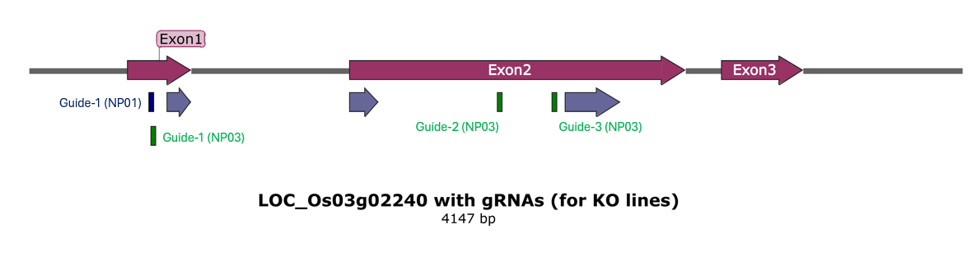
Supplementary Figure 1. The position of gRNAs in the OsGTL1 gene (dark blue bar represents gRNA for construct NP01 and dark green bar represents gRNAs for construct NP03. Grey bars represent protein motifs, while magenta bars represent exons in OsGTL1.
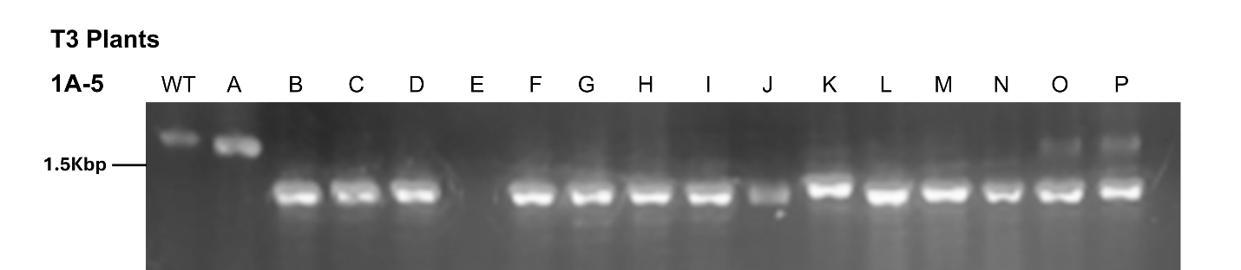
Supplementary Figure 2. The amplified fragments from 1A5A1-A (lane A), 1A5A1-B (lane B), and other siblings in 1A5A1 (lane C – N).

Supplementary Figure 3. The alignment sequences of WT vs line 1A5A1-A (A), WT vs line 1A5A1-B (B), WT vs line 2B3B2-A (C), WT vs line 2B7B1-A (D), WT vs line 20B9B1-A (E), and WT vs line 20B13B2-B (F). Multiple sequence alignment was performed using CLUSTAL O (1.2.4).

A
WT GCTTGAAGGAGATGGAGAGCTCGATCGGTCTCCTCTCTCTTGCTGAGTGGCTAACTAGCT 60
1A5A1-A --------------------TGGATCG------TTTCTCTTGCTGAGTGGCTA-CTAGCT 34
* ***** * ****************** ******
gRNA 7

WT CGTAGTGTGGACTATGAGAGAGACGGAGCCATGGCATCCATATCCATCCACA-ACGACGA 119
1A5A1-A CGTAGTGTGGACTATGAGAGAGACGGAGCCATGGCATCCATATCCATCCACAAACGACGA 94
**************************************************** *******

WT CCTAATAAGCTTTACCAGCTACCAGTAGTAGTACTAACTGGAAAGAAGCCAGTGAGGAAA 179
1A5A1-A CCTAATAAGCTTTACCAGCTACCAGTAGTAGTACTAACTGGAAAGAAGCCAGTGAGGAAA 154
************************************************************

WT AGAGGAAAGAAAAAGAGAGGAGAAGCTAAGCTTAGCTAACCCTCGAGCTAGCTAAGCAGA 239
1A5A1-A AGAGGAAAGAAAAAGAGAGGAGAAGCTAAGCTTAGCTAACCCTCGAGCTAGCTAAGCAGA 214
************************************************************

WT AAGAGAGAGAAGAGAAGAGTGAGATAGTACTAGGCTGGCAGAGATATGGTGGTTGCTGCA 299
1A5A1-A AAGAGAGAGAAGAGAAGAGTGAGATAGTACTAGGCTGGCAGAGATATGGTGGTTGCTGCA 274
************************************************************

WT ACTGCAAGGCCAGGGAGAAGGCGAGGAGGAAGAAGAAGAGGAGGCAAAGCTAGCAAGAGA 359
1A5A1-A ACTGCAAGGCCAGGGAGAAGGCGAGGAGGAAGAAGAAGAGGAGGCAAAGCTAGCAAGAGA 334
************************************************************

WT GAGCAGTATACTAGTAGTACTAGTACTGGTCACTACTGTAGCAGCAGCAGCGATAGGGCT 419
1A5A1-A GAGCAGTATACTAGTAGTACTAGTACTGGTCACTACTGTAGCAGCAGCAGCGATAGGGCT 394
************************************************************

WT GTACTAAATATAATACTAGGGCGGTGGAGAAGAAAGAAAGAAAGAAAGGCACTGTGCTGT 479
1A5A1-A GTACTAAATATAATACTAGGGCGGTGGAGAAGAAAGAAAGAAAGAAAGGCACTGTGCTGT 454
************************************************************

WT GAAGAAGAAGAAGAAGGCGAGGAAAGAAATGCTTCTGCGGATCGAAGGTGAAGATGACGA 539
1A5A1-A GAAGAAGAAGAAGAAGGCGAGGAAAGAAATGCTTCTGCGGATCGAAGGTGAAGATGACGA 514
************************************************************

WT TGATGATGTGAGAGATGAAGG--AGGTGATAGATAGATGGACAGAACAAACCAGATGCTG 597
1A5A1-A TGATGATGTGAGAGATGAAGGAGAGGTGATAGATAGATGGACAGAACAAACCAGATGCTG 574
********************* *************************************
gRNA 6

WT CATGCGCTGTCAGGATGGCTACGTACGGCCACCCTCCCCCCTCCTGCCCTGTAATAGTAC 657
1A5A1-A CATGCGCTGTCAGGATGGGTACGTACGGCCACCCTCCCCCCTCCTGCCCTGTAATAGTAC 634
****************** *****************************************

WT TCCTTCCAGGGTTAATTTAATCAAGTCACTAAAACTACCTAATTAACTCAATGTTTTACT 717
1A5A1-A TCCTTCCAGGGTTAATTTAATCAAGTCACTAAAACTACCTAATTAACTCAATGTT----- 689
*******************************************************

WT ATACTATTAACTGTATGTCACTTTGTAGCTATACTAGTACTGGTAAGCTAGCTAAGCTCA 777
1A5A1-A -------------------GCCCCGTAATAGAGCTCTCTCCAG--GGTTAATTAA-TCAG 727
* *** ** * * * ** ***
gRNA 5

WT TGTGTGATTTTCAGGTTTGATGGTGCAGAGTGGCCGGGGAATCTGGACCCTACATTTTGG 837
1A5A1-A TCTCTAAACTACCTAATTAA-----CTCACTGTTAATTTAATCTGTACCCTACATTTTGG 782
* * * * * * ** * * * ** ****** **************

WT ATCCCACGATGCTCTGATTCCTGCACAACAACAGGCCGTCCTTGCTGTACGTTGTTGCCC 897
1A5A1-A ATCTCACGATGCTCTGATTCTCGCACACCAACACACCGTCTCTGCTGTGTGTGGTTGCCC 842
*** **************** ***** ***** ***** ****** ** *******

WT CTCTTTGTTTTTTCACAAATTCACTGTAAAATCACAAGGGGGAGGCATTGCAATGCAACA 957
1A5A1-A CTCTCTGTTTTTTCACAAATTCACTGTAAAATCACACGGGGGAGGCATTGCAATGCAACA 902
**** ******************************* ***********************

WT CATCAAACACAGCACTGTAGCTAGATGATCACAATGAATTATTGATAGAGAGAGAGAGAG 1017
1A5A1-A CATCACACACACCACTGTATCTAGATGATCACACTGAATTATTGATAGAGAGAGAGAGAG 962
***** ***** ******* ************* **************************

WT ATCAATTAATTATAAGAAAGACAAAAGAAAACAAAAAAGAGAGAGAGAGAGAGAGAGAGA 1077
1A5A1-A ATCAATTATTTATAAGAAAGACACAAGAAAACAAAAAAGAGAGAGAGAGAGAGAGAGAGA 1022
******** ************** ************************************

WT GATAGAGGAGAATTAAGCGGTAGGAGGGTGGACGAGAGTGGCCAGACAAGGCCACACTGT 1137
1A5A1-A --TAGAGGAGAATTAAGCGGTAGGAGGGTGGACGAGAGTGGCCAGACAAGGCCACACTGT 1080
**********************************************************
gRNA 1
gRNA 2
gRNA 3
gRNA 4

WT AACAGCCTGTGTGGTGGGCCCGGCAGGGCAGGGGTAGAGAGAGAGAGATGGTGGTGGTGG 1197
1A5A1-A AACAGCCTGTGTGGTGGGCCCGGCAGGGCAGGGGTAGAGAGAGAGAGATGGTGGTGGTGG 1140
************************************************************

WT CGCGCAACGTGCATCCAGAGAGGGATGTGAGTGAGTATAAACGCGAACGCGGACCCCCTC 1257
1A5A1-A CGCGCAACGTGCATCCAGAGAGGGATGTGAGTGAGTATAAACGCGA-------------- 1186
**********************************************

WT TCGCTAACCCCACACGCCCCACGTTGCGTACCACACAGGTCACTCCCATTCTAGCTCAGC 1317
1A5A1-A ----------------------GTTGCGTACCACACAGGTCACTCCCATTCTAGCTCAGC 1224
**************************************

WT TAAGCTTGATTAGGTACTAGTGCTAGTTGCTAGTAACATGCATGCATGCATCCACATGTT 1377
1A5A1-A TAAGCTTGATTAGGTACTAGTGCTAGTTGCTAGTAACATGCATGCATGCATCCACATGTT 1284
************************************************************

WT TTTGATTCCTGAACTTATTCATTTTTACTGCTAATTAATCAAATGGTATAGTAGTAGAAA 1437
1A5A1-A TTTGATTCCTGAACTTATTCATTTTTACTGCTAATTAATCAAATGGTATAGTAGTAGAAA 1344
************************************************************

WT AGTTGTGACAAGCATGGCATAGATAATTAAGTACTAGTCCTTCATCAAGAATAAAAGAAA 1497
1A5A1-A AGTTGTGACAAGCATGGCATAGATAATTAAGTACTAGTCCTTCATCAAGAATAAAAGAAA 1404
************************************************************

WT CTCTCTCTCTCTCTCTCTCTATGTGCTTAGAAATAGATAATACTTCCTTCCAAAATAAGT 1557
1A5A1-A CTCTCTCTCTCTCTCTCTCTATGTGCTTAGAAATAGATAATACTTCCTTCCAAAATAAGT 1464
************************************************************

WT GCATCCAAATTTAAACTACAGGGTTGCATTTATTTTTGGGATGAAGGGAGTATTGTACAT 1617
1A5A1-A GCATCCAAATTTAAACTACAGGGTTGCATTTATTTTTGGGATGAAGGGAGTATTGTACAT 1524
************************************************************

WT TGCATCAGGTAAAGTGCATCTTGTTTTGCTCGGTATCAGGTTTTTAGCACACGCTTTCGC 1677
1A5A1-A TGCATCAGGTAAAGTGCATCT--------------------------------------- 1545
*********************

WT TTTATACTAGGGTTTAACAATTTAAGTTTTACTTAACACTAGGATCGATACATCATCAGA 1737
1A5A1-A ------------------------------------------------------------ 1545

WT TATATAGAATTTT 1750
1A5A1-A ------------- 1545
B

WT GCTTGAAGGAGATGGAGAGCTCGATCGGTCTCCTCTCTCTTGCTGAGTGGCTAACTAGCT 60
1A5A1-B GCTTGAAGGAGATGGAGAGCTCGATCGGTCTCCTCTCTCTTGCTGAGTGGCTAACTAGCT 60
************************************************************
gRNA 7

WT CGTAGTGTGGACTATGAGAGAGACGGAGCCATGGCATCCATATCCATCCACAACGACGAC 120
1A5A1-B CGTAGTGTGGACTATGAGAGAGACGGAGCCATGGCATCCATATCCATCCACAACGACGAC 120
************************************************************

WT CTAATAAGCTTTACCAGCTACCAGTAGTAGTACTAACTGGAAAGAAGCCAGTGAGGAAAA 180
1A5A1-B CTAATAAGCTTTACCAGCTACCAGTAGTAGTACTAACTGGAAAGAAGCCAGTGAGGAAAA 180
************************************************************

WT GAGGAAAGAAAAAGAGAGGAGAAGCTAAGCTTAGCTAACCCTCGAGCTAGCTAAGCAGAA 240
1A5A1-B GAGGAAAGAAAAAGAGAGGAGAAGCTAAGCTTAGCTAACCCTCGAGCTAGCTAAGCAGAA 240
************************************************************

WT AGAGAGAGAAGAGAAGAGTGAGATAGTACTAGGCTGGCAGAGATATGGTGGTTGCTGCAA 300
1A5A1-B AGAGAGAGAAGAGAAGAGTGAGATAGTACTAGGCTGGCAGAGATATGGTGGTTGCTGCAA 300
************************************************************

WT CTGCAAGGCCAGGGAGAAGGCGAGGAGGAAGAAGAAGAGGAGGCAAAGCTAGCAAGAGAG 360
1A5A1-B CTGCAAGGCCAGGGAGAAGGCGAGGAGGAAGAAGAAGAGGAGGCAAAGCTAGCAAGAGAG 360
************************************************************

WT AGCAGTATACTAGTAGTACTAGTACTGGTCACTACTGTAGCAGCAGCAGCGATAGGGCTG 420
1A5A1-B AGCAGTATACTAGTAGTACTAGTACTGGTCACTACTGTAGCAGCAGCAGCGATAGGGCTG 420
************************************************************

WT TACTAAATATAATACTAGGGCGGTGGAGAAGAAAGAAAGAAAGAAAGGCACTGTGCTGTG 480
1A5A1-B TACTAAATATAATACTAGGGCGGTGGAGAAGAAAGAAAGAAAGAAAGGCACTGTGCTGTG 480
************************************************************

WT AAGAAGAAGAAGAAGGCGAGGAAAGAAATGCTTCTGCGGATCGAAGGTGAAGATGACGAT 540
1A5A1-B AAGAAGAAGAAGAAGGCGAGGAAAGAAATGCTTCTGCGGATCGAAGGTGAAGATGACGAT 540
************************************************************

WT GATGATGTGAGAGATGAAGGAGGTGATAGATAGATGGACAGAACAAACCAGATGCTGCAT 600
1A5A1-B GATGATGTGAGAGATGAAGGAGGTGATAGATAGATGGACAGAACAAACCAGATGCTGCAT 600
************************************************************
gRNA 6

WT GCGCTGTCAGGATGGCTACGTACGGCCACCCTCCCCCCTCCTGCCCTGTAATAGTACTCC 660
1A5A1-B GCGCTGTCAGGATGGCTAC----------------------------------------- 619
*******************

WT TTCCAGGGTTAATTTAATCAAGTCACTAAAACTACCTAATTAACTCAATGTTTTACTATA 720
1A5A1-B ------------------------------------------------------------ 619

WT CTATTAACTGTATGTCACTTTGTAGCTATACTAGTACTGGTAAGCTAGCTAAGCTCATGT 780
1A5A1-B ------------------------------------------------------------ 619

WT GTGATTTTCAGGTTTGATGGTGCAGAGTGGCCGGGGAATCTGGACCCTACATTTTGGATC 840
1A5A1-B ------------------------------------------------------------ 619

WT CCACGATGCTCTGATTCCTGCACAACAACAGGCCGTCCTTGCTGTACGTTGTTGCCCCTC 900
1A5A1-B ------------------------------------------------------------ 619

WT TTTGTTTTTTCACAAATTCACTGTAAAATCACAAGGGGGAGGCATTGCAATGCAACACAT 960
1A5A1-B ------------------------------------------------------------ 619

WT CAAACACAGCACTGTAGCTAGATGATCACAATGAATTATTGATAGAGAGAGAGAGAGATC 1020
1A5A1-B ------------------------------------------------------------ 619

WT AATTAATTATAAGAAAGACAAAAGAAAACAAAAAAGAGAGAGAGAGAGAGAGAGAGAGAT 1080
1A5A1-B ------------------------------------------------------------ 619

WT AGAGGAGAATTAAGCGGTAGGAGGGTGGACGAGAGTGGCCAGACAAGGCCACACTGTAAC 1140
1A5A1-B ------------------------------------------------------------ 619

WT AGCCTGTGTGGTGGGCCCGGCAGGGCAGGGGTAGAGAGAGAGAGATGGTGGTGGTGGCGC 1200
1A5A1-B ------------------------------------------------------------ 619

WT GCAACGTGCATCCAGAGAGGGATGTGAGTGAGTATAAACGCGAACGCGGACCCCCTCTCG 1260
1A5A1-B ------------------------------------------------------------ 619

WT CTAACCCCACACGCCCCACGTTGCGTACCACACAGGTCACTCCCATTCTAGCTCAGCTAA 1320
1A5A1-B ------------------------------------------------------------ 619
gRNA 1

WT GCTTGATTAGGTACTAGTGCTAGTTGCTAGTAACATGCATGCATGCATCCACATGTTTTT 1380
1A5A1-B -----------------------------------------------------AGTTTTT 626
******

WT GATTCCTGAACTTATTCATTTTTACTGCTAATTAATCAAATGGTATAGTAGTAGAAAAGT 1440
1A5A1-B GATTCCTGAACTTATTCATTTTTACTGCTAATTAATCAAATGGTATAGTAGTAGAAAAGT 686
************************************************************

WT TGTGACAAGCATGGCATAGATAATTAAGTACTAGTCCTTCATCAAGAATAAAAGAAACTC 1500
1A5A1-B TGTGACAAGCATGGCATAGATAATTAAGTACTAGTCCTTCATCAAGAATAAAAGAAACTC 746
************************************************************

WT TCTCTCTCTCTCTCTCTATGTGCTTAGAAATAGATAATACTTCCTTCCAAAATAAGTGCA 1560
1A5A1-B TCTCTCTCTCTCTCTCTATGTGCTTAGAAATAGATAATACTTCCTTCCAAAATAAGTGCA 806
************************************************************

WT TCCAAATTTAAACTACAGGGTTGCATTTATTTTTGGGATGAAGGGAGTATTGTACATTGC 1620
1A5A1-B TCCAAATTTAAACTACAGGGTTGCATTTATTTTTGGGATGAAGGGAGTATTGTACATTGC 866
************************************************************

WT ATCAGGTAAAGTGC 1634
1A5A1-B ATCAGGT------- 873
*******

C

WT GCTTGAAGGAGATGGAGAGCTCGATCGGTCTCCTCTCTCTTGCTGAGTGGCTAACTAGCT 60
2B3B2-A GCTTGAAGGAGATGGAGAGCTCGATCGGTCTCCTCTCTCTTGCTGAGTGGCTAACTAGCT 60
************************************************************
gRNA 7

WT CGTAGTGTGGACTATGAGAGAGACGGAGCCATGGCATCCATATCCATCCACAACGACGAC 120
2B3B2-A CGTAGTGTGGACTATGAGAGAGACGGAGCCATGGCATCCATATCCATCCACAACGACGAC 120
************************************************************

WT CTAATAAGCTTTACCAGCTACCAGTAGTAGTACTAACTGGAAAGAAGCCAGTGAGGAAAA 180
2B3B2-A CTAATAAGCTTTACCAGCTACCAGTAGTAGTACTAACTGGAAAGAAGCCAGTGAGGAAAA 180
************************************************************

WT GAGGAAAGAAAAAGAGAGGAGAAGCTAAGCTTAGCTAACCCTCGAGCTAGCTAAGCAGAA 240
2B3B2-A GAGGAAAGAAAAAGAGAGGAGAAGCTAAGCTTAGCTAACCCTCGAGCTAGCTAAGCAGAA 240
************************************************************

WT AGAGAGAGAAGAGAAGAGTGAGATAGTACTAGGCTGGCAGAGATATGGTGGTTGCTGCAA 300
2B3B2-A AGAGAGAGAAGAGAAGAGTGAGATAGTACTAGGCTGGCAGAGATATGGTGGTTGCTGCAA 300
************************************************************

WT CTGCAAGGCCAGGGAGAAGGCGAGGAGGAAGAAGAAGAGGAGGCAAAGCTAGCAAGAGAG 360
2B3B2-A CTGCAAGGCCAGGGAGAAGGCGAGGAGGAAGAAGAAGAGGAGGCAAAGCTAGCAAGAGAG 360
************************************************************

WT AGCAGTATACTAGTAGTACTAGTACTGGTCACTACTGTAGCAGCAGCAGCGATAGGGCTG 420
2B3B2-A AGCAGTATACTAGTAGTACTAGTACTGGTCACTACTGTAGCAGCAGCAGCGATAGGGCTG 420
************************************************************

WT TACTAAATATAATACTAGGGCGGTGGAGAAGAAAGAAAGAAAGAAAGGCACTGTGCTGTG 480
2B3B2-A TACTAAATATAATACTAGGGCGGTGGAGAAGAAAGAAAGAAAGAAAGGCACTGTGCTGTG 480
************************************************************

WT AAGAAGAAGAAGAAGGCGAGGAAAGAAATGCTTCTGCGGATCGAAGGTGAAGATGACGAT 540
2B3B2-A AAGAAGAAGAAGAAGGCGAGGAAAGAAATGCTTCTGCGGATCGAAGGTGAAGATGACGAT 540
************************************************************

WT GATGATGTGAGAGATGAAGGAGGTGATAGATAGATGGACAGAACAAACCAGATGCTGCAT 600
2B3B2-A GATGATGTGAGAGATGAAGGAGGTGATAGATAGATGGACAGAACAAACCAGATGCTGCAT 600
************************************************************
gRNA 6

WT GCGCTGTCAGGATGGCTACGTACGGCCACCCTCCCCCCTCCTGCCCTGTAATAGTACTCC 660
2B3B2-A GCGCTGTCAGGATGGCTACGTACGGCCACCCTCCCCCCTCCTGCCCTGTAATAGTACTCC 660
************************************************************

WT TTCCAGGGTTAATTTAATCAAGTCACTAAAACTACCTAATTAACTCAATGTTTTACTATA 720
2B3B2-A TTCCAGGGTTAATTTAATCAAGTCACTAAAACTACCTAATTAACTCAATGTTTTACTATA 720
************************************************************

WT CTATTAACTGTATGTCACTTTGTAGCTATACTAGTACTGGTAAGCTAGCTAAGCTCATGT 780
2B3B2-A CTATTAACTGTATGTCACTTTGTAGCTATACTAGTACTGGTAAGCTAGCTAAGCTCATGT 780
************************************************************
gRNA 5

WT GTGATTTTCAGGTTTGATGGTGCAGAGTGGCCGGGGAATCTGGACCCTACATTTTGGATC 840
2B3B2-A GTGATTTTCAGGTTTGATGGTGCAGAGTGGCCGGGGAATCTGGACCCTACATTTTGGATC 840
************************************************************

WT CCACGATGCTCTGATTCCTGCACAACAACAGGCCGTCCTTGCTGTACGTTGTTGCCCCTC 900
2B3B2-A CCACGATGCTCTGATTCCTGCACAACAACAGGCCGTCCTTGCTGTACGTTGTTGCCCCTC 900
************************************************************

WT TTTGTTTTTTCACAAATTCACTGTAAAATCACAAGGGGGAGGCATTGCAATGCAACACAT 960
2B3B2-A TTTGTTTTTTCACAAATTCACTGAA-AATCACAAGGGGGAGGCATTTCAATGCAACACAT 959
*********************** * ******************** *************

WT CAAACACAGCACTGTAGCTAGATGATCACAATGAATTATTGATAGAGAGAGAGAGAGATC 1020
2B3B2-A CAAACACACCACTGTAGATAGATGATCTCAATGAATTATTGATAGAGAGAGAGAGAGATC 1019
******** ******** ********* ********************************

WT AATTAATTATAAGAAAGACAAAAGAAAACAAAAAAGAGAGAGAGAGAGAGAGAGAGAGAT 1080
2B3B2-A AATTAATTATAAGAAAGACAAAAGAAAACAAAAAAGAGAGAGAGAGAGAGAGAGAGA--T 1077
********************************************************* *

WT AGAGGAGAATTAAGCGGTAGGAGGGTGGACGAGAGTGGCCAGACAAGGCCACACTGTAAC 1140
2B3B2-A AGAGGAGAATTAAGCGGTAGGAGGGTGGACGAGAGTGGCCAGACAAGGCCACACTGTAAC 1137
************************************************************
gRNA 4

WT AGCCTGTGTGGTGGGCCCGGCAGGGCAGGGGTAGAGAGAGAGAGATGGTGGTGGTGGCGC 1200
2B3B2-A AGCCTGTGTGGTGGGCCCGGCAGGGCAGGGGTAGAGAGAGAGAGATGGTGGTGGTGGCGC 1197
************************************************************
gRNA 3

WT GCAACGTGCATCCAGAGAGGGATGTGAGTGAGTATAAACGCGAACGCGGACCCCCTCTCG 1260
2B3B2-A GCAACGTGCATCCAGAGAGGGATGTGAGTGAGTATAAACGCGAACGCGGACCCCCTCTCG 1257
gRNA 2
************************************************************

WT CTAACCCCACACGCCCCACGTTGCGTACCACACAGGTCACTCCCATTCTAGCTCAGCTAA 1320
2B3B2-A CTAACCCCACACGCCCCACGTTGCGTACCACACAGGTCACTCCCATTCTAGCTCAGCTAA 1317
************************************************************
gRNA 1

WT GCTTGATTAGGTACTAGTGCTAGTTGCTAGTAACATGCATGCATGCATCCACATGTTTTT 1380
2B3B2-A GCTTGATTAGGTACTAGTGCTAGTTGCTAGTAACATGCATGCATGCATCCACATGTTTTT 1377
************************************************************

WT GATTCCTGAACTTATTCATTTTTACTGCTAATTAATCAAATGGTATAGTAGTAGAAAAGT 1440
2B3B2-A GATTCCTGAACTTATTCATTTTTACTGCTAATTAATCAAATGGTATAGTAGTAGAAAAGT 1437
************************************************************

WT TGTGACAAGCATGGCATAGATAATTAAGTACTAGTCCTTCATCAAGAATAAAAGAAACTC 1500
2B3B2-A TGTGACAAGCATGGCATAGATAATTAAGTACTAGTCCTTCATCAAGAATAAAAGAAACTC 1497
************************************************************

WT TCTCTCTCTCTCTCTCTATGTGCTTAGAAATAGATAATACTTCCTTCCAAAATAAGTGCA 1560
2B3B2-A TCTCTCTCTCTCTCTCTATGTGCTTAGAAATAGATAATACTTCCTTCCAAAATAAGTGCA 1557
************************************************************

WT TCCAAATTTAAACTACAGGGTTGCATTTATTTTTGGGATGAAGGGAGTATTGTACATTGC 1620
2B3B2-A TCCAAATTTAAACTACAGGGTTGCATTTATTTTTGGGATGAAGGGAGTATTGTACATTGC 1617
************************************************************

WT ATCAGGTAAAGTGCATCTTGTTTTGCTCGGTATCAGGTTTTTAGCACACGCTTTCGCTTT 1680
2B3B2-A ATCAGGTAAAGTGCATCTGTTTGTCCTCGGTATCAGGTTTATATTACTCGCTTTCGCTTT 1677
****************** ** * *************** ** ** ************

WT ATACTAGGGTTTAACAATTTAAGTTTTACTTAACACTAGGATCGATACATCATCAGATAT 1740
2B3B2-A ATACTAGGGTTTAACAATTTAAGTTTTACTTAACACTAGGATCGATACATCATCAGATAT 1737
************************************************************

WT ATAGAATTTT 1750
2B3B2-A ATAGAATTTT 1747
**********

D

WT GCTTGAAGGAGATGGAGAGCTCGATCGGTCTCCTCTCTCTTGCTGAGTGGCTAACTAGCT 60
2B7B1-A GCTTGAAGGAGATGGAGAGCTCGATCGGTCTCCTCTCTCTTGCTGAGTGGCTAACTAGCT 60
************************************************************
gRNA 7

WT CGTAGTGTGGACTATGAGAGAGACGGAGCCATGGCATCCATATCCATCCACAACGACGAC 120
2B7B1-A CGTAGTGTGGACTATGAGAGAGACGGAGCCATGGCATCCATATCCATCCACAACGACGAC 120
************************************************************

WT CTAATAAGCTTTACCAGCTACCAGTAGTAGTACTAACTGGAAAGAAGCCAGTGAGGAAAA 180
2B7B1-A CTAATAAGCTTTACCAGCTACCAGTAGTAGTACTAACTGGAAAGAAGCCAGTGAGGAAAA 180
************************************************************

WT GAGGAAAGAAAAAGAGAGGAGAAGCTAAGCTTAGCTAACCCTCGAGCTAGCTAAGCAGAA 240
2B7B1-A GAGGAAAGAAAAAGAGAGGAGAAGCTAAGCTTAGCTAACCCTCGAGCTAGCTAAGCAGAA 240
************************************************************

WT AGAGAGAGAAGAGAAGAGTGAGATAGTACTAGGCTGGCAGAGATATGGTGGTTGCTGCAA 300
2B7B1-A AGAGAGAGAAGAGAAGAGTGAGATAGTACTAGGCTGGCAGAGATATGGTGGTTGCTGCAA 300
************************************************************

WT CTGCAAGGCCAGGGAGAAGGCGAGGAGGAAGAAGAAGAGGAGGCAAAGCTAGCAAGAGAG 360
2B7B1-A CTGCAAGGCCAGGGAGAAGGCGAGGAGGAAGAAGAAGAGGAGGCAAAGCTAGCAAGAGAG 360
************************************************************

WT AGCAGTATACTAGTAGTACTAGTACTGGTCACTACTGTAGCAGCAGCAGCGATAGGGCTG 420
2B7B1-A AGCAGTATACTAGTAGTACTAGTACTGGTCACTACTGTAGCAGCAGCAGCGATAGGGCTG 420
************************************************************

WT TACTAAATATAATACTAGGGCGGTGGAGAAGAAAGAAAGAAAGAAAGGCACTGTGCTGTG 480
2B7B1-A TACTAAATATAATACTAGGGCGGTGGAGAAGAAAGAAAGAAAGAAAGGCACTGTGCTGTG 480
************************************************************

WT AAGAAGAAGAAGAAGGCGAGGAAAGAAATGCTTCTGCGGATCGAAGGTGAAGATGACGAT 540
2B7B1-A AAGAAGAAGAAGAAGGCGAGGAAAGAAATGCTTCTGCGGATCGAAGGTGAAGATGACGAT 540
************************************************************

WT GATGATGTGAGAGATGAAGGAGGTGATAGATAGATGGACAGAACAAACCAGATGCTGCAT 600
2B7B1-A GATGATGTGAGAGATGAAGGAGGTGATAGATAGATGGACAGAACAAACCAGATGCTGCAT 600
************************************************************
gRNA 6

WT GCGCTGTCAGGATGGCTACGTACGGCCACCCTCCCCCCTCCTGCCCTGTAATAGTACTCC 660
2B7B1-A GCGCTGTCAGGATGGCTACGTACGGCCACCCTCCCCCCTCCTGCCCTGTAATAGTACTCC 660
************************************************************

WT TTCCAGGGTTAATTTAATCAAGTCACTAAAACTACCTAATTAACTCAATGTTTTACTATA 720
2B7B1-A TTCCAGGGTTAATTTAATCAAGTCACTAAAACTACCTAATTAACTCAATGTTTTACTATA 720
************************************************************

WT CTATTAACTGTATGTCACTTTGTAGCTATACTAGTACTGGTAAGCTAGCTAAGCTCATGT 780
2B7B1-A CTATTAACTGTATGTCACTTTGTAGCTATACTAGTACTGGTAAGCTAGCTAAGCTCATGT 780
************************************************************
gRNA 5

WT GTGATTTTCAGGTTTGATGGTGCAGAGTGGCCGGGGAATCTGGACCCTACATTTTGGATC 840
2B7B1-A GTGATTTTCAGGTTTGATGGTGCAGAGTGGCCGGGGAATCTGGACCCTACATTTTGGATC 840
************************************************************

WT CCACGATGCTCTGATTCCTGCACAACAACAGGCCGTCCTTGCTGTACGTTGTTGCCCCTC 900
2B7B1-A CCACGATGCTCTGATTCCTGCACAACAACAGGCCGTCCTTGCTGTACGTTGTTGCCCCTC 900
************************************************************

WT TTTGTTTTTTCACAAATTCACTGTAAAATCACAAGGGGGAGGCATTGCAATGCAACACAT 960
2B7B1-A TTTGTTTTTTCACAAATTCACTGTAAAATCACAAGGGGGAGGCATTGCAATGCAACACAT 960
************************************************************

WT CAAACACAGCACTGTAGCTAGATGATCACAATGAATTATTGATAGAGAGAGAGAGAGATC 1020
2B7B1-A CAAACACAGCACTGTAGCTAGATGATCACAATGAATTATTGATAGAGAGAGAGAGAGATC 1020
************************************************************

WT AATTAATTATAAGAAAGACAAAAGAAAACAAAAAAGAGAGAGAGAGAGAGAGAGAGAGAT 1080
2B7B1-A AATTAATTATAAGAAAGACAAAAGAAAACAAAAAAGAGAGAGAGAGAGAGAGAGAGA--T 1078
********************************************************* *

WT AGAGGAGAATTAAGCGGTAGGA---GGGTGGACGAGAGTGGCCAGACAAGGCCACACTGT 1137
2B7B1-A AGAGGAGAATTAAGCGGTAGGAGGCCAGTGGACGAGAGTGGCCAGACAAGGCCACACTGT 1138
********************** *********************************
gRNA 4

WT AACAGCCTGTGTGGTGGGCCCGGCAGGGCAGGGGTAGAGAGAGAGAGATGGTGGTGGTGG 1197
2B7B1-A AACAGCCTGTGTGGTGGGCCCGGCAGGGCAGGGGTAGAGAGAGAGAGATGGTGGTGGTGG 1198
************************************************************
gRNA 3

WT CGCGCAACGTGCATCCAGAGAGGGATGTGAGTGAGTATAAACGCGAACGCGGACCCCCTC 1257
2B7B1-A CGCGCAACGTGCATCCAGAGAGGGATGTGAGTGAGTATAAACGCGAACGCGGACCCCCTC 1258
************************************************************
gRNA 2

WT TCGCTAACCCCACACGCCCCACGTTGCGTACCACACAGGTCACTCCCATTCTAGCTCAGC 1317
2B7B1-A TCGCTAACCCCACACGCCCCACGTTGCGTACCACACAGGTCACTCCCATTCTAGCTCAGC 1318
************************************************************

WT TAAGCTTGATTAGGTACTAGTGCTAGTTGCTAGTAACATGCATGCATGCATCCACATGTT 1377
2B7B1-A TAAGCTTGATTAGGTACTAGTGCTAGTTGCTAGTAACATGCATGCATGCATCCACATGTT 1378
************************************************************
gRNA 1

WT TTTGATTCCTGAACTTATTCATTTTTACTGCTAATTAATCAAATGGTATAGTAGTAGAAA 1437
2B7B1-A TTTGATTCCTGAACTTATTCATTTTTACTGCTAATTAATCAAATGGTATAGTAGTAGAAA 1438
************************************************************

WT AGTTGTGACAAGCATGGCATAGATAATTAAGTACTAGTC---CTTCATCAAGAATAAAAG 1494
2B7B1-A AGTTGTGACAAGCATGGCATAGATAATTAAAGTACTAGTCCTTCGGATCAAGAATAAAAG 1498
****************************** **************

WT AAACTCTCTCTCTCTCTCTCTCTATGTGCTTAGAAATAGATAATACTTCCTTCCAAAATA 1554
2B7B1-A AAACTCTCTCTCTCTCTCTCTCTATGTGCTTAGAAATAGATAATACTTCCTTCCAAAATA 1558
************************************************************

WT AGTGCATCCAAATTTAAACTACAGGGTTGCATTTATTTTTGGGATGAAGGGAGTATTGTA 1614
2B7B1-A AGTGCATCCAAATTTAAACTACAGGGTTGCATTTATTTTTGGGATGAAGGGAGTATTGTA 1618
************************************************************

WT CATTGCATCAGGTAAAGTGCATCTTGTTTTGCTCGGTATCAGGTTTTTAGCACACGCTTT 1674
2B7B1-A CATTGCATCAGGTAAAGTGCATCTTGTTTTGCTCGGTATCAGGTTTTTAGCACACGCTTT 1678
************************************************************

WT CGCTTTATACTAGGGTTTAACAATTTAAGTTTTACTTAACACTAGGATCGATACATCATC 1734
2B7B1-A CGCTTTATACTAGGGTTTAACAATTTAAGTTTTACTTAACACTAGGATCGATACATCATC 1738
************************************************************

WT AGATATATAGAATTTT 1750
2B7B1-A AGATATATAGAATTTT 1754
****************

E

WT GCTTGAAGGAGATGGAGAGCTCGATCGGTCTCCTCTCTCTTGCTGAGTGGCTAACTAGCT 60
20B9 GCTTGAAGGAGATGGAGAGCTCGATCGGTCTCCTCTCTCTTGCTGAGTGGCTAACTAGCT 60
************************************************************
gRNA 7

WT CGTAGTGTGGACTATGAGAGAGACGGAGCCATGGCATCCATATCCATCCACA-ACGACGA 119
20B9 CGTAGTGTGGACTATGAGAGAGACGGAGCCATGGCATCCATATCCATCCACAAACGACGA 120
**************************************************** *******

WT CCTAATAAGCTTTACCAGCTACCAGTAGTAGTACTAACTGGAAAGAAGCCAGTGAGGAAA 179
20B9 CCTAATAAGCTTTACCAGCTACCAGTAGTAGTACTAACTGGAAAGAAGCCAGTGAGGAAA 180
************************************************************

WT AGAGGAAAGAAAAAGAGAGGAGAAGCTAAGCTTAGCTAACCCTCGAGCTAGCTAAGCAGA 239
20B9 AGAGGAAAGAAAAAGAGAGGAGAAGCTAAGCTTAGCTAACCCTCGAGCTAGCTAAGCAGA 240
************************************************************

WT AAGAGAGAGAAGAGAAGAGTGAGATAGTACTAGGCTGGCAGAGATATGGTGGTTGCTGCA 299
20B9 AAGAGAGAGAAGAGAAGAGTGAGATAGTACTAGGCTGGCAGAGATATGGTGGTTGCTGCA 300
************************************************************

WT ACTGCAAGGCCAGGGAGAAGGCGAGGAGGAAGAAGAAGAGGAGGCAAAGCTAGCAAGAGA 359
20B9 ACTGCAAGGCCAGGGAGAAGGCGAGGAGGAAGAAGAAGAGGAGGCAAAGCTAGCAAGAGA 360
************************************************************

WT GAGCAGTATACTAGTAGTACTAGTACTGGTCACTACTGTAGCAGCAGCAGCGATAGGGCT 419
20B9 GAGCAGTATACTAGTAGTACTAGTACTGGTCACTACTGTAGCAGCAGCAGCGATAGGGCT 420
************************************************************

WT GTACTAAATATAATACTAGGGCGGTGGAGAAGAAAGAAAGAAAGAAAGGCACTGTGCTGT 479
20B9 GTACTAAATATAATACTAGGGCGGTGGAGAAGAAAGAAAGAAAGAAAGGCACTGTGCTGT 480
************************************************************

WT GAAGAAGAAGAAGAAGGCGAGGAAAGAAATGCTTCTGCGGATCGAAGGTGAAGATGACGA 539
20B9 GAAGAAGAAGAAGAAGGCGAGGAAAGAAATGCTTCTGCGGATCGAAGGTGAAGATGACGA 540
************************************************************

WT TGATGATGTGAGAGATGAAGGAGGTGATAGATAGATGGACAGAACAAACCAGATGCTGCA 599
20B9 TGATGATGTGAGAGATGAAGGAGGTGATAGATAGATGGACAGAACAAACCAGATGCTGCA 600
************************************************************
gRNA 6

WT TGCGCTGTCAGGATGGCTACGTACGGCCACCCTCCCCCCTCCTGCCCTGTAATAGTACTC 659
20B9 TGCGCTGTCAGGATGGCT------------------------------------------ 618
******************

WT CTTCCAGGGTTAATTTAATCAAGTCACTAAAACTACCTAATTAACTCAATGTTTTACTAT 719
20B9 ------------------------------------------------------------ 618

WT ACTATTAACTGTATGTCACTTTGTAGCTATACTAGTACTGGTAAGCTAGCTAAGCTCATG 779
20B9 ------------------------------------------------------------ 618
gRNA 5

WT TGTGATTTTCAGGTTTGATGGTGCAGAGTGGCCGGGGAATCTGGACCCTACATTTTGGAT 839
20B9 ------------------------------------------------------------ 618

WT CCCACGATGCTCTGATTCCTGCACAACAACAGGCCGTCCTTGCTGTACGTTGTTGCCCCT 899
20B9 ------------------------------------------------------------ 618

WT CTTTGTTTTTTCACAAATTCACTGTAAAATCACAAGGGGGAGGCATTGCAATGCAACACA 959
20B9 ------------------------------------------------------------ 618

WT TCAAACACAGCACTGTAGCTAGATGATCACAATGAATTATTGATAGAGAGAGAGAGAGAT 1019
20B9 ------------------------------------------------------------ 618

WT CAATTAATTATAAGAAAGACAAAAGAAAACAAAAAAGAGAGAGAGAGAGAGAGAGAGAGA 1079
20B9 ------------------------------------------------------------ 618

WT TAGAGGAGAATTAAGCGGTAGGAGGGTGGACGAGAGTGGCCAGACAAGGCCACACTGTAA 1139
20B9 ------------------------------------------------------------ 618
gRNA 4

WT CAGCCTGTGTGGTGGGCCCGGCAGGGCAGGGGTAGAGAGAGAGAGATGGTGGTGGTGGCG 1199
20B9 ------------------------------------------------------------ 618
gRNA 3

WT CGCAACGTGCATCCAGAGAGGGATGTGAGTGAGTATAAACGCGAACGCGGACCCCCTCTC 1259
20B9 ------------------------------------------------------------ 618
gRNA 2

WT GCTAACCCCACACGCCCCACGTTGCGTACCACACAGGTCACTCCCATTCTAGCTCAGCTA 1319
20B9 --------------------GTTGCGTACCACACAGGTCACTCCCATTCTAGCTCAGCTA 658
***************************************

WT AGCTTGATTAGGTACTAGTGCTAGTTGCTAGTAACATGCATGCATGCATCCACATGTTTT 1379
20B9 AGCTTGATTAGGTACTAGTGCTAGTTGCTAGTAACATGCATGCATAGATA---------- 708
********************************************* **
gRNA 1

WT TGATTCCTGAACTTATTCATTTTTACTGCTAATTAATCAAATGGTATAGTAGTAGAAAAG 1439
20B9 -----------ATTATTCATTTTTACTGCTAATTAATCAAATGGTATAGTAGTAGAAAAG 757
************************************************

WT TTGTGACAAGCATGGCATAGATAATTAAGTACTAGTCCTTCATCAAGAATAAAAGAAACT 1499
20B9 TTGTGACAAGCATGGCATAGATAATTAAGTACTAGTCCTTCATCAAGAATAAAAGAAACT 817
************************************************************

WT CTCTCTCTCTCTCTCTCTATGTGCTTAGAAATAGATAATACTTCCTTCCAAAATAAGTGC 1559
20B9 CTCTCTCTCTCTCTCTCTATGTGCTTAGAAATAGATAATACTTCCTTCCAAAATAAGTGC 877
************************************************************

WT ATCCAAATTTAAACTACAGGGTTGCATTTATTTTTGGGATGAAGGGAGTATTGTACATTG 1619
20B9 ATCCAAATTTAAACTACAGGGTTGCATTTATTTTTGGGATGAAGGGAGTATTGTACATTG 937
************************************************************

WT CATCAGGTAAAGTGC 1634
20B9 CATCAGGTAAAGTGC 952
***************

F

WT GCTTGAAGGAGATGGAGAGCTCGATCGGTCTCCTCTCTCTTGCTGAGTGGCTAACTAGCT 60
20B13 ------AGGAGATGGAGAGCTCGATCGGTCTCCTCTCTCTTGCTGAGTGGCTAACTAGCT 54
******************************************************
gRNA 7

WT CGTAGTGTGGACTATGAGAGAGACGGAGCCATGGCATCCATATCCATCCACA-ACGACGA 119
20B13 CGTAGTGTGGACTATGAGAGAGACGGAGCCATGGCATCCATATCCATCCACAAACGACGA 114
**************************************************** *******

WT CCTAATAAGCTTTACCAGCTACCAGTAGTAGTACTAACTGGAAAGAAGCCAGTGAGGAAA 179
20B13 CCTAATAAGCTTTACCAGCTACCAGTAGTAGTACTAACTGGAAAGAAGCCAGTGAGGAAA 174
************************************************************

WT AGAGGAAAGAAAAAGAGAGGAGAAGCTAAGCTTAGCTAACCCTCGAGCTAGCTAAGCAGA 239
20B13 AGAGGAAAGAAAAAGAGAGGAGAAGCTAAGCTTAGCTAACCCTCGAGCTAGCTAAGCAGA 234
************************************************************

WT AAGAGAGAGAAGAGAAGAGTGAGATAGTACTAGGCTGGCAGAGATATGGTGGTTGCTGCA 299
20B13 AAGAGAGAGAAGAGAAGAGTGAGATAGTACTAGGCTGGCAGAGATATGGTGGTTGCTGCA 294
************************************************************

WT ACTGCAAGGCCAGGGAGAAGGCGAGGAGGAAGAAGAAGAGGAGGCAAAGCTAGCAAGAGA 359
20B13 ACTGCAAGGCCAGGGAGAAGGCGAGGAGGAAGAAGAAGAGGAGGCAAAGCTAGCAAGAGA 354
************************************************************

WT GAGCAGTATACTAGTAGTACTAGTACTGGTCACTACTGTAGCAGCAGCAGCGATAGGGCT 419
20B13 GAGCAGTATACTAGTAGTACTAGTACTGGTCACTACTGTAGCAGCAGCAGCGATAGGGCT 414
************************************************************

WT GTACTAAATATAATACTAGGGCGGTGGAGAAGAAAGAAAGAAAGAAAGGCACTGTGCTGT 479
20B13 GTACTAAATATAATACTAGGGCGGTGGAGAAGAAAGAAAGAAAGAAAGGCACTGTGCTGT 474
************************************************************

WT GAAGAAGAAGAAGAAGGCGAGGAAAGAAATGCTTCTGCGGATCGAAGGTGAAGATGACGA 539
20B13 GAAGAAGAAGAAGAAGGCGAGGAAAGAAATGCTTCTGCGGATCGAAGGTGAAGATGACGA 534
************************************************************

WT TGATGATGTGAGAGATGAAGGAGGTGATAGATAGATGGACAGAACAAACCAGATGCTGCA 599
20B13 TGATGATGTGAGAGATGAAGGAGGTGATAGATAGATGGACAGAACAAACCAGATGCTGCA 594
************************************************************
gRNA 6

WT TGCGCTGTCAGGATGGCTACGTACGGCCACCCTCCCCCCTCCTGCCCTGTAATAGTACTC 659
20B13 TGCGCTGTCAGGATGGCTGC---------------------------------------- 614
****************** *

WT CTTCCAGGGTTAATTTAATCAAGTCACTAAAACTACCTAATTAACTCAATGTTTTACTAT 719
20B13 ------------------------------------------------------------ 614

WT ACTATTAACTGTATGTCACTTTGTAGCTATACTAGTACTGGTAAGCTAGCTAAGCTCATG 779
20B13 ------------------------------------------AAGCTAGCTAAGCTCATG 632
******************
gRNA 5

WT TGTGATTTTCAGGTTTGATGGTGCAGAGTGGCCGGGGAATCTGGACCCTACATTTTGGAT 839
20B13 TGTGATTTTCAGGTTTGATGGTGCAGAGTGGCCGGGGAATCTGGACCCTACATTTTGGAT 692
************************************************************

WT CCCACGATGCTCTGATTCCTGCACAACAACAGGCCGTCCTTGCTGTACGTTGTTGCCCCT 899
20B13 CCCACGATGCTCTGATTCCTGCA------------------------------------- 715
***********************

WT CTTTGTTTTTTCACAAATTCACTGTAAAATCACAAGGGGGAGGCATTGCAATGCAACACA 959
20B13 ------------------------------------------------------------ 715

WT TCAAACACAGCACTGTAGCTAGATGATCACAATGAATTATTGATAGAGAGAGAGAGAGAT 1019
20B13 ------------------------------------------------------------ 715

WT CAATTAATTATAAGAAAGACAAAAGAAAACAAAAAAGAGAGAGAGAGAGAGAGAGAGAGA 1079
20B13 ------------------------------------------------------------ 715

WT TAGAGGAGAATTAAGCGGTAGGAGGGTGGACGAGAGTGGCCAGACAAGGCCACACTGTAA 1139
20B13 ------------------------------------------------------------ 715
gRNA 4

WT CAGCCTGTGTGGTGGGCCCGGCAGGGCAGGGGTAGAGAGAGAGAGATGGTGGTGGTGGCG 1199
20B13 ------------------------------------------------------------ 715
gRNA 3

WT CGCAACGTGCATCCAGAGAGGGATGTGAGTGAGTATAAACGCGAACGCGGACCCCCTCTC 1259
20B13 ------------------------------------------------------------ 715
gRNA 2

WT GCTAACCCCACACGCCCCACGTTGCGTACCACACAGGTCACTCCCATTCTAGCTCAGCTA 1319
20B13 -----------------CAGGTTGCGTACCACACAGGTCACTCCCATTCTAGCTCAGCTA 758
** ****************************************

WT AGCTTGATTAGGTACTAGTGCTAGTTGCTAGTAACATGCATGCATGCATCCACATGTTTT 1379
20B13 AGCTTGATTAGGTACTAGTGCTAGTTGCTAGTAACATGCATGCATAGATA---------- 808
********************************************* **
gRNA 1

WT TGATTCCTGAACTTATTCATTTTTACTGCTAATTAATCAAATGGTATAGTAGTAGAAAAG 1439
20B13 -----------ATTATTCATTTTTACTGCTAATTAATCAAATGGTATAGTAGTAGAAAAG 857
************************************************

WT TTGTGACAAGCATGGCATAGATAATTAAGTACTAGTCCTTCATCAAGAATAAAAGAAACT 1499
20B13 TTGTGACAAGCATGGCATAGATAATTAAGTACTAGTCCTTCATCAAGAATAAAAGAAACT 917
************************************************************

WT CTCTCTCTCTCTCTCTCTATGTGCTTAGAAATAGATAATACTTCCTTCCAAAATAAGTGC 1559
20B13 CTCTCTCTCTCTCTCTCTATGTGCTTAGAAATAGATAATACTTCCTTCCAAAATAAGTGC 977
************************************************************

WT ATCCAAATTTAAACTACAGGGTTGCATTTATTTTTGGGATGAAGGGAGTATTGTACATTG 1619
20B13 ATCCAAATTTAAACTACAGGGTTGCATTTATTTTTGGGATGAAGGGAGTATTGTACATTG 1037
************************************************************

WT CATCAGGTAAAGTGC 1634
20B13 CATCAGGTAAAGTGC 1052
***************

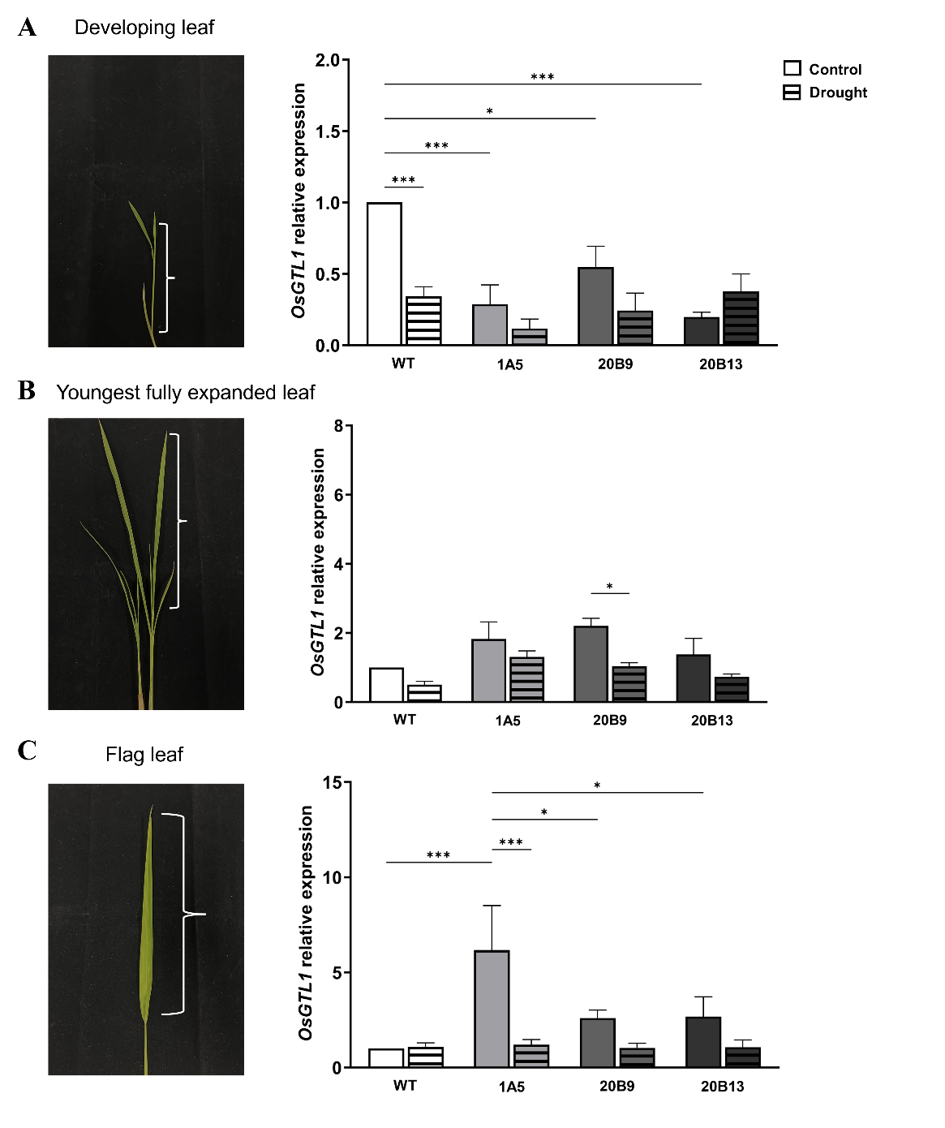
Supplementary Figure 4. Relative OsGTL1 gene expression of the wild-type (WT) and edited lines, 1A5, 20B9, and 20B13, in various tissue types, which include the developing leaf (A), youngest fully expanded leaf (B), and flag leaf (C) normalized with OsEF1a gene expression. The significant difference was analyzed using a Two-Way ANOVA with a Tukey post hoc test. Error bars represent ± SE (* means p < 0.05, ** means p < 0.01, and *** means p < 0.001, n ≥ 3).

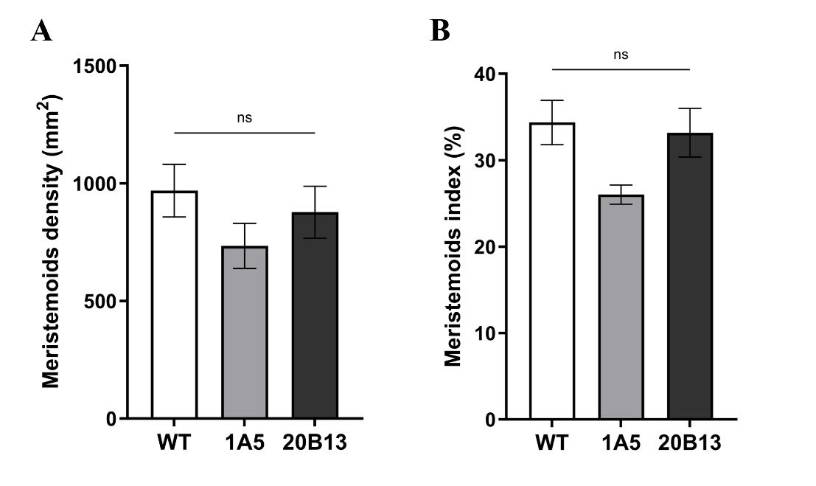
Supplementary Figure 5. Stomatal lineage initiation in wild-type and OsGTL1 edited lines. Meristemoid density (mm²) (A) and meristemoid index (MI) (B). The significant difference was analyzed using a One-Way ANOVA with a Tukey post hoc test at p < 0.05. Error bars represent ± SE (*p 0.033, **p 0.002, ***p < 0.001, n ≥ 3).

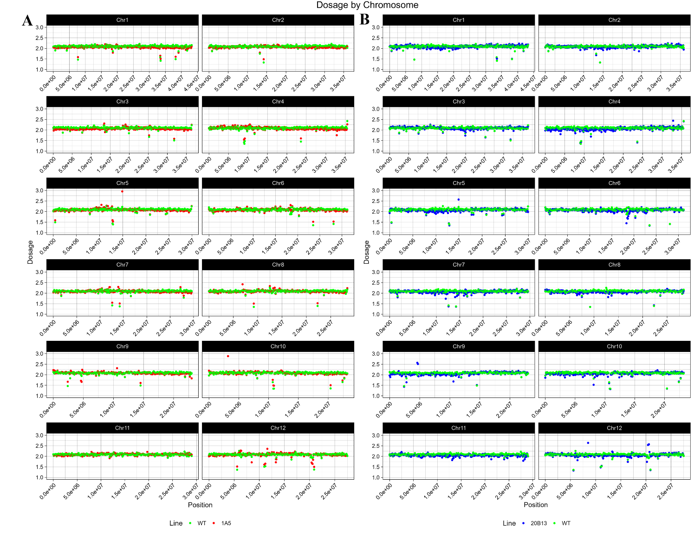
Supplementary Figure 6. Dosage variation detection among the wild-type (WT) and the edited line progeny 1A5 (A) and 20B13 (B). The relative read coverage shows dosage variation. The data points show the average read coverage in non-overlapping 100-kb bins, normalized to the average read depth across all samples. Diploid lines should have a relative read coverage of 2. Values of approximately 1 indicate deletions, whereas values of approximately 3 indicate insertions.

Supplementary Figure 7. The light response curve of the wild-type (WT) and OsGTL1 promoter edited lines, 1A5 and 20B13. The significant difference was analyzed using a Two-Way ANOVA with a Tukey post hoc test at p < 0.05. Error bars represent ± SE (* means p < 0.05, ** means p < 0.01, and *** means p < 0.001, n = 3).

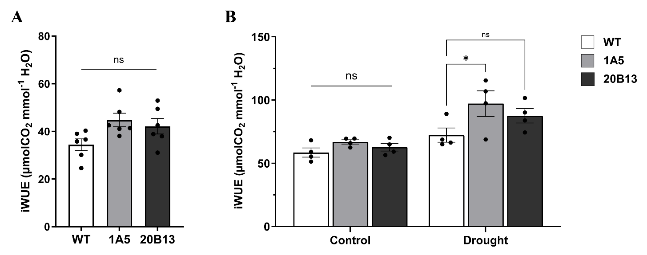
Supplementary Figure 8. Intrinsic water use efficiency (iWUE) of the wild-type (WT) and OsGTL1 promoter edited lines, 1A5 and 20B13, of F₂ plants at tillering stage (A) and was iWUE of F₃ plants was determined at non-stress plants as a control and after 9 days of drought-stress conditions. Error bars represent ± SE (* means p < 0.05, ** means p < 0.01, and *** means p < 0.001, n ≥ 4).
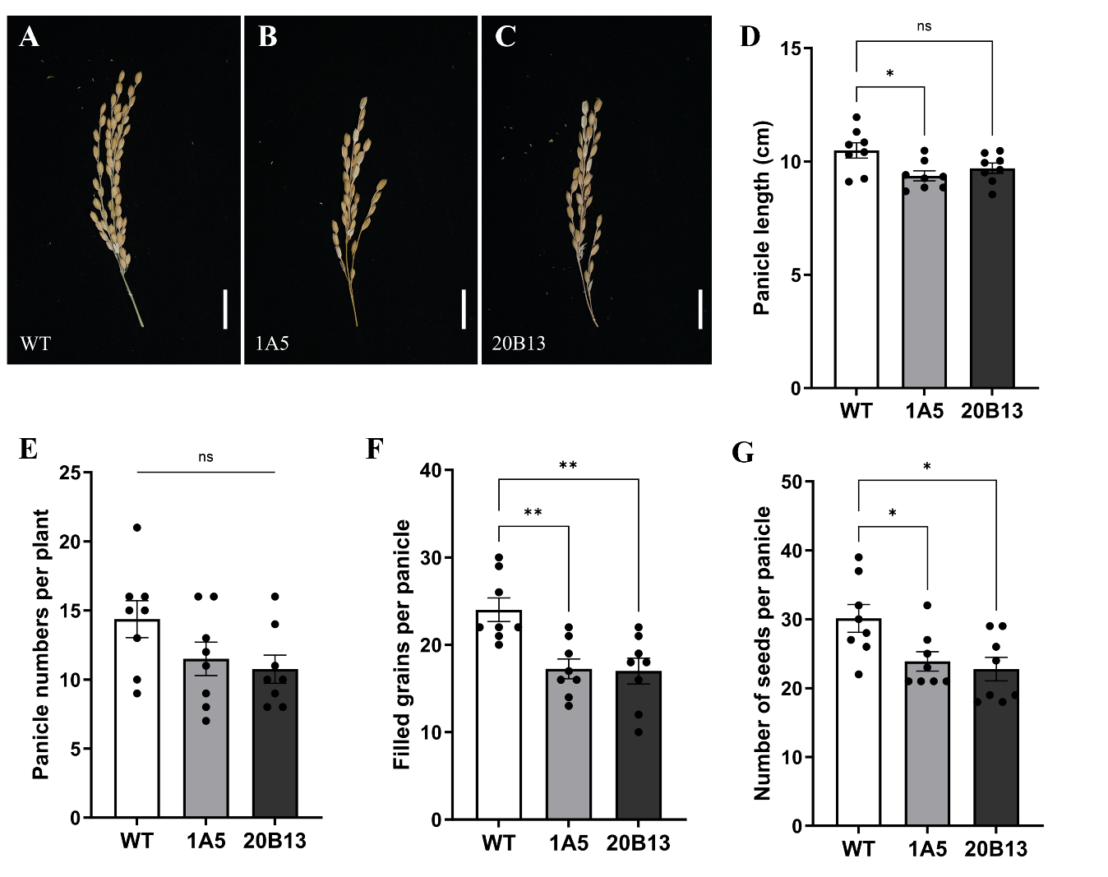
Supplementary Figure 9. Yield components of the wild-type (WT) and OsGTL1 promoter edited lines, 1A5 and 20B13. The significant difference was analyzed using a One-Way ANOVA with a Tukey post hoc test at p < 0.05. Error bars represent ± SE (* means p < 0.05, ** means p < 0.01, and *** means p < 0.001, n = 8). Bars, 1 cm.

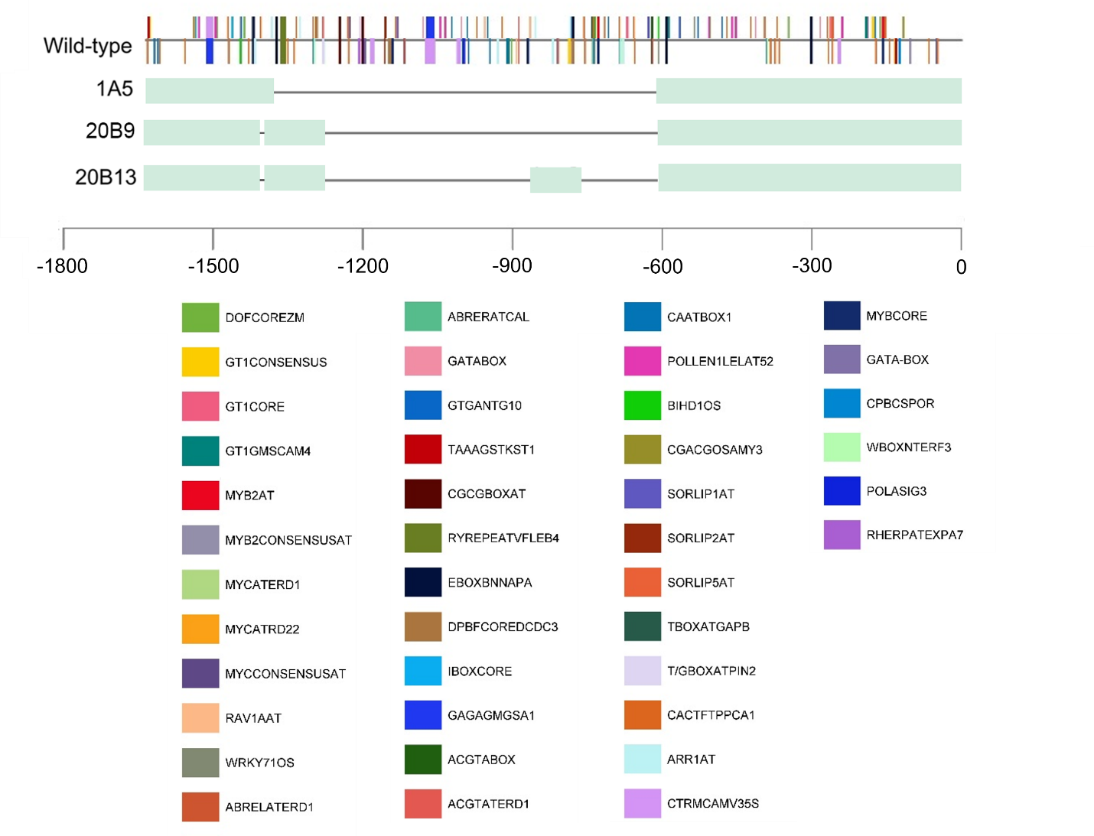
Supplementary Figure 10. The cis elements deleted in the promoter of the edited lines are indicated. The green box represents the existence of the promoter sequences, whereas the line represents the deleted regions in the OsGTL1 promoter.

