Online Resource 1

The reproductive ecology of the Antarctic bivalve Aequiyoldia eightsii (Protobranchia: Sareptidae) follows neither Antarctic nor taxonomic patterns

Sally C. Y. Lau¹, Laura J. Grange¹, Lloyd S. Peck², Adam J. Reed¹

¹ University of Southampton, Ocean and Earth Science, National Oceanography Centre Southampton, European Way, Southampton, SO14 3ZH, UK
² British Antarctic Survey, Natural Environment Research Council, High Cross, Madingley Road, Cambridge, CB3 0ET, UK

Corresponding Author: Adam J. Reed
Email: ajr104@soton.ac.uk

Figure S1 Ovarian maturity in Aequiyoldia eightsii from Hangar Cove, Adelaide Island, West Antarctic Peninsula (67º 33’ 52 S, 68º 07’ 43 W). Specimens collected in January (a, c) and February (b) 2014. Transverse histological sections showing (a) previtellogenic oocytes (PVO) with basophilic cytoplasm and large nucleus, (b) vitellogenic oocytes (VO) with eosinophilic cytoplasm and yolk platelets, and (c) mature oocytes (MO) with outer vitelline layer and jelly coat. Evaluated based on the overall oocyte cellular appearance and description of marine bivalve ovary development outlined in Morse and Zardus (1997)
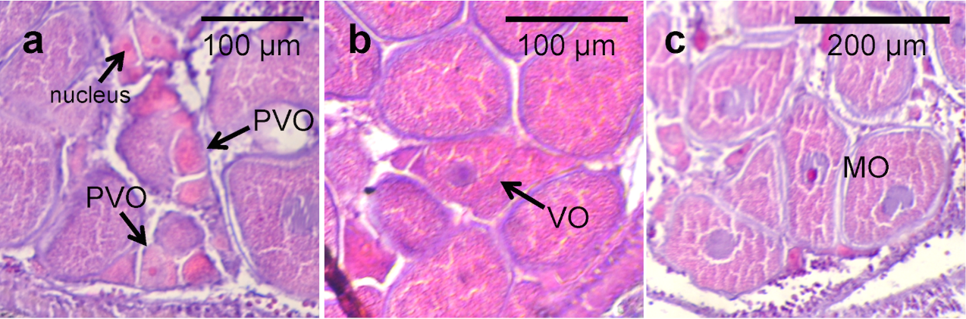

Figure S2 Testes maturity in Aequiyoldia eightsii from Hangar Cove, Adelaide Island, West Antarctic Peninsula (67º 33’ 52 S, 68º 07’ 43 W). Specimens collected between January 2013 and May 2014. Transverse histological sections showing (a) Stage I: early developing stage, (b) Stage II: mid developing stage, (c) Stage III: late developing stage, (d) Stage IV: ripe stage and (e) Stage V: spent stage. LM lumen, RS residual sperm, SC spermatocytes, SG spermatogonia, SS spent spermaries, SZ spermatozoa. Evaluated based on the overall development and distribution of spermatozoa in marine bivalve testes development described in Morse and Zardus (1997)

