Electronic Supplementary Material
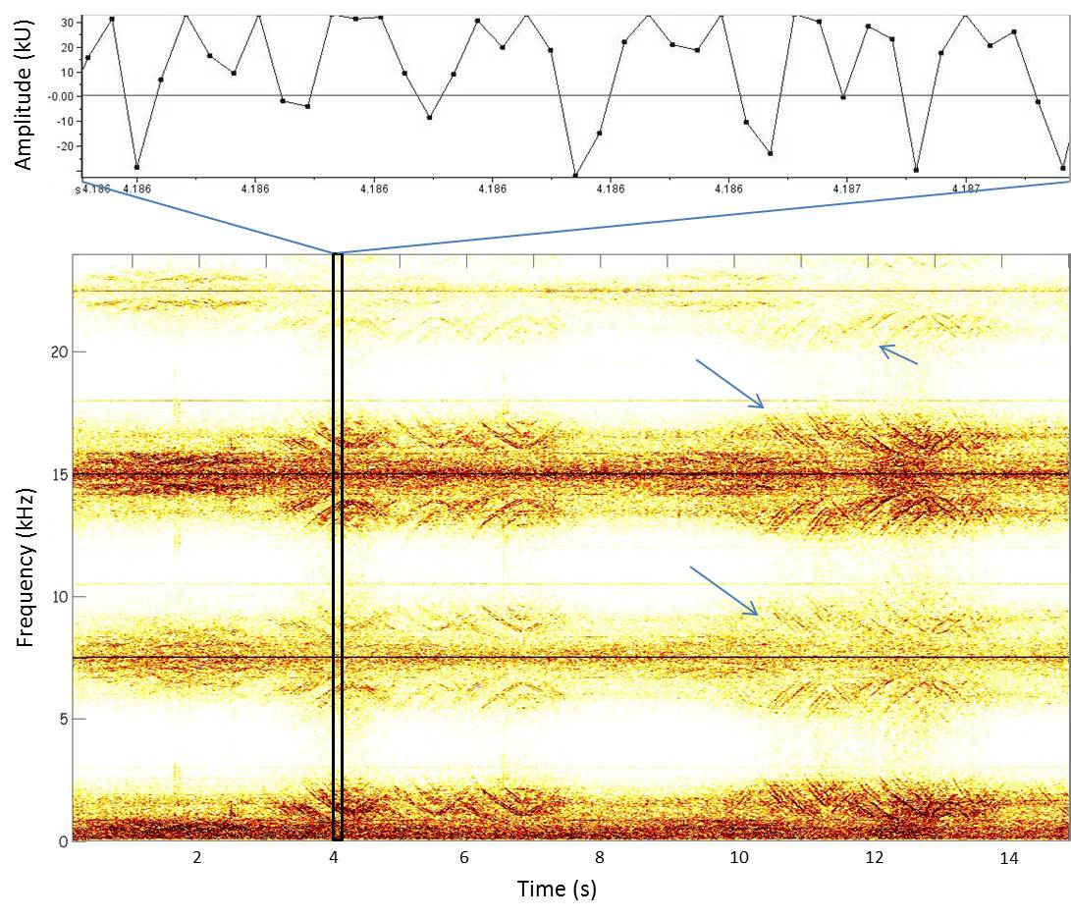
Supplementary Fig. 1 An example of spurious harmonics (arrows) for mid and high siren calls of Ross seals at 7, 15 and 24 kHz; clipped waveforms are shown in the top panel. Spectrogram was generated in XBAT program, using parameters: frame size 0.126 s, 25% overlap, FFT size 3384 points, Hann window
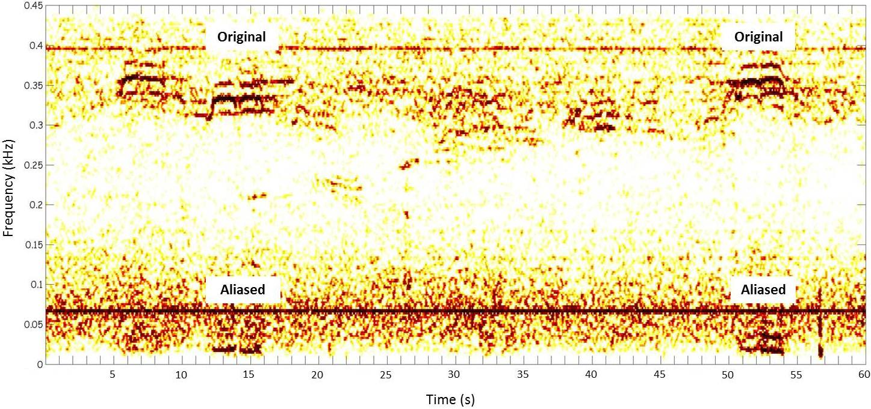
Supplementary Fig. 2 Exemplary spectrogram showing the original and aliased calls of leopard seal low double trills. Spectrogram was generated in XBAT program, using parameters: frame size 0.135 s, 25% overlap, FFT size 424 points, Hann window

