Electronic Supplementary Material

Sea-ice habitat minimizes grazing impact and predation risk for larval Antarctic krill
Carmen L. David^{1,2,3*}, Fokje L. Schaafsma⁴, Jan A. van Franeker⁴, Evgeny A. Pakhomov^{5,6,7}, Brian P.V. Hunt^{5,6,7}, Benjamin A. Lange^{1,2,8}, Giulia Castellani¹, Angelika Brandt^{9,10}, Hauke Flores^{1,2}

¹ Alfred-Wegener-Institut Helmholtz-Zentrum für Polar- und Meeresforschung (AWI), Am Handelshafen 12, 27570, Bremerhaven, Germany
² University of Hamburg, Centre for Natural History (CeNak), Zoological Museum, Martin-Luther-King-Platz 3, 20146 Hamburg, Germany
³ currently at Department of Biology, Dalhousie University, Halifax, NS, B3H4R2, Canada
⁴ Wageningen Marine Research, Ankerpark 27, 1781 AG Den Helder, The Netherlands
⁵ Department of Earth, Ocean and Atmospheric Sciences, 2207 Main Mall, University of British Columbia, Vancouver, BC, V6T 1Z4, Canada
⁶ Institute of the Oceans and Fisheries, 2202 Main Mall, University of British Columbia, Vancouver, BC, V6T 1Z4, Canada
⁷ Hakai Institute, P.O. Box 309, Heriot Bay, British Columbia, V0P 1H0, Canada
⁸ currently at Norwegian Polar Institute, Fram Centre, Tromsø, Norway
⁹ Senckenberg Research Institute and Natural History Museum, Senckenberganlage 25, 60325, Frankfurt, Germany
¹⁰ Institute for Ecology, Evolution and Diversity, Goethe-University of Frankfurt, FB 15, Max-von-Laue-Str. 13, 60439, Frankfurt, Germany

*Corresponding author:
carmen.david@dal.ca
ORCID: https://orcid.org/0000-0002-4241-1284

Polar Biology Journal

Methods
We quantified the sensitivity of total community grazing to variation in species ingestion rates through individual parameter perturbations (IPP; Bartell et al. 1986). Total community grazing was calculated as the mean grazing over all stations, including grazing by copepods and larval krill. Each species’ ingestion rate was varied 5-times less or 5-times more than their nominal value (Table 2) at a time, while the other species’ ingestion rates were kept unchanged. This conservative range of variation in ingestion rates was chosen to cover the variability in reported ingestion rates of each species. We then compared the ratio of change in total community grazing from the baseline value (i.e. the value used in the paper, representing the average of the column “Total” from Table 4), by dividing the newly estimated total community grazing by the baseline value when ingestion rates were increased and dividing the baseline by the total community grazing when ingestion rates were decreased. We estimated the potential ratio of change induced by each species, separately for the ice-water interface community and for the water-column community.
Results
The sensitivity analysis performed for each sampled habitat, at the ice-water interface (SUIT, Figure S1 upper panel) and in the water column (RMT, Figure S1 lower panel) identified three sensitive species, which have higher potential to induce change in community grazing, such as Stephos longipes for the ice-water interface habitat and Ctenocalanus spp. and Oithona similis for the water column. In both habitats, the ratio of change varied from 1 (indicating no significant change from the baseline) to about 3 times the baseline value when the ingestion rate of a sensitive species was increased 5 times their nominal value. Considering that the baseline for total grazing at the ice-water interface was estimated at 0.08% of the phytoplankton standing stock, while in the water column this was 1.9%, an up to 3-times increase (max change when individual species ingestion was increased by 5 times) or decrease to about half in total community grazing (max change when individual species ingestion was lowered by 5 times) do not outweigh the large difference in grazing between the two habitats. Therefore, even though the ingestion rate of a certain species can be considered sensitive to change, i.e. having a larger impact on the total community grazing, the extent of its variation range does not modify the conclusion that estimated grazing is one order of magnitude larger in the water column compared to the ice-water interface.
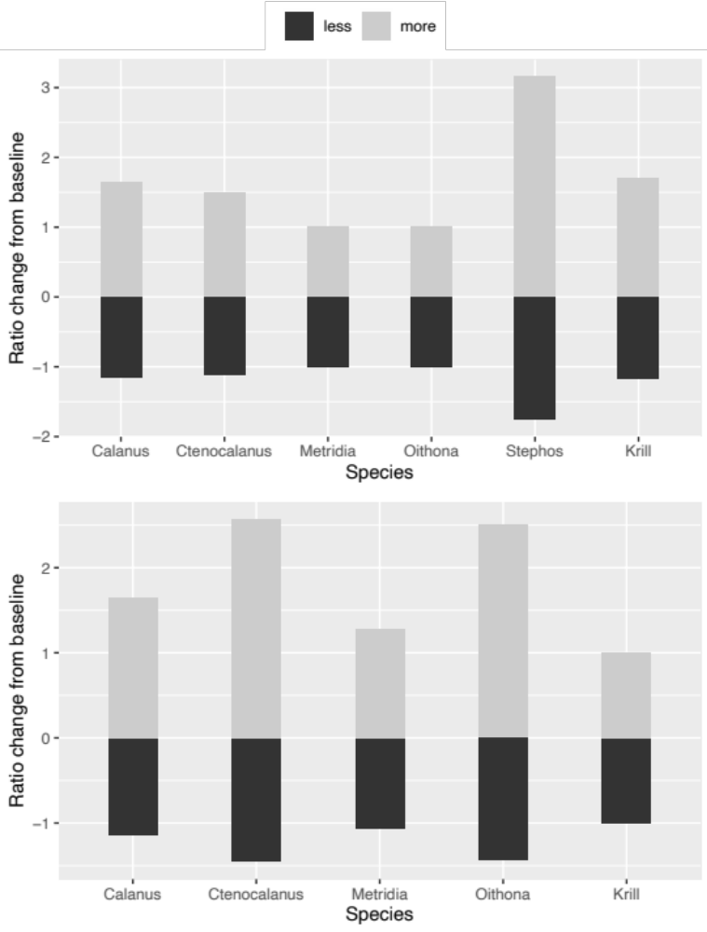
Figure S1 Ratio of change in the average total community grazing over all stations (upper panel represents ice-water interface community; lower panel represents water-column community), when ingestion rate of each species was decreased/increased by a factor of five at a time (showed in the legend by less/more). Species’ full names are: Calanus propinquus, Ctenocalanus spp., Metridia gerlachei, Oithona similis and larval Euphausia superba (Krill).

Reference
Bartell SM, Breck JE, Gardner RH, Brenkert AL (1986) Individual Parameter Perturbation and Error Analysis of Fish Bioenergetics Models. Canadian Journal of Fisheries and Aquatic Sciences 43:160–168.

