Fig. S 1 Distribution of a. incident light, upper two panels (100 µmol m⁻² s⁻¹ categories) and air relative humidity, lower two panels (10% categories) for Hymenoloma crispulum (left-hand panels) and Usnea aurantiaco-atra (right-hand panels) The bars represent the proportion (%) of the total number of measurements within each category while active (black bars) or inactive (grey bars).
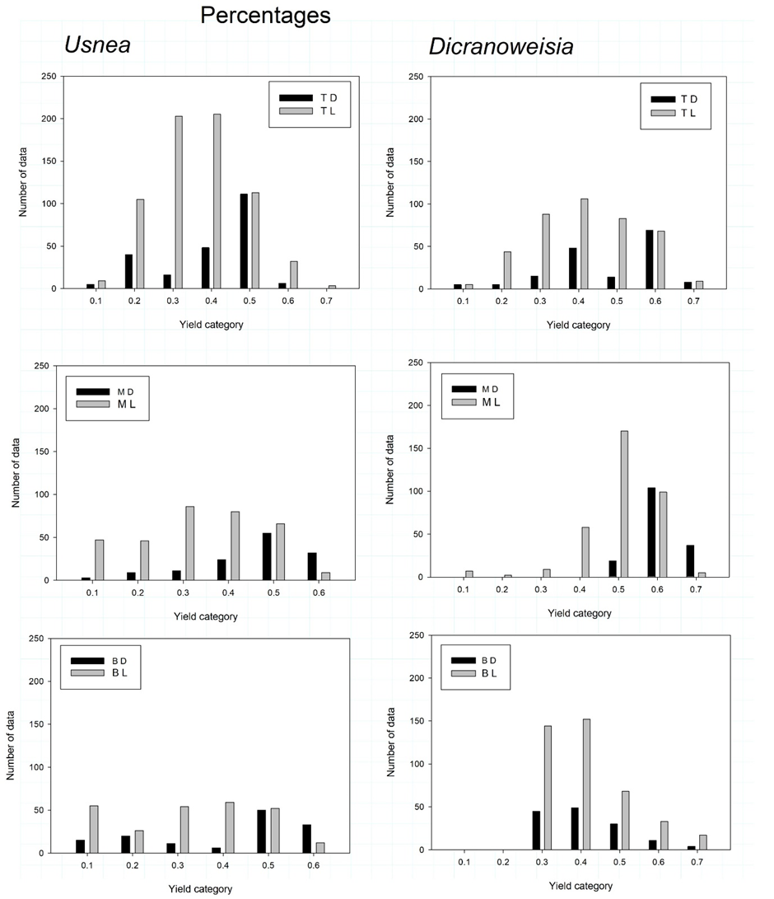

Fig. S 2 Distribution of Photosystem II yield (Φ_{PSII}) for Usnea aurantiaco-atra (left-hand panels) and Hymenoloma. crispulum (right-hand panels) at the three sites, Top (upper panels), Middle (middle panels) and Bottom (lower panels). The Yields are in 0.1 categories and the height of the bars are number of data points in the dark (black bars) and in the light (grey bars).

Table S1 Summary Table of carbon model results for Usnea aurantiaco-atra (upperpanel) and Hymenoloma crispulum (middle panel), and the Warming event (bottom panel). The individual columns, from the left, are SITE, Top and Bottom; DATA 100, predicted carbon exchange from the complete data set assuming continuous activity, and x Yield, Model output multiplied by Y_{(II)} / 0.6 in order to take into account both activity and exchange rate (assumed to be proportional to the ratio).; UPTAKE, predicted CO₂ uptake, mmol m⁻² for H. crispulum) and mmol kg⁻¹ for U. aurantiaco-atra, for the selected time period; LOSS, predicted carbon loss; NET C GAIN, the net CO₂ gain, = (UPTAKE – LOSS) Note: both UPTAKE and LOSS are given positive values; TOTAL C EXCHANGE = (UPTAKE + LOSS); R % Pg, is LOSS as a proportion (%) of TOTAL C EXCHANGE; EVENT % LOSS, is, for U. aurantiaco-atra, the proportion (%) of LOSS contributed by the warming event.

Usnea aurantiaco-atra
 | SITE | DATA | UPTAKE | LOSS | NET C  GAIN |  | TOTAL C EXCHANGE | R % Pg |  | EVENT % LOSS
 | TOP | 100 | 281.87 | 79.46 | 202.41 |  | 361.33 | 22.0 |  | 58.8
 |  | x Yield | 90.09 | 38.19 | 51.90 |  | 128.28 | 29.8 |  | 64.4
 | BOTTOM | 100 | 184.87 | 121.34 | 63.53 |  | 306.20 | 39.6
 |  | x Yield | 21.28 | 36.64 | -15.37 |  | 57.92 | 63.3
Hymenoloma crispulum
 | TOP | 100 | 204.98 | 7.15 | 197.82 |  | 212.13 | 3.4
 |  | x Yield | 59.90 | 3.68 | 56.21 |  | 63.58 | 5.8
 | BOTTOM | 100 | 283.37 | 37.22 | 246.15 |  | 320.60 | 11.6
 |  | x Yield | 102.04 | 17.71 | 84.33 |  | 119.75 | 14.8
Event |  | 100 | 10.80 | 46.72 | -35.92 |  | 57.52 | 81.2
 |  | x Yield | 4.41 | 24.59 | -20.18 |  | 29.00 | 84.8

