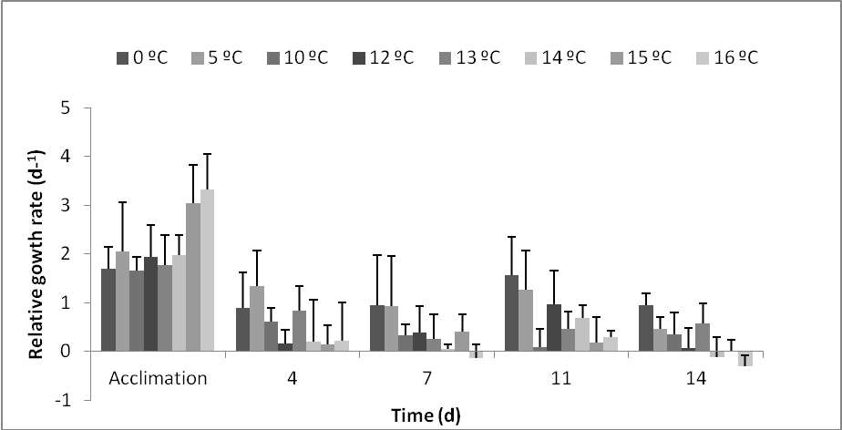
Electronic Supplementary Material 1 Experiment 1 (a and b). Relative growth rate (RGR) of Desmarestia menziesii sporophytes in a temperature gradient over 14 days. Mean values ± SD (n=4). RGR always relates to the measuring day before. The acclimation period took 6 days.

Electronic Supplementary Material 2 Overall growth rates (d ⁻¹) of Desmarestia menziesii sporophytes in a temperature gradient over 14 days. Boxes represent the upper and lower quartile, the line is the median and whiskers indicate maximum and minimum values (excluding outliers).

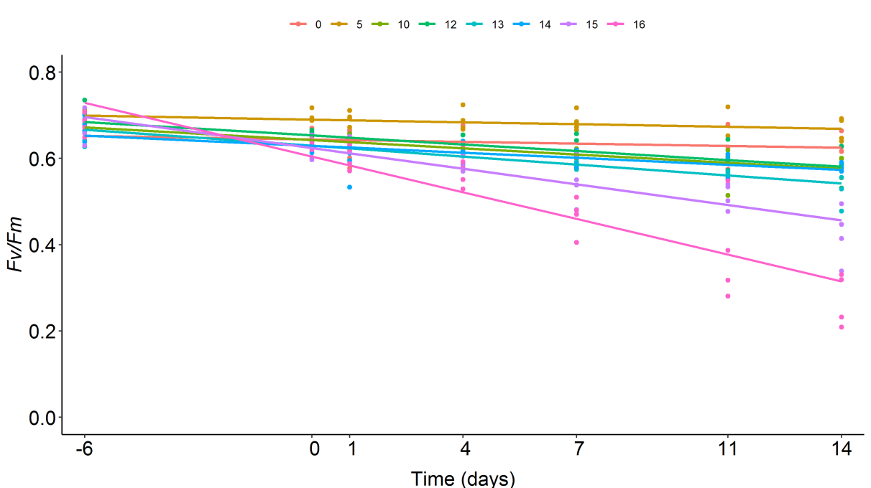
Electronic Supplementary Material 3 Time course of maximum quantum yield (F_{v}/F_{m}) of Desmarestia menziesii sporophytes cultivated in a temperature gradient over 14 days. Each colour corresponds to the different temperatures in °C. Dots represent single values.

