S1: Length-frequency distribution of samples which central vertebrae were collected from.

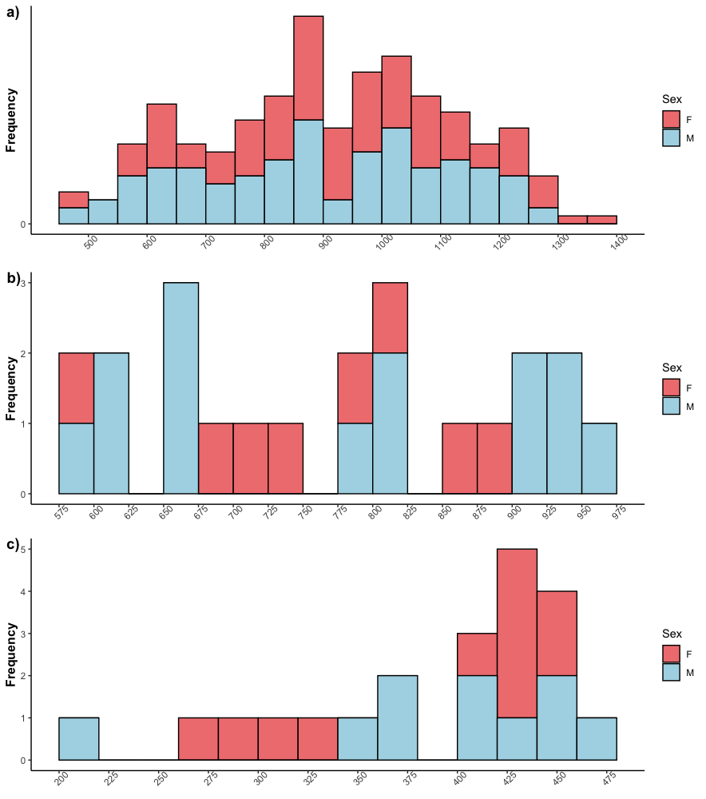
Length-frequency distribution of a) Bathyraja. irrasa (n = 249), b) Bathyraja. eatonii (n = 22) and c) Bathyraja. murrayi (n = 21) which central vertebrae samples were collected from.

S2: Summary of known length-at-maturity information of Bathyraja spp.
Species | Sex | L₅₀ (mm) | Reference
Bathyraja  albomaculata | M | 628 | Ruocco et al. 2006
Bathyraja  albomaculata | F | 653 | Ruocco et al. 2006
Bathyraja  aleutica | M | 1210 | Ebert 2005
Bathyraja  aleutica | F | 1330 | Ebert 2005
Bathyraja  brachyurops | M | 579 | Arkhipkin et al. 2008
Bathyraja  brachyurops | F | 639 | Arkhipkin et al. 2008
Bathyraja  brachyurops | F | 653 | Arkhipkin et al. 2008
Bathyraja  eatonii | M | 900 | Francis 2006
Bathyraja  eatonii | M | 986 | Nowara et al. 2016
Bathyraja  eatonii | M | 1000 | Francis 2006
Bathyraja  eatonii | F | 1000 | Francis 2006
Bathyraja  eatonii | F | 1072 | Nowara et al. 2016
Bathyraja  eatonii | F | 1100 | Francis 2006
Bathyraja  griseocauda | M | 945 | Arkhipkin et al. 2008
Bathyraja  griseocauda | F | 1082 | Arkhipkin et al. 2008
Bathyraja  interrupta | M | 690 | Ainsley et al. 2014
Bathyraja  interrupta | M | 694 | Ebert 2005
Bathyraja  interrupta | M | 700 | Ainsley et al. 2011b
Bathyraja  interrupta | F | 700 | Ebert 2005
Bathyraja  interrupta | F | 710 | Ainsley et al. 2014
Bathyraja  interrupta | F | 720 | Ainsley et al. 2011b
Bathyraja  irrasa | M | 1069 | Nowara et al. 2016
Bathyraja  irrasa | F | 1124 | Nowara et al. 2016
Bathyraja  irrasa | NA | 1210 | van Wijk & Williams 2005
Bathyraja  lindbergi | M | 784 | Ebert 2005
Bathyraja  lindbergi | F | 846 | Ebert 2005
Bathyraja  maculata | M | 937 | Ebert 2005
Bathyraja  maculata | F | 990 | Ebert 2005
Bathyraja  maculata | F | 1082 | Ebert 2005
Bathyraja  minispinosa | M | 695 | Ebert 2005
Bathyraja  minispinosa | M | 701 | Ainsley et al. 2011a
Bathyraja  minispinosa | F | 661 | Ebert 2005
Bathyraja  minispinosa | F | 674 | Ainsley et al. 2011a
Bathyraja  murrayi | M | 449 | Nowara et al. 2016
Bathyraja  murrayi | F | 434 | Nowara et al. 2016
Bathyraja  parmifera | M | 879 | Ebert 2005
Bathyraja  parmifera | F | 920 | Ebert 2005
Bathyraja  parmifera | F | 990 | Ebert 2005
Bathyraja  parmifera | F | 1082 | Ebert 2005
Bathyraja  taranetzi | M | 560 | Ebert 2005
Bathyraja  taranetzi | F | 630 | Ebert 2005
Bathyraja  taranetzi | F | 639 | Ebert 2005
Bathyraja  taranetzi | F | 653 | Ebert 2005
Bathyraja  trachura | M | 735 | Ebert 2005
Bathyraja  trachura | F | 755 | Ebert 2005

S2 shows the known length-at-maturity of several Bathyraja spp. through past studies. The length-at-maturity information in this table was presented for separate sexes (males- M and females- F) as well as for both sexes combined (NA).

S3: Posterior density plots (left panels) and trace plots (right panels) for the best fitting Bayesian Gompertz growth model for Bathyraja irrasa.

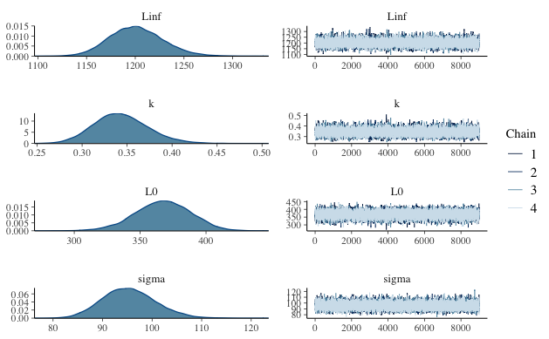

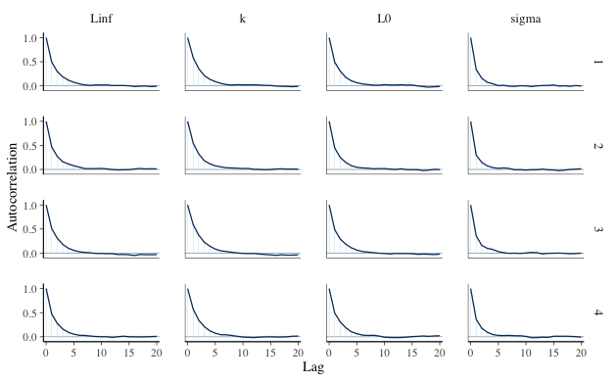
From S3, there was good convergence, and all the growth parameters had a unimodal distribution. The trace plots show that the chains have mixed well, and the Auto Correlation Function (ACF) plot shows almost non-existent autocorrelation.

S4: Posterior density plots (left panels) and trace plots (right panels) for the best fitting Bayesian Gompertz growth model for Bathyraja eatonii.
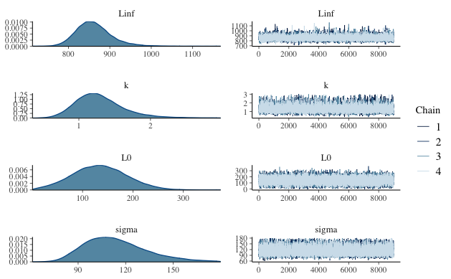

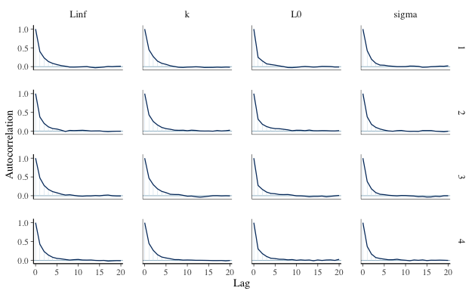
From S4, there was good convergence, and all the growth parameters had a unimodal distribution as well. The trace plots show that the chains have mixed relatively well, and the ACF plot shows almost non-existent autocorrelation.

S5: Posterior density plots (left panels) and trace plots (right panels) for the best fitting Bayesian Gompertz growth model for Bathyraja murrayi.
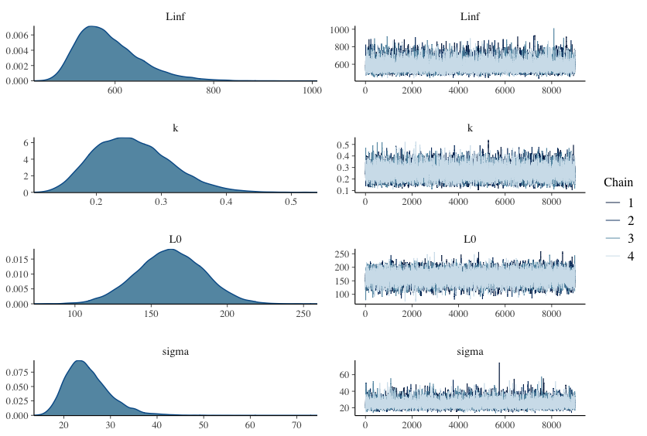

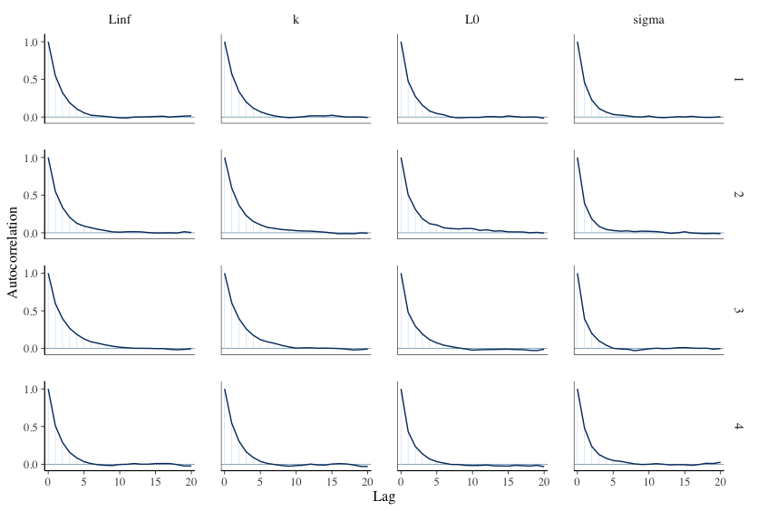

From S5, there was good convergence, and all the growth parameters had a unimodal distribution as well. The trace plots show that the chains have mixed relatively well, and the ACF plot shows almost non-existent autocorrelation.

S6: Age-bias plots for Bathyraja irrasa vertebral counts.
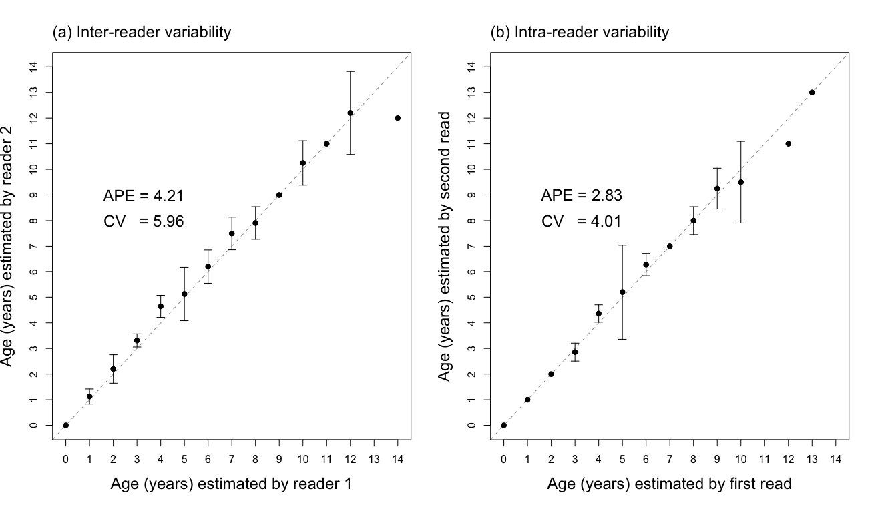
Age-bias plot for 249 Bathyraja irrasa vertebral counts with (a) inter-reader variability between two independent readers and (b) intra-reader variability between two readings from a single reader. The mean age-specific agreements are plotted against a 1:1 equivalence line for comparison. APE and CV values are shown.

Estimated ages ranged from 0 to 14 years, with an average of 4.87 (±3.31 s.d.) years. Males had an age range from 0 to 14 years, with an average of 4.73 (±3.14 s.d.) years. Females ranged from 0 to 13 years, with an average of 5 (±3.48 s.d.) years. The age bias plot showed a slight bias for ages 3-4 (S6) but had minimal variation around the 1:1 line. Variation was lower within Reader 1’s estimates (APE 2.83, CV 4.01; S2b).

S7: Age-bias plots for (a) Bathyraja eatonii and (b) Bathyraja murrayi vertebral counts.

Age-bias plots for (a) Bathyraja eatonii and (b) Bathyraja murrayi vertebral counts showing the intra-reader variability between two readings from a single reader. The mean age-specific agreements are plotted against a 1:1 equivalence line for comparison. APE and CV values are shown.

Bathyraja eatonii estimated ages ranged from 2 to 7 years, with an average of 3.95 (±1.62 s.d.) years. Males had a broader age range from 2 to 7 years, with an average of 4.36 (±1.74 s.d.) years and included both the youngest and oldest individuals of the species. Females ranged from 2 to 5 years, with an average of 3.25 (±1.16 s.d.) years. The age bias plot for B. eatonii showed a noticeable variation around the 1:1 line (Bowker; x²= 12.00, P = 0.15; S7a).

Bathyraja murrayi estimated ages ranged from 2 to 7 years, with an average of 4.95 (±1.60 s.d.) years. Males had an age range from 2 to 7 years with an average of 5.10 (±1.73 s.d.) years, while females had an age range from 2 to 6 years with an average of 4.82 (±1.53 s.d.) years. The age bias plot for B. murrayi showed only a slight variation around the 1:1 line (Bowker; x²= 7.00, P = 0.43; S7b).

S8: Length-frequency distribution of samples which length-at-maturity analyses were conducted on.

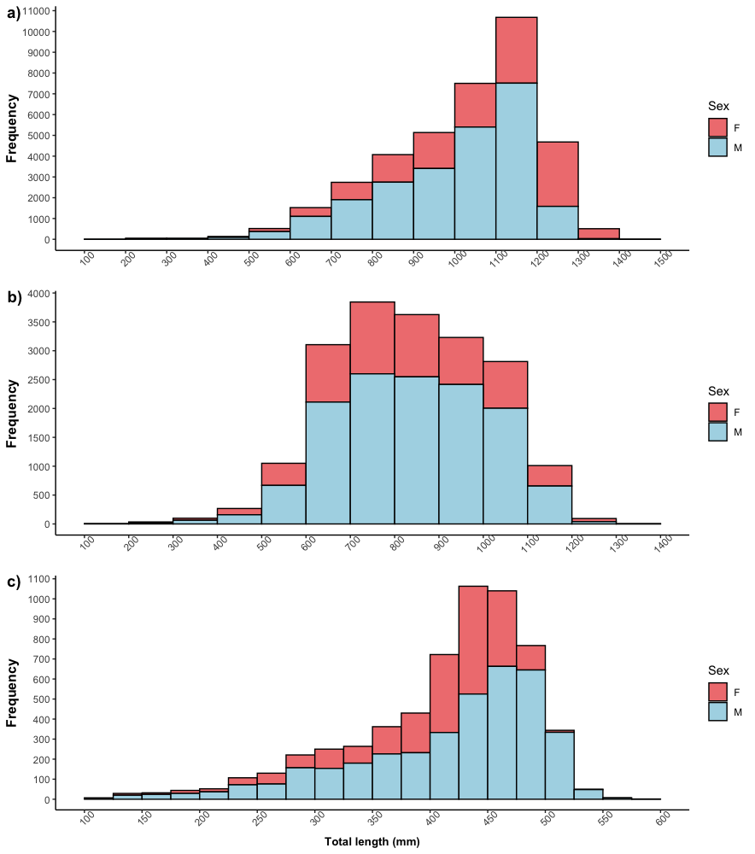
Length-frequency distribution of a) Bathyraja irrasa (n = 37,612), b) Bathyraja eatonii (n = 19,186) and c) Bathyraja murrayi (n = 5,922) which length-at-maturity analyses were conducted on.
S9: Summary of known age-at-maturity information of skate species.

Genus | Species | Sex | Age-at-maturity (years) | Reference
Amblyraja | georgiana | M | 6 | Francis 2006
Amblyraja | georgiana | M | 6 | Francis & Ó Maolagáin 2005
Amblyraja | georgiana | M | 7 | Francis 2006
Amblyraja | georgiana | M | 7 | Francis & Ó Maolagáin 2005
Amblyraja | georgiana | F | 8 | Francis 2006
Amblyraja | georgiana | F | 8 | Francis & Ó Maolagáin 2005
Amblyraja | georgiana | F | 11 | Francis & Ó Maolagáin 2005
Amblyraja | georgiana | F | 13 | Francis 2006
Amblyraja | georgiana | NA | 20 | Francis & Gallagher 2009
Bathyraja | brachyurops | M | 8 | Arkhipkin et al. 2008
Bathyraja | brachyurops | F | 10 | Arkhipkin et al. 2008
Bathyraja | griseocauda | M | 14 | Arkhipkin et al. 2008
Bathyraja | griseocauda | F | 18 | Arkhipkin et al. 2008
Bathyraja | minispinosa | M | 23 | Ainsley et al. 2011
Bathyraja | minispinosa | F | 24 | Ainsley et al. 2011
Bathyraja | spp. | NA | 8 | Constable, Williams & de la Mare 1998
Beringraja | binoculata | NA | 10 | Zeiner and Wolf 1993
Beringraja | binoculata | NA | 12 | Zeiner and Wolf 1993
Dipturus | chilensis | M | 14 | Licandeo et al. 2006
Dipturus | chilensis | F | 11 | Licandeo et al. 2006
Dipturus | innominatus | M | 7 | Francis et al. 2001
Dipturus | innominatus | F | 11 | Francis et al. 2001
Dipturus | innominatus | NA | 13 | Francis et al. 2001
Dipturus | nasutus | M | 4 | Francis et al. 2001
Dipturus | nasutus | F | 5 | Francis et al. 2001
Dipturus | nasutus | NA | 6 | Francis et al. 2001
Dipturus | pullopunctata | NA | 9 | Walmsley-Hart et al 1999
Leucoraja | erinacea | NA | 4 | Waring 1984
Leucoraja | wallacei | NA | 7 | Walmsley-Hart et al. 1999
Raja | clavata | NA | 5 | Ryland and Ajayi 1984
Raja | microocellata | NA | 5 | Ryland and Ajayi 1984
Raja | montagui | NA | 5 | Ryland and Ajayi 1984
Raja | rhina | NA | 10 | Zeiner and Wolf 1993

S10: Comparison of von Bertalanffy growth curves for Bathyraja irrasa, Bathyraja eatonii, Bathyraja murrayi and other similar skate species including Amblyraja georgiana, Bathyraja griseocauda, Bathyraja minispinosa from previous studies.
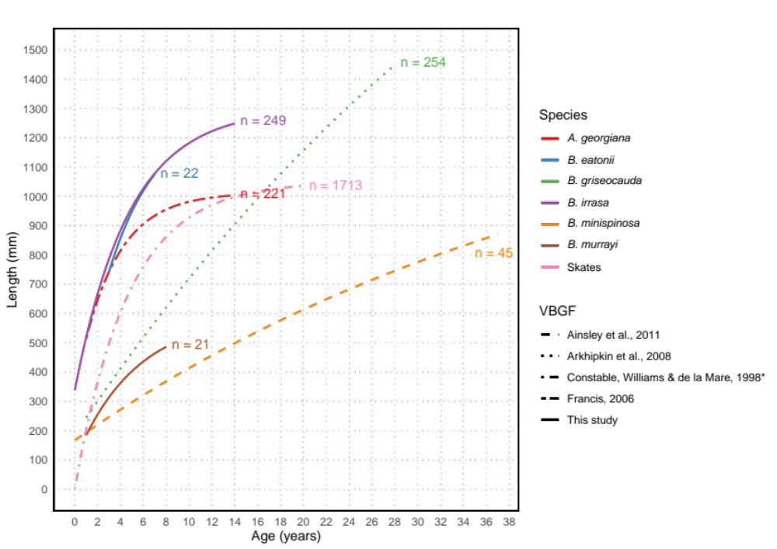

S10 shows a comparison of the von Bertalanffy growth curves of known length-at-age of different skate species through past studies.

References

Ainsley SM, Ebert DA, Calliet GM (2011a) Age, growth, and maturity of the whitebrow skate, Bathyraja minispinosa, from the eastern Bering Sea. ICES Journal of Marine Science 68: 1426-1434

Ainsley SM, Ebert DA, Calliet GM (2011b) A comparison of reproductive parameters of the Bering skate, Bathyraja interrupta, from two Alaskan large marine ecosystems. Marine and Freshwater Research 62: 557-566

Ainsley SM, Ebert DA, Natanson LJ, Calliet GM (2014) A comparison of age and growth of the Bering skate, Bathyraja interrupta (Gill and Townsend, 1897), from two Alaskan large marine ecosystems.

Arkhipkin AI, Baumgartner N, Brickle P, Laptikhovsky VV, Pompert JH, Shcherbich ZN (2008) Biology of the skates Bathyraja brachyurops and B. griseocauda in waters around the Falkland Islands, Southwest Atlantic. ICES Journal of Marine Science 65: 560-570

Constable AJ, Williams R, de la Mare WK (1998) Assessment of by-catch in trawl fisheries at Heard and Mcdonald Islands. CCAMLR Science 5: 231-243

Ebert DA (2005) Reproductive biology of skates, Bathyraja (Ishiyama) along the eastern Bering Sea continental slope. Journal of Fish Biology 66: 618–649

Francis MP (2006) Review of biological parameters for Ross Sea skates. Available at https://meetings.ccamlr.org/en/wg-fsa-06/31

Francis MP, Gallagher MJ (2009) Revised Age and Growth Estimates for Antarctic Starry Skate (Amblyraja georgiana) from the Ross Sea. CCAMLR Science 16: 211-220

Francis MP, Maolagáin CÓ (2005) Age and Growth of the Antarctic Skate (Amblyraja. georgiana) in the Ross Sea. CCAMLR Science 12: 183-194

Francis MP, Maolagáin CÓ, Stevens D (2001) Age, growth, and sexual maturity of two New Zealand endemic skates, Dipturus nasutus and D. innominatus. New Zealand Journal of Marine and Freshwater Research 35: 831-842
Licandeo RR, Lamilla JG, Rubilar PG, Vegas RM (2006) Age, growth, and sexual maturity of the yellownose skate Dipturus chilensis in the south-eastern Pacific. Journal of Fish Biology 68: 488-506
Nowara GB, Burch P, Gasco N et al. (2016) Distribution and abundance of skates (Bathyraja spp.) on the Kerguelen Plateau through the lens of the toothfish fisheries. Fisheries Research 186: 65-81

Ruocco NL, Lucifora LO, Díaz de Astarloa JM, Wöhler O (2006) Reproductive biology and abundance of the white-dotted skate, Bathyraja albomaculata, in the Southwest Atlantic. ICES Journal of Marine Science 63: 105-116

Ryland JS, Ajayi TO (1984) Growth and population dynamics of three Raja species (Batoidei) in Carmarthen Bay, British Isles. ICES Journal of Marine Science 41: 111-120
Van Wijk EM, Williams R (2005) Biological and fishery information for skates in Division 58.5.2. Document WG-FSA-05/70. CCAMLR, Hobart.
Walmsley-Hart SA, Sauer WHH, Buxton CD (1999) The biology of the skates Raja wallacei and R.pullopunctata (batoidea: rajidae) on the Agulhas bank, South Africa. African Journal of Marine Science 21: 165-179
Waring GT (1984) Age, Growth, and Mortality of the Little Skate off the Northeast Coast of the United States. Transactions of the American Fisheries Society 113: 314-321
Zeiner SJ, Wolf PG (1993) Growth characteristics and estimates of age at maturity of two species of skates (Raja binoculata and Raja rhina) from Monterey Bay, California. In: Branstetter S (ed) Conservation Biology of Elasmobranchs. US. Dept. Comm., NOAA Technical Report, NMFS 115, pp. 87-99

