Estimating the population size of nesting barnacle geese on Vaygach Island
As the proportion of nests from tracking data at the various sites did not differ between 2008 – 2010 and 2018 – 2020, we used the combined proportions (Table 1) for population estimates. Using the methods as described in the main text and breeding pair numbers for Kolguev Island for 2006 (50 000 pairs) and 2019 (86 000), we estimate a median of 18 750 (95% CI: 5 556 – 45 000) breeding pairs on Vaygach Island for 2008 – 2010 and a median of 32 250 (95% CI: 9 052 – 77 400) breeding pairs in 2018 – 2020.
The last nest count on Vaygach Island has been conducted in 2013 (Dorofeev et al. 2018). A very large colony was found in the mouth of the Yunoyakha River, consisting of 8 000 breeding pairs (Figure 1, indicated by A). Two of the nest locations from our study were also located in this region. The survey found mostly smaller colonies on the rest of the island, with one other nest location which we located from tracking data also likely to have been covered in the survey area (Figure 1). In total, the survey found 9 000 breeding pairs on Vaygach island. Given that 3 out of 6 of the nests located from tracking data fall outside of the surveyed area., and our estimates of local population size are 2 to 4 times as large as the number of nests counted in 2013, our data suggests that the local breeding population of breeding barnacle geese could be larger than 9 000. However caution is warranted, as our sample size of nest locations on Vaygach Island is relatively low, and our confidence intervals overlap with the count of 9 000.
Dorofeev DS, Glazov PM, Litvin KE (2018) Present status of the Barnacle Goose (Branta leucopsis) on Vaygach Island. Casarca: Bull of the Goose, Swan and Duck Study Group of Northern Eurasia 20:13–27

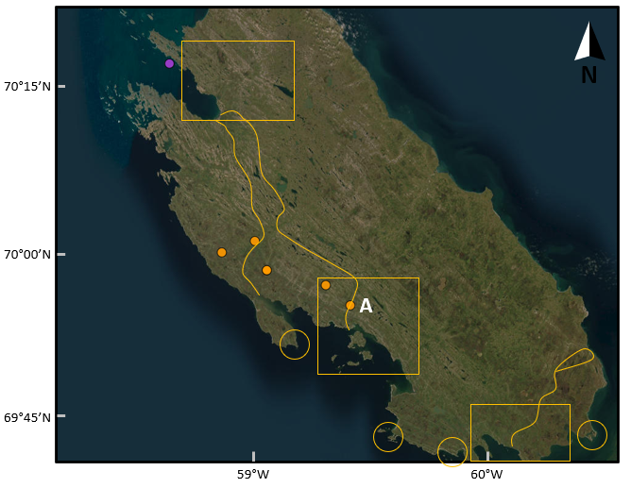
Figure S1: Close-up of nest locations on Vaygach Island. Nest locations located in 2008 – 2010 are marked with purple dots, and in 2018 – 2020 with orange dots. Yellow lines, squares and circles show the transects, areas and islands / capes that were surveyed for nesting barnacle geese in 2013 (Dorofeev et al. 2018).

