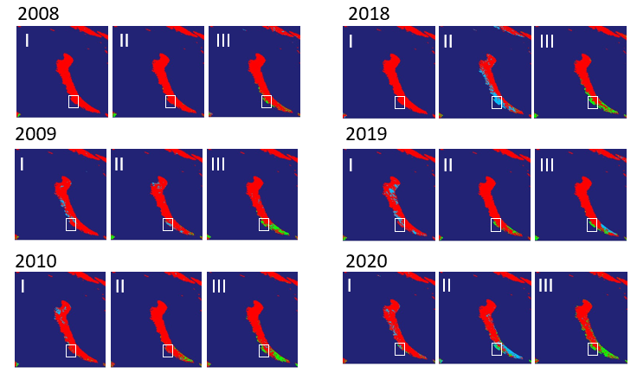
Figure S2: Snow cover on Novaya Zemlya in June – July, 2008 – 2010 and 2018 – 2020. Maps show 8-day composite images of snow cover data from MODIS/Terra snow cover product (MOD10A2, Hall and Riggs 2021) for Novaya Zemlya. For each year 3 maps are provided, corresponding to 8-day periods before 18-25 June (I), 26 June - 3 July (II) and 4-11 July (III). Dark blue shows ocean, red shows areas covered by snow, light blue shows area covered by clouds, green shows land free from snow. Gusinaya Zemlya Peninsula is outlined in a white box. In the period 2008 – 2010 it is visible that Gusinaya Zemlya Peninsula is free from snow only in early July (III). In the period 2018 – 2020, Gusinaya Zemlya Peninsula is at least partly free from snow by late June (II) in 2019 and in mid-June (I) in 2020. Cloud cover make it difficult to assess snow cover in late June 2018.
Hall DK and Riggs GA (2021). MODIS/Terra Snow Cover 8-Day L3 Global 500m SIN Grid, Version 61 [Data Set]. Boulder, Colorado USA. NASA National Snow and Ice Data Center Distributed Active Archive Center. https://doi.org/10.5067/MODIS/MOD10A2.061. Date Accessed 01-12-2022.

