Supplementary Material

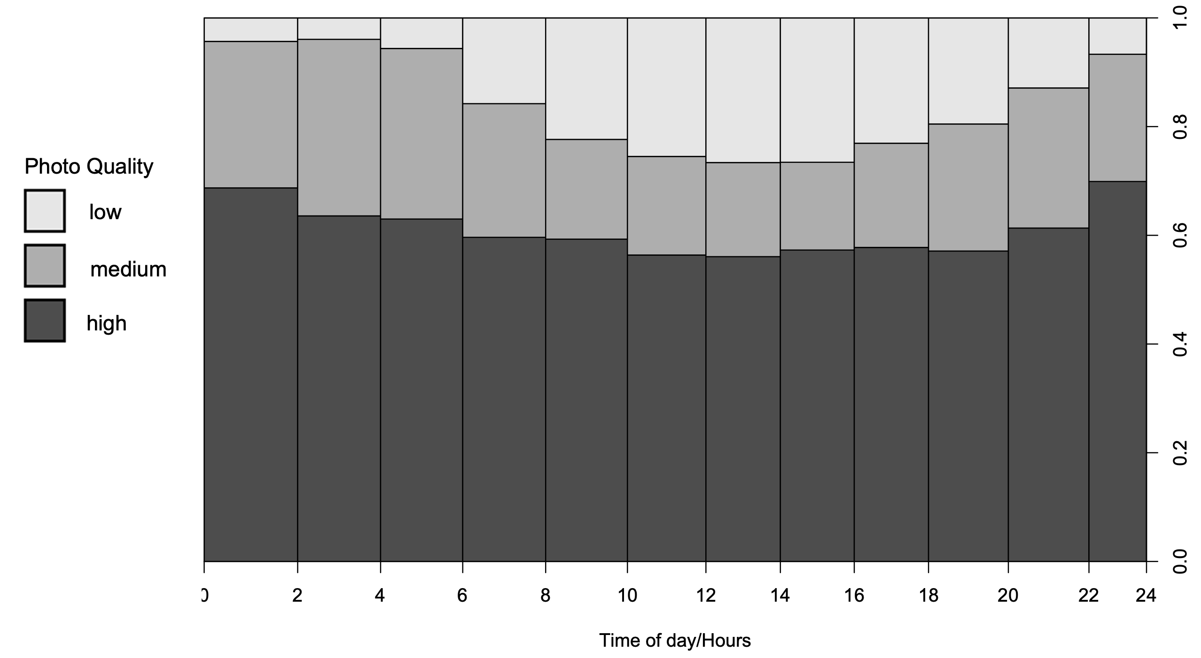
Fig. 1 Proportion of photographs listed as low, medium, or high quality by time of day. Photographs were taken at half-hourly intervals by three separate Cuddeback cameras at Cape Royds, Antarctica between 31 October and 28 December 2017. The majority of photographs (75-90%) are of medium or high quality. The highest proportion of low-quality photographs occurs between 1200 and 1600 NZST

Table 1 Definitions of photograph quality recorded to identify possible under-sampling of Weddell seal counts. The quality of each individual photograph was assessed according to these requirements and placed in one of four categories representing our confidence that the number of seals we counted in a photograph was the true number of seals on the sea ice captured in that image. If there is a temporal structure in photo quality distribution, this could indicate a systemic under-sampling of seal numbers at certain times of day thus suppressing or exaggerating the presence of a haulout cycle
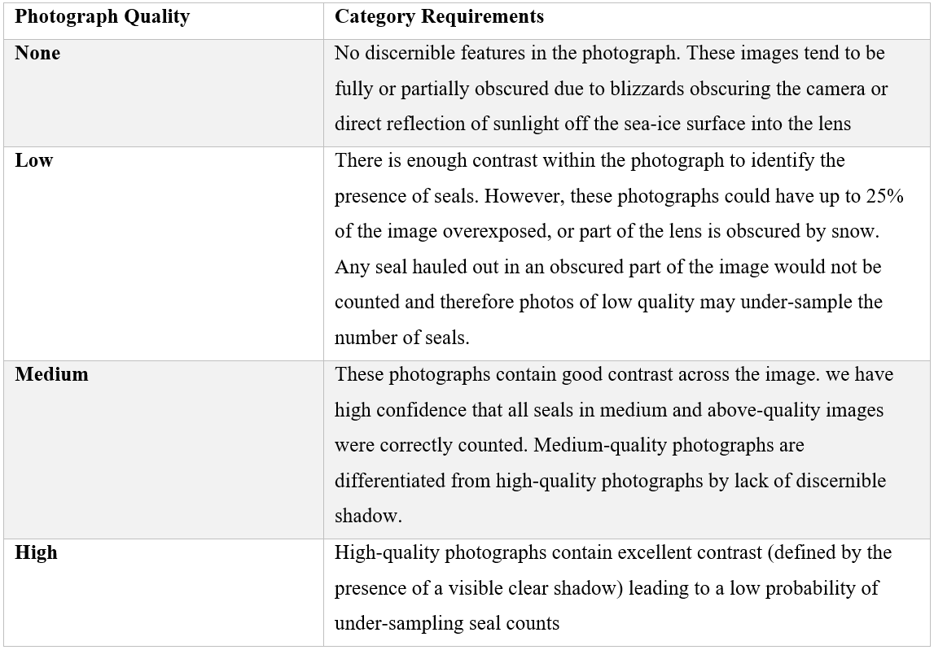

Table 2 Descriptive statistics for selected environmental variables used as covariates to determine haulout behaviour in Weddell seals at Cape Royds between 31 October and 28 December 2017, collected by the PenguinCam Automated Weather Station, Antarctica. Variables included Temperature (in degrees Celsius), Pressure (in hectopascals), Wind speed (in metres per second), Relative Humidity (as a percentage), and Solar radiation (in volts). All values are given to 1 decimal place
