Article title: What’s Inside the Net? Insights into Fish Bycatch Diversity in the Antarctic Krill Fishery
Journal name: Polar Biology
Authors: María Lorena Romero Martínez, William D.K. Reid, Martin A. Collins, Katia L. Treviño Cuellar, William P. Goodall-Copestake, James M. Clark, Benedict Viney, Susan Gregory, Kate Owen, Philip R. Hollyman.
Affiliation of the corresponding author: British Antarctic Survey, NERC, High Cross, Madingley Road, Cambridge, CB3 OET, UK
E-mail of corresponding author: mamero@bas.ac.uk

Vessel | Fishing Gear | Total net length (m) | Net-mouth height | Net-mouth width | Codend mesh size (mm) | Codend length (m) | Codend-mouth height (m) | Codend-mouth width (m)
Antarctic Endeavour | MOT | 106.8 | 16 | 32 | 16 | 26 | 3.4 | 3.4
Fu Yuan Yu 9818 | MOT* | 143 | 15 | 15 | 11 | 24 | 2 | 2
Hua Xiang 9 | MOT | 167 | 25 | 25 | 11 | 21 | 5 | 5
Long Fa | MBT | 154.2 | 20 | 40 | 11 | 24 | 1.8 | 1.8
Long Teng | MBT | 154.2 | 20 | 40 | 11 | 24 | 1.8 | 1.8
Shen Lan | MBT | 168.8 | 18 | 23 | 11 | 24 | 2 | 2
Insung Ho | MOT | 105.1 | 20 | 57 | 15 | 23 | 2.1 | 2.5
Sae In Leader | MOT | 167.6 | 30 | 72 | 15 | 32 | 1.5 | 3
Sejong | MOT* | 137.5 | 25 | 27.6 | 15 | 28 | 2.88 | 4.56
Antarctic Endurance | MBT* | 165 | 26 | 26 | 11 | 28 | 3.8 | 3.8
Antarctic Sea | MBT* | 154 | 22 | 22 | 11 | 27 | 4 | 4
Saga Sea | MBT* | 135 | 20 | 20 | 20 | 28 | 3.8 | 3.8
More Sodruzhestva | MOT | 188.09 | 30 | 35 | 20 | 49.5 | 9.6 | 9.6
MOT: midwater otter trawler
MBT: midwater beam trawler
Authorised vessels for seasons 01 Dec 2021-30 Nov 2022 and 01 Dec 2022 - 30 Nov 2023
Source: CCAMLR (2026): List of authorised vessels, https://www.ccamlr.org/en/compliance/authorised-vessels-0
* Vessels that supplied bycatch samples for the present study
Table S1: List of authorised vessels for krill fishing in Area 48.

Table S2: List of PCR primers designed for the identification of fish bycatch species.

Gene region | primer name | Sequence | primer direction 5'-3' | length (bp) | Tm (°C)
Cox1 | FCOXL1 | GATTYTTYTCYACCAACCATAAAGATATTG | Forward | 48 | 56.9-60.7
Cox1 | FCOXL2 | GATTYTTYTCYACCAACCATAAAGACATTG | Forward | 48 | 58.9-62.7
Cox1 | FCOXL3 | GATTYTTYTCYACCAACCATAAAGATATCG | Forward | 48 | 58.2-62.0
Cox1 | FCOXL4 | GATTYTTYTCYACCAACCATAAAGACATCG | Forward | 48 | 60.2-63.9
Cox1 | FCOXL5 | GATTYTTYTCYACTAACCATAAAGACATCG | Forward | 48 | 58.2-61.9
Cox1 | FCOXL6 | GATTMTTCTCRACTAACCACAAAGAYATTG | Forward | 48 | 57.8-62.6
Cox1 | FCOXL10 | GATTYTTYTCGACWAATCACAAAGACATTG | Forward | 48 | 59.3-61.8
Cox1 | FCOXL13 | GATTYTTYTCGACWAACCACAAAGATATCG | Forward | 48 | 60.2-62.7
Cox1 | FCOXL16 | GAYTTTTCTCAACYAATCACAAAGAYATTG | Forward | 48 | 56.9-62.1
Cox1 | FCOXL17 | GRTTYTTYTCAACCAATCATAAAGA | Forward | 43 | 53.3-57.3
Cox1 | FCOXL20 | GRTTYTTYTCGACTAATCATAAAGA | Forward | 43 | 52.5-56.5
Cox1 | FCOXL22 | GRTTYTTYTCGACCAATCACAAAGA | Forward | 43 | 57.3-61.3
Cox1 | FR adapter | ACTGCCATCTTGGAGGAC | Forward | 25
Cox1 | RCOXL1 | CCGAAGAATCAGAANARRTGYTG | Reverse | 41 | 54.1-61.7
Cox1 | RCOXL2 | CCGAAGAATCAAAANARRTGYTG | Reverse | 41 | 53.0-60.6
Cox1 | RCOXL3 | CCGAAGAACCAGAANARRTGYTG | Reverse | 41 | 56.2-63.7
Cox1 | RCOXL4 | CCGAAGAACCAAAANARRTGYTG | Reverse | 41 | 55.1-62.6
Cox1 | RCOXL5 | CCGAAAAATCAGAANARRTGYTG | Reverse | 41 | 53.0-60.6
Cox1 | RCOXL6 | CCGAAAAATCAAAANARRTGYTG | Reverse | 41 | 52.0-59.5
Cox1 | RCOXL7 | CCGAAAAACCAGAANARRTGYTG | Reverse | 41 | 55.1-62.6
Cox1 | RCOXL8 | CCAAAAAACCAAAANARRTGYTG | Reverse | 41 | 52.3-59.9
Cox1 | RV adapter | CCCAGGATTATGGAACGG | Reverse | 26

Table S2 continued
Gene region | primer name | Sequence | primer direction 5'-3' | length (bp) | Tm (°C)
Control region | FR _4 | GCGCCCACTAATGTACCTG | Forward | 19 | 58.3
Control region | FR_5 | CTATGTACACACATCAGTACAGC | Forward | 23 | 56.8
Control region | FR_6 | CATTTAATGGACATTCGTGAG | Forward | 21 | 53
Control region | FR_8 | TCACTTGGCCCATCAGAG | Forward | 18 | 56.2
Control region | FR_16 | GATTACTTCGTGATCAATATGTG | Forward | 23 | 53.5
Control region | FR_17 | GTACCTAGGCATTTTGTGATC | Forward | 21 | 54.4
Control region | FR_18 | GTCTTTACTAGGCTACACTC | Forward | 20 | 52.2
Control region | FR_19 | GTGCCTGCTATACGGAAATG | Forward | 20 | 56.7
Control region | FR_21 | GCATTATCACCATGAATCG | Forward | 19 | 51.8
Control region | FR_22 | GTATGTATTATCAGCATTCATC | Forward | 22 | 50.4
Control region | FR_24 | GCATTCGTGGACAGGATTTG | Forward | 20 | 57.5
Control region | FR_26 | CCATTTAACAGTCATTCACGG | Forward | 21 | 55.2
Control region | FR_27 | GCCAACACACATCAAAACTAAC | Forward | 22 | 56.7
Control region | FR_32 | GGTATGTATGTATTATCAGCATTC | Forward | 24 | 53.3
Control region | FR_34 | GCAGGTATGTATGTATTATCAG | Forward | 22 | 51.7
Control region | FR_36 | GCATTATCACCATATATCGA | Forward | 20 | 50
Control region | FR_38 | CTTATATTGATTACTTCGTGATC | Forward | 23 | 50.8
Control region | FP2 | CATATCTTAAGGCCAACG | Forward | 18 | 50.2
CtyB-12s | Myct_FR | CTDACATGAATTGGGGGYATGCCTGT | Forward | 26 | 63.1-67.6
Control region | NTO_FR | CCGCTCTTATATGTACCAGC | Forward | 20 | 55.5
Control region | PGE_FR | CCATTCAATACTCATTCTTGGG | Forward | 22 | 54.9
Control region | RV_4 | CACCTCAATCACCAGCGC | Reverse | 18 | 58.8
Control region | RV_5 | CACTTCCAAAGCAACACATAACG | Reverse | 23 | 52.7
Control region | RV_8 | TCCTGAGATTGTACTTATCCT | Reverse | 21 | 52.8
Control region | RV_11 | CGTTCACTCCAGCGAGC | Reverse | 17 | 58.1
Control region | RV_12 | GTCCGTAACCAATGTGCCAC | Reverse | 20 | 59.5
Control region | RV_16 | GCCTGAGCCCCACCTTAA | Reverse | 18 | 58.2
Control region | RV_17 | CTGACCTTCACGCGATTG | Reverse | 18 | 56.2
Control region | RV_18 | CCTTGCTTCATCAATCAGAC | Reverse | 20 | 54.4
Control region | RV_21 | GGCCGCTCTAGTATCG | Reverse | 16 | 53
Control region | RV_23 | GGTGTGTTGTTGAGAGCTG | Reverse | 19 | 56.5
Control region | RV_24 | GGTGTTTAAGAGGTCGG | Reverse | 17 | 51.5
Control region | RV_25 | GGGCTCACTAAAGTTTAGG | Reverse | 19 | 52.6
Control region | RV_26 | GGTATGCACATATATCTGGG | Reverse | 20 | 52.7
Control region | RV_27 | CAGCCAGGAGTACTTGTG | Reverse | 18 | 56
Control region | RV_32 | AGGTTAGTGTTCATAATACATC | Reverse | 23 | 52.8
Control region | RV_36 | GGCTAATGGTGGAAGGTAG | Reverse | 19 | 54.6
Control region | RV_35 | CCAGATGAATGTATATATGC | Reverse | 20 | 48.5
Control region | RV_38 | CAAACGGGTTAAGGTGG | Reverse | 17 | 52.5
CtyB-12s | Myct_RV1 | TRTAGTTCCCGGGCGAATAGRWGTTG | Reverse | 26 | 62.4-66.5
CtyB-12s | Myct_RV2 | CTAGGTCAAGTTTRCACTTATTGCCT | Reverse | 26 | 59.1-61.7
Control region | NTO_RV | CCATTTCTACGAGCAATC | Reverse | 18 | 50.6
Control region | PGE_RV | CCTTAAGTATGTGCTTGTTGG | Reverse | 21 | 54.9

Table S3: Primer pairs used for PCR amplification per species
Primer pair | Family | species
FCOXL3 RCOXL3 | Bathydraconidae | Parachaenichthys georgianus
 |  | Parachaenichthys charcoti
 |  | Gymnodraco acuticeps
 | Harpagiferidae | Harpagifer georgianus
 |  | Harpagifer antarcticus
 | Nototheniidae | Dissostichus eleginoides
 |  | Dissostichus mawsoni
 |  | Gobionotothen marionensis
 |  | Paranotothenia mangellanica
 |  | Patagonotothen gunteri
 |  | Pleuragramma antarcticum
 |  | Trematomus eulepidotus
 |  | Trematomus hansoni
 |  | Trematomus loennbergii
 | Macrouridae | Cynomacrurus pirerei
 | Moridae | Antimora rostrata
 | Scopelarchidae | Benthalbella elongata
 |  | Benthalbella macropina
 | Stomiidae | Borostomias antarcticus
 |  | Stomias gracilis
FCOXL1 RCOXL3 | Carapidae | Echiodon cryomargarites
 | Centrolophidae | Ichichthys australis
 | Microstomatidae | Nansenia antarctica
 | Notacanthidae | Polycanthonotus challengueri
 | Nototheniidae | Lepidonotothen larseni
 |  | Lepidonotothen squamifrons
 |  | Lindbergichthys nudifrons
 | Moridae | Macrourus whitsoni
 | Paralepididae | Magnisudis prionosa
FCOXL2 RCOXL3 | Channichthyidae | Chaenocephalus aceratus
 |  | Chaenodraco wilsoni
 |  | Champsocephalus gunnari
 |  | Chionodraco hamatus
 |  | Chionodraco rastrospinosus
 |  | Cryodraco antarcticus
 |  | Neopagetopsis ionah
 |  | Pagetopsis macropterus
 |  | Pseudochaenichthys georgianus
 | Nototheniidae | Gobionotothen gibberifrons
FCOXL4 RCOXL1 | Nototheniidae | Notothenia rossii
FCOXL2 RCOXL1 | Nototheniidae | Notothenia coriiceps
FCOXL16 RCOXL1 | Myctophidae | Electrona anatarctica
 |  | Electrona carlsbergi
 |  | Gymnoscopelus brauri

Table S3 continued
Primer pair | Family | species
FCOXL16 RCOXL1 |  | Gymnoscopelus microlapas
 |  | Gymnoscopelus nicholsi
 |  | Gymnoscopelus opisthopterus
 |  | Lampanyctus achirus
 |  | Protomyctophum andriashevi
 |  | Protomyctophum bolini
 |  | Protomyctophum parallelum
 |  | Protomyctophum tenisoni
 |  | Taaningichthys bathypilus
FCOXL16 RCOXL3 | Myctophidae | Krefftichthys anderssoni
FCOXL10 RCOXL3 | Zoarcidae | Melanostigma gelatinosum
FCOXL6 RCOXL7 | Paralepididae | Notolepis annulata
 |  | Notolepis coatsorum
FCOXL5 RCOXL5 | Gempylidae | Paradiplospinus antarcticus
FCOXL17 RCOXL2 | Achiropsettidae | Archiropsetta tricholepis
 |  | Mancopsetta maculata
 |  | Neoachiropsetta milfordi
 | Muraenolepididae | Muraenolepis marmoratus
FCOXL13 RCOXL1 | Anotopteridae | Anotopterus pharao
 | Gonostomatidae | Cyclothone braueri
FR21 RV21 | Achiropsettidae | Achiropsetta tricholepis
 |  | Neoachiropsetta milfordi
 |  | Mancopsetta maculata
FR17 RV17 | Anotopteridae | Anotopterus pharao
FP2 RV11 | Bathydraconidae | Psilodraco breviceps
PGE_FR PGE_RV | Bathydraconidae | Parachaenichthys georgianus
FR22 RV23 | Channichthyidae | Champsocephalus gunnari
FR26 RV26 |  | Chaenocephalus aceratus
FR32 RV32 |  | Chionodraco rastrospinosus
FR34 RV12 |  | Pseudochaenichthys georgianus
FR34 RV35 |  | Chionodraco rastospinosus
 |  | Cryodraco antarcticus
FR36 RV36 | Gempylidae | Paradiplospinus gracilis
FR6 RV11 | Harpagiferidae | Harpagifer antarcticus
Myct_FR RV1 | Myctophidae | Krefftichthys anderssoni
 |  | Gymnoscopelus braueri
 |  | Gymnoscopelus fraseri

Figure S1: Example depicting the process of designing, testing and validating PCR primers developed for the identification of fish bycatch in the Antarctic krill fishery with two mitochondrial markers.
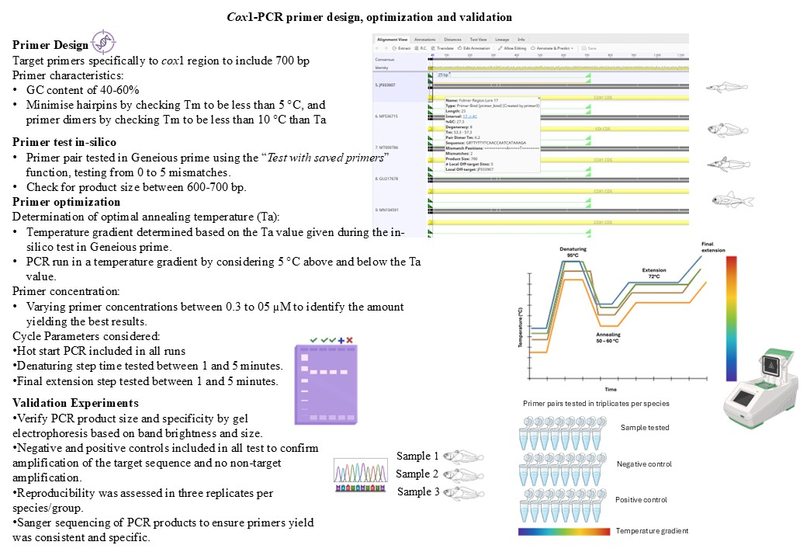

Figure S2: Details of sequencing runs for control region samples with ONT MinION Mk1B on R10.4.1 Flongle Flow Cells with the Native Barcoding Kit 96 V14 (SQK-NBD114.96)
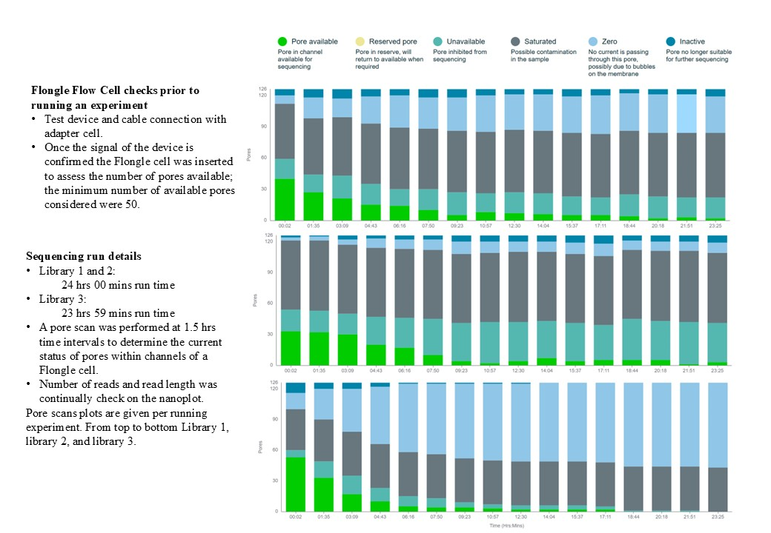
Figure S3: Neighbour joining tree based on cox1

Figure S4: Neighbour joining tree based on control region.

Figure S5: Maximum Likelihood (ML) phylogenetic trees based on cox1.

Figure S6: Maximum Likelihood (ML) phylogenetic trees based on control region.

Figure S7: Observers’ identification score per subarea. Four scoring categories were considered: 0 represented cases where species were erroneously identified, 1 was a correct identification, 2 correct identifications at the genus level only, and 3 for unknown or unidentified samples. Relative proportions of the scoring categories are given per subarea.
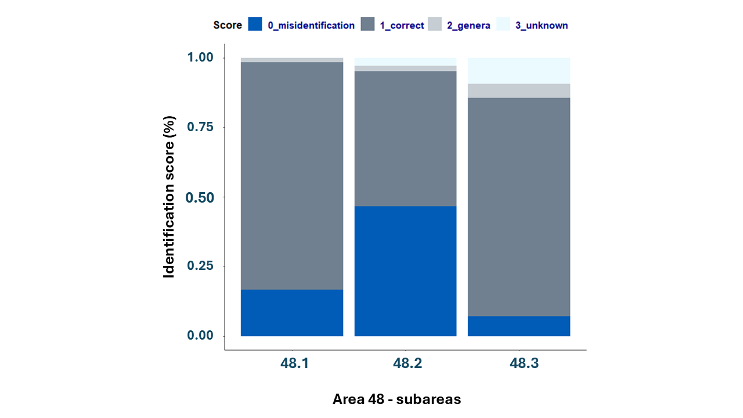

Table S4: List of fish species and codes used by CCAMLR and fishery observers.
Code | Species name | Common name | Family
HHJ | Achiropsetta tricholepis | Prickly flounder | Achiropsettidae
MMM | Mancopsetta maculata | Antarctic armless flounder | Achiropsettidae
PAZ | Neoachiropsetta milfordi | Finless flounder | Achiropsettidae
ANP | Anotopterus pharao | Daggertooth | Anotopteridae
ART | Artedidraco spp |  | Artedidraconidae
AZT | Artedidraco mirus | Plunderfish | Artedidraconidae
PGM | Pogonophryne marmorata | Marbled plunderfish | Artedidraconidae
GDR | Gymnodraco acuticeps | Ploughfish | Bathydraconidae
PCH | Parachaenichthys charcoti | Antarctic dragonfishes | Bathydraconidae
PEV | Prionodraco evansii | Dragonfish spp. | Bathydraconidae
PGE | Parachaenichthys georgianus | Crocodile dragonfish | Bathydraconidae
PSR | Psilodraco breviceps | Dragonfish spp. | Bathydraconidae
PWH | Parachaenichthys spp |  | Bathydraconidae
BAA | Bathylagus antarcticus | Deepsea smelt | Bathylagidae
BTY | Bathylagus spp | Blacksmelts | Bathylagidae
ECI | Echiodon cryomargarites | Messmate | Carapidae
ICA | Icichthys australis | Southern driftfish | Centrolophidae
ANI | Champsocephalus gunnari | Mackerel icefish | Channichthyidae
CES | Champsocephalus esox | Pike icefish | Channichthyidae
DAH | Dacodraco hunteri | Crocodile icefish | Channichthyidae
FIC | Cryodraco antarcticus | Long-fingered icefish | Channichthyidae
AEM | Aethotaxis mitopteryx | Longfin icedevil | Channichthyidae
JIC | Neopagetopsis ionah | Jonah's icefish | Channichthyidae
KIF | Chionodraco rastrospinosus | Ocellated icefish | Channichthyidae
MIC | Chionodraco myersi | Myers' icefish | Channichthyidae
PMA | Pagetopsis macropterus | Icefish spp. | Channichthyidae
PZS | Pagetopsis maculatus |  | Channichthyidae
SGI | Pseudochaenichthys georgianus | South Georgia icefish | Channichthyidae
SSI | Chaenocephalus aceratus | Blackfin icefish | Channichthyidae
TIC | Chionodraco hamatus |  | Channichthyidae
WIC | Chaenodraco wilsoni | Spiny icefish | Channichthyidae
ICX | Unidentified icefish |  | Channichthyidae
PDG | Paradiplospinus gracilis | Slender escolar | Gempylidae
TEZ | Paradiplospinus antarcticus | Antarctic escolar | Gempylidae
HBG | Harpagifer georgianus | S. Georgia spiny plunderfish | Harpagiferidae
HGW | Harpagifer antarcticus | Antarctic spiny plunderfish | Harpagiferidae
PLG | Paraliparis gracilis | Snailfishes | Liparidae
PVZ | Paraliparis spp | Snailfishes | Liparidae
LPX | Unidentified snailfish | Snailfishes nei | Liparidae
CVY | Coryphaenoides spp | Grenadiers, whiptails nei | Macrouridae
Code | Species name | Common name | Family
MNI | Cynomacrurus piriei | Dogtooth grenadier | Macrouridae
WGR | Macrourus whitsoni | Whitson's grenadier | Macrouridae
NSZ | Nansenia antarctica |  | Microstomatidae
NAN | Nansenia spp | Smelts | Microstomatidae
ANT | Antimora rostrata | Blue antimora | Moridae
LPE | Lepidion ensiferus | Patagonian codling | Moridae
LEV | Lepidion spp | Lepidion codlings nei | Moridae
MVC | Muraenolepis marmorata | Marbled moray cod | Muraenolepididae
MWO | Muraenolepis orangiensis | Patagonian moray cod | Muraenolepididae
MRL | Muraenolepis spp | Moray cods nei | Muraenolepididae
MOR |  | Moras nei | Moridae
ELC | Electrona carlsbergi | Electron subantarctic | Myctophidae
ELN | Electrona antarctica | Antarctic lanternfish | Myctophidae
ELT | Electrona spp | Lanternfishes | Myctophidae
GYB | Gymnoscopelus bolini | Lanternfish | Myctophidae
GYN | Gymnoscopelus nicholsi | Nichol's lanternfish | Myctophidae
GYO | Gymnoscopelus opisthopterus | Lanternfish | Myctophidae
GYR | Gymnoscopelus braueri | Lanternfish | Myctophidae
GYY | Gymnoscopelus spp | Lanternfish | Myctophidae
KRA | Krefftichthys anderssoni | Lanternfish spp. | Myctophidae
LAC | Nannobrachium achirus | Lantern fish | Myctophidae
LXX | Unidentified lanternfish | Lanternfishes nei | Myctophidae
PRE | Protomyctophum tenisoni |  | Myctophidae
PRM | Protomyctophum bolini | Lanternfish | Myctophidae
PRY | Protomyctophum choriodon | Lanternfish | Myctophidae
PVP | Protomyctophum spp |  | Myctophidae
NNN | Notacanthus chemnitzii | Spiny eel | Notacanthidae
SLH | Scopelosaurus hamiltoni | Grinner | Notosudidae
GHP | Patagonotothen guntheri | Yellowfin notothen | Nototheniidae
TOA | Dissostichus mawsoni | Antarctic toothfish | Nototheniidae
TOP | Dissostichus eleginoides | Patagonian toothfish | Nototheniidae
ANS | Pleuragramma antarcticum | Antarctic silverfish | Nototheniidae
NOC | Notothenia coriiceps | Black rockcod | Nototheniidae
NOD | Lindbergichthys nudifrons | Yellowfin notie | Nototheniidae
NOF | Gobionotothen angustifrons | Narrowhead rockcod | Nototheniidae
NOG | Gobionotothen gibberifrons | Humped rockcod | Nototheniidae
NYM | Gobionotothen marionensis | Lobe-lip notothen | Nototheniidae
NOL | Nototheniops larseni | Painted notie | Nototheniidae
NOM | Paranotothenia magellanica | Magellanic rockcod | Nototheniidae
NOR | Notothenia rossii | Marbled rockcod | Nototheniidae
NOS | Lepidonotothen squamifrons | Striped-eyed rockcod | Nototheniidae
NOT | Patagonotothen brevicauda | Patagonian rockcod | Nototheniidae
PTC | Trematomus pennellii | Sharp-spined notothenia | Nototheniidae
Code | Species name | Common name | Family
TLO | Trematomus loennbergii | Scaly rockcod | Nototheniidae
TOT | Dissostichus spp | Antarctic toothfishes nei | Nototheniidae
TRD | Trematomus lepidorhinus | Slender scalyhead | Nototheniidae
TRH | Trematomus hansoni | Striped rockcod | Nototheniidae
TRL | Trematomus eulepidotus | Blunt scalyhead | Nototheniidae
TRM | Trematomus scotti | Crowned rockcod | Nototheniidae
TRW | Trematomus newnesi | Dusky rockcod | Nototheniidae
TRT | Trematomus spp | Trematomus nei | Nototheniidae
NOX | Unidentified notothenid | Antarctic rockcods, noties nei | Nototheniidae
MAP | Magnisudis prionosa | Southern barracudina | Paralepididae
NNV | Notolepis annulata | Ringed barracudina | Paralepididae
NTO | Notolepis coatsorum | Antarctic jonasfish | Paralepididae
NOE | Notolepis spp | Barracudinas nei | Paralepididae
BEE | Benthalbella elongata | Pearleyes | Scopelarchidae
BNZ | Benthalbella macropinna |  | Scopelarchidae
PEY | Unidentified scopelarchidae | Pearleyes, etc. nei | Scopelarchidae
BRT | Borostomias antarcticus | Snaggletooth | Stomiidae
LYZ | Lycodapus antarcticus |  | Zoarcidae
MWG | Melanostigma gelatinosum | Limp eelpout | Zoarcidae
LYA | Ophthalmolycus amberensis | Eelpout | Zoarcidae
LXY | Lycodapus spp |  | Zoarcidae
LVD | Unidentified eelpout | Eelpouts nei | Zoarcidae

