Table 1. Results from un-crewed aerial vehicle (UAV) and on-ground surveys at 12 sites across the Western Antarctic Peninsula in the 2023/24 season, and the date and result of the previous survey at each site, from Oceanites (2023).
Site name | Survey date | Penguin species included in study | Result on-ground count | Result UAV count 1 | Result UAV count 2 | First survey date | First survey result | Previous most recent survey date | Previous most recent survey result
Damoy Point | 2024-01-02 | Gentoo (Pygoscelis papua) | 1523 | 1609 | 1605 | 22/01/83 | 619 | 21/01/23 | 1333
Damoy Point | 2024-01-22 | Gentoo | 1584 | 1642 | 1648 | 22/01/83 | 619 | 21/01/23 | 1333
Damoy Point | 2024-01-24 | Gentoo | 1625 | 1673 | 1660 | 22/01/83 | 619 | 21/01/23 | 1333
Danco Island | 2024-02-03 | Gentoo | 2136 | 2488 | 2475 | 31/12/92 | 1573 | 08/02/22 | 732
Dorian Beacon | 2024-01-02 | Gentoo | 131 | 177 | 187 | 15/01/05 | 132 | 12/01/23 | 101
Dorian Beacon | 2024-01-24 | Gentoo | 188 | 179 | 180 | 15/01/05 | 132 | 12/01/23 | 101
Fort Point | 2023-12-16 | Gentoo (Chinstrap (Pygoscelis antarcticus) also present but not included in study) | 1501 | 1694 | 1573 | 13/12/99 | 282 | 08/01/18 | 837
Half Moon Island | 2024-01-07 | Chinstrap | 1067 | 1230 | 1359 | 1987 (date not specified) | 2500 | 22/11/22 | 922
Hydrurga Rocks | 2023-12-17 | Chinstrap | 790 | 885 | 920 | 29/01/86 | 500 | 02/02/20 | 516
Mikkelsen Harbour | 2024-01-06 | Gentoo | 1244 | 1377 | 1372 | 16/01/84 | 300 | 26/01/23 | 677
Neko Harbour | 2024-01-04 | Gentoo | 830 | 1162 | 1125 | 16/12/99 | 864 | 02/02/23 | 705
Palaver Point | 2023-12-17 | Chinstrap | 1044 | 1029 | 1012 | 16/03/86 | 3000 | 29/11/2018 | 450
Skottsberg Point | 2024-01-06 | Gentoo | 469 | 450 | 458 | 22/01/87 | 300 | 05/02/2023 | 216
Spigot Point Peak | 2023-12-02 | Gentoo | 82 | 80 | 79 | 15/12/07 | 1 | 11/01/2019 | 3
Spigot Point Peak | 2023-12-02 | Chinstrap | 252 | 271 | 331 | 08/01/93 | 206 | 11/01/2019 | 250
Tetrad Islands | 2024-01-06 | Chinstrap | 238 | 242 | 239 | 16/01/84 | 180 | 05/02/2023 | 200

Figures

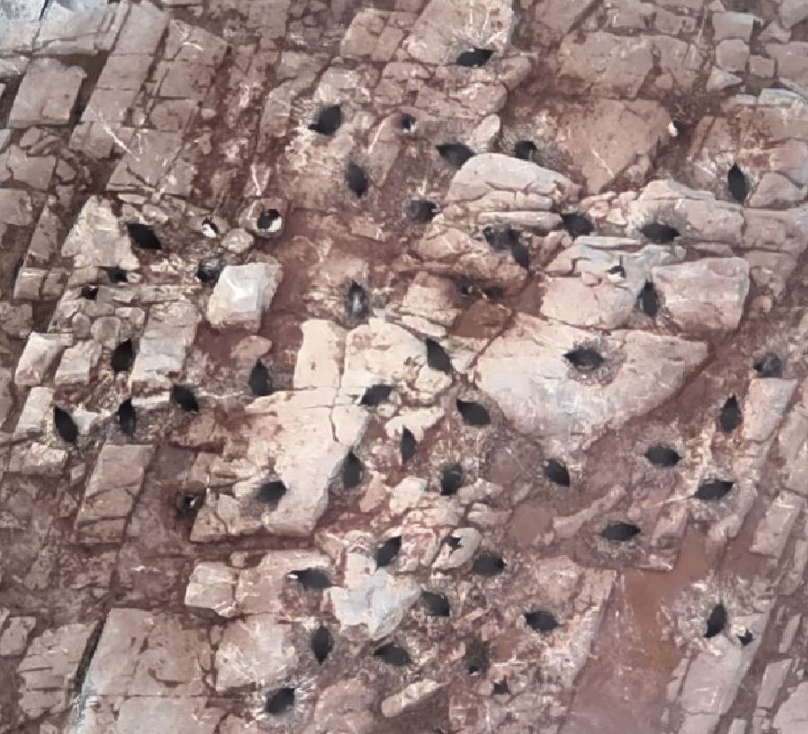
B)
A)
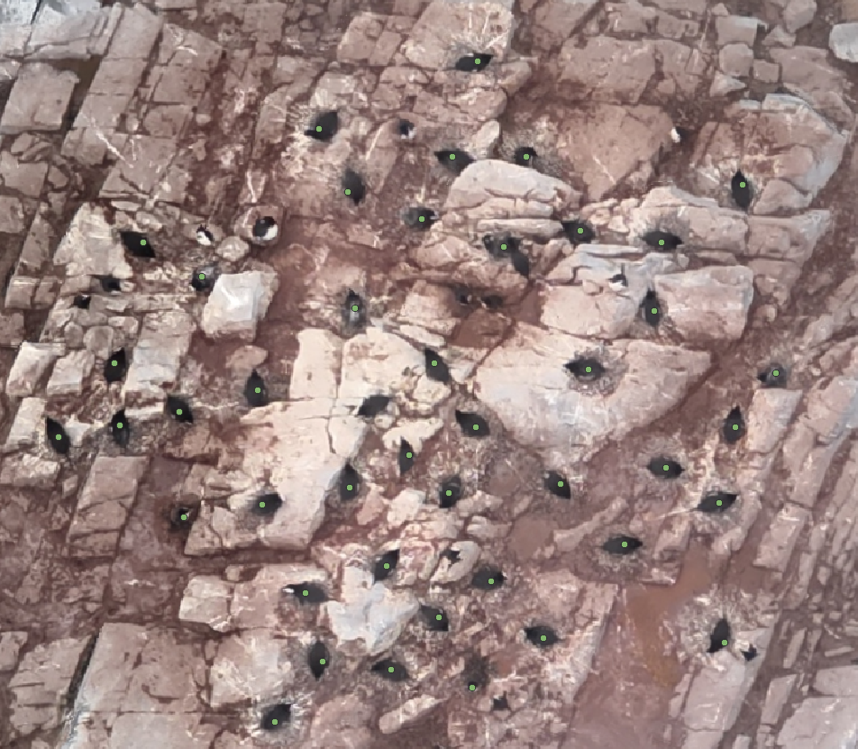

Figure A1. A) A close up of some of the imagery from our study, demonstrating in B) how nesting penguins were identified in QGIS
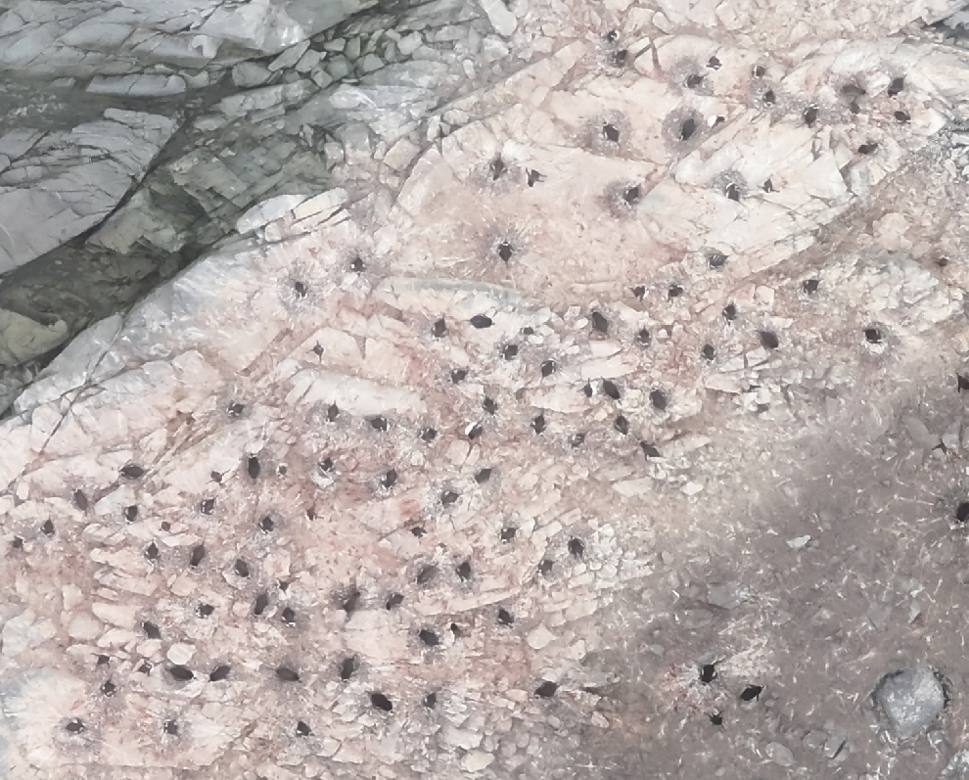
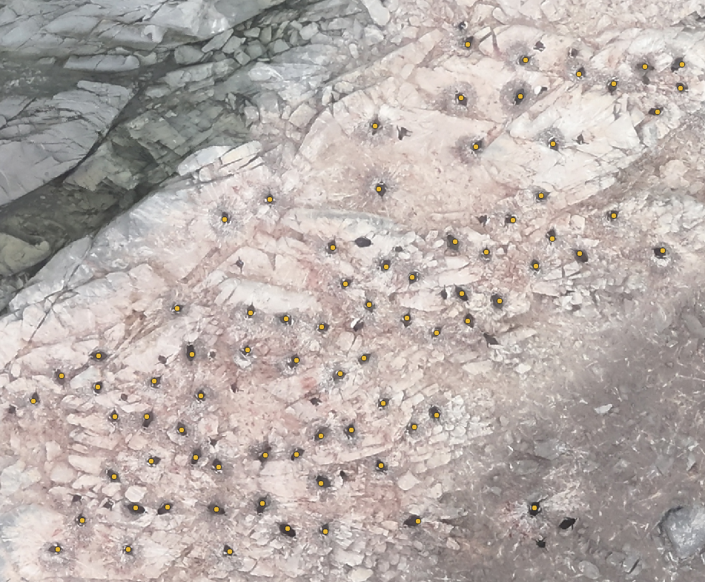
A)
B)

Figure A2. A) A close up of a second set of imagery, again demonstrating in B) how nesting penguins were identified in QGIS

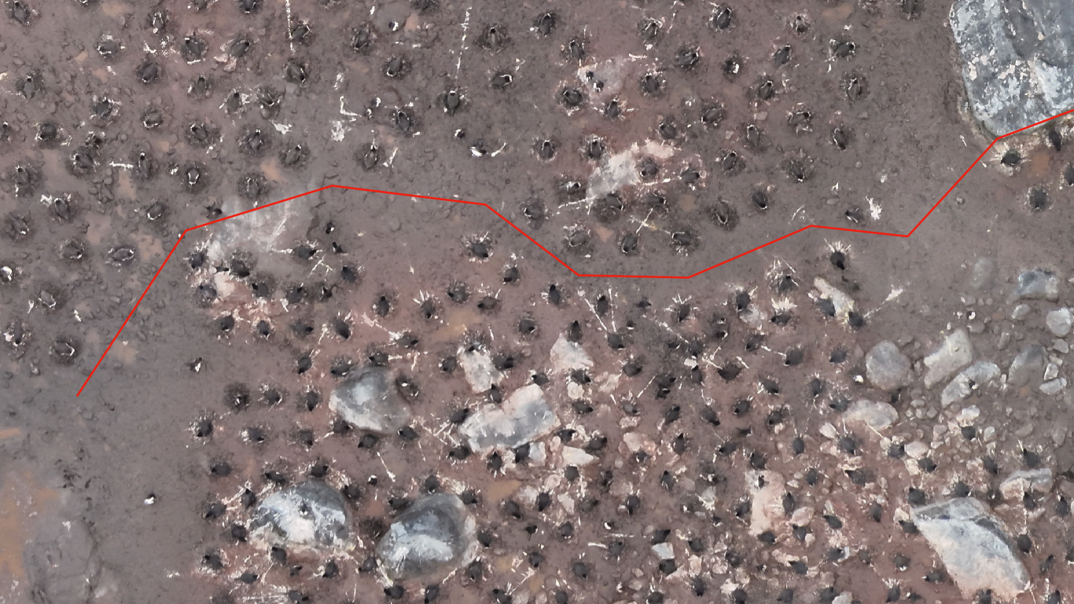
Figure A3. Imagery of a mixed species colony at Fort Point included in our study, showing clear segregation between species; Gentoo are above the red line, and Chinstrap below. Phenotypic distances are visible, including the white band atop the Gentoos head, and more extensive white on the face of the Chinstrap.

References
Oceanites. (2023). MAPPPD v4.1. https://www.penguinmap.com/mapppd/

