Supplementary information (SI)
Online Resource 1. All recorded Cephalopoda Cuvier, 1795 occurrences within the spatial extent of Northeast Greenland National Park (see Online Resource 2) Ocean Biodiversity Information System (OBIS, 2020) (OBIS = 7), OBIS mapper query: {"taxonid": "11707", "geometry": "POLYGON ((-55.0195 83.4000, -55.1953 80.8169, -26.8945 79.9052, -29.0479 72.5940, -22.6978 71.1381, -22.3022 70.9597, -20.1270 70.9454, -12.4805 70.8158, -8.7891 76.9999, -2.9004 81.8113, -13.0078 84.0889, -43.5938 84.5078, -55.0195 83.4000))", "extensions": "MeasurementOrFact,DNADerivedData"}.
See attached.
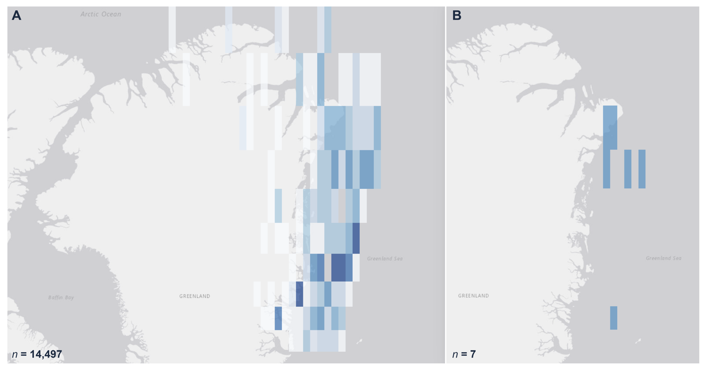
Online Resource 2. A) Spatial extent of Northeast Greenland National Park showing all available biodiversity records from the Ocean Biodiversity Information System (OBIS, 2020) (OBIS; n = 14,497), with darker blue tones indicating areas of higher sampling density. B) Distribution of all recorded Cephalopoda Cuvier, 1795 occurrences within the same region (n = 7), OBIS mapper query: {"taxonid": "11707", "geometry": "POLYGON ((-55.0195 83.4000, -55.1953 80.8169, -26.8945 79.9052, -29.0479 72.5940, -22.6978 71.1381, -22.3022 70.9597, -20.1270 70.9454, -12.4805 70.8158, -8.7891 76.9999, -2.9004 81.8113, -13.0078 84.0889, -43.5938 84.5078, -55.0195 83.4000))", "extensions": "MeasurementOrFact,DNADerivedData"}.

