Supplemental Material
Online Resource 1
An Ecologically Important Leopard Seal Aggregation Site in South Bay, Livingston Island
Polar Biology
Emily S. Sperou¹; José Seco²; Ariel Leahy¹; José C. Xavier^{3,4}; Samuel M. Woodman⁵; Travis D. Bayer^{1,7}; Elka Vasileva⁸; Kamen Nedkov⁸; Dragomir Mateev⁸; Carolina A. Bonin⁹; Sarah S. Kienle¹
¹Natural Resources Science, University of Rhode Island, Kingston, RI, USA
² University of Coimbra, MARE – Marine and Environmental Sciences Centre/ARNET – Aquatic Research Network, Department of Life Sciences, 3000-456, Coimbra, Portugal
³British Antarctic Survey, Natural Environment Research Council, Cambridge, United Kingdom
⁴Centre for Functional Ecology – Science for People & the Planet (CFE), Associate Laboratory TERRA, University of Coimbra Campus at Figueira da Foz, Quinta das Olaias, 3080-183 Figueira da Foz, Portugal
⁵U.S. Antarctic Marine Living Resources Program, Ecosystem Science Division, Southwest Fisheries Science Center, NOAA Fisheries, La Jolla, California, USA
⁶British Antarctic Survey, Natural Environment Research Council, Cambridge, United Kingdom
⁷Pathos Wildlife, Fiskeville, RI, USA
⁸National Centre for Polar Studies, Sofia University St. Kliment Ohridski, Sofia, Bulgaria
⁹Department of Marine and Environmental Sciences, Hampton University, Hampton, VA, USA

*Corresponding Author: Emily S. Sperou; emily.sperou@uri.edu

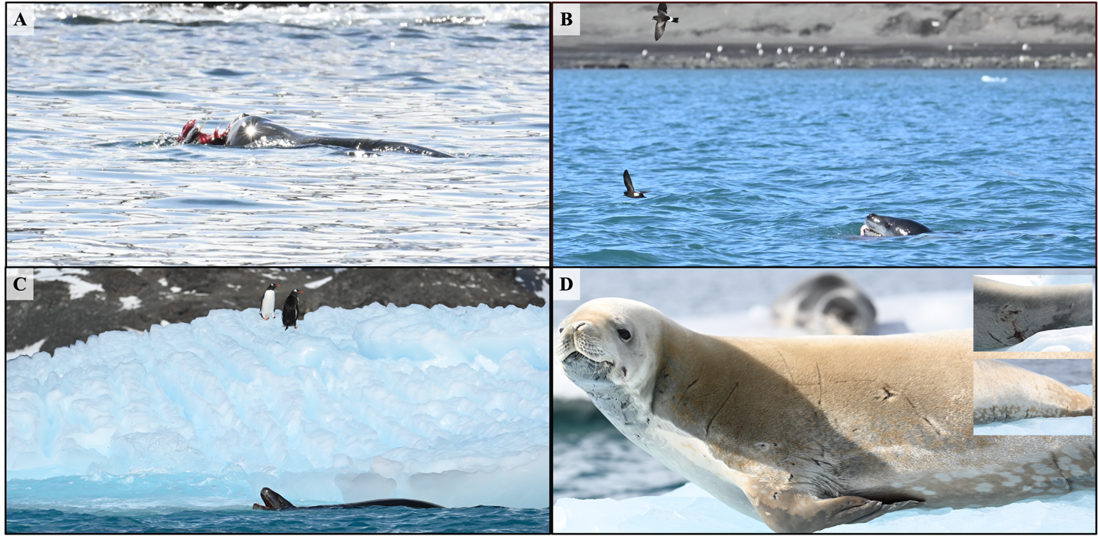
Online Resource 1. Feeding events and predation evidence of leopard seals in South Bay. (A) Leopard seal consuming a skua; (B) leopard seal feeding on a penguin at the water surface; (C) leopard seal observed during a potential krill feeding event near icebergs; (D) crabeater seal displaying parallel lacerations consistent with leopard seal predation, with a leopard seal in the background; inset images show additional examples of scars and wounds observed on crabeater seals. Photo credit: José Seco

