Supplemental material

Supplemental Table 1: GLMM for the outcome „allergic-like AAE“ with submitting institution as random effect.
Covariate | Molarity [mml/ml] | Odds Ratio | 95% CI  (lower-upper) |  | p-value
age |  | 0.981 | 0.968 | 0.994 | 0.005
gender
male |  | reference
female |  | 1.261 | 0.79 | 2.013 | 0.331
MR stress test
No stress test |  | reference
adenosine stress test |  | 1.879 | 0.943 | 3.745 | 0.073
regadenoson stress test |  | 1.216 | 0.152 | 9.703 | 0.854
dobutamine stress test |  | 0 | 0 | Inf | 0.986
GBCA
Gadobutrol (i.e. Gadovist®) | 1.0 | reference
Gadobenate (i.e. Multihance®) | 0.5 | 2.023 | 1.033 | 3.962 | 0.04
Gadodiamide (i.e. Omniscan®) | 0.5 | 0.47 | 0.062 | 3.537 | 0.463
Gadopentetate (i.e. Magnevist®) | 0.5 | 1.033 | 0.39 | 2.732 | 0.948
Gadoteric acid (i.e. Dotarem®) | 0.5 | 0.872 | 0.436 | 1.741 | 0.697
Gadoteridol (i.e. Prohance®) | 0.5 | 1.849 | 0.691 | 4.945 | 0.221
Main indication
known CAD |  | reference
suspected CAD |  | 0.743 | 0.364 | 1.52 | 0.416
suspected/known CMP |  | 0.749 | 0.312 | 1.797 | 0.517
suspected/known Myocarditis |  | 0.8 | 0.341 | 1.875 | 0.607
other main indications |  | 0.642 | 0.265 | 1.556 | 0.327

Supplemental Table 2: Multivariable GLMM for the outcome “physiologic AAE” with submitting institution as random effect.
Covariate | Molarity [mml/ml] | Odds Ratio | 95% CI  (lower-upper) |  | p-value
age |  | 0.999 | 0.989 | 1.009 | 0.892
gender
male |  | reference
female |  | 1.025 | 0.749 | 1.405 | 0.876
MR stress test
No stress test |  | reference
adenosine stress test |  | 2.613 | 1.632 | 4.185 | <0.001
regadenoson stress test |  | 4.023 | 2.193 | 7.377 | <0.001
dobutamine stress test |  | 5.497 | 2.154 | 14.029 | <0.001
GBCA
Gadobutrol (i.e. Gadovist®) | 1.0 | reference
Gadobenate (i.e. Multihance®) | 0.5 | 1.393 | 0.652 | 2.976 | 0.392
Gadodiamide (i.e. Omniscan®) | 0.5 | 0.857 | 0.154 | 4.768 | 0.86
Gadopentetate (i.e. Magnevist®) | 0.5 | 2.004 | 0.976 | 4.117 | 0.058
Gadoteric acid (i.e. Dotarem®) | 0.5 | 0.931 | 0.488 | 1.776 | 0.829
Gadoteridol (i.e. Prohance®) | 0.5 | 4.978 | 2.139 | 11.588 | <0.001
Main indication
known CAD |  | reference
suspected CAD |  | 1.029 | 0.708 | 1.496 | 0.881
suspected/known CMP |  | 0.519 | 0.269 | 1 | 0.05
suspected/known Myocarditis |  | 0.328 | 0.154 | 0.699 | 0.004
other main indications |  | 0.554 | 0.307 | 1.001 | 0.05

Supplemental Table 3: Baseline characteristics of included patients stratified by GBCA subtype.
 | Total  No. 72,839 | Gadobutrol (i.e. Gadovist®)  No. 40,620 | Gadobenate (i.e. Multihance®)  No. 7,092 | Gadodiamide (i.e. Omniscan®)  No. 2,252 |  | Gadopentetate (i.e. Magnevist®)  No. 5,624 |  | Gadoteric acid (i.e. Dotarem®)  No. 14,257 | Gadoteridol (i.e. Prohance®)  No. 2,994
age | 52 (± 19) | 51 (± 20) | 56 (± 18) | 47 (± 23) |  | 54 (± 17) |  | 53 (± 19) | 55 (± 17)
gender
male | 47,040 (65%) | 26,025 (64%) | 4,749 (67%) | 1,442 (64%) |  | 3,605 (64%) |  | 9,324 (65%) | 1,895 (63%)
female | 25,799 (35%) | 14,595 (36%) | 2,343 (33%) | 810 (36%) |  | 2,019 (36%) |  | 4,933 (35%) | 1,099 (37%)
main indication
known CAD | 12,936 (18%) | 6,392 (16%) | 1,906 (27%) | 273 (12%) | 1,013 (18%) |  | 2,793 (20%) |  | 559 (19%)
suspected CAD | 15,016 (21%) | 8,231 (20%) | 1,603 (23%) | 355 (16%) | 1,453 (26%) |  | 2,740 (19%) |  | 634 (21%)
suspected/known CMP | 12,856 (18%) | 7,085 (17%) | 1,392 (20%) | 523 (23%) | 780 (14%) |  | 2,594 (18%) |  | 482 (16%)
suspected/known Myocarditis | 16,040 (22%) | 8,037 (20%) | 1,275 (18%) | 266 (12%) | 1,667 (30%) |  | 4,013 (28%) |  | 782 (26%)
others | 15,991 (22%) | 10,875 (27%) | 916 (13%) | 835 (37%) | 711 (13%) |  | 2,117 (15%) |  | 537 (18%)
GBCA volume [ml]
Mean (SD) | 18.90 (±10.23) | 13.39 (±5.00) | 17.29 (±5.34) | 18.64 (±9.03) | 27.82 (±12.87) |  | 27.49 (±9.87) |  | 33.83 (±7.93)
Missing | 44,394 (60.95%) | 25,352 (62.41%) | 4,291 (60.50%) | 1,393 (61.86%) | 2,396 (42.60%) |  | 8,912 (62.51%) |  | 2,050 (68.47%)
GBCA concentration [mmol/kg]
Mean (SD) | 0.17 (±0.06) | 0.16 (±0.05) | 0.17 (±0.08) | 0.15 (±0.05) | 0.18 (±0.07) |  | 0.17 (±0.07) |  | 0.19 (±0.04)
Missing | 43,630 (59.90%) | 24,311 (59.85%) | 4,588 (64.69%) | 1,375 (61.06%) | 3,130 (55.65%) |  | 8,159 (57.23%) |  | 2,067 (69.04%)

Supplemental Table 4: adverse events by GBCA subtype (grey shade=physiologic adverse events / blue shade=allergic adverse events).

 |  |  | Total  No. 72,839 | Gadobutrol (i.e. Gadovist®)  No. 40,620 | Gadobenate (i.e. Multihance®)  No. 7,092 | Gadodiamide (i.e. Omniscan®)  No. 2,252 | Gadopentetate (i.e. Magnevist®)  No. 5,624 | Gadoteric acid (i.e. Dotarem®)  No. 14,257 | Gadoteridol (Prohance)  No. 2,994
category | severity | specific adverse event
physiologic adverse ephsphysiolveph (n=184) | mild | back pain | 2 | 2 | 0 | 0 | 0 | 0 | 0
physiologic adverse ephsphysiolveph (n=184) | mild | emesis | 17 | 7 | 2 | 0 | 0 | 3 | 5
physiologic adverse ephsphysiolveph (n=184) | mild | heating | 6 | 4 | 0 | 0 | 0 | 1 | 1
physiologic adverse ephsphysiolveph (n=184) | mild | Others | 4 | 4 | 0 | 0 | 0 | 0 | 0
physiologic adverse ephsphysiolveph (n=184) | mild | anxiety | 17 | 7 | 0 | 0 | 4 | 1 | 5
physiologic adverse ephsphysiolveph (n=184) | moderate | angina pectoris | 13 | 10 | 0 | 0 | 0 | 3 | 0
physiologic adverse ephsphysiolveph (n=184) | moderate | dyspnea | 88 | 57 | 6 | 1 | 9 | 9 | 6
physiologic adverse ephsphysiolveph (n=184) | moderate | symptomatic bradycardia | 12 | 2 | 4 | 0 | 1 | 2 | 3
physiologic adverse ephsphysiolveph (n=184) | moderate | symptomatic hypertension | 2 | 0 | 0 | 0 | 1 | 1 | 0
physiologic adverse ephsphysiolveph (n=184) | moderate | symptomatic hypotension | 6 | 2 | 0 | 0 | 0 | 2 | 2
physiologic adverse ephsphysiolveph (n=184) | severe | arrhythmia | 13 | 9 | 0 | 0 | 1 | 1 | 2
physiologic adverse ephsphysiolveph (n=184) | severe | renal failure | 1 | 0 | 1 | 0 | 0 | 0 | 0
physiologic adverse ephsphysiolveph (n=184) | severe | resuscitation | 3 | 0 | 0 | 1 | 2 | 0 | 0
allergic-like adverse events (n=76) | mild | hypersensitive reaction | 61 | 33 | 12 | 0 | 2 | 10 | 4
allergic-like adverse events (n=76) | moderate | respiratory adverse event | 8 | 2 | 2 | 0 | 2 | 2 | 0
allergic-like adverse events (n=76) | severe | severe allergic reaction | 7 | 4 | 0 | 1 | 1 | 0 | 1

Supplemental Table 5. Baseline characteristics of patients with data on GBCA volume and concentration.
 | No. 18,849
age | 54 (± 19)
gender
male | 12,624 (67%)
female | 6,225 (33%)
MR stress test
No stress test | 12,516 (66%)
adenosine stress test | 5,632 (30%)
regadenoson stress test | 512 (3%)
dobutamine stress test | 189 (1%)
GBCA
Gadobutrol (i.e. Gadovist®) | 8,871 (47%)
Gadobenate (i.e. Multihance®) | 2,035 (11%)
Gadodiamide (i.e. Omniscan®) | 726 (4%)
Gadopentetate (i.e. Magnevist®) | 1,925 (10%)
Gadoteric acid (i.e. Dotarem®) | 4,704 (25%)
Gadoteridol (i.e. Prohance®) | 588 (3%)
GBCA volume [ml, mean±SD] | 19.66 (±10.52)
GBCA concentration [mmol/ml, mean±SD] | 0.17 (±0.06)
Main indication
known CAD | 4,092 (22%)
suspected CAD | 4,491 (24%)
suspected/known CMP | 2,964 (16%)
suspected/known Myocarditis | 4,033 (21%)
other main indications | 3,269 (17%)

Supplemental Table 6: Logistic regression model for the outcome “acute adverse event” in the subset of patients with data on GBCA volume and concentration
 | OR | LCI | UCI | p value
GBCA volume (ml) | 1.018 | 1 | 1.037 | 0.051
GBCA concentration (mmol/kg) | 0.003 | 0 | 0.259 | 0.011
GBCA
Gadubutrol (i.e. Gadovist®) | reference
Gadoteric acid (i.e. Dotarem®) | 0.295 | 0.137 | 0.639 | 0.002
Gadoteridol (i.e. Prohance®) | 1.272 | 0.429 | 3.77 | 0.665
Gadobenate (i.e. Multihance®) | 0.824 | 0.401 | 1.695 | 0.6
Gadodiamide (i.e. Omniscan®) | 0 | 0 | Inf | 0.971
Gadopentetate (i.e. Magnevist®) | 1.232 | 0.644 | 2.359 | 0.528

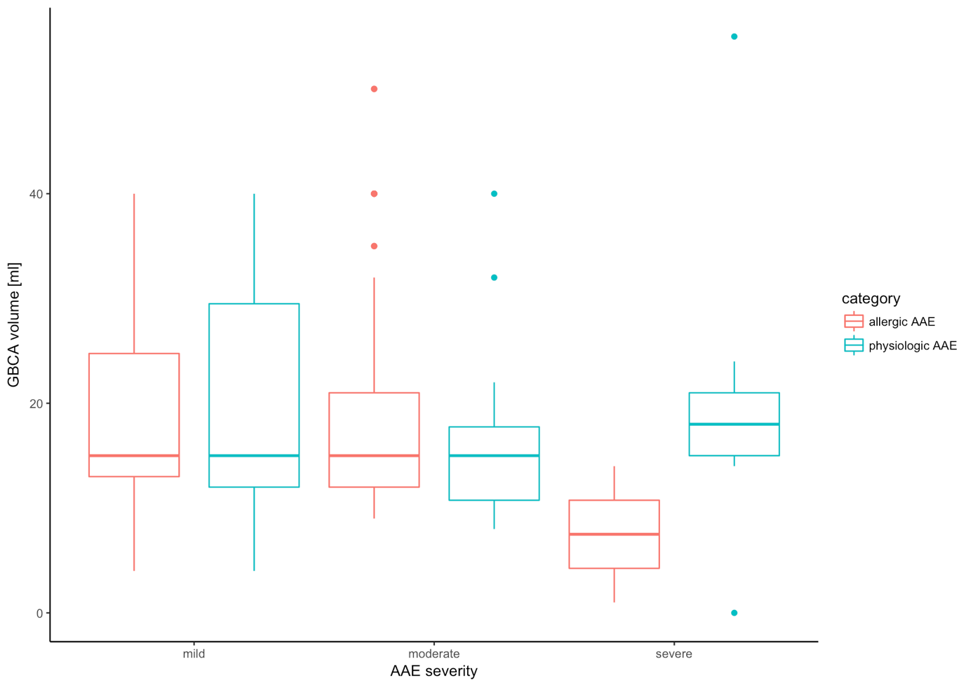
Supplemental Figure 1: GBCA volume in milliliter across different acute adverse event (AAE) severity for allergic and physiologic AAEs.

