Table S1 The clinical, laboratory basic data of PC-AKI with persistent renal dysfunction and transient renal dysfunction
Variables | PC-AKI  with Transient RD  (n=153) | PC-AKI  with Persistent RD  (n=135) | P value
Age，year | 56.09±12.77 | 55.07±13.81 | 0.516
Age ≥ 65 years, No. (%) | 41 (26.8) | 35 (25.9) | 0.867
Gender (Women), No. (%) | 57 (37.3) | 51 (37.8) | 0.927
Oliguria or anuria, No. (%) | 3 (2.0) | 31 (23.0) | 0.000
X-ray procedures, No. (%) |  |  | 0.006
Enhanced CT | 92 (60.1) | 59 (43.7)
CT angiography | 38 (24.8) | 57 (42.2)
PCI | 23 (15.0) | 19 (14.1)
Type of contrast media (IOCM%), No. (%) | 7 (4.6) | 5 (3.7) | 0.695
Volumes of injected contrast media，ml | 82.78±35.07 | 89.67±52.06 | 0.185
Volumes of injected contrast media, No. (%) |  |  | 0.003
< 50 ml | 12 (7.8) | 9 (6.7)
≥ 50 ml, < 100 ml | 96 (62.7) | 60 (44.4)
≥ 100 ml | 45 (29.4) | 66 (48.9)
Complications of AKI, No. (%)
Hyperkalemia | 3 (2.0) | 16 (11.9) | 0.001
Metabolic acidosis | 23 (15.0) | 37 (27.4) | 0.010
Heart failure | 30 (19.6) | 45 (33.3) | 0.008
Respiratory failure | 9 (5.9) | 25 (18.5) | 0.001
Shock | 9 (5.9) | 26 (19.3) | 0.001
Central nervous system failure | 20 (13.1) | 26 (19.3) | 0.153
Gastrointestinal bleeding | 5 (3.3) | 11 (8.1) | 0.071
hypertension | 51 (33.3) | 64 (47.4) | 0.015
diabetes | 27 (17.6) | 24 (17.8) | 0.977
Chronic kidney disease | 25 (16.3) | 17 (12.6) | 0.369
cardiopulmonary bypass surgery | 21 (13.7) | 38 (28.1) | 0.002
Hb, g/l | 111.93±24.66 | 107.96±27.73 | 0.204
Anemia(Hb < 100 g/l) | 31 (20.3) | 43 (31.9) | 0.025
Alb, g/l | 35.88±6.57 | 33.83±6.55 | 0.009
hypoalbuminemia (Alb < 30 g/l), No. (%) | 19 (12.6) | 34 (25.4) | 0.006
TC, mmol/L | 4.13±1.60 | 4.18±1.80 | 0.881
Hyperlipidemia (TC ≥ 6.22 mmol/L), No. (%) | 9 (6.0) | 7 (5.3) | 0.799
Total bilirubin, µmol/L, | 33.86±76.90 | 31.50±55.83 | 0.769
Total bilirubin, No. (%) |  |  | 0.500
0 < 20 µmol/L | 102 (67.5) | 89 (66.4)
20 – 32 µmol/L | 29 (19.2) | 22 (16.4)
33 – 101 µmol/L | 10 (6.6) | 12 (9.0)
102 – 204 µmol/L | 4 (2.6) | 8 (6.0)
> 204 µmol/L | 6 (4.0) | 3 (2.2)
Blood urea nitrogen, mmol/L | 8.47±5.26 | 14.70±9.59 | 0.000
Blood urea nitrogen ≥ 7.14 mmol/L, No. (%) | 73 (47.7) | 109 (80.7) | 0.000
RDW-CV, % | 13.95±2.58 | 14.54±2.67 | 0.063
RDW-CV ≥13.7%, No. (%) | 65 (42.5) | 81 (60.0) | 0.003
PLT，300*10⁹/L | 182.00±94.20 | 156.02±94.46 | 0.022
PLT < 100 or > 300*10⁹ /L, No. (%) | 42 (27.5) | 49 (36.5) | 0.107
The baseline eGFR, mL/min/1.73 m² | 91.10±24.05 | 85.24±22.78 | 0.035
The baseline eGFR, No. (%) |  |  | 0.349
< 60 mL/min/1.73 m² | 16 (10.5) | 19 (14.1%)
≥ 60 mL/min/1.73 m² | 137 (89.5) | 116 (85.9%)
Proteinuria, No. (%) | 30 (19.6) | 36 (26.7%) | 0.155
Acute kidney injury stage, No. (%) |  |  | 0.000
Stage 1 | 153 (100%) | 5 (3.7%)
Stage 2 | / | 69 (51.1%)
Stage 3 | / | 61 (45.2%)
Use of diuretics, No. (%) | 60 (39.2%) | 85 (63.0%) | 0.000
Use of nephroprotective drugs, No. (%) | 13 (8.5%) | 17 (12.6%) | 0.256

Table S2 Risk factors for MAKE30 of PC-AKI patients
(Kaplan-Meier analysis-Log Rank)
Variables | P value
Age ≥ 65 years | 0.759
Gender (Women) | 0.980
X-ray procedures | 0.555
Intravenous CT procedures
Intraarterial procedure (PCI)
Type of contrast media | 0.504
Iodixanol
Iohexol
Iopromide
Iopamidol
Ioversol
Others
Volumes of injected contrast media, ml | 0.002
<50
≥ 50, < 100
≥ 100
Oliguria or anuria | 0.000
Hyperkalemia | 0.001
Metabolic acidosis | 0.021
Heart failure | 0.005
Respiratory failure | 0.008
Shock | 0.001
Central nervous system failure | 0.977
Gastrointestinal bleeding | 0.428
hypertension | 0.007
diabetes | 0.521
Chronic kidney disease | 0.377
cardiopulmonary bypass surgery | 0.024
Anemia (Hb < 100 g/l) | 0.119
Hypoalbuminemia (Alb < 30 g/l) | 0.007
Hyperlipidemia (TC ≥ 6.22 mmol/L) | 0.602
Total bilirubin, µmol/L, | 0.740
0 < 20
20 - 32
33 - 101
102 - 204
> 204
Blood urea nitrogen ≥ 7.14mmol/L | 0.000
RDW-CV ≥ 13.7% | 0.092
PLT < 100 or > 300*10⁹/L | 0.415
The baseline eGFR, mL/min/1.73 m² | 0.097
< 60
≥ 60
Proteinuria | 0.004
Acute kidney injury stage | 0.000
Stage 1
Stage 2
Stage 3
Use of diuretics | 0.000
Use of nephroprotective drugs | 0.589

Table S3 Risk factors for 90-day all-cause mortality of PC-AKI patients
(Kaplan-Meier analysis-Log Rank)
Variables | P value
Age ≥ 65 years, No. (%) | 0.206
Gender (Women), No. (%) | 0.076
X-ray procedures | 0.017
Intravenous CT procedures
Intraarterial procedure (PCI)
Type of contrast media | 0.065
Iodixanol
Iohexol
Iopromide
Iopamidol
Ioversol
Others
Volumes of injected contrast media, ml | 0.967
<50
≥ 50, < 100
≥ 100
Oliguria or anuria | 0.000
Hyperkalemia | 0.001
Metabolic acidosis | 0.000
Heart failure | 0.000
Respiratory failure | 0.000
Shock | 0.000
Central nervous system failure | 0.000
Gastrointestinal bleeding | 0.441
hypertension | 0.057
diabetes | 0.798
Chronic kidney disease | 0.512
cardiopulmonary bypass surgery | 0.515
Anemia (Hb < 100 g/l) | 0.136
Hypoalbuminemia (Alb < 30 g/l) | 0.156
Hyperlipidemia (TC ≥ 6.22 mmol/L) | 0.493
Total bilirubin, µmol/L, | 0.722
0 < 20
20 - 32
33 - 101
102 - 204
> 204
Blood urea nitrogen ≥ 7.14mmol/L | 0.000
RDW-CV ≥ 13.7% | 0.069
PLT < 100 or > 300*10⁹/L | 0.629
The baseline eGFR, mL/min/1.73 m² | 0.001
< 60
≥ 60
Proteinuria | 0.136
Acute kidney injury stage | 0.002
Stage 1
Stage 2
Stage 3
Use of diuretics | 0.004
Use of nephroprotective drugs or hydration | 0.515
Persistent renal dysfunction (serum creatinine value ≥ 200% the baseline serum creatinine value) | 0.000
Receipt of new RRT within 30 days | 0.000

Table S4 Risk factors for one-year all-cause mortality of PC-AKI patients.
(Kaplan-Meier analysis-Log Rank)
Variables | P value
Age ≥ 65 years, No. (%) | 0.076
Gender (Women), No. (%) | 0.209
X-ray procedures | 0.007
Intravenous CT procedures
Intraarterial procedure (PCI)
Type of contrast media | 0.088
Iodixanol
Iohexol
Iopromide
Iopamidol
Ioversol
Others
Volumes of injected contrast media, ml | 0.909
<50
≥ 50, < 100
≥ 100
Oliguria or anuria | 0.000
Hyperkalemia | 0.001
Metabolic acidosis | 0.000
Heart failure | 0.000
Respiratory failure | 0.000
Shock | 0.000
Central nervous system failure | 0.000
Gastrointestinal bleeding | 0.404
hypertension | 0.053
diabetes | 0.687
Chronic kidney disease | 0.437
cardiopulmonary bypass surgery | 0.639
Anemia (Hb < 100 g/l)，No. (%) | 0.205
Hypoalbuminemia (Alb < 30 g/l), No. (%) | 0.211
Hyperlipidemia (TC ≥ 6.22 mmol/L), No. (%) | 0.533
Total bilirubin, µmol/L | 0.707
0 < 20
20 - 32
33 - 101
102 - 204
> 204
Blood urea nitrogen ≥ 7.14mmol/L | 0.000
RDW-CV ≥ 13.7% | 0.074
PLT < 100 or > 300*10⁹/L
The baseline eGFR, mL/min/1.73 m² | 0.002
< 60
≥ 60
Proteinuria | 0.095
Acute kidney injury stage, No. (%) | 0.000
Stage 1
Stage 2
Stage 3
Use of diuretics | 0.011
Use of nephroprotective drugs | 0.585
Persistent renal dysfunction (serum creatinine value ≥ 200% the baseline serum creatinine value) | 0.000
Receipt of new RRT within 30 days | 0.000

Table S5 Effect of diuretics or nephroprotective drugs on prognosis of PC-AKI patients
Drugs | No. (%) of  PC-AKI Patients | P value (Log Rank method)
Drugs | No. (%) of  PC-AKI Patients | MAKE30 | 90-day mortality | 1-year mortality
Nephroprotective drugs
Prior | 26 (9.0) | 0.894 | 0.310 | 0.360
After | 18 (6.3) | 0.056 | 0.574 | 0.624
Prior and after | 14 (4.9) | 0.187 | 0.279 | 0.309
Prior or after | 30 (10.4) | 0.589 | 0.515 | 0.585
Diuretics | 145 (50.3%) | 0.000 | 0.004 | 0.011

Figure S1
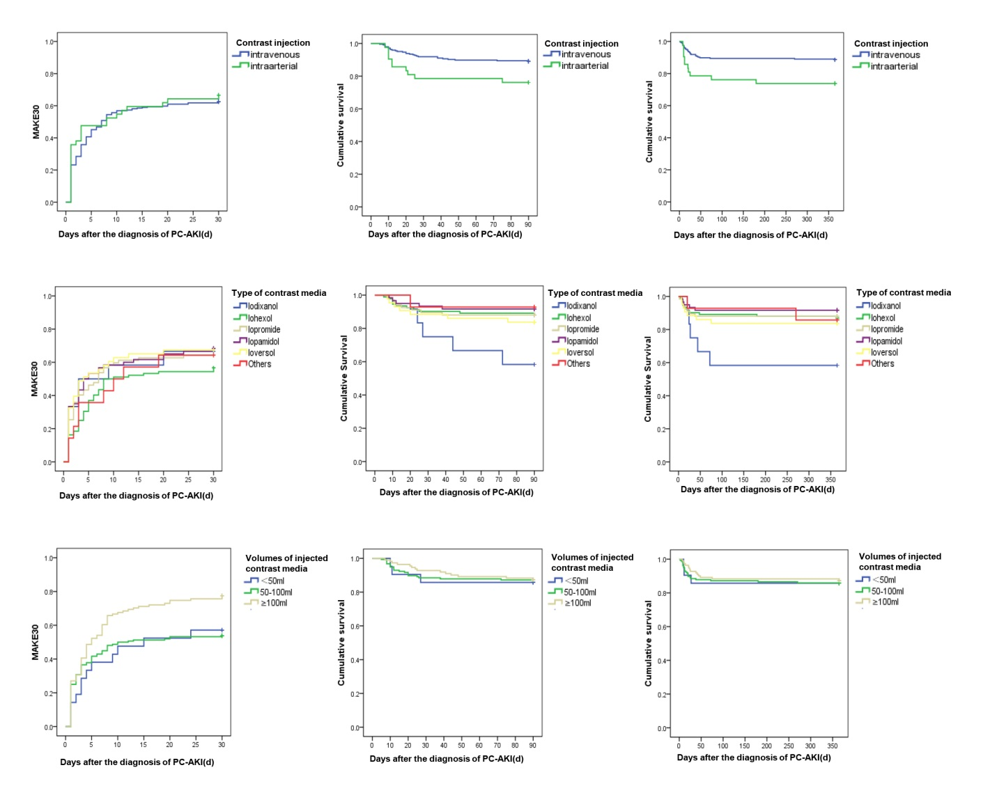

Figure S2

