Appendix
Table. A.1: Relative absolute volume difference (RAVD) metric in percentage for the 5-fold cross-validation models and respective ensemble model complementary to Table 1.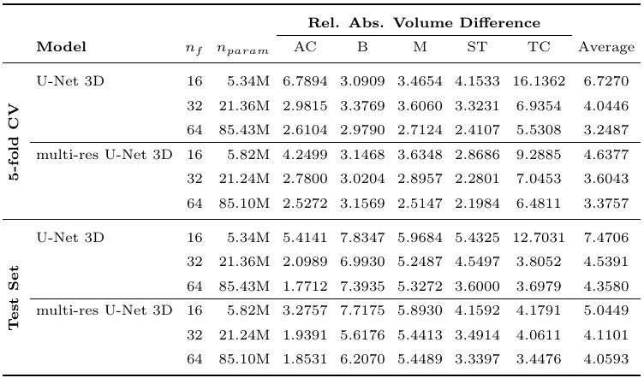
Table A.2: True positive rate (TPR) metric for the 5-fold cross-validation models and respective ensemble model complementary to Table 1.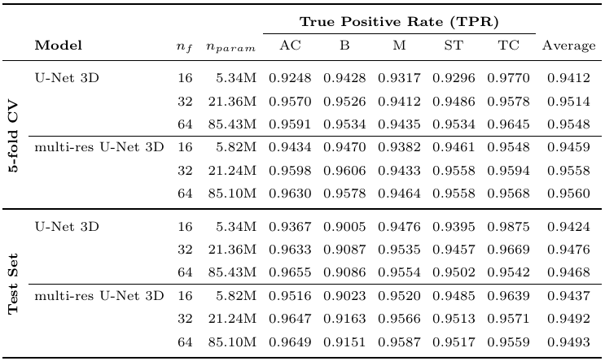
Table A.3: False positive rate (FPR) metric for the 5-fold cross-validation models and respective ensemble model complementary to Table 1.