Supplementary figures

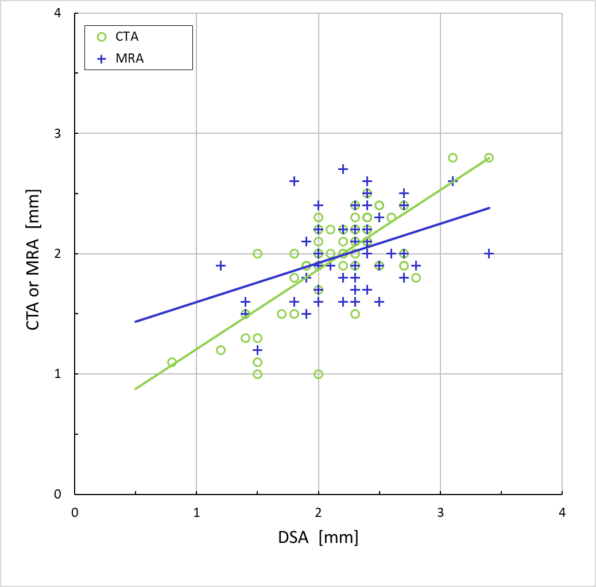
Figure Xa. Lumen diameter measured in CTA or MRA images compared to the corresponding measured in DSA images. The CTA and DSA examination give higher degree of agreement than MRA and DSA. CTA-DSA (Pearson’s r = +0.74) and MRA-DSA (r = +0.38).

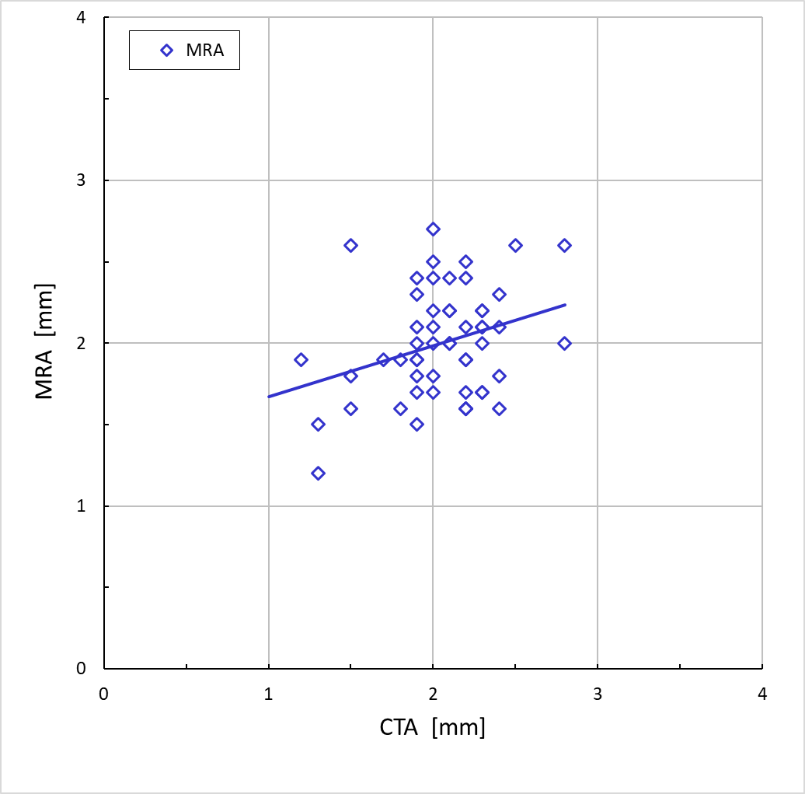
Figure Xb. Lumen diameter measured in MRA images compared to the corresponding measured in CTA images. MRA-CTA (Pearson’s r = +0.31).
Abbreviations: CTA=Computed Tomography Angiography and MRA=Magnetic Resonance Angiography.

