Supplementary Appendix

Index
Supplementary Tables
Table 1 Strata used during the systematic stratified convenience sampling
Table 2 Detailed description of the individual bleeding locations
Table 3 Breakdown of our test results
Table 4 Overview of different methods for ICH detection and comparison of the findings to the present study
Table 5 Overview of different methods of ICH segmentation and comparison of the results to the present study
Table 6 Detailed description of the calculated IPH volumes

Supplementary Figures
Figure 1 Resume of the inclusion criteria and the sampling process

Supplementary Tables
Table 1
Strata used during the systematic stratified convenience sampling

Main groups | Subgroups | Aimed number of cases
1. Cases without intracranial hemorrhage | 1 a. pronounced physiological or pathological intracranial calcifications | 15
1. Cases without intracranial hemorrhage | 1 b. hemorrhage-like structures (e.g., meningioma, hyperdense vessel sign, aneurysma and tumors) | 15
1. Cases without intracranial hemorrhage | 1 c. pronounced brain tissue defects | 10
1. Cases without intracranial hemorrhage | 1 d. normal findings without 1 a, 1 b and 1 c | 40
2. Cases with intracranial hemorrhage | 2 a. subarachnoidal hemorrhage | 20
2. Cases with intracranial hemorrhage | 2 b. basal ganglia hemorrhage | 15
2. Cases with intracranial hemorrhage | 2 c. lobar hemorrhage | 15
2. Cases with intracranial hemorrhage | 2 d. subdural hematoma and epidural hematoma | 10
2. Cases with intracranial hemorrhage | 2 e. infratentorial, including mixed infra- and supratentorial | 10
2. Cases with intracranial hemorrhage | 2 f. mixed hemorrhage, excluding 2 e | 10

Table 2
Detailed description of the individual bleeding locations
IPH intraparenchymal hemorrhage
SAH subarachnoidal hemorrhage
SDH subdural hemorrhage
IVH intraventricular hemorrhage
EDH epidural hematoma
Infra infratentorial
Supra supratentorial

Cases | IPH1 / SAH2 / SDH3 /  IVH4 / EDH5 | Infra 1  Supra 2 | Right 1  Left 2 | Localization
ICH003 | 2 | 2 | 1; 2 | suprasellar, perisylvic
ICH004 | 1 | 2 | 2 | Frontal, basal ganglia
ICH005 | 1 | 2 | 1 | frontal
ICH009 | 1 | 2 | 2 | frontal
ICH010 | 2 | 2 | 1 | sulcus centralis
ICH011 | 2 | 2 | 1; 2 | suprasellar, perisylvic
ICH012 | 3 | 2 | 1 | temporal
ICH013 | 1 | 2 | 2 | temporal
ICH014 | 2 | 1; 2 | 1; 2 | perimesencephalic, suprasellar
ICH015 | 2 | 2 | 0 | suprasellar
ICH017 | 1 | 2 | 2 | basal ganglia
ICH022 | 3 | 2 | 1 | fronto-temporal
ICH024 | 2 | 2 | 1; 2 | suprasellar, perisylvic
ICH026 | 4 | 2 | 0 | third ventricle
ICH028 | 2; 1 | 2 | 1 | temporo-parietal
ICH030 | 4 | 2 | 1 | occipital
ICH032 | 3 | 2 | 0 | frontal, both sides
ICH035 | 2; 1 | 2 | 2 | massive hemispheric hemorrhage
ICH037 | 1 | 2 | 2 | Temporal, parietal
ICH040 | 5 | 2 | 2 | frontal
ICH041 | 1 | 2 | 2 | frontal, parietal
ICH042 | 1 | 1 | 0 | pons
ICH043 | 1; 2 | 1 | 2 | cerebellum
ICH046 | 2 | 1; 2 | 1; 2 | perimesencephalic, suprasellar
ICH047 | 2 | 2 | 0 | frontoparietal
ICH048 | 3 | 2 | 1 | frontal
ICH055 | 2 (1) | 2 | 0 | suprasellar, perisylvic
ICH057 | 1; 4 | 2 | 1 | basal ganglia, ventricular
ICH058 | 1; 4 | 2 | 1 | thalamic, ventricular
ICH059 | 3 | 2 | 1; 2 | bihemispheric
ICH061 | 1; 2; 4 | 1 | 0 | nucleus dentatus R, ventricular
ICH063 | 1 | 2 | 1 | parietal
ICH064 | 2 | 2 | 1; 2 | suprasellar, perisylvic
ICH065 | 1 | 2 | 2 | occipital
ICH068 | 2 | 2 | 1; 2 | suprasellar, perisylvic
ICH072 | 1 | 2 | 0 | Parietal both sides
ICH076 | 1; 4 | 2 | 1 | basal ganglia, ventricular
ICH078 | 1 | 2 | 1 | frontal
ICH082 | 3 | 2 | 2 | hemispherical
ICH084 | 1 | 1 | 0 | pons
ICH085 | 1 | 1 | 0 | pons
ICH087 | 1 | 2 | 1 | frontal
ICH091 | 1; 4 | 2 | 2 | basal ganglia, ventricular
ICH094 | 2 | 2 | 1; 2 | insular dorsal
ICH095 | 3 | 2 | 2 | frontal
ICH097 | 1; 4 | 2 | 2 | basal ganglia, ventricular
ICH098 | 1; 3 | 2 | 1 | temporal
ICH099 | 1 | 2 | 2 | basal ganglia
ICH100 | 2 | 2 | 1; 2 | suprasellar, perisylvic
ICH101 | 1 | 2 | 1 | basal ganglia
ICH103 | 2 | 1; 2 | 1; 2 | perimesencephalic, suprasellar
ICH105 | 1; 4 | 2 | 1 | basal ganglia, ventricular
ICH106 | 2 | 2 | 1; 2 | suprasellar, perisylvic
ICH110 | 1 | 2 | 1 | putamen
ICH112 | 1 | 2 | 1 | thalamic
ICH113 | 2 | 2 | 1; 2 | suprasellar, perisylvic
ICH114 | 1; 4 | 2 | 1 | frontal, ventricular
ICH115 | 1 | 2 | 2 | basal ganglia
ICH116 | 1 | 2 | 1 | temporal
ICH117 | 1; 4 | 2 | 2 | frontal, ventricular
ICH118 | 1; 4 | 1 | 2 | cerebellar, ventricular
ICH120 | 2 | 2 | 0 | massive SAH
ICH124 | 1 | 1 | 0 | vermis
ICH125 | 2 | 2 | 2 | sulcus praecentralis
ICH126 | 1; 4 | 1 | 1 | basal ganglia
ICH127 | 2 | 2 | 1; 2 | suprasellar, perisylvic
ICH128 | 2 | 2 | 2 | sulcus frontalis
ICH130 | 1 | 1 | 2 | cerebellum
ICH131 | 1; 2 | 1 | 2 | temporal
ICH132 | 1 | 1 | 0 | vermis, Pons
ICH134 | 2 | 2 | 1; 2 | suprasellar, perisylvic
ICH136 | 1 | 2 | 2 | basal ganglia (very small)
ICH140 | 1 | 2 | 2 | basal ganglia
ICH143 | 1; 4 | 2 | 2 | basal ganglia, ventricular
ICH147 | 3 | 2 | 0 | both sides
ICH148 | 4; 1 | 2 | 2 | occipital
ICH150 | 3 | 2 | 2 | frontal
ICH154 | 1 | 2; 1 | 1; 2 | paracentral, nucleus dentatus
ICH159 | 1 | 2 | 1 | temporal

Table 3
Breakdown of our test results
 | TP | TN | FP | FN
ICH-BX | 72 | 72 | 9 | 7
ICH-R1 | 78 | 79 | 2 | 1
ICH-R2 | 79 | 79 | 2 | 0
IPH-BX | 46 | 72 | 9 | 1
IPH-R1 | 39 | 80 | 1 | 8
IPH-R2 | 43 | 80 | 1 | 4

BX Brainomix algorithm
R1 Neuroradiology resident 1
R2 Neuroradiology resident 2
TP True positive
TN True negative
FP False positive
FN False negative

Table 4
An overview based on the review of Hssayeni et al.[1] regarding the different methods for ICH detection proposed in various studies and a comparison of their findings to ours as well as to other commercially available tools.

ª CNN: Convolutional Neural Networks
^{b} RF: Random Forest
^{c} RNN: Recurrent neural network
^{d} ROI: Regions of interest
# Information provided by the company on its official website

References  (Included acute hemorrhage types) | Number of CT scans  used for testing |  |  | ICH detection results
 | with ICH (all types) | without ICH | Method | Sensitivity (%) | Specificity  Precision*  (%) | AUC
Our study | 79 | 81 | CNNª (Brainomix Ltd.) | 91 | 89 | 0.90
Our study | 79 | 81 | Reader 1 | 99 | 98 | 0.98
Our study | 79 | 81 | Reader 2 | 100 | 98 | 0.99
RapidAI # | n/a | n/a | 2D/3D CNN  (Rapid ICH; iSchemaView, Inc.) | 95 | 94 | n/a
Yuh et al. [2] | 52 | 158 | Threshold-based | 98 | 59 | n/a
Prevedello et al. [3] | 50 | 35 | CNN | 90 | 85 | 0.91
Jnawali et al. [4] | 1891 | 3618 | CNN | 77 | 80* | 0.87
Chilamkurthy et al. [5] | 2494 + 205 | 18601 + 286 | CNN (ResNet18) and RF^{b} | 92 | 70 | 0.93
Ye et al.[6] | 194 | 105 | 3D joint CNN-RNN^{c} | 98 | 99 | 1.00
Chang et al. [7] | 82 | 780 | ROI^{d}-based CNN | 95 | 97 | 0.97
Lee et al. [8] | 100 + 107 | 100 + 130 | CNN | 95 | 95 | 0.98
References | Number of CT scans  used for testing |  |  | IPH Detection Results
 | with IPH | without IPH | Method | Sensitivity (%) | Specificity  (%) | AUC
Our Study | 47 | 81 | CNN (Brainomix Ltd.) | 98 | 89 | 0.93
Our Study | 47 | 81 | Reader 1 | 83 | 99 | 0.91
Our Study | 47 | 81 | Reader 2 | 91 | 99 | 0.95
Mohammaden et al. [9] | 163 | 48 | CNN (Viz ICH v1.4; Viz.ai, Inc.) | 94 | 88 | 0.94
Barreira et al. [10] | 132 | 152 | CNN (Viz ICH v2.0; Viz.ai, Inc.) | 90 | 99 | 0.96

Table 5
An overview based on the review of Hssayeni et al. [1] regarding different methods of ICH segmentation proposed in various studies and a comparison of their results to the present study.

ª CNN: Convolutional Neural Networks
^{b} ROI: Regions of interest

References | Number of segmented ICHs/IPHs | Ground truth | Evaluated ICH segmentation method | Dice coefficient
Our study | 44 | Semi-automatic segmentation using Amira software (Thermo Fisher Scientific Inc.) | CNNª (Brainomix Ltd.) | 0.82 (IPH)
Bhadauria et al. [11] | 20 | manually delineated hemorrhage region drawn by an expert | Fuzzy c-mean clustering  region-based active contour | 0.87
Muschelli et al. [12] | 102 | Manual segmentation using OsiriX imaging software (OsiriX v. 4.1, Pixmeo) | Logistic regression  Logistic regression with LASSO  Generalized additive model  Random forest classifier | 0.89
Kuang et al. [13] | 30 | Manual segmentation using the ITK-SNAP software | semi-automated segmentation approach (Semi-D-Unet) based on U-Net (deep Fully Convolutional Networks) | 0.65
Chang et al. [7] | 82 | Manual segmentation | ROI^{b}-based CNN | 0.85 (Average)  0.93 (IPH)  0.86 (EDH/SDH)  0.77 (SAH)

Table 6
Detailed description of the automatically (by the Brainomix algorithm) and the semi-automatically (ground truth) calculated volumes of all 44 cases with intraparenchymal hemorrhage (IPH). Volumes are demonstrated in ml.

Cases | IPH-volumes calculated automated by the Brainomix algorithm | IPH-volumes calculated semi-automated (ground truth)
ICH004 | 147.533 | 123.59
ICH005 | 11.796 | 9.81
ICH009 | 157.104 | 135.31
ICH013 | 1.702 | 1.52
ICH017 | 8.27 | 6.30
ICH028 | 114.546 | 77.67
ICH037 | 67.539 | 58.49
ICH041 | 71.793 | 50.80
ICH042 | 4.464 | 6.96
ICH043 | 27.809 | 45.67
ICH057 | 86.839 | 80.21
ICH058 | 43.622 | 59.67
ICH061 | 28.354 | 31.37
ICH063 | 35.74 | 30.36
ICH065 | 3.299 | 8.44
ICH072 | 2.164 | 4.32
ICH076 | 37.461 | 34.18
ICH078 | 60.864 | 34.29
ICH084 | 1.705 | 2.97
ICH085 | 4.435 | 5.74
ICH087 | 9.748 | 7.19
ICH091 | 28.069 | 21.01
ICH097 | 39.088 | 34.26
ICH098 | 104.302 | 95.15
ICH099 | 1.489 | 3.58
ICH101 | 14.219 | 13.38
ICH105 | 165.348 | 153.74
ICH110 | 17.144 | 13.75
ICH112 | 13.837 | 13.76
ICH114 | 31.409 | 55.17
ICH115 | 27.991 | 25.13
ICH116 | 0 | 0.14
ICH117 | 120.499 | 101.90
ICH118 | 76.129 | 49.71
ICH124 | 52.443 | 48.49
ICH126 | 75.336 | 68.17
ICH130 | 4.094 | 11.84
ICH132 | 10.68 | 8.88
ICH136 | 0.249 | 0.80
ICH140 | 17.453 | 18.07
ICH143 | 46.316 | 42.63
ICH148 | 76.228 | 67.41
ICH154 | 20.463 | 18.38
ICH159 | 44.644 | 39.91

Supplementary Figures
Figure 1
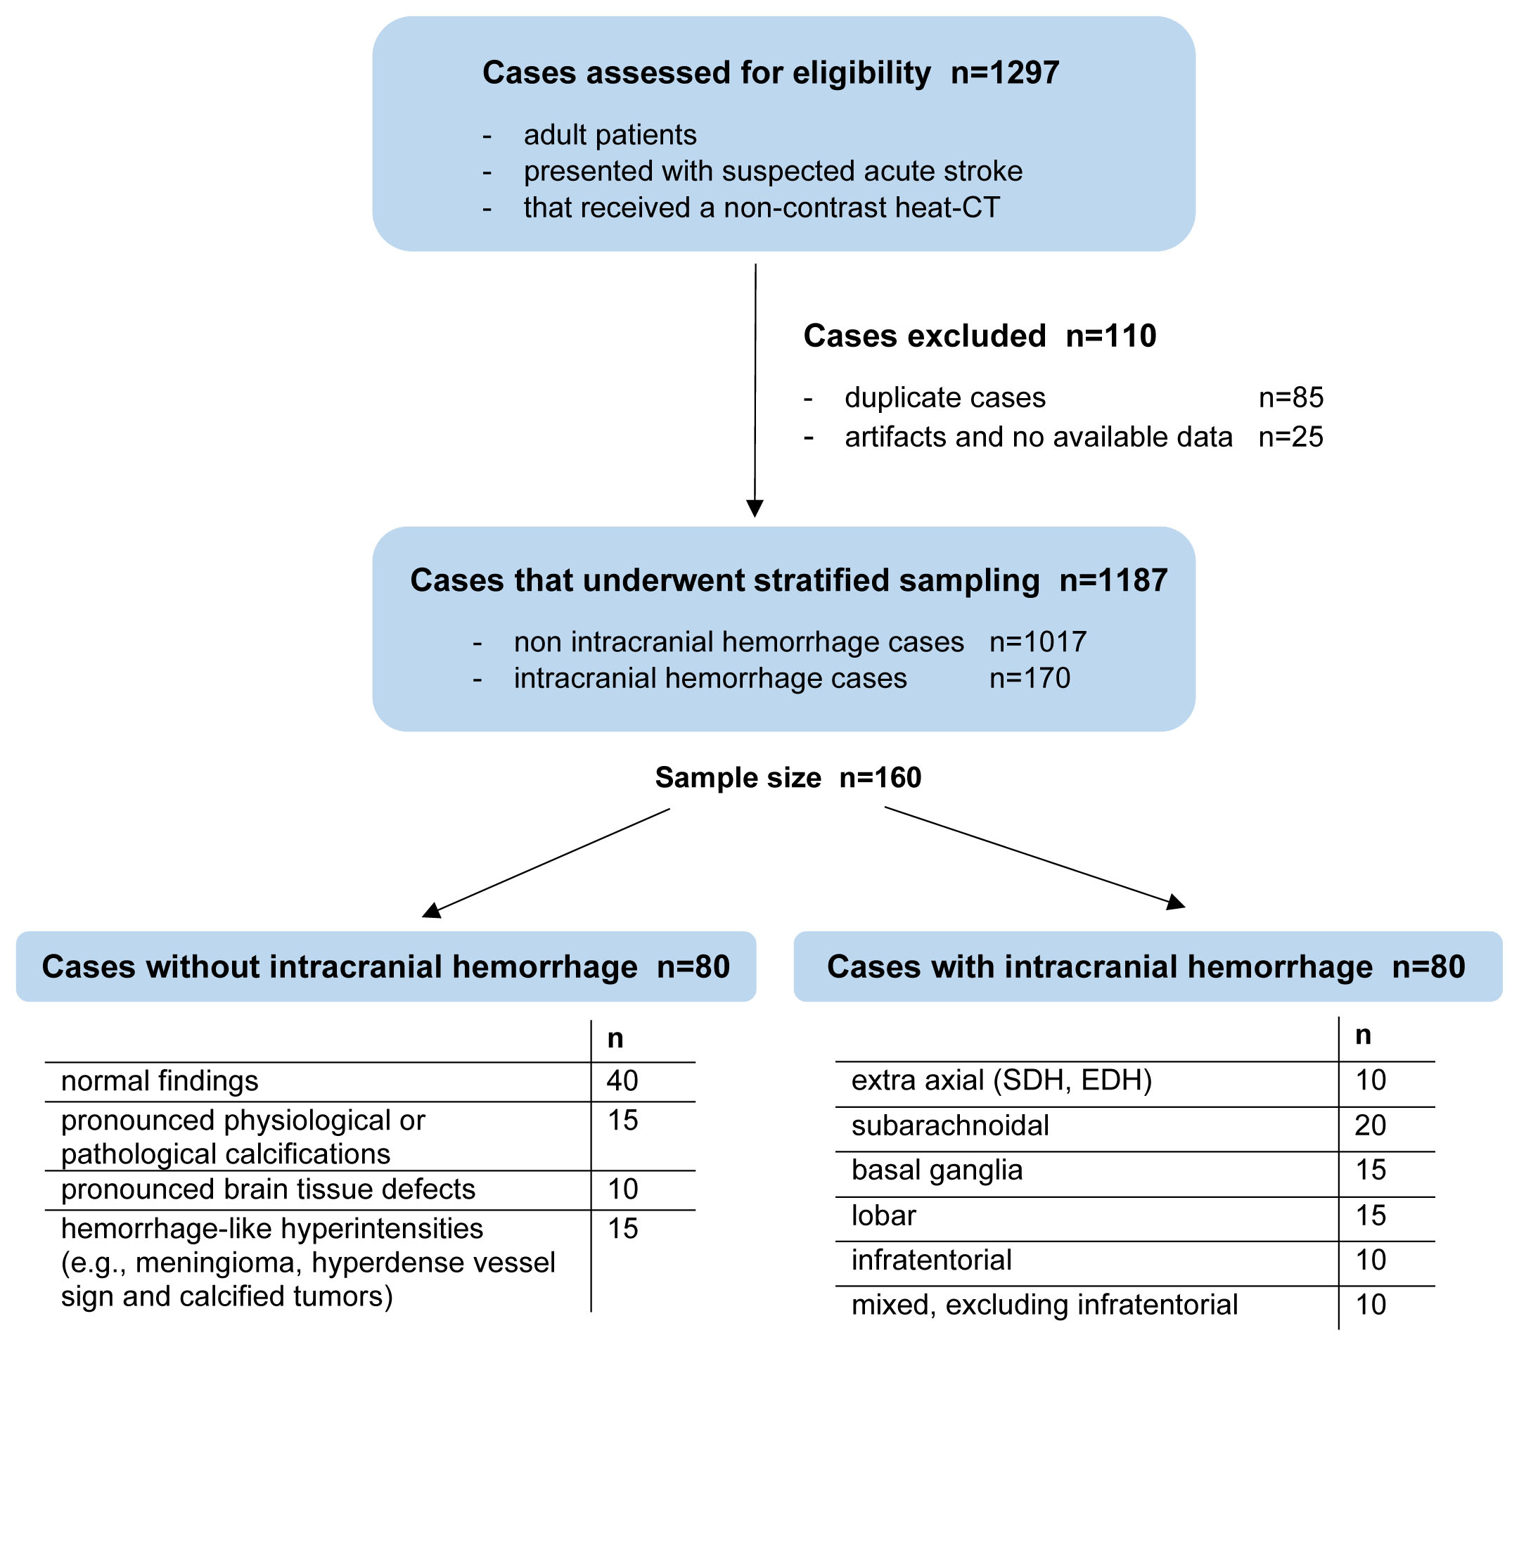
Flow chart summarizing the inclusion criteria and sampling process.
References
1 Hssayeni MD, Croock MS, Salman AD, Al-khafaji HF, Yahya ZA, Ghoraani B (2020) Intracranial Hemorrhage Segmentation Using a Deep Convolutional Model. Data 5:14

2 Yuh EL, Gean AD, Manley GT, Callen AL, Wintermark M (2008) Computer-Aided Assessment of Head Computed Tomography (CT) Studies in Patients with Suspected Traumatic Brain Injury. Journal of Neurotrauma 25:1163-1172

3 Prevedello LM, Erdal BS, Ryu JL et al (2017) Automated Critical Test Findings Identification and Online Notification System Using Artificial Intelligence in Imaging. Radiology 285:923-931

4 Jnawali K, Mohammad RA, Navalgund R, Alpen APMD (2018) Deep 3D convolution neural network for CT brain hemorrhage classificationProcSPIE,

5 Chilamkurthy S, Ghosh R, Tanamala S et al (2018) Deep learning algorithms for detection of critical findings in head CT scans: a retrospective study. The Lancet 392:2388-2396

6 Ye H, Gao F, Yin Y et al (2019) Precise diagnosis of intracranial hemorrhage and subtypes using a three-dimensional joint convolutional and recurrent neural network. Eur Radiol 29:6191-6201

7 Chang PD, Kuoy E, Grinband J et al (2018) Hybrid 3D/2D Convolutional Neural Network for Hemorrhage Evaluation on Head CT. American Journal of Neuroradiology 39:1609

8 Lee H, Yune S, Mansouri M et al (2019) An explainable deep-learning algorithm for the detection of acute intracranial haemorrhage from small datasets. Nature Biomedical Engineering 3:173-182

9 Mohammaden M, Pisani L, Camara CPd et al (2020) Abstract TP90: Advance: Automated Detection and Volumetric Assessment of Intracerebral Hemorrhage. Stroke 51:ATP90-ATP90

10 Barreira CM, Rahman HA, Bouslama M et al (2018) Advance study: automated detection and volumetric assessment of intracerebral hemorrhage. European Stroke Journal European Stroke Organisation Conference: Abstracts 3:3–204

11 Bhadauria HS, Dewal ML (2014) Intracranial hemorrhage detection using spatial fuzzy c-mean and region-based active contour on brain CT imaging. Signal, Image and Video Processing 8:357-364

12 Muschelli J, Sweeney EM, Ullman NL, Vespa P, Hanley DF, Crainiceanu CM (2017) PItcHPERFeCT: Primary Intracranial Hemorrhage Probability Estimation using Random Forests on CT. NeuroImage: Clinical 14:379-390

13 Kuang H, Menon BK, Qiu W (2019) Segmenting Hemorrhagic and Ischemic Infarct Simultaneously From Follow-Up Non-Contrast CT Images in Patients With Acute Ischemic Stroke. IEEE Access 7:39842-39851

