Supplementary material
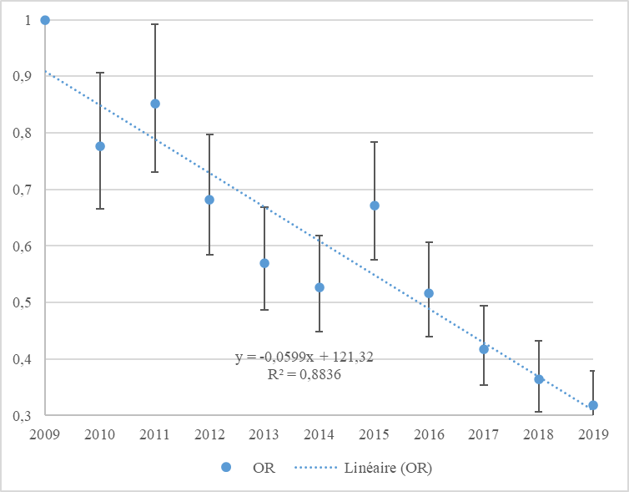
Figure S1: OR for recording a nonzero dose according to the year of exposure

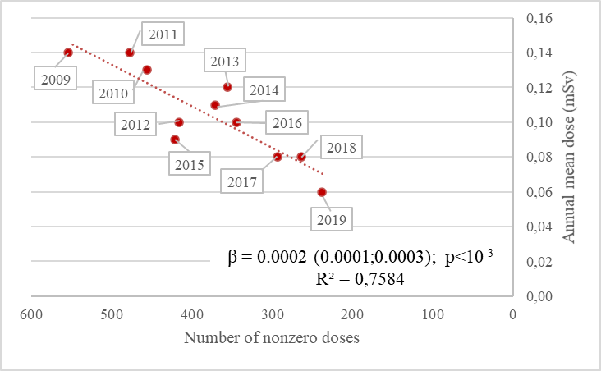
Figure S2: Relationship between AMD and the number of nonzero doses (with the corresponding year in label)

Table S1: Annual dose means for the 2009 to 2019 years (mean (95%CI) in mSv), cumulative dose mean over the 2009-2019 period (mean (±95%CI) in mSv), and relative change between 2009 and 2019 (%)
 |  | N | AMD 2009 | AMD 2010 | AMD 2011 | AMD 2012 | AMD 2013 | AMD 2014 | AMD 2015 | AMD 2016 | AMD 2017 | AMD 2018 | AMD 2019 | Cumulative dose over the 2009-2019 period (mSv) | Relative change between 2009-2019 AMD (%)
All workers |  | 1,457 | 0.14 (0.11;0.17) | 0.13 (0.11;0.15) | 0.14 (0.11;0.16) | 0.10 (0.08;0.12) | 0.11 (0.09;0.13) | 0.12 (0.08;0.15) | 0.09 (0.08;0.10) | 0.10 (0.07;0.12) | 0.08 (0.05;0.1) | 0.08 (0.05;0.11) | 0.06 (0.04;0.08) | 1.12 (0.95;1.30) | -58,5
 | By Medical department
 | Nuclear medicine | 112 | 0.33 (0.24;0.42) | 0.36 (0.26;0.47) | 0.35 (0.26;0.44) | 0.31 (0.22;0.40) | 0.36 (0.26;0.46) | 0.34 (0.23;0.44) | 0.35 (0.25;0.45) | 0.38 (0.27;0.49) | 0.41 (0.30;0.52) | 0.40 (0.29;0.52) | 0.33 (0.24;0.43) | 3.88 (2.94;4.83) | 1.6
 | Interventional radiology | 95 | 0.26 (0.16;0.37) | 0.25 (0.18;0.33) | 0.27 (0.21;0.32) | 0.19 (0.11;0.28) | 0.33 (0.10;0.55) | 0.20 (0.15;0.25) | 0.19 (0.14;0.24) | 0.26 (0.04;0.48) | 0.08 (0.00;0.16) | 0.07 (0.01;0.13) | 0.10 (0.01;0.19) | 2.20 (1.51;2.88) | -61.7
 | Cardiology | 113 | 0.19 (0.10;0.27) | 0.16 (0.06;0.26) | 0.22 (0.07;0.38) | 0.12 (0.04;0.19) | 0.13 (0.06;0.20) | 0.11 (0.04;0.18) | 0.08 (0.04;0.11) | 0.09 (0.03;0.15) | 0.05 (0.02;0.08) | 0.04 (0.02;0.06) | 0.03 (0.01;0.05) | 1.19 (0.67;1.72) | -81.8
 | Operating room | 58 | 0.11 (0.07;0.15) | 0.12 (0.07;0.17) | 0.11 (0.06;0.16) | 0.11 (0.07;0.16) | 0.14 (0.09;0.20) | 0.12 (0.07;0.17) | 0.06 (0.03;0.10) | 0.07 (0.02;0.11) | 0.02 (0.00;0.03) | 0.02 (0.00;0.03) | 0.02 (0.00;0.04) | 0.87 (0.61;1.13) | -84,0
 | Surgery | 370 | 0.11 (0.01;0.21) | 0.08 (0.05;0.11) | 0.07 (0.04;0.09) | 0.08 (0.03;0.12) | 0.06 (0.03;0.09) | 0.15 (0.01;0.29) | 0.05 (0.02;0.08) | 0.06 (0.02;0.11) | 0.07 (0.00;0.14) | 0.10 (0.00;0.21) | 0.04 (0.00;0.09) | 0.84 (0.36;1.33) | -67.9
 | Anesthetic and intensive care | 172 | 0.08 (0.05;0.11) | 0.14 (0.10;0.19) | 0.11 (0.07;0.15) | 0.03 (0.02;0.05) | 0.06 (0.03;0.09) | 0.04 (0.03;0.06) | 0.08 (0.05;0.11) | 0.07 (0.05;0.09) | 0.02 (0.01;0.03) | 0.02 (0.01;0.03) | 0.02 (0.01;0.03) | 0.65 (0.49;0.81) | -73.5
 | Conventional radiology | 335 | 0.12 (0.08;0.16) | 0.09 (0.06;0.12) | 0.10 (0.05;0.16) | 0.07 (0.05;0.09) | 0.06 (0.04;0.08) | 0.06 (0.04;0.09) | 0.06 (0.03;0.08) | 0.04 (0.02;0.06) | 0.04 (0.03;0.06) | 0.04 (0.03;0.06) | 0.02 (0.01;0.03) | 0.70 (0.51;0.89) | -81.8
 | Radiotherapy | 59 | 0.04 (0.02;0.07) | 0.05 (0.00;0.11) | 0.18 (0.00;0.49) | 0.02 (0.01;0.04) | 0.05 (0.03;0.07) | 0.02 (0.01;0.03) | 0.02 (0.00;0.04) | 0.01 (0.01;0.02) | 0.03 (0.00;0.07) | 0.02 (0.01;0.03) | 0.11 (0.00;0.26) | 0.55 (0.19;0.92) | 141.9
 | Pediatrics | 26 | 0.17 (0.00;0.47) | 0.13 (0.01;0.25) | 0.04 (0.00;0.09) | 0.01 (0.00;0.01) | 0.03 (0.00;0.05) | 0.05 (0.00;0.12) | 0.01 (0.00;0.03) | 0.00 (0.00;0.01) | 0 (0;0) | 0 (0;0) | 0 (0;0) | 0.44 (0.05;0.83) | -100,0
 | Other* | 85 | 0.12 (0.02;0.23) | 0.10 (0.00;0.23) | 0.08 (0.01;0.14) | 0.08 (0.00;0.18) | 0.07 (0.00;0.16) | 0.06 (0.00;0.15) | 0.06 (0.00;0.16) | 0.09 (0.00;0.23) | 0.07 (0.02;0.12) | 0.04 (0.02;0.07) | 0.04 (0.00;0.08) | 0.79 (0.00;1.64) | -66,0
 | unknown | 32 | 0.15 (0.07;0.23) | 0.27 (0.08;0.46) | 0.20 (0.08;0.31) | 0.13 (0.05;0.21) | 0.17 (0.07;0.28) | 0.12 (0.02;0.23) | 0.09 (0.03;0.15) | 0.11 (0.05;0.18) | 0.01 (0.00;0.02) | 0.01 (0.00;0.02) | 0.01 (0.00;0.02) | 1.26 (0.70;1.82) | -95.3
 | By Professions
 | Radiologic technologist | 414 | 0.18 (0.15;0.22) | 0.19 (0.15;0.22) | 0.21 (0.16;0.26) | 0.15 (0.12;0.18) | 0.16 (0.12;0.19) | 0.15 (0.12;0.19) | 0.14 (0.11;0.18) | 0.13 (0.09;0.16) | 0.13 (0.09;0.16) | 0.13 (0.09;0.16) | 0.12 (0.08;0.15) | 1.67 (1.36;1.97) | -37.5
 | Dentist | 42 | 0.15 (0.08;0.22) | 0.16 (0.08;0.23) | 0.09 (0.05;0.13) | 0.08 (0.02;0.13) | 0.16 (0.08;0.24) | 0.17 (0.07;0.27) | 0.12 (0.08;0.17) | 0.09 (0.04;0.15) | 0.02 (0.01;0.03) | 0.44 (0.00;1.30) | 0.01 (0.00;0.02) | 1.45 (0.49;2.42) | -93.4
 | Physician | 403 | 0.19 (0.09;0.29) | 0.15 (0.10;0.21) | 0.15 (0.09;0.20) | 0.12 (0.07;0.18) | 0.13 (0.07;0.20) | 0.16 (0.03;0.29) | 0.09 (0.05;0.13) | 0.14 (0.07;0.22) | 0.11 (0.04;0.19) | 0.09 (0.03;0.14) | 0.06 (0.01;0.11) | 1.37 (0.85;1.89) | -65.9
 | Pharmacist | 6 | 0.17 (0.00;0.47) | 0.17 (0.00;0.54) | 0.14 (0.00;0.39) | 0.01 (0.00;0.04) | 0.02 (0.00;0.06) | 0.01 (0.00;0.04) | 0.03 (0.00;0.10) | 0.05 (0.00;0.16) | 0.08 (0.00;0.30) | 0.11 (0.00;0.32) | 0.05 (0.00;0.18) | 0.82 (0.00;1.85) | -70.2
 | Caregiver | 92 | 0.10 (0.01;0.19) | 0.05 (0.00;0.09) | 0.13 (0.00;0.31) | 0.03 (0.01;0.05) | 0.04 (0.01;0.07) | 0.08 (0.00;0.22) | 0.03 (0.01;0.04) | 0.04 (0.02;0.06) | 0.03 (0.01;0.06) | 0.03 (0.01;0.05) | 0.03 (0.01;0.05) | 0.57 (0.29;0.86) | -72.6
 | Nurse | 437 | 0.07 (0.06;0.09) | 0.08 (0.06;0.1à) | 0.07 (0.05;0.09) | 0.05 (0.04;0.06) | 0.07 (0.05;0.08) | 0.06 (0.04;0.07) | 0.05 (0.04;0.07) | 0.05 (0.04;0.06) | 0.02 (0.01;0.02) | 0.01 (0.01;0.02) | 0.02 (0.01;0.02) | 0.53 (0.44;0.62) | -77,0
 | Engineer | 11 | 0.02 (0.00;0.05) | 0.02 (0.00;0.04) | 0.07 (0.00;0.21) | 0.11 (0.00;0.28) | 0.09 (0.00;0.22) | 0.04 (0.00;0.10) | 0.01 (0.00;0.03) | 0.03 (0.00;0.07) | 0.02 (0.00;0.05) | 0.02 (0.00;0.07) | 0.01 (0.00;0.03) | 0.42 (0.00;0.87) | -45.8
 | Technician | 38 | 0.11 (0.05;0.17) | 0.04 (0.01;0.07) | 0.05 (0.01;0.09) | 0.03 (0.00;0.05) | 0.01 (0.00;0.01) | 0.05 (0.00;0.13) | 0.02 (0.00;0.05) | 0.02 (0.00;0.04) | 0.01 (0.00;0.03) | 0.01 (0.00;0.02) | 0.05 (0.00;0.12) | 0.38 (0.17;0.59) | -59.3
 | unknown | 14 | 0.19 (0.02;0.36) | 0.46 (0.05;0.86) | 0.27 (0.07;0.47) | 0.13 (0.02;0.23) | 0.23 (0.02;0.44) | 0.12 (0.00;0.26) | 0.16 (0.04;0.28) | 0.21 (0.07;0.35) | 0.02 (0.00;0.04) | 0.02 (0.00;0.04) | 0.02 (0.00;0.04) | 1.81 (0.76;2.86) | -91.3
 | By gender
 | Men | 601 | 0.19 (0.12;0.26) | 0.16 (0.12;0.20) | 0.17 (0.12;0.22) | 0.12 (0.08;0.16) | 0.12 (0.09;0.16) | 0.16 (0.08;0.25) | 0.11 (0.08;0.14) | 0.14 (0.09;0.19) | 0.10 (0.05;0.15) | 0.08 (0.05;0.12) | 0.06 (0.03;0.10) | 1.40 (1.03;1.77) | -67.3
 | Women | 856 | 0.11 (0.09;0.13) | 0.11 (0.10;0.13) | 0.12 (0.09;0.14) | 0.08 (0.07;0.10) | 0.10 (0.07;0.13) | 0.08 (0.07;0.10) | 0.08 (0.06;0.09) | 0.07 (0.05;0.09) | 0.06 (0.04;0.08) | 0.08 (0.03;0.12) | 0.06 (0.04;0.08) | 0.93 (0.79;1.08) | -47.9
 | By age at inclusion
 | 1st quartile (≤33 y.o.) ^{b} | 381 | 0.16 (0.12;0.20) | 0.15 (0.11;0.18) | 0.15 (0.09;0.21) | 0.11 (0.08;0.14) | 0.11 (0.08;0.14) | 0.11 (0.08;0.14) | 0.10 (0.07;0.13) | 0.09 (0.06;0.12) | 0.09 (0.06;0.12) | 0.07 (0.05;0.10) | 0.09 (0.05;0.12) | 1.18 (0.93;1.43) | -44.7
 | 2nd quartile ]33;40 y.o.] | 368 | 0.12 (0.09;0.14) | 0.13 (0.10;0.16) | 0.16 (0.10;0.21) | 0.08 (0.06;0.10) | 0.09 (0.07;0.12) | 0.10 (0.07;0.13) | 0.09 (0.07;0.11) | 0.11 (0.05;0.18) | 0.09 (0.01;0.16) | 0.12 (0.01;0.23) | 0.07 (0.01;0.12) | 1.13 (0.81;1.45) | -42.7
 | 3rd quartile ]40;47 y.o.] | 353 | 0.13 (0.09;0.16) | 0.15 (0.10;0.20) | 0.11 (0.07;0.16) | 0.10 (0.06;0.13) | 0.12 (0.06;0.18) | 0.09 (0.05;0.14) | 0.08 (0.05;0.11) | 0.09 (0.05;0.13) | 0.06 (0.04;0.09) | 0.06 (0.03;0.09) | 0.05 (0.03;0.07) | 1.01 (0.71;1.32) | -62,0
 | 4th quartile (>47 y.o.) | 354 | 0.17 (0.06;0.28) | 0.11 (0.07;0.15) | 0.13 (0.08;0.18) | 0.11 (0.06;0.16) | 0.12 (0.07;0.18) | 0.17 (0.03;0.31) | 0.09 (0.05;0.13) | 0.11 (0.06;0.15) | 0.07 (0.04;0.10) | 0.06 (0.03;0.09) | 0.03 (0.01;0.05) | 1.17 (0.67;1.66) | -80.4

Table S2: Description of radiation exposure in the EXPERTS study, according to medical activities following the UNSCEAR classification
 |  | N workers | OM (mSv) in the whole population  over the 2009-2019 period |  |  |  |  | OM (mSv) in the non0 subpopulation  over the 2009-2019 period
 |  | N workers | N doses | Mean (95% CI) | P75 | Max | pª | N^{b} (%) nonzero doses | Mean (95% CI) | P75 | Max | pª
 | By Medical activity |  |  |  |  |  | <.001 |  |  |  |  | <.001
 | Nuclear medicine | 112 | 1221 | 0.36 (0.33;0.39) | 0.59 | 2.82 |  | 647 (53) | 0.67 (0.63;0.72) | 1.03 | 2.82
 | Interventional radiology | 604 | 6550 | 0.10 (0.09;0.12) | 0.05 | 24.74 |  | 1,655 (25) | 0.40 (0.35;0.46) | 0.35 | 24.74
 | Operating room | 58 | 624 | 0.08 (0.07;0.09) | 0.10 | 1.15 |  | 207 (33) | 0.24 (0.22;0.27) | 0.32 | 1.15
 | Conventional radiology | 335 | 3646 | 0.06 (0.06;0.07) | 0.00 | 8.00 |  | 795 (22) | 0.29 (0.26;0.33) | 0.28 | 8.00
 | Radiotherapy | 59 | 641 | 0.05 (0.02;0.08) | 0.00 | 8.97 |  | 141 (22) | 0.23 (0.09;0.37) | 0.16 | 8.97
 | Other* | 85 | 911 | 0.07 (0.05;0.10) | 0.00 | 5.90 |  | 199 (22) | 0.34 (0.22;0.46) | 0.23 | 5.90
 | unknown | 32 | 350 | 0.12 (0.09;0.14) | 0.12 | 2.60 |  | 125 (36) | 0.32 (0.26;0.38) | 0.44 | 2.60
ª p-value for the F-test following an ANOVA for comparisons of means between covariate classes; ^{b} raw percentage as compared to the total number of doses; *Other: gynecology, physical rehabilitation, ENT, pneumology, anatomopathology, pharmacy, Emergency Medical Service (EMS), ambulatory, administrative, radiation protection, endocrinology, rheumatology, neurology, laboratory, maintenance-logistics; y.o.: years old; SD: standard deviation; P75: 75th percentile

Table S3: Trends in AMD and OR for the recording of a nonzero dose in the EXPERTS study over the 2009-2019 period, according to the medical activity following the UNSCEAR classification
 |  | Whole population |  |  |  |  | Non0 subpopulation
 |  | N | βª (95% CI) | R² | OR^{b} (95% CI) | p_{interaction}^{c} | βª (95% CI) | R²
 | By Medical activity |  |  |  |  | <10⁻³
 | Operating room | 58 | -0.012 (-0.018;-0.006) | 0.71 | 0.82 (0.78;0.87) |  | -0.013 (-0.023;-0.003) | 0.47
 | Interventional radiology | 604 | -0.009 (-0.013;-0.005) | 0.71 | 0.87 (0.85;0.88) |  | 0.012 (-0.01;0.034) | 0.14
 | Conventional radiology | 335 | -0.008 (-0.011;-0.006) | 0.88 | 0.94 (0.91;0.96) |  | -0.023 (-0.037;-0.009) | 0.60
 | Radiotherapy | 59 | 0.003 (-0.014;0.008) | 0.04 | 0.93 (0.87;0.99) |  | -0.002 (-0.045;0.040) | 0.00
 | Nuclear medicine | 112 | 0.005 (-0.002;0.011) | 0.24 | 1.00 (0.96;1.03) |  | 0.008 (-0.005;0.021) | 0.17
 | Other* | 85 | -0.006 (-0.009;-0.003) | 0.67 | 0.91 (0.87;0.96) |  | -0.004 (-0.028;0.020) | 0.02
 | unknown | 32 | -0.022 (-0.031;-0.013) | 0.77 | 0.80 (0.74;0.86) |  | -0.034 (-0.054;-0.014) | 0.62
ª Slope of the linear trend line from the AMD of Hp(10) doses; ^{b} Odds ratio (95% confidence interval) for the recording of a nonzero dose in relation to a 1-year increase of exposure; ^{c} p-value for the interaction test between the year of exposure and the socio-professional covariates; *Other : gynecology, physical rehabilitation, ENT, pneumology, anatomopathology, pharmacy, Emergency Medical Service (EMS), ambulatory, administrative, radiation protection, endocrinology, rheumatology, neurology, laboratory, maintenance-logistics; in bold are statistically significant results

