Supplementary Material
Supplementary Table 1. Details of malignant findings.
Primary tumors (n=11; n=10 would have been undetected without WB-MRI)
Tumor type | Location | Number | Histologically confirmed | In previous radiation  field | Symptomatic or known from an examination other than MRI screening
Angiosarcoma | Gluteal muscle | 1 | Yes | Yes | Yes
Adenoid cystic carcinoma | Lacrimal gland | 1 | Yes | No | No
Breast cancer | Right mamma | 2 | Yes | No | No
Leiomyosarcoma | - Retroperitoneal (n=2)  - Small pelvis (n=1) | 3 | Yes | No | No
Low-grade glioma | Frontal lobe (n=2) | 2 | No | No | No
Pancreatic cancer | Pancreatic tail | 1 | Yes | No | No
Pleomorphic sarcoma | Quadriceps muscle | 1 | Yes | Yes | No
Metastases (n=27; n=22 would have been undetected without WB-MRI)
Organ | Exact location | Number | Histologically confirmed | In previous radiation  field | Symptomatic or known from an examination other than MRI screening
Bone | - 7th thoracic vertebra (n=1)  - 9th thoracic vertebra (n=1)  - 1st lumbar vertebra (n=1)  - Os ilium (n=1) | 4 | No | No | No
Lymph nodes | - Axillary (n=1)  - Subpectoral (n=2)  - Retroperitoneal (n=3)  - Small pelvis (n=3) | 9 | Subpectoral: yes (n=1)  Others: No | No | Axillary: yes (n=1)  Others: no
Lung | - Lower lobe of left lung (n=1)  - Lower lobe of right lung (n=1) | 2 | No | No | Yes
Liver | - Segment VII (n=2)  - Segment II (n=1) | 3 | No | No | Segment VII: Yes (n=1)  Others: No (n=2)
Brain | - Temporal lobe (n=2)  - Cerebellum (n=1) | 3 | No | No | No
Fatty tissue | Paracolic gutter | 1 | No | No | Yes
Skin | - Frontal scalp (n=2)  - Gluteal (n=2) | 4 | No | No | No
Muscle | - 11th intercostal space left | 1 | No | No | No

Supplementary Table 2. Sensitivities for all lesions including benign lesions, calculated from ratings in the reader evaluation, a) of individual sequences, b) of the five best performing combinations of two sequences and c) of the five best performing combinations of three sequences.
Sequence names | Reader 1 | Reader 2 | Reader 3 | Avg
- Individual sequences
FLAIR (head only) | 92.9 [62.5;99.0] | 94.4 [73.7;99.0] | 100.0 [100.0;100.0] | 95.8
DWI | 86.7 [81.2;90.8] | 70.2 [63.1;76.5] | 77.5 [71.0;83.0] | 78.2
TIRM | 73.9 [65.3;81.1] | 63.8 [56.9;70.2] | 71.8 [64.2;78.4] | 69.9
T1CE | 79.3 [71.8;85.2] | 61.7 [53.5;69.3] | 67.0 [57.4;75.4] | 69.3
HASTE | 76.6 [68.7;83.0] | 59.0 [52.4;65.3] | 69.0 [62.5;74.8] | 68.2
T1noCE | 60.6 [52.6;68.1] | 46.8 [39.6;54.2] | 62.2 [54.8;69.1] | 56.6
T1cor | 50.5 [41.9;59.2] | 34.6 [27.9;41.9] | 46.3 [39.0;53.8] | 43.8
- Combinations of two sequences
DWI.T1CE | 96.3 [92.8;98.1] | 86.7 [81.0;90.9] | 91.4 [86.8;94.6] | 91.5
DWI.TIRM | 92.6 [87.3;95.7] | 89.9 [85.1;93.3] | 90.9 [85.8;94.3] | 91.1
DWI.HASTE | 93.6 [89.3;96.3] | 86.2 [80.7;90.3] | 88.8 [83.7;92.4] | 89.5
T1CE.HASTE | 92.0 [86.5;95.4] | 80.9 [74.5;85.9] | 88.2 [83.0;92.0] | 87.0
T1CE.TIRM | 89.4 [83.2;93.5] | 80.9 [74.2;86.1] | 89.4 [82.6;93.7] | 86.5
- Combinations of three sequences
 | Reader 1 | Reader 2 | Reader 3 | Avg
DWI.T1CE.TIRM | 97.3 [93.8;98.9] | 94.1 [90.0;96.6] | 96.3 [91.6;98.4] | 95.9
DWI.T1CE.HASTE | 97.9 [94.7;99.2] | 94.1 [89.9;96.7] | 94.7 [90.8;96.9] | 95.6
DWI.T1CE.FLAIR | 99.5 [96.4;99.9] | 89.9 [84.2;93.7] | 94.7 [90.0;97.2] | 94.7
DWI.TIRM.HASTE | 95.2 [90.8;97.6] | 94.7 [90.3;97.1] | 94.1 [89.3;96.8] | 94.7
DWI.TIRM.FLAIR | 95.2 [91.0;97.5] | 93.6 [89.2;96.3] | 93.6 [88.8;96.4] | 94.1
FLAIR = fluid-attenuated inversion recovery, DWI = diffusion-weighted imaging with b-value 900, TIRM = turbo-inversion recovery-magnitude, T1CE = contrast-enhanced T1 VIBE Dixon, HASTE = half Fourier-acquisition single-shot turbo spin echo, T1noCE = T1 VIBE Dixon without contrast agent, T1cor = T1 TSE in coronal plane

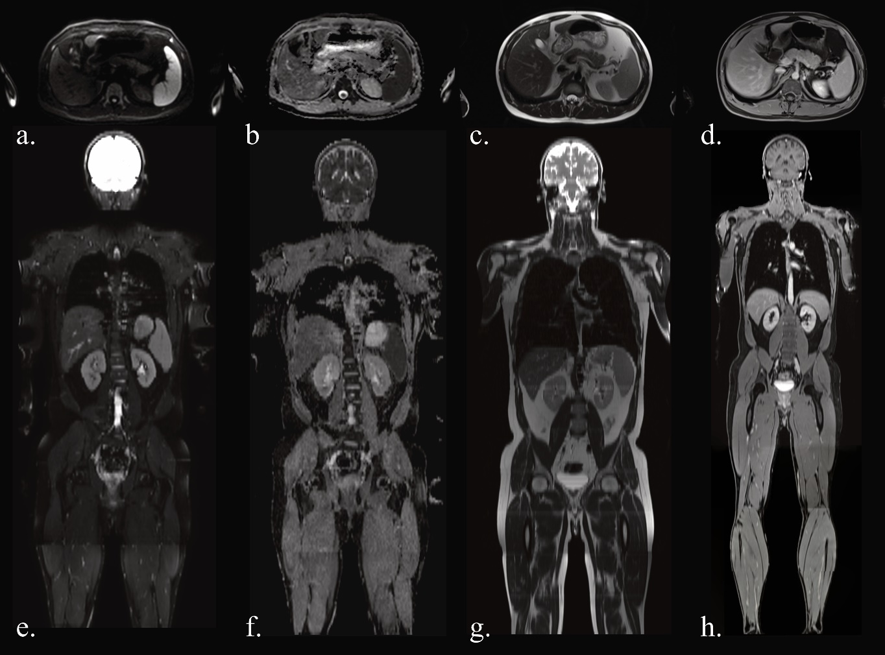
Supplementary Figure 1. Examples of uncropped images: DWI at b-value 900 (axial reconstruction: a, coronal reconstruction: e), ADC map (axial: b, coronal: f), HASTE (axial: c, coronal: g) and T1 VIBE Dixon water-only image after contrast agent administration (axial: d, coronal: h). Although the assessment of the upper extremities is limited due to partial coverage and artifacts, the clinical impact of this is likely limited.

