Genetic and biometric patterns of rangewide divergence of iconic, Neogene relic broadleaved shrub species Staphylea pinnata L. – post-glacial expansion and human impact
Piechnik L, Łabiszak B, Cieślak E, Szczepański S, Kurek P, Novikov A, Rosati L, Dönmez AA, Dering M, Wójcik T, Wiatrowska B, Żywiec M, Wachowiak W
Vegetation History and Archaeobotany
Electronic supplementary material

Polymorphism screening and marker development
For the initial screening of DNA polymorphism in European bladdernut Staphylea pinnata L. we selected 32 individuals across the species range to ensure the maximum polymorphism. In particular, we chose samples from Romania (RO_1, RO_2, RO_4), Switzerland (CH_01, CH_03), Italy (IT_01, IT_03, IT_04 x 2, IT_05), Czechia (CZ_06 x 2), Slovakia (SK_01, SK_04), Croatia (HR_01), Georgia (GE_01, GE_03), Türkiye (TR_03), Poland (PL_01 x 2, PL_02, PL_08, PL_12, PL_13, PL_17, PL_18), Bulgaria (BG_01), Montenegro (MN_02), Greece (GR_01), Serbia (RS_01), Northern Macedonia (MK_01), Austria (AT_01). Genomic DNA was extracted from the leaves using Genomic Mini AX Plant extraction kit (A&A Biotechnology, Poland). The quantity of DNA was measured by Qubit 4 fluorometer, using the Broad Range (BR) Assay Kit and DNA was diluted to the working concentration of 40 ng/µl.
We screened several regions in the chloroplast genome, with known polymorphism in other species and also the ITS region (see Table S1). We carried the PCR amplification of the 16regions using PCR reaction mixture: 1µl of Solis Biodyne HOT FIREPol® Blend Master Mix (5x) polymerase, 5 µM of each primer, 3 µl of Milli-Q water and 1 µl of sample DNA (40 ng/µl). The PCRs included the following steps: initial denaturation (95°C, 15 min), 32 cycles of denaturation (95°C, 30 s), annealing (60°C, 1:30 min), extension (72°C, 1:30 min) and final extension (72°C, 10 min). The resulting PCR fragments of all 16 regions were purified using Exonuclease I-Shrimp Alkaline Phosphatase enzymatic treatment. About 20 ng of PCR product was used as a template in 10 µl sequencing reactions with the Big Dye Terminator DNA Sequencing Kit (Applied Biosystems) performed by Molecular Biology Techniques Laboratory, AMU (Poznań, Poland). CODONCODE ALIGNER (Codon Code Corporation) was used to edit and align sequences to find polymorphism. From the initial set of 18 regions, only four regions were found to be polymorphic (three cpDNA and one nDNA) and the total number of SNPs was nine (see Table S2). This set was subsequently used for creating SNaPshot assay.

List of regions used in initial screening of European Staphylea pinnata genetic diversity
# | region name | Primer forward | Primer reverse | Reference
1 | atpB - rbcL | CRGGTTGAGGAGTTACTCG | GACCRGAAGTAGTAGGATT | Chung et al., 2006
2 | petL – psbE | AGTAGAAAACCGAAATAACTAGTTA | TATCGAATACTGGTAATAATATCAGC | Shaw et al., 2007
3 | psbA - trnH^{GUG} | GTTATGCATATGAACGTAATGCTC | CGCGCATGGTGGATTCACAATCC | Shaw et al., 2007
4 | psbD - trnT^{GGU} | CTCCGTARCCAGTCATCCATA | CCCTTTTAACTCAGTGGTAG | Shaw et al., 2007
5 | rpl32F - trnL^{UAG} | CAGTTCCAAAAAAACGTACTTC | CTGCTTCCTAAGAGCAGCGT | Shaw et al., 2007
6 | rps16x2F2 - trnK^{UUU}x1 | AAGTGGGTTTTTATGATCC | TTAAAAGCCCGAGTACTCTACC | Shaw et al., 2007
7 | trnH^{GUG}  trnK^{UUU}x1 | CGCGCATGGTGGATTCACAATCC  - | -  TTAAAAGCCGAGTACTCTACC | Shaw et al., 2005  Shaw et al., 2007
8 | trnL-trnF^{GAA} | CGAAATCGGTAGACGCTACG | ATTTGAACTGGTGACACGAG | Taberlet et al., 1991
9 | trnS^{UGA} -trnfM^{CAU} | GAGAGAGAGGGATTCGAACC | CATAACCTTGAGGTCACGGG | Shaw et al., 2005
10 | trnS^{GCU}  trnG^{UUC} | AGATAGGGATTCGAACCCTCGGT  - | -  GAATCGAACCCGCATCGTTAG | Shaw et al., 2005  Shaw et al., 2007
11 | trnQ^{UUG} – rps16x1 | GCGTGGCCAAGYGGTAAGGC | GTTGCTTTYTACCACATCGTTT | Shaw et al., 2007
12 | ITSA  ITS4 | GGAAGGAGAAGTCGTAACAAGG  - | -  TCCTCCGCTTATTGATATGC | Blattner, 1990  White et al., 1990
13 | trnL-c- trnL-d | CGAAATCGGTAGACGCTACG | GGGGATAGAGGGACTTGAAC | Taberlet et al., 1991
14 | rpl20 - rps12 | TTTGTTCTACGTCTCCGAGC | GTCGAGGAACATGTACTAGG | (Hamilton, 1999)
15 | rpl32 - trnL | CAGTTCCAAAAAAACGTACTTC | CTGCTTCCTAAGAGCAGCGT | (Shaw et al., 2007)
16 | ndhF - rpl32 | GAA AGG TAT KAT CCA YGM ATA TT | CCAATATCCCTTYYTTTTCCAA | (Shaw et al., 2007)

List of regions found to be polymorphic in initial screening test and used in subsequent SNaPshot development
Marker | Reference region | Origin | Variant position | SNP variant | SNaPshot primer | Length | Sequence | Position in SNaPshot
M3_1 | trnS-trnGª | cpDNA | 239 | [G/A] | 3_trnS_1sF | 44 | CAGCAATTCAAAATCCATTTATATT  TATAATTTATATAACTAAA | 4
M3_2 | trnS-trnGª | cpDNA | 725 | [A/C] | 3_trnS _2sF | 58 | TCTTTTCCTAATCTCATTAGGTCTCC  TAACCAAGCACGTCAATTCTCTAATT  TTCATG | 6
M5_1 | rpl32-trnL^{b} | cpDNA | 512 | [A/C] | 5_rpl32_1sF | 37 | ATACAAGGTTTCACTTGTTTTTTAAT  ATGTTTTATTT | 3
M5_2 | rpl32-trnL^{b} | cpDNA | 664 | [T/G] | 5_rpl32_2sF | 65 | TCATACTAGAGAATTTGTAGTCAAA  ATAAATGGGCCGTAGAAACTAGTTG  ATTAAGCTTAAAATT | 7
M5_4 | rpl32-trnL^{b} | cpDNA | 1064 | [T/C] | 5_rpl32_4sF | 82 | TAAAGTAAAATTAACTAAAACAAAT  CCCCTATTTAATTTATATTTTTTTATT  CATCATTTGAATCTTTCCTAAAAAAT  ATTG | 9
M9_1 | psbD-trnT^{GGU b} | cpDNA | 507 | [A/C] | 9_psbD_1sF | 30 | ATATATTTAAATCTTTTATAGAGATA  AATT | 2
M9_2 | psbD-trnT^{GGU b} | cpDNA | 608 | [A/C] | 9_psbD_2sF | 51 | TGGTGTGACTTGGAATAAACGTCTCT  CCGCGGAGGAACGAAATATTAATTT | 5
M9_3 | psbD-trnT^{GGU b} | cpDNA | 644 | [T/A] | 9_psbD_3sF | 23 | GTCAAATCTAGGAATAAGAAGAT | 1
M15_1 | ITSA-ITS4^{c} | nDNA | 354 | [T/C] | 15_ITSA_1sF | 75 | TGAAATCGCCCCAAGGAAATTCAAAT  GTAGACCTTGCTCCCTTTGTCCCGGAA  ACGGTGTGCGTGGGAAGCAATG | 8
ª Hamilton (1999) primers: F – GCCGCTTTAGTCCACTCAGC, R – GAACGAATCACACTTTTACCAC;
^{b} 1 Shaw et al. (2007) rpl32-trnL primers: F- CAGTTCCAAAAAAACGTACTTC, R – CTGCTTCCTAAGAGCAGCGT; psbD-trnTGGU primers: F CTCCGTARCCAGTCATCCATA, R: CCCTTTTAACTCAGTGGTAG;
^{c} Blattner (1990) and White et al. (1990) primers: F – GGAAGGAGAAGTCGTAACAAGG, R – TCCTCCGCTTATTGATATGC
SNaPshot assay development and genotyping
The SNaPshot method involves amplifying and purifying the DNA amplicons before using a specific primer to target a sequence next to the SNP site. We followed the method for SNaPshot assay development for our four regions according to Szczepański et al. (2023). Briefly, after amplifying the target regions in a PCR multiplex (using the conditions described above), we purified the PCR products using exonuclease I and phosphatase enzymes. Then, the SNaPshot reaction was carried out according to SNaPshot™ Multiplex Kit protocol with specific primers differing in length and designed to extend by a single base at each targeted SNP marker position, using fluorescently labeled dideoxynucleotides (see Table S2 for SNaPshot primer length and sequences). After final purification step with phosphatase solution (0.25 µl phosphatase (1 U/µl), 2.25 µl Milli-Q water) to ensure the removal of unincorporated fluorescent nucleotides, the capillary electrophoresis was carried out on the ABI Prism 3130XL Genetic Analyser (Applied Biosystems, Foster City, CA, USA) in Molecular Biology Techniques Laboratory, AMU (Poznań, Poland). The chromatograms, reflecting the primer size used in the SNaPshot assay and extended by a labeled base (targeted SNP), were viewed and analyzed in Peak Scanner™ Software v1.0. We genotyped all 979 individuals of Staphylea pinnata, scored them and stored individual genotypes initially in Excel spreadsheets.
Filtering the genotypes and quality control
The overall level of missing data was 15%. However, missing genotypes mainly drove this at one marker per individual and no locus showed a level of missing data < 5%. To ensure proper analysis of the haplotypes network, which does not allow for any missing data to be present, we decided to remove only individuals with more than two missing loci due to the imputation of the missing data at remaining positions. The imputation was done by replacing the missing SNP at a given position with the median value within the population. Our refined set used throughout the genetic analysis was 938 individuals.
Dating the divergence of haplotypes
To indicate the timing of the split between two bladdernut lineages, we calculated the divergence time between two major haplotypes found within our samples (H1 and H3). We used sequenced data of the whole chloroplast of two individuals from Poland, representing those two haplotypes (Łabiszak et al., unpublished data). We estimated the minimum divergence time of those haplotypes using the formula
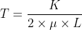 , where
T – divergence time,
K – number of substitutions,
µ – mutation rate,
L – genome length.
In our case, the number of substitutions was equal to 5 (one of them being mutation A/T in marker M3_1), and the mutation rate of chloroplast was set based on the described mutation rate in the angiosperm chloroplast in the range of 0.5–1 × 10⁻⁹ per site per year and the length of chloroplast was 160551 bp. The resulting divergence time was in the range 15 571 – 31 142 years. Since the casual mutation must have been already present within much more diverged populations (e.g., from Poland and Italy), our dating is, in fact, informative about the lower bound of this divergence, and it is more than likely that the exact divergence between those lineages is more ancient.

Table S1 Haplotypes composition and frequency across all sampled individuals
Marker | M9_3 | M9_1 | M5_1 | M3_1 | M9_2 | M3_2 | M5_2 | M5_4 | Frequency %
H1 | T | A | A | A | A | A | T | T | 62.69
H3 | T | A | A | G | A | A | T | T | 34.00
H6 | A | A | C | A | C | A | G | C | 1.28
H4 | T | A | C | A | A | A | G | C | 1.17
H2 | T | A | A | A | A | C | T | T | 0.43
H5 | A | A | A | A | C | A | T | T | 0.43

Table S2 Frequency of haplotypes and diversity in nDNA ITS region across Staphylea pinnata range
Pop. | H1 | H2 | H3 | H4 | H5 | H6 | ITS  TC | ITS  TT | ITS  CC | Pop. | H1 | H2 | H3 | H4 | H5 | H6 | ITS  TC | ITS  TT | ITS  CC
AT_01 | 0 | 0 | 1 | 0 | 0 | 0 | 0 | 0 | 1 | PL_09 | 1 | 0 | 0 | 0 | 0 | 0 | 0 | 0.33 | 0.67
AT_02 | 1 | 0 | 0 | 0 | 0 | 0 | 1 | 0 | 0 | PL_10 | 1 | 0 | 0 | 0 | 0 | 0 | 1 | 0 | 0
BG_01 | 1 | 0 | 0 | 0 | 0 | 0 | 0.64 | 0 | 0.36 | PL_11 | 1 | 0 | 0 | 0 | 0 | 0 | 0.2 | 0 | 0.8
BA_01 | 1 | 0 | 0 | 0 | 0 | 0 | 0.2 | 0 | 0.8 | PL_12 | 1 | 0 | 0 | 0 | 0 | 0 | 0.13 | 0 | 0.87
HR_01 | 0 | 0 | 1 | 0 | 0 | 0 | 0.13 | 0.2 | 0.67 | PL_13 | 0 | 0 | 1 | 0 | 0 | 0 | 0.2 | 0.13 | 0.67
HR_02 | 0.92 | 0 | 0.08 | 0 | 0 | 0 | 0.15 | 0 | 0.85 | PL_14 | 1 | 0 | 0 | 0 | 0 | 0 | 1 | 0 | 0
HR_03 | 1 | 0 | 0 | 0 | 0 | 0 | 0.87 | 0 | 0.13 | PL_15 | 1 | 0 | 0 | 0 | 0 | 0 | 0.93 | 0 | 0.07
CZ_01 | 0 | 0 | 1 | 0 | 0 | 0 | 0 | 0 | 1 | PL_16 | 1 | 0 | 0 | 0 | 0 | 0 | 0.93 | 0 | 0.07
CZ_02 | 0 | 0 | 1 | 0 | 0 | 0 | 0 | 0 | 1 | PL_17 | 0 | 0 | 1 | 0 | 0 | 0 | 0 | 0 | 1
CZ_03 | 0 | 0 | 1 | 0 | 0 | 0 | 0.07 | 0.13 | 0.8 | PL_18 | 0.93 | 0 | 0.07 | 0 | 0 | 0 | 0 | 0.13 | 0.87
CZ_04 | 0.83 | 0 | 0.17 | 0 | 0 | 0 | 0.33 | 0 | 0.67 | PL_19 | 1 | 0 | 0 | 0 | 0 | 0 | 0 | 0 | 1
CZ_05 | 0 | 0 | 1 | 0 | 0 | 0 | 0 | 0 | 1 | PL_20 | 1 | 0 | 0 | 0 | 0 | 0 | 0 | 0.17 | 0.83
CZ_06 | 0 | 0 | 1 | 0 | 0 | 0 | 0.2 | 0 | 0.8 | PL_21 | 1 | 0 | 0 | 0 | 0 | 0 | 0.6 | 0 | 0.4
CZ_07 | 1 | 0 | 0 | 0 | 0 | 0 | 0 | 0 | 1 | PL_22 | 1 | 0 | 0 | 0 | 0 | 0 | 0 | 0 | 1
CZ_08 | 0 | 0 | 1 | 0 | 0 | 0 | 0.3 | 0 | 0.7 | PL_23 | 1 | 0 | 0 | 0 | 0 | 0 | 0.1 | 0.1 | 0.8
DE_01 | 0 | 0 | 1 | 0 | 0 | 0 | 0 | 0 | 1 | PL_25a | 1 | 0 | 0 | 0 | 0 | 0 | 0 | 0 | 1
DE_02 | 0 | 0 | 1 | 0 | 0 | 0 | 0 | 0 | 1 | PL_25b | 0 | 0 | 1 | 0 | 0 | 0 | 0.6 | 0 | 0.4
DE_03 | 1 | 0 | 0 | 0 | 0 | 0 | 0 | 0 | 1 | PL_26 | 0.91 | 0 | 0.09 | 0 | 0 | 0 | 0.18 | 0 | 0.82
DE_04 | 0.47 | 0 | 0.53 | 0 | 0 | 0 | 0 | 0 | 1 | RO_1 | 1 | 0 | 0 | 0 | 0 | 0 | 0.43 | 0 | 0.57
FR_01 | 1 | 0 | 0 | 0 | 0 | 0 | 0 | 0 | 1 | RO_2 | 1 | 0 | 0 | 0 | 0 | 0 | 1 | 0 | 0
FR_02 | 1 | 0 | 0 | 0 | 0 | 0 | 0 | 0 | 1 | RO_3 | 1 | 0 | 0 | 0 | 0 | 0 | 1 | 0 | 0
GE_01 | 1 | 0 | 0 | 0 | 0 | 0 | 0 | 1 | 0 | RO_4 | 1 | 0 | 0 | 0 | 0 | 0 | 0.73 | 0.07 | 0.2
GE_02 | 0 | 0 | 0 | 1 | 0 | 0 | 0 | 1 | 0 | RO_5 | 1 | 0 | 0 | 0 | 0 | 0 | 0.67 | 0 | 0.33
GE_03 | 0 | 0 | 0 | 0.08 | 0 | 0.92 | 0 | 1 | 0 | CH_01 | 0 | 0 | 1 | 0 | 0 | 0 | 0 | 0 | 1
GE_04 | 0 | 0 | 0 | 0 | 1 | 0 | 0 | 1 | 0 | CH_02 | 0 | 0 | 1 | 0 | 0 | 0 | 0 | 0 | 1
GR_01 | 1 | 0 | 0 | 0 | 0 | 0 | 1 | 0 | 0 | CH_03 | 0 | 0 | 1 | 0 | 0 | 0 | 0 | 0 | 1
HU_01 | 1 | 0 | 0 | 0 | 0 | 0 | 0.79 | 0 | 0.21 | SK_01 | 1 | 0 | 0 | 0 | 0 | 0 | 0.5 | 0 | 0.5
IT_01 | 0 | 0 | 1 | 0 | 0 | 0 | 0 | 0 | 1 | SK_02 | 1 | 0 | 0 | 0 | 0 | 0 | 0.8 | 0 | 0.2
IT_02 | 0 | 0 | 1 | 0 | 0 | 0 | 0.13 | 0 | 0.87 | SK_03 | 1 | 0 | 0 | 0 | 0 | 0 | 0.31 | 0 | 0.69
IT_03 | 0 | 0 | 1 | 0 | 0 | 0 | 0.4 | 0 | 0.6 | SK_04 | 0 | 0 | 1 | 0 | 0 | 0 | 0.33 | 0.07 | 0.6
IT_04 | 0 | 0 | 1 | 0 | 0 | 0 | 0 | 0 | 1 | SK_05 | 0 | 0 | 1 | 0 | 0 | 0 | 0 | 0.2 | 0.8
IT_05 | 0 | 0 | 1 | 0 | 0 | 0 | 0 | 0 | 1 | RS_01 | 1 | 0 | 0 | 0 | 0 | 0 | 0.92 | 0 | 0.08
MK_01 | 1 | 0 | 0 | 0 | 0 | 0 | 0 | 0 | 1 | TR_01 | 0 | 1 | 0 | 0 | 0 | 0 | 0 | 1 | 0
MN_01 | 1 | 0 | 0 | 0 | 0 | 0 | 0.08 | 0 | 0.92 | TR_02 | 0 | 1 | 0 | 0 | 0 | 0 | 0 | 1 | 0
MN_02 | 1 | 0 | 0 | 0 | 0 | 0 | 0.9 | 0 | 0.1 | TR_03 | 0 | 1 | 0 | 0 | 0 | 0 | 0 | 1 | 0
PL_01 | 0 | 0 | 1 | 0 | 0 | 0 | 0.27 | 0 | 0.73 | TR_05 | 1 | 0 | 0 | 0 | 0 | 0 | 0 | 1 | 0
PL_02 | 0.47 | 0 | 0.53 | 0 | 0 | 0 | 0.47 | 0 | 0.53 | TR_08 | 1 | 0 | 0 | 0 | 0 | 0 | 0 | 1 | 0
PL_03 | 1 | 0 | 0 | 0 | 0 | 0 | 0.53 | 0 | 0.47 | UA_02 | 0.07 | 0 | 0.93 | 0 | 0 | 0 | 0 | 0 | 1
PL_04 | 1 | 0 | 0 | 0 | 0 | 0 | 0 | 0.5 | 0.5 | UA_03 | 1 | 0 | 0 | 0 | 0 | 0 | 0.53 | 0 | 0.47
PL_06 | 1 | 0 | 0 | 0 | 0 | 0 | 0 | 0 | 1 | UA_04 | 1 | 0 | 0 | 0 | 0 | 0 | 0.87 | 0 | 0.13
PL_07 | 1 | 0 | 0 | 0 | 0 | 0 | 0.067 | 0.067 | 0.87 | UA_05 | 1 | 0 | 0 | 0 | 0 | 0 | 0.93 | 0 | 0.07
PL_08 | 1 | 0 | 0 | 0 | 0 | 0 | 0.25 | 0 | 0.75
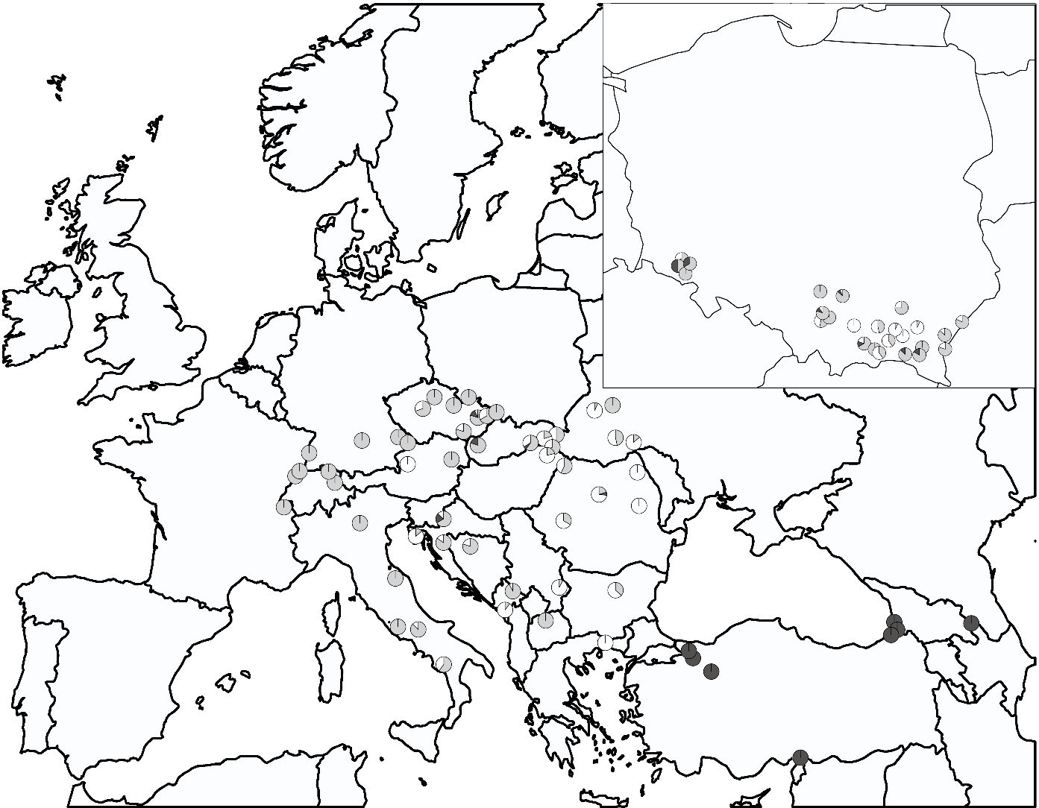
Fig. S1 Genetic diversity based on nuclear DNA variation in Staphylea pinnata. Pie charts presenting the proportion of three genotypes of ITS region detected at 87 populations are depicted on the map. Genotypes are color coded: black - homozygote TT; grey - heterozygote TC; white – homozygote CC
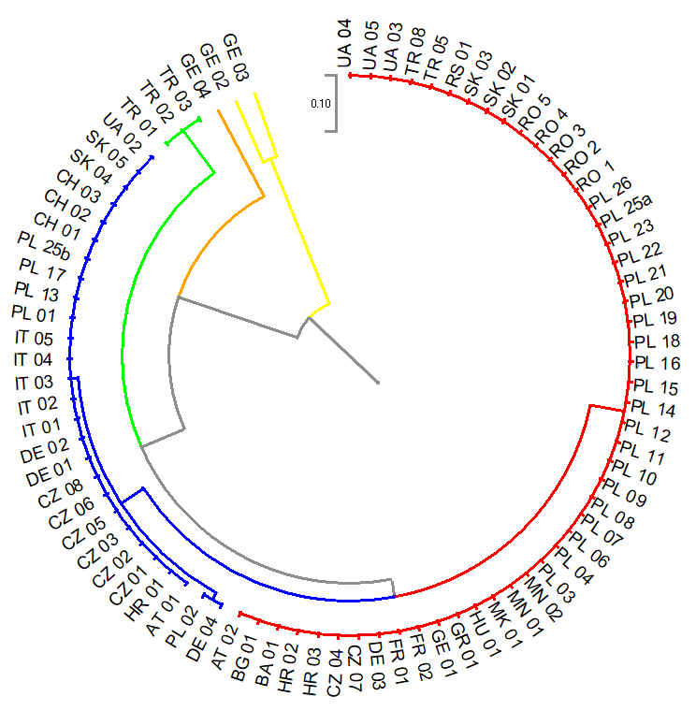
Fig. S2 Genetic relationships between studied bladdernut populations. The UPGMA dendrogram of 87 Staphylea pinnata populations based on Nei's genetic distance. Samples are grouped into clusters reflecting their genetic similarity. Clusters are color-coded according to dominant haplotype, colors are constituent with Figure 1 (see main text)

a b
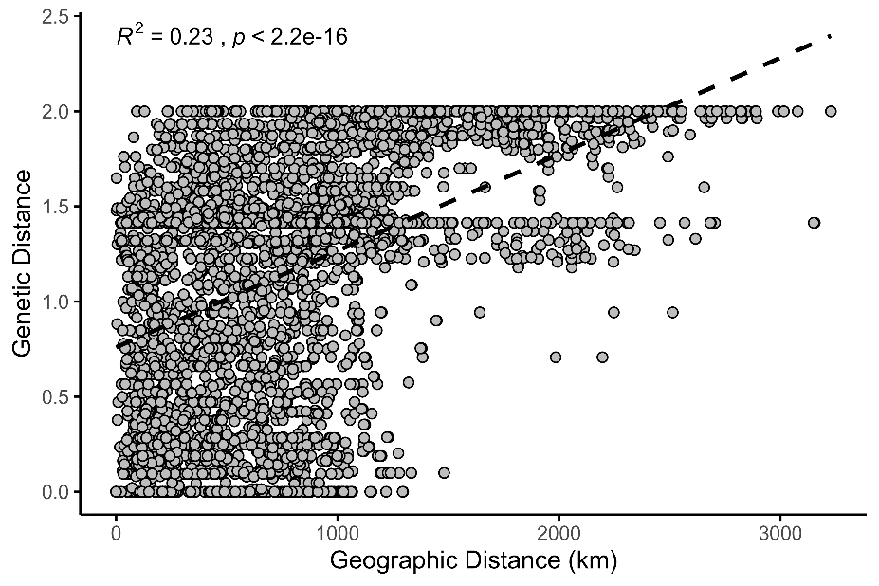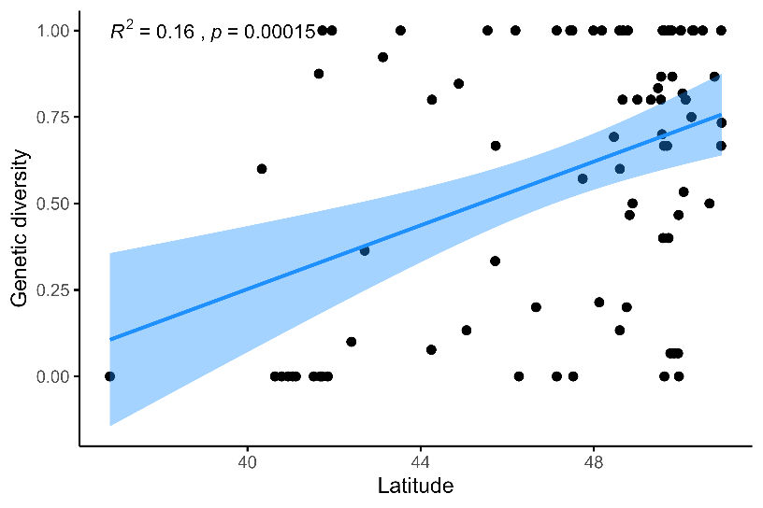
Fig. S3 Spatial patterns of genetic diversity across wide distribution range in bladdernut; a linear regression analysis of genetic diversity measure and latitude of population origin for 87 population of S. pinnata. The line of best fit is shown, along with a shaded 95% confidence interval. Statistical significance is presented as R² and p value in the plot; b results of isolation by distance test. Correlation between genetic and geographic distance. The dashed line represents a best-fit linear regression model. Statistical significance is presented as R² and p value in the plot.

Fig. S4 Contributions of morphometric variables to Principal Components. The barplot represents most important variables explaining the variability in the data and correlated with PC1 and PC2 (a, b, respectively). The red dashed line indicates the expected average contribution, provided the variables were uniformly contributing. Variables exciding this cutoff should be considered as important in contributing to the given PC

