Tracking medieval and early modern expansion of livestock farming in Sweden’s Boreal Forest: two high-resolution studies of pollen, coprophilous fungi and charcoal from Hälsingland and Jämtland
Eugene Costello, Petter I. Larsson, Sigrún Dögg Eddudóttir, Kevin Kearney,
Electronic Supplementary Material

Appendix 1

Here, a more detailed description on palynological methodology and results are presented for both Väster-Brännåslon and Kronvallen mire.

Table S1 Taxa present in the text. Many taxa have more than one common name, here we have included one, and in some cases two, of the most used names. Note that not all fungi have common names in English

Scientific name | Common (English-language) name | Type
Alnus | Alder | Trees
Andromeda polifolia | Bog-rosemary | shrubs
Arnium |  | Fungi
Artemisia vulgaris | Mugwort, wormwood | Herbs
Avena | Oats | Herbs (cereal)
Betula | Birch | Trees and shrubs
Betula nana | Dwarf birch | Shrubs
Calluna | Common heather | Shrubs
Cannabis | Hemp | Herbs
Chenopodiaceae | Goosefoot family | Herbs
Coniochaeta |  | Fungi
Corylus | Hazel | Shrubs and trees
Cyperaceae | Sedges | Herbs
Delitschia |  | Fungi
Drosera rotundifolia | Round-leaved sundew, common sundew | Herbs
Equisetum | Horsetail, mare’s tail | Vascular plant
Gelasinospora |  | Fungi
Hordeum | Barley | Herbs (cereal)
Menyanthes trifoliata | Bogbean, buckbean | Aquatic (wetland)
Myrica | Sweet gale | Shrubs and trees
Picea abies | Norway spruce | Trees
Pinus sylvestris | Scots pine, Baltic pine | Trees
Plantago major | Broadleaf plantain | Herbs
Plantago media | Hoary plantain | Herbs
Poaceae | Grasses | Herbs
Rumex | Docks and sorrels (buckwheat family) | Herbs
Secale cereale | Rye | Herbs (cereal)
Sordaria |  | Fungi
Sphagnum | Sphagnum moss, bog moss | Mosses
Triticum | Wheats | Herbs (cereal)

Fieldwork
Fieldwork was conducted in early July 2021, with a total of five mires visited and sampled. Three of these were in north-west Hälsingland and two in south-east Jämtland. Three out of the five were found to have large (0.6-1.3 m deep) accumulations of poorly-humified sphagnum moss on top of the peat, making extraction of cores difficult with a handheld Russian corer. The two most suitable mires for coring were found to be Väster-Brännåsflon in the parish of Hällesjö, Jämtland, and Kronvallen mire in the Kårböle area of Färila parish, Hälsingland (Figure 1).

Palaeoecological record of Väster-Brännåsflon
Sampling context
Vegetation on the mire is characterised by Sphagnum, Equisetum, Cyperaceae, Poaceae, Menyanthes trifoliata and Betula nana. Young Pinus sylvestris are also colonising the mire’s edges. Bedrock in the area consists of metagreywacke, mica schist, graphite- and/or sulphide-bearing schist, paragneiss, migmatite, quartzite and amphibolite (SGU Bedrock Viewer 2025), with the soil cover consisting mainly of lithosols or exposed bedrock (SGU Soil Type Viewer 2025).
Sub-sampling and analysis
A total of 36 samples from the peat-core were subsampled from 83.5 cm to 2.5 cm of depth (with an analysis resolution of 1–2 cm). The samples were prepared with standard methodology of 10% HCl, 10% NaOH and acetolysis (Moore et al. 1991). Pollen, spores and microscopic charcoal particles were identified using a light-microscope with a magnification of 200x–1000x (using immersion oil at 100x magnification). Identification of pollen grains were made following Moore et al. (1991). Spores were identified following several independent research articles (van Geel 1978; van Geel et al. 2003, 2007; Cugny et al. 2010; Lee et al. 2022) as well as the Non-Pollen Palynomorph Image Database (Shumilovskikh et al. 2022, 2023). A total of 500 terrestrial pollen types were identified to ensure statistical significance, except for the levels of 50.5 cm (n=303) and 74.5 cm (n=137) where the total pollen count was too scarce to reach set minimum. No clear anomalies were identified in these levels; hence they were still included. The pollen diagram presents the results in percentages, based on the total land pollen (TLP). Percentages of spores have been calculated based on the TLP plus the spore sum (TLP+S), and the same method was applied for charcoal particles (TLP+C). The diagram has been produced in R version 4.5.2 (R Core Team 2022) with the rioja package (version 1.0-7 Juggins 2023). The diagram has been sectioned into pollen assemblage zones (PAZs) via CONISS zonation (Grimm 1987), which was analysed using the Bray-Curtis dissimilarity index in the vegan-package (version 2.7-2 Oksanen et al. 2022).
A total of eleven samples, from a depth of 83.5cm up to 8.5cm, were taken and successfully radiocarbon dated at Tandem Laboratory in Uppsala. Only one of these samples, a seed at 16.5cm, was a macrofossil as the peat was quite well humified and very few suitable macrofossils could be found. The other ten samples were all 1cm-thick bulk samples of peat, with the humic acid fraction being extracted and dated.

Results
PAZ 1 (83.5–50.5 cm; 753-403 cal bc to 166-326 cal ad, at 95.4% probability)
This PAZ is dominated by trees, where Picea (c. 20–30%), Pinus (c. 25–31%) and Betula (c. 12–22%) are the dominant taxa. Tree-taxa identified with lower frequency are Alnus, Populus, Corylus/Myrica, Ulmus, Tilia, Quercus, Carpinus and Fraxinus. The levels of shrubs and dwarf shrubs is low, mainly represented by Ericaceae. The level of herbs is relatively high due to pollen input from species growing on the wetland, where Cyperaceae make up most of the herb taxa (c. 10–20%), followed by Poaceae (c. 1–5%). A relatively large degree of the spores identified in this PAZ come from taxa growing on the site, especially Sphagnum (c. 0.5–5%, with a peak of 21% at the uppermost layer of the zone) and Equisetaceae (c. 0–3.5%). A few occurrences of coprophilous spores in the form of Coniochaeta and Sordaria are identified in the pollen signal. The level of charcoal particles fluctuates throughout this zone. Charcoal particles have a mean value of 8.2%, with peaks at 83.5 cm (14.1%), 65.5 cm (17.5%), 50.5 cm (17.7%),

PAZ 2 (47.5–32.5 cm; 232-387 cal ad to 667-820 cal ad, at 95.4% probability)
The pollen signal is still dominated by forest. Picea (c. 25–35 %) and Pinus (c. 24–36 %) increase initially before starting to decline slightly, while Betula (c. 6–11 %) is reduced throughout. Corylus/Myrica (c. 2.5–7%) and Alnus (c. 1.3–3.8 %) are relatively stable, with Corylus/Myrica showing a slight increase in the upper part of the PAZ. Populus, Tilia, Quercus, Carpinus and Fraxinus also occur sporadically (<1%). Shrubs are still only present with low values, mostly through Ericaceae (<1%). Herbs are still relatively well represented as a result of taxa growing on the site – foremost Cyperaceae (c. 13–19.5 %, with a peak in the uppermost layer of 27.8%) and Poaceae (c. 1.2–2.9%). The signal of spores is similar to the previous zone, one clear stand-out is a peak of Sphagnum at 44.5 cm of depth (82%). Fire and smoke can increase germination in some Sphagnum species and as there is a peak of small charcoal particles at the same level (28.3%) it is possible that this reflects a smaller forest-fire at the site (Yusup et al. 2022) – although it cannot have been too heat intensive as this would have the opposite effect on Sphagnum (Noble et al. 2019). Charcoal particles mostly have a frequency of around 3%, but peaks at 44.5 cm (29.4%) and is slightly higher at the 32.5 cm (6.4%). There is one occurrence each of the coprophilous fungal spores Coniochaeta and Sordariaceae (<1%).

PAZ 3 (29.5–16.5 cm; 723-1008 cal ad to 1275-1401 cal ad, at 95.4% probability)
Pinus increases to become the most dominant tree (c. 33–42%) while Picea continues to decline (c. 15–20%). Betula recovers (c. 10–21%) and has a peak of 25% at a depth of 22.5 cm. There is also a slightly increased occurrence of Populus (<1%) and Salix (<1%). The herbs continue to be dominated by Cyperaceae (c. 6–17%) and Poaceae (c. 2–7%), but with an increase in Poaceae over time. This increase is first evident at 26.5cm and is more pronounced from 20.5cm. Furthermore, Urtica is common throughout this zone. Herb taxa are still found at low frequency, yet more diverse than previously, including Filipendula, Rosaceae, Artemisia, Apiaceae, Ranunculaceae, Epilobium, Rumex acetosa, and Rubus chamaenorus. There is also an increase in ferns, especially in Equisetaceae (c. 0.4–4.4%, peaking at the uppermost level at 11.6%). Sphagnum decreases compared to the previous zone (c. 0.4–2%, being absent in the uppermost level). There is an increased occurrence of coprophilous spore types (Sordaria and Sordariaceae) (<1%). There is also an increased occurrence of Gelasinospora (<1%). Gelasinospora is sometimes referred to as in indicator of anthropogenic activities as some species in this genus can live on animal excrement but other species lives on dead or burnt wood as well (Cugny et al. 2010). Mean values of charcoal slightly decrease to 5.63%, with peaks at 22.5 cm (14.1%) and 16.5 cm (12.3%).

PAZ 4 (14.5 cm; 1450-1561 cal ad, at 95.4% probability)
The pollen signal at this level indicates increased fire, leading to a clear change in the pollen record. Charcoal particles reach a level of 37.7%, the highest value recorded for the whole of the core. Furthermore, there is a decrease in both Picea (5.3%) and Pinus (11.8%). Picea are commonly affected by forest fires, while Pinus are usually resistant (Feurdean et al. 2020). Betula (37.4%), Alnus (9.4%) and Corylus/Myrica (11.6%) increase. Ferns peak in this zone as they are favoured by fire and higher degree of landscape openness. Cyperaceae drops while Poaceae increase further, possibly in response to the fire event. One occurrence of Delitschia-t is registered, a fungi growing on animal excrement (Cugny et al. 2010).

PAZ 5 (13.5–2.5 cm; 1459-1577 cal ad to 1767-2023 cal ad, at 95.4% probability)
Picea stays relatively low (c. 9–20 %) while Pinus increase (c. 45–50%). This composition in conifer trees might be a result of a changed fire regime, where charcoal particles (c. 6–18%, except for 7.5 cm of depth where it only reaches 1.7%) indicate a more regular occurrence of smaller fires. The deciduous trees mostly consist of Betula (c. 7–15%), Alnus (c. 0.6–4%), Populus (<1%), Corylus/Myrica (c. 1–4%) and Quercus (<1%). Ericaceae (c. 3.3–18%) and Calluna (c. 0.2–1.3%) increase, indicating an expansion of heathlands in the area. Herbs are still dominated by Cyperaceae (c. 7–18 %, except for a lower occurrence of 3.3% at 10.5 cm of depth) and Poaceae (c. 2–8 %). The herb taxa composition remains relatively diverse with occurrences of Filipendula, Rosaceae, Caryophyllaceae, Artemisia, Caltha-t, Ranunculaceae, Epilobium, Cichorium intybus-t, R. acetosa, R. acetosella and Urtica (<1%). There is also one grain of Hordeum-t pollen recorded. Sphagnum first increases with values of 10% and 20% at the two oldest analysed layers in the zone and then decrease throughout the zone (mostly stable around 1%). There is an increased presence of coprophilous spores in this zone with Coniochaeta, Sordaria and Sordariaceae (<1%). Gelasinospora is sporadically present at a few levels as well (<1%).

Palaeoecological record of Kronvallen mire
Sampling context
Vegetation on Kronvallen mire is characterized by Sphagnum mosses, Poaceae, Cyperaceae, Drosera rotundifolia, Andromeda polifolia and Menyanthes trifoliata. Birch trees grow around its edges, with scattered Pinus sylvestris now also colonising the mire itself, especially its eastern half. Small areas of mixed deciduous-coniferous marsh forest can be found alongside streams near the mire but otherwise. Bedrock in the area consists of granite, granodiorite, syenitoid, quartz monzodiorite and metamorphic equivalents (SGU Bedrock Viewer 2025). This bedrock is covered with peat in wetlands like the sampled mire and with lithosols on the moraines and hills (SGU Soil Type Viewer 2025). Exposed bedrock is also visible on some hills (SGU Soil Type Viewer 2025).
Sub-sampling and analysis
Subsamples were taken at contiguous 1 cm intervals for measurement of organic matter content (OM %). OM was estimated based on loss on ignition (LOI) by combusting the samples at 550°C for 4 hours (Berglund, 1986). The core was subsampled for pollen analysis by taking samples at contiguous 1 cm intervals between 12.5 and 40.5 cm, every 2 cm between 8.5 and 12.5 cm and every 4 cm between 40.5 and 48.5 cm. Pollen samples were prepared using standard chemical methods (Moore, Webb, & Collison, 1991) and density separation (Björck, Persson, & Kristersson, 1978; Nakagawa et al., 1998). The samples were mounted on microscope slides in silicone oil of 12,500 cSt viscosity. In total 32 samples were counted, with the main key of reference being Moore et al., 1991. Identification of fungal spores was based on various published references (i.e. Cugny, Mazier, & Galop, 2010; van Geel, 1978; van Geel & Aptroot, 2006; van Geel et al., 2003). A minimum of 500 terrestrial pollen grains were counted for each sample, with the exception of the samples at the depths of 8.5 cm (n=384), 17.5 cm (n=379), 25.5 cm (n=322), and 40.5 cm (n=270). Grain sizes and annulus diameters of Poaceae pollen grains were measured to identify potential cereal pollen grains, in accordance with Andersen (1979). Pollen percentages were calculated as a percentage of total land pollen (TLP), including Cyperaceae. Spore percentages were calculated using the TLP plus the sum of all spores. Microscopic charcoal fragments were measured and divided into fractions of ˂ 50 µm and ≥ 50 µm. Charcoal percentages were then calculated based on the sum of charcoal plus TLP. Samples were divided into pollen assemblage zones (PAZ), based on TLP and using Hellinger distance as dissimilarity index in the vegan package (Oksanen et al. 2022). The pollen diagram was plotted via the rioja package in R (Juggins 2020).

Results
PAZ 1 (48.5-33.5 cm; 807-1088 cal ad to 1475-1655 cal ad, at 95.4% probability)
This PAZ is dominated by arboreal pollen, i.e., Pinus (36-55%), Picea (13-24%) and Betula (12-18%). Over the course of the zone, Pinus increases slightly while Picea decreases slightly. Betula peaks at 34.5cm while Alnus is present in lower quantities (≤ 2.5%). Cyperaceae ranges between 9 and 20%; except for the depth of 35.5 cm, where it only reaches 4.2%. Poaceae ranges between 1.4 and 6%, with small peaks at 48.5cm and 38.5cm. Calluna is present in low quantities (≤ 1%). A small number of apophytes are recorded in this zone, mainly from 38.5cm and upwards. They include Artemisia vulgaris-type and Cannabis-t pollen grains. Cereal pollen of Hordeum-t (48.5 cm), Cerealia-t (39.5 & 38.5 cm) and Secale cereale (35.5 cm) is also present. Coprophilous fungal spores Sordaria sp., Arnium spp., Gelasinospora, Coniochaeta A and B are also recorded in the upper part of the zone, starting at 40.5cm. Peaks in microscopic charcoal occur at 38.5 cm (33.7%) and 35.5 cm (21.5%).. The abundance of Sphagnum spores varies greatly within the PAZ, ranging from a high of 41.8% in the lower part (44.5 cm) to a low around 10–3.4% at the top.
PAZ 2 (32.5-21.5 cm; 1487-1682 cal ad to 1694-1888 cal ad, at 95.4% probability)
Pinus continues to increase slightly in the lower half of this zone, peaking at 62% at 25.5cm. Picea decreases further to 10–17%, before increasing again in the uppermost part of the zone (16–24%). Betula decreases, reaching a low of 4.65% at 25.5cm. Calluna increases (0.4-2%), as do the number and frequency of apophytes, starting with Artemisia vulgaris-type and Cannabis-t and then including other taxa, particularly Chenopodiaceae and Rumex sp. Cereal pollen, in the form of Cerealia-t, Hordeum-t and Secale cereale, are recorded throughout. Coprophilous fungal spores of Sporormiella, Arnium spp., Gelasinospora, Coniochaeta A and B, Trichodelitschia are recorded too, but are most plentiful in the lower part of the zone (up to and at 28.5cm). There is a peak in microscopic charcoal at 32.5 cm (23.4%). Sphagnum spores vary within the PAZ, with low values mostly around 9% in the lower half but peak at 54.9% at 25.5 and 59% at 26.5 cm.
PAZ 3 (19.5-13.5 cm; 1716–1905 to 1835-1955 cal ad, at 95.4% probability)
Pinus decreases markedly to 34-49% while Picea increases to 17–33%. Calluna decreases and is ˂1% in most of the samples in this PAZ. Cyperaceae and Poaceae both increase from 19.5 cm, to ˃16% and ˃3%, respectively. Pollen grains of apophytes are recorded in all samples (e.g., Artemisia vulgaris-t, Chenopodiaceae, Plantago media/major and Rumex sp.) and grains of Cerealia-t, Avena-Triticum and Hordeum-t are recorded throughout the zone. Coprophilous fungal spores are also recorded throughout, albeit there are fewer taxa. Sphagnum spores are 28–43%. Charcoal particles decline, with a mean value of 8.34%. However, values >10% are recorded at 17.5 cm and 14.5 cm.
PAZ 4 (12.5-8.5 cm; 1863-1959 cal ad to 1951-1989 cal ad, at 95.4% probability)
Pinus increases again (49-64%) and there is a relative decrease in Picea (5-12%) and Alnus (0.3-0.4%). Poaceae (2-4%) and Cyperaceae (8-12%) decrease as well. Few apophytes are found within this PAZ and only one cereal pollen, of Hordeum-t, is recorded. Coprophilous fungal spores (Sordaria sp. and Sporormiella) are reduced. Charcoal fragments continuous to decrease, with a mean value of 5.43%. . Sphagnum measures 20% in the two bottom samples and then increases to 49% in the uppermost sample.

Appendix 2
Information on Bayesian modelling approach
In order to better refine the chronology of palynological ‘events’ and to extend the chronological framework to ‘events’ which fall between dated horizons in the stratigraphic sequence, a Bayesian approach was employed (Buck et al. 1992). Radiocarbon dates were modelled using the programme OxCal v4.4 (Bronk Ramsey 1995; 1998; 2008; 2009a; 2017), IntCal20 (Reimer et al. 2020) and CALIBomb (Reimer and Reimer 2025). A general introduction to the application of the Bayesian approach has been widely discussed in the literature (e.g. Blaauw and Christen 2005; Blaauw et al. 2007a; Blaauw et al. 2007b; Bronk Ramsey 2008), with the application Bayesian modelling to palaeoenvironmental sequences reviewed in Parnell et al. (2011).
For each sequences a model was produced assuming a ‘Poisson’ process which treated the sediment accumulation process as being random (see P_Sequence models in supplementary material). Deposition models were constructed to allow for flexibility in the estimation of sediment accumulation rates, by averaging the values of the rigidity of the model (k value) of between 0.01 and 100cm⁻¹ (Bronk Ramsey and Lee 2013). The k factor is estimated based on the relationship between the number of depositional events and the overall stratigraphic process. The value used was estimated from the radiocarbon dates following the approach outlined in Blockley et al. (2007; 2008).
The ranges quoted in italics are posterior density estimates, derived from this Bayesian mathematical modelling of the radiocarbon chronology (Bayliss et al. 2007), while conventional calibrated radiocarbon ages are quoted in accordance with the international standard established by the Trondheim Convention (Stuiver and Kra 1986) and are not italicised. The calibrated date/posterior density estimate are quoted in the form recommended by Mook (1986), with the end points rounded outward to 10 years and are cited at two sigma, (95.4% confidence) unless stated otherwise. The Date () parameter was used to extrapolate a posterior density estimate for palynological features from the resulting P_Sequence.
Table S2 Radiocarbon dates used in Bayesian chronological modelling for Väster-Brännåsflon pollen record
 |  | Unmodelled dates |  | Modelled dates
Depth (cm) | Lab code | 95.4% (2 Sigma) probability | 68.3% (1 Sigma) probability | 95.4% (2 Sigma) probability | 68.3% (1 Sigma) probability
8.5 | Ua-79565 | cal ad 1474–1637 | cal ad 1492–1631 | cal ad 1545–1646 | cal ad 1594–1638
11.5 | Ua-78267 | cal ad 1456–1635 | cal ad 1474–1624 | cal ad 1485–1614 | cal ad 1500–1598
14.5 | Ua-78268 | cal ad 1470–1637 | cal ad 1488–1631 | cal ad 1450–1561 | cal ad 1460–1503
16.5 | Ua-79567 | cal ad 1225–1395 | cal ad 1269–1385 | cal ad 1275–1401 | cal ad 1293–1395
20.5 | Ua-79566 | cal ad 1224–1281 | cal ad 1230–1279 | cal ad 1222–1281 | cal ad 1228–1276
23.5 | Ua-78269 | cal ad 1030–1165 | cal ad 1040–1156 | cal ad 1035–1167 | cal ad 1084–1158
32.5 | Ua-78270 | cal ad 661–819 | cal ad 676–771 | cal ad 667–820 | cal ad 689–774
44.5 | Ua-78271 | cal ad 255–420 | cal ad 265–408 | cal ad 269–423 | cal ad 362–411
50.5 | Ua-78272 | cal ad 131–333 | cal ad 212–317 | cal ad 166–326 | cal ad 210–305
62.5 | Ua-78273 | 162 cal bc–cal ad 20 | 107 cal bc–cal ad 7 | 152 cal bc–cal ad 17 | 102 cal bc–cal ad 5
83.5 | Ua-78274 | 749–402 cal bc | 541-413 cal bc | 753-403 cal bc | 739-416 cal bc

Table S3 Depths selected from Väster-Brännåsflon and results of chronological modelling. Good overall agreement A_{model}=89.1, A_{overall}=89.3. Note: High grass = more than 40 pollen grains. Medium grass = more than 30 pollen grains
Depth (cm) | Point of interest | 95.4% (2 Sigma) probability | 68.3% (1 Sigma) probability
2.5 | High charcoal | cal ad 1760–2020 | cal ad 1830–1990
4.5 | High grass and Calluna | cal ad 1640–1960 | cal ad 1720–1890
5.5 | High charcoal | cal ad 1600–1910 | cal ad 1670–1820
7.5 | Possible lull | cal ad 1540–1790 | cal ad 1590–1690
10.5 | Copro spore and Calluna peak | cal ad 1500–1620 | cal ad 1540–1610
11.5 | Sphagnum peak | cal ad 1480–1610 | cal ad 1500–1590
13.5 | Start PAZ 5 | cal ad 1450–1570 | cal ad 1470–1530
14.5 | Peak charcoal, medium grass | cal ad 1450–1560 | cal ad 1460–1500
16.5 | Medium grass | cal ad 1270–1400 | cal ad 1290–1390
19.5 | Medium grass/Start continuous copro spores | cal ad 1220–1340 | cal ad 1240–1300
20.5 | Medium grass | cal ad 1220–1280 | cal ad 1220–1270
22.5 | High charcoal | cal ad 1060–1240 | cal ad 1110–1210
25.5 | Start livestock grazing | cal ad 890–1150 | cal ad 970–1100
29.5 | Start PAZ 3 | cal ad 720–1000 | cal ad 780–920
32.5 | End PAZ 2 | cal ad 660–820 | cal ad 680–770
44.5 | Peak charcoal | cal ad 260–420 | cal ad 360–410
47.5 | Start PAZ 2 | cal ad 230–380 | cal ad 270–350
50.5 | End PAZ 1 | cal ad 160–320 | cal ad 210–300
83.5 | Start PAZ 1 | 750–400 cal bc | 730–410 cal bc
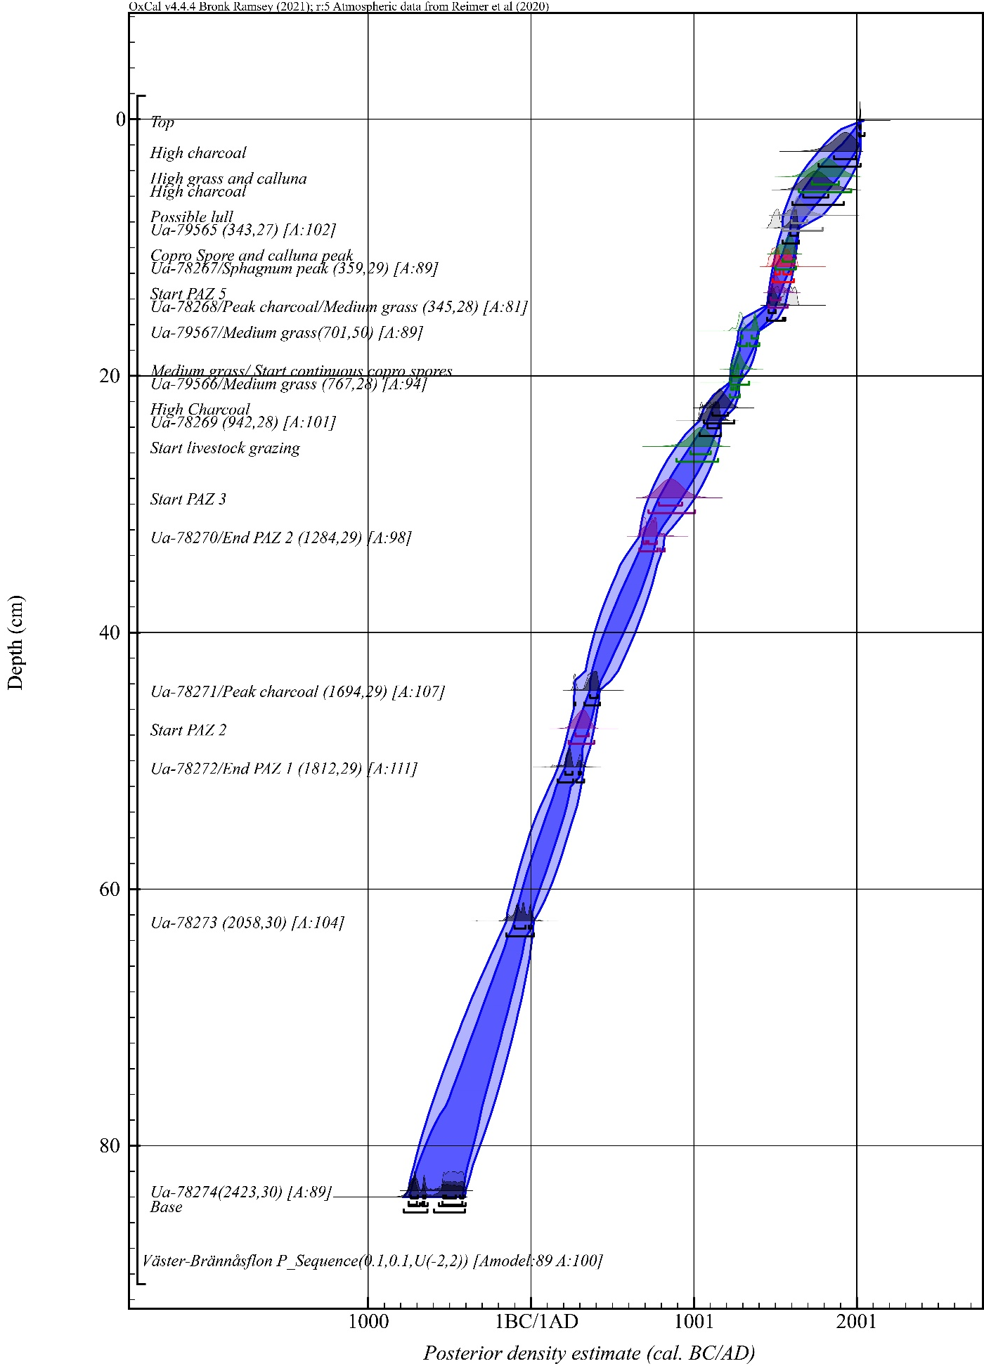
Fig. S1 Väster-Brännåsflon P_Sequence

Table S4 Radiocarbon dates used in Bayesian chronological modelling for Kronvallen mire pollen record. *=pMC date
 |  | Unmodelled dates |  | Modelled dates
Depth (cm) | Lab code | 95.4% (2 Sigma) probability | 68.3% (1 Sigma) probability | 95.4% (2 Sigma) probability | 68.3% (1 Sigma) probability
10.5 | Ua-75053* | cal ad 1951–1959 | cal ad 1952–1957 | cal ad 1948–1960 | cal ad 1952–1958
22.5 | Ua-71409 | cal ad 1692–1919 | cal ad 1698–1910 | cal ad 1688–1871 | cal ad 1701–1832
25.5 | Ua-72480 | cal ad 1662–1950 | cal ad 1669–1950 | cal ad 1658–1815 | cal ad 1665–1806
35.5 | Ua-78190 | cal ad1479 1640– | cal ad 1500–1635 | cal ad 1457–1592 | cal ad 1471–1542
38.5 | UA-72481 | cal ad 1219–1282 | cal ad 1229–1276 | cal ad 1221–1284 | cal ad 1235–1278
51.5 | Ua-71410 | cal ad 704–944 | cal ad 783–880 | cal ad 712–955 | cal ad 808–887

Table S5 Depths selected from Kronvallen mire and results of chronological modelling. Good overall agreement A_{model}=87.4, A_{overall}=87.4. Note: High grass = 30 or more pollen grains. Medium grass = 20-29 pollen grains
Depth (cm) | Point of interest | 95.4% (2 Sigma) probability | 68.3% (1 Sigma) probability
8.5 | End PAZ 4 | cal ad 1950–1990 | cal ad 1950–1970
12.5 | Start PAZ 4 | cal ad 1860–1950 | cal ad 1910–1950
13.5 | End PAZ 3 | cal ad 1830–1950 | cal ad 1890–1950
14.5 | High grass | cal ad 1810–1950 | cal ad 1870–1940
16.5 | Medium grass | cal ad 1760–1940 | cal ad 1830–1920
17.5 | High sedge | cal ad 1740–1930 | cal ad 1800–1910
18.5 | Medium grass | cal ad 1720–1910 | cal ad 1760–1900
19.5 | Start PAZ 3 | cal ad 1710–1900 | cal ad 1720–1880
21.5 | End PAZ 2 | cal ad 1690–1890 | cal ad 1700–1850
22.5 | Medium grass | cal ad 1680–1880 | cal ad 1700–1830
25.5 | Possible lull | cal ad 1650–1810 | cal ad 1660–1800
26.5 | Possible lull | cal ad 1610–1810 | cal ad 1640–1760
30.5 | Calluna increase | cal ad 1510–1730 | cal ad 1550–1660
31.5 | Copro spore peak | cal ad 1500–1700 | cal ad 1530–1640
32.5 | High charcoal, start increased apophytes | cal ad 1480–1680 | cal ad 1510–1610
33.5 | End PAZ 1 | cal ad 1470–1650 | cal ad 1500–1590
34.5 | Possible lull | cal ad 1460–1620 | cal ad 1480–1560
35.5 | High charcoal | cal ad 1450–1590 | cal ad 1470–1540
37.5 | High copro spore | cal ad 1220–1490 | cal ad 1240–1380
38.5 | Charcoal peak, medium grass, apophyte start | cal ad 1220–1280 | cal ad 1230–1270
39.5 | Cereal start | cal ad 1120–1280 | cal ad 1210–1270
40.5 | Copro spore start | cal ad 1070–1270 | cal ad 1160–1260
48.5 | Start PAZ 1 | cal ad 800–1090 | cal ad 860–1000

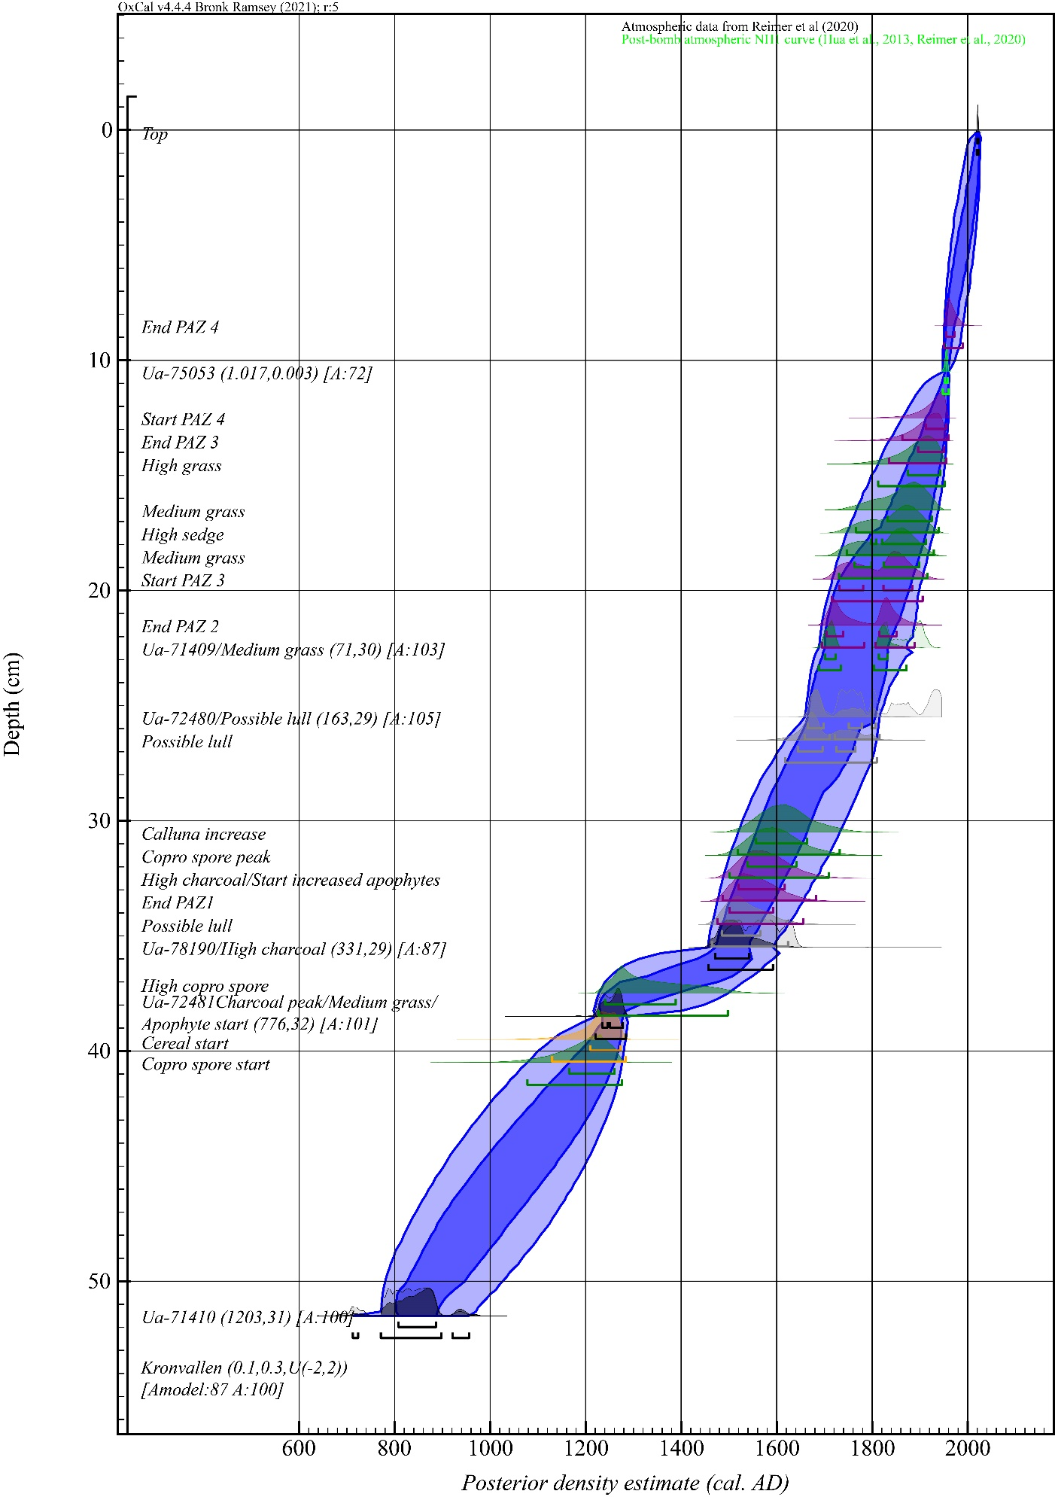
Fig. S2 Kronvallen mire P_Sequence.

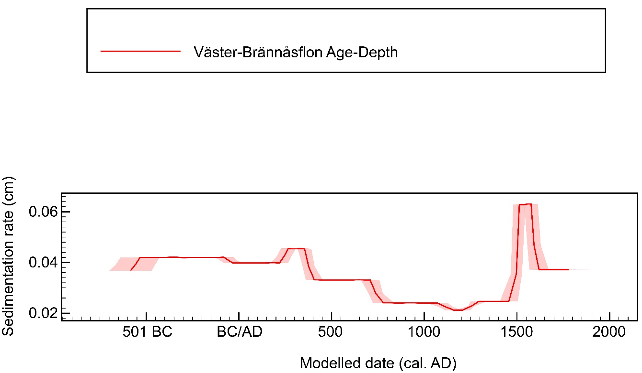
Fig. S3 Deposition model for Väster-Brännåsflon.

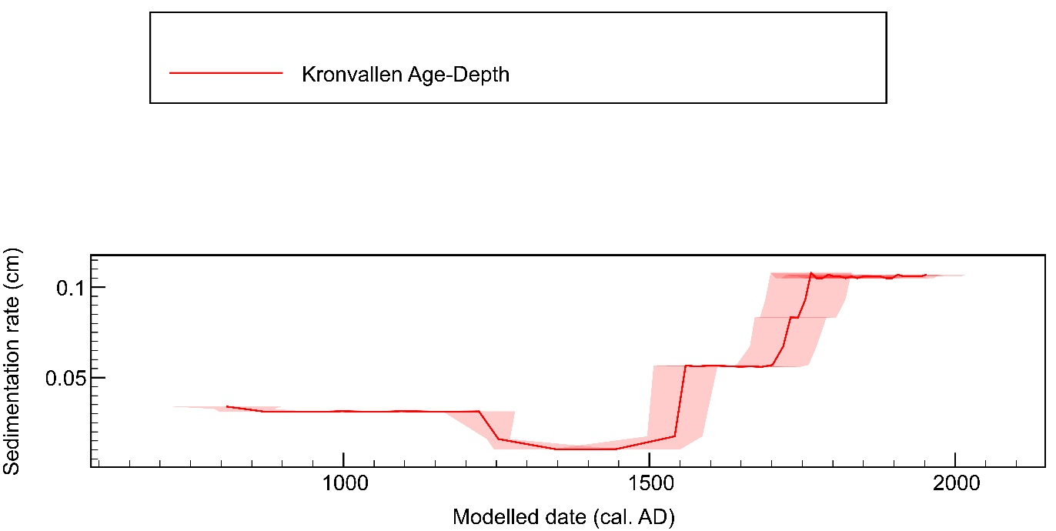
Fig. S4 Deposition model for Kronvallen mire.

References
Bayliss, A., C. Bronk Ramsey, J. van der Plicht, and A. Whittle. 2007. “Bradshaw and Bayes: Towards a Timetable for the Neolithic.” Cambridge Archaeological Journal 17: 1–28
Berglund, B.E. (ed.) 1986. Handbook of Holocene Palaeoecology and Palaeohydrology. New York: Wiley-Interscience.
Blaauw, M. and J.A. Christen. 2005. Radiocarbon peat chronologies and environmental change. Journal of the Royal Statistical Society Series C-Applied Statistics 54:805-816.
Blaauw, M., Bakker, R., Christen, J.A., Hall, V.A. and Van Der Plicht, J. 2007a. A Bayesian framework for age modeling of radiocarbon-dated peat deposits: case studies from the Netherlands. Radiocarbon 49(2), 357-367.
Blaauw, M., Christen, J.A., Mauquoy, D., van der Plicht, J. and K.D. Bennett. 2007b. Testing the timing of radiocarbon-dated events between proxy archives. The Holocene 17:283-288.
Blockley, S.P.E., Blaauw, M., Bronk Ramsey, C. and J. van der Plicht. 2007. Building and testing age models for radiocarbon dates in Late Glacial and Early Holocene sediments. Quaternary Science Reviews 26:1915-1926.
Blockley, S.P.E., Ramsey, C.B., Lane, C.S. and A.F. Lotter. 2008. Improved age modelling approaches as exemplified by the revised chronology for the Central European varved lake Soppensee. Quaternary Science Reviews 27:61-71.
Bronk Ramsey, C. 1995. Radiocarbon calibration and analysis of stratigraphy: the OxCal program. Radiocarbon 37:425-430.
Bronk Ramsey, C. 1998. Probability and dating. Radiocarbon 40:461-474.
Bronk Ramsey, C. 2008. Deposition models for chronological records. Quaternary Science Reviews 27:42-60.
Bronk Ramsey, C. 2009a. Bayesian analysis of radiocarbon dates. Radiocarbon 51:337-360.
Bronk Ramsey, C. 2017. Methods for Summarizing Radiocarbon Datasets. Radiocarbon 59:1809-1833.
Bronk Ramsey, C. and S. Lee. 2013. Recent and Planned Developments of the Program OxCal Radiocarbon 55:720-730.
Buck, C.E., Litton, C.D. and A.F. Smith. 1992. Calibration of radiocarbon results pertaining to related archaeological events. Journal of Archaeological Science 19(5):497-512.
Cugny, C., F. Mazier & D. Galop. 2010. Modern and fossil non-pollen palynomorphs from the Basque mountains (western Pyrenees, France): the use of coprophilous fungi to reconstruct pastoral activity. Vegetation History and Archaeobotany 19: 391–408.
Feurdean, A. et al. 2020. Recent fire regime in the southern boreal forests of western Siberia is unprecedented in the last five millennia. Quaternary Science Reviews 244: 106495.
Grimm, E.C. 1987. CONISS: a FORTRAN 77 program for stratigraphically constrained cluster analysis by the method of incremental sum of squares. Computers & Geosciences 13: 13–35.
Juggins, S. 2023. rioja: Analysis of Quaternary Science Data. (version 1.0-6). https://CRAN.R-project.org/package=rioja.
Lee, C.M., B. van Geel & W.D. Gosling. 2022. On the Use of Spores of Coprophilous Fungi Preserved in Sediments to Indicate Past Herbivore Presence. Quaternary 5. Multidisciplinary Digital Publishing Institute: 30.
Mook, W.G. 1986. Business meeting: Recommendations/resolutions adopted by the twelfth International Radiocarbon Conference. Radiocarbon 28:799.
Moore, P.. D., J.A. Webb & M.E. Collinson (ed.). 1991. Pollen Analysis. 2nd ed. Oxford: Blackwell Sience Ltd.
Noble, A., A. Crowle, D.J. Glaves, S.M. Palmer & J. Holden. 2019. Fire temperatures and Sphagnum damage during prescribed burning on peatlands. Ecological Indicators 103: 471–78. https://doi.org/10.1016/j.ecolind.2019.04.044.
Oksanen, J. et al. 2022. vegan: Community Ecology Package. (version 2.6-4). https://CRAN.R-project.org/package=vegan.
Parnell, A.C., Buck, C.E. and T.K. Doan. 2011. A review of statistical chronology models for high-resolution, proxy-based Holocene palaeoenvironmental reconstruction. Quaternary Science Reviews 30:2948-2960.
Reimer, P.J., Austin, W.E., Bard, E., Bayliss, A., Blackwell, P.G., Ramsey, C.B., Butzin, M., Cheng, H., Edwards, R.L., Friedrich, M. and P.M. Grootes. 2020. The IntCal20 Northern Hemisphere radiocarbon age calibration curve (0–55 cal kBP). Radiocarbon 62(4):725-757.
Reimer, R.W. & Reimer, P.J. 2025. CALIBomb program. http://calib.org/CALIBomb/.
R Core Team. 2022. R: A Language and Environment for Statistical Computing. R (version 4.1.3). Vienna, Austria: R Foundation for Statistical Computing. https://www.R-project.org/.
SGU Bedrock Viewer 2025. https://www.sgu.se/produkter-och-tjanster/kartor/kartvisaren/bergkartvisare/berggrund-150-000-1250-000/
SGU Soil Type Viewer 2025. https://www.sgu.se/produkter-och-tjanster/kartor/kartvisaren/jordkartvisare/jordarter-125-000-1100-000/
Shumilovskikh, L.S., F. Schlütz, I. Achterberg, A. Bauerochse & H.H. Leuschner. 2015. Non-Pollen Palynomorphs from Mid-Holocene Peat of the Raised Bog Borsteler Moor (Lower Saxony, Germany). Studia Quaternaria 32: 5–18.
Shumilovskikh, L.S., E.S. Shumilovskikh, F. Schlütz & B. Van Geel. 2022. NPP-ID: Non-Pollen Palynomorph Image Database as a research and educational platform. Vegetation History and Archaeobotany 31: 323–28.
Shumilovskikh, L.S., E.S. Shumilovskikh, F. Schlütz & B. van Geel. 2023. Correction: NPP-ID: Non-Pollen Palynomorph Image Database as a research and educational platform. Vegetation History and Archaeobotany 32: 109–109.
Stuiver, M. and R.S. Kra. 1986. Editorial comment. Radiocarbon 28:ii.
van Geel, B. 1978. A paleoecological study of Holocene peat bog sections in Germany and the Netherlands, based on the analysis of pollen, spores and macro- and microscopic remains of fungi, algae, cormophytes and animals. Review of Palaeobotany and Palynology 25: 1–120.
van Geel, B., J. Buurman, O. Brinkkemper, J. Schelvis, A. Aptroot, G. van Reenen & T. Hakbijl. 2003. Environmental reconstruction of a Roman Period settlement site in Uitgeest (The Netherlands), with special reference to coprophilous fungi. Journal of Archaeological Science 30: 873–83.
van Geel, B., G.D. Zazula & C.E. Schweger. 2007. Spores of coprophilous fungi from under the Dawson tephra (25,300 14C years BP), Yukon Territory, northwestern Canada. Palaeogeography, Palaeoclimatology, Palaeoecology 252: 481–85. https://doi.org/10.1016/j.palaeo.2007.04.017.
Yusup, S., S. Sundberg, B. Fan, M. Sulayman & Z.-J. Bu. 2022. The Response of Spore Germination of Sphagnum Mosses to Single and Combined Fire-Related Cues. Plants 11: 485.

Equisetum is a vascular plant producing spores, making up a type of its own.
There is an overlap of size between Hordeum pollen and pollen of some wild grasses.

