Supplementary material

OnlineResource1.png
Online Resource 1: Graphical overview of the JAX Synteny Browser application architecture
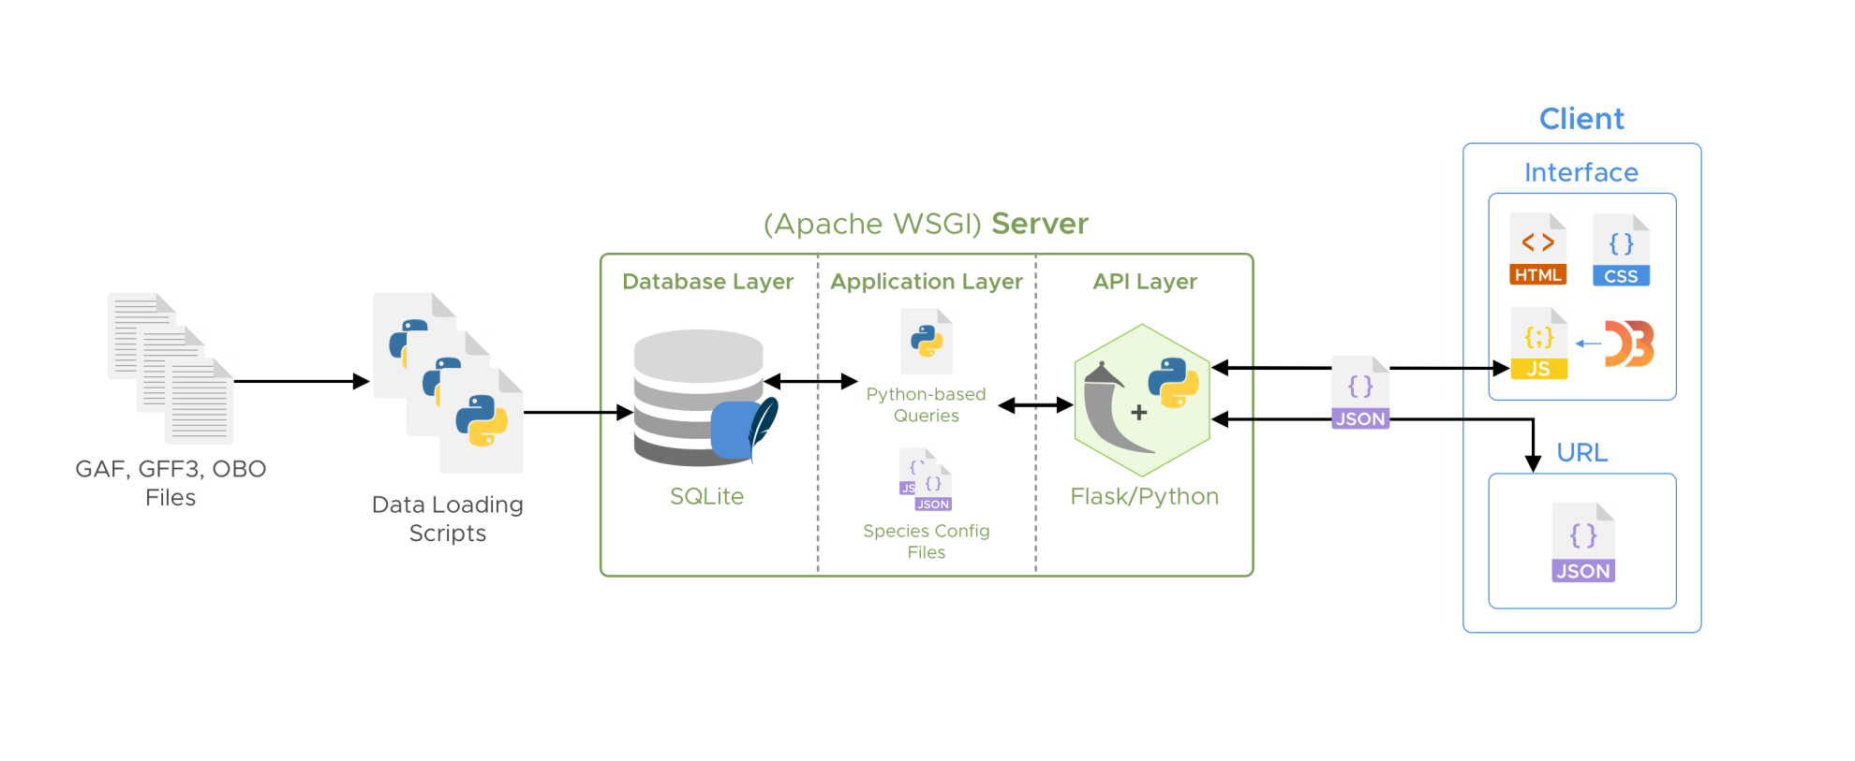

OnlineResource2.png
Online Resource 2: Example of a JSON-encoded application configuration file for the human genome
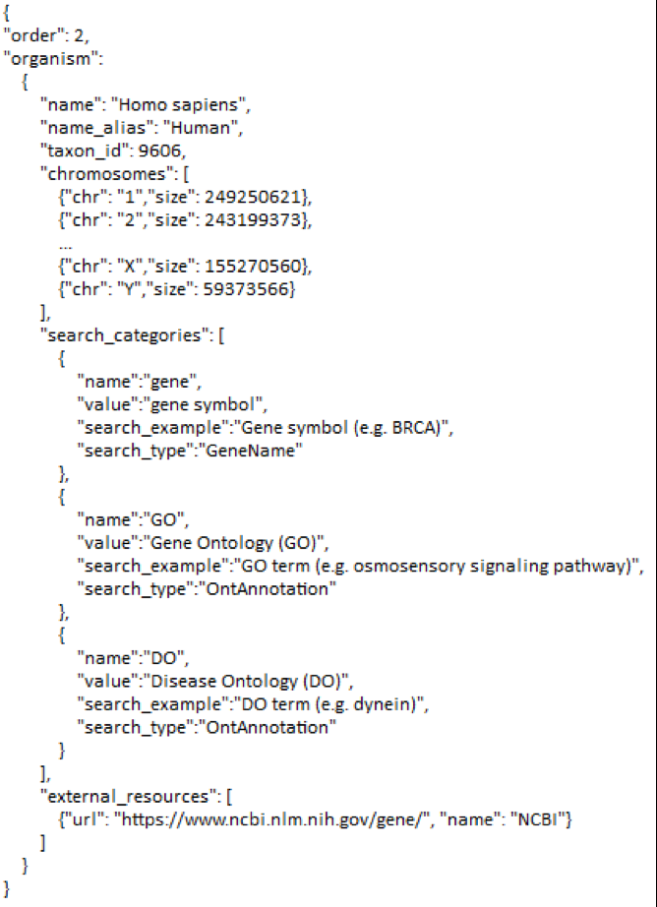

OnlineResource3.pdf
Online Resource 3. Data types, file formats, and data sources for the JAX Synteny Browser

