Contents
Excluded skeletal parameters 2
Supplemental table 1. 4
Supplemental table 2. 9
Supplemental figure S1. 11
Supplemental figure S2. 12
Supplemental figure S3. 13

See also:
Supplemental file 1 – 204 vertebral genes and their associated phenotypes, zygosity data, sex effects, and penetrance
Supplemental file 2 – Panther results for the IMPC gene set reference
Supplemental file 3 – ReviGO clustering
Supplemental file 4 – Somite trio RNA-Seq expression and clustering results

Excluded skeletal parameters

Parameters with no associated genes:
Caudal vertebrae morphology [IMPC_XRY_074_001]
Cervical vertebrae morphology [IMPC_XRY_070_001]
Fusion of ribs [IMPC_XRY_011_001]
Lumbar vertebrae morphology [IMPC_XRY_072_001]
Missing cranial rib [IMPC_XRY_068_001]
Number of cervical vertebrae [IMPC_XRY_013_001]
Number of thoracic vertebrae [IMPC_XRY_014_001]
Number of ribs (right) [IMPC_XRY_008_001]
Number of ribs (left) [IMPC_XRY_009_001]
Pelvic vertebrae morphology [IMPC_XRY_073_001]
Rib morphology [IMPC_XRY_069_001]
Scoliosis [IMPC_XRY_056_001]
Thoracic vertebrae morphology [IMPC_XRY_071_001]

Ribcage parameters:
Shape of ribcage [IMPC_XRY_059_001]
Shape of ribs [IMPC_XRY_010_001]

Tooth or skull parameters:
Branchial arch morphology [IMPC_GEL_024_001]
Craniofacial morphology [IMPC_GEO_063_001 and IMPC_GEM_062_001]
Mandibles [IMPC_XRY_004_001]
Maxilla/Pre-maxilla [IMPC_XRY_003_001]
Skull shape [IMPC_XRY_001_001]
Teeth [IMPC_XRY_005_001]
Teeth presence [IMPC_CSD_068_001]
Zygomatic bone [IMPC_XRY_002_001]

Appendicular skeleton parameters:
Brachydactyly [IMPC_XRY_030_001]
Clavicle [IMPC_XRY_007_001]
Digit integrity [IMPC_XRY_031_001]
Femur [IMPC_XRY_024_001]
Fibula [IMPC_XRY_026_001]
Hindlimbs – size [IMPC_CSD_022_001]
Hindpaw – shape [IMPC_CSD_043_001]
Humerus [IMPC_XRY_021_001]
Joints [IMPC_XRY_027_001]
Limb Bud Morphology [IMPC_GEL_038_001 and IMPC_GEM_027_001]
Limb morphology [IMPC_GEP_084_001 and IMPC_GEO_065_001]
Limb Plate Morphology [IMPC_GEM_028_001]
Number of digits [IMPC_XRY_028_001]
Pelvis [IMPC_XRY_012_001]
Polysyndactylism [IMPC_XRY_062_001]
Radius [IMPC_XRY_022_001]
Scapulae [IMPC_XRY_006_001]
Syndactylism [IMPC_XRY_029_001]
Syndactyly [IMPC_GEP_082_001 and IMPC_GEO_067_001]
Tibia [IMPC_XRY_025_001]
Tibia length (long) [IMPC_XRY_033_001]
Tibia length (short) [IMPC_XRY_033_001]
Ulna [IMPC_XRY_023_001]

Body length
body length [IMPC_DXA_006_001]

Supplemental table 1. Chromosomal locations of genes affecting vertebral phenotypes based on mouse GRCm39

Ensembl ID | Chromosome | Genomic location (strand)
1110059G10Rik | 9 | 122774154-122780065(-1)
4932438H23Rik | 16 | 90850823-90892010(-1)
Abca4 | 3 | 121838092-121973772(1)
Adamts1 | 16 | 85590715-85600001(-1)
Aebp1 | 11 | 5811947-5822088(1)
Aff3 | 1 | 38216407-38704036(-1)
Aff4 | 11 | 53241660-53312657(1)
Alg10b | 15 | 90108514-90117674(1)
Ambra1 | 2 | 91560479-91749194(1)
Ankmy2 | 12 | 36207113-36247290(1)
Arpc1b | 5 | 145051025-145067515(1)
Asphd1 | 7 | 126544739-126548754(-1)
Atp1b1 | 1 | 164264678-164285924(-1)
Atp1b3 | 9 | 96214708-96246495(-1)
Barx2 | 9 | 31757340-31824758(-1)
Bptf | 11 | 106923907-107022953(-1)
Brd2 | 17 | 34330997-34341608(-1)
C9orf72 | 4 | 35191285-35226175(-1)
Cacna1c | 6 | 118564201-119173851(-1)
Cant1 | 11 | 118297115-118309912(-1)
Capza1 | 3 | 104730095-104771821(-1)
Cbx5 | 15 | 103099971-103148243(-1)
Ccnd2 | 6 | 127102125-127129156(-1)
Cdcp3 | 7 | 130776131-130908180(1)
Celsr1 | 15 | 85783130-85918404(-1)
Cfd | 10 | 79726687-79728489(1)
Cgn | 3 | 94667376-94693826(-1)
Chd1l | 3 | 97468058-97517519(-1)
Chrna2 | 14 | 66372488-66390397(1)
Cog6 | 3 | 52889296-52924658(-1)
Col11a1 | 3 | 113824189-114014367(1)
Colec10 | 15 | 54274170-54329754(1)
Coq6 | 12 | 84408431-84420570(1)
Cpt2 | 4 | 107761178-107780807(-1)
Ctbp2 | 7 | 132589292-132726083(-1)
Cx3cr1 | 9 | 119730682-119898945(-1)
Cyb561 | 11 | 105824528-105844162(-1)
Cyp27b1 | 10 | 126884119-126888875(1)
Cysltr2 | 14 | 73263043-73286554(-1)
Dbn1 | 13 | 55621242-55635924(-1)
Dcbld2 | 16 | 58228806-58290090(1)
Dcdc2c | 12 | 28487794-28602398(-1)
Dis3l2 | 1 | 86631530-86977817(1)
Dnase1l2 | 17 | 24659055-24662079(-1)
Dpf2 | 19 | 5946544-5963038(-1)
Dph6 | 2 | 114346897-114485445(-1)
Duoxa2 | 2 | 122129381-122133366(1)
Eng | 2 | 32536607-32572681(1)
Fbn2 | 18 | 58141695-58343559(-1)
Fbrsl1 | 5 | 110509620-110596468(-1)
Fbxo22 | 9 | 55116209-55131717(1)
Fgf3 | 7 | 144391820-144398173(1)
Fgf7 | 2 | 125876578-125933105(1)
Fgfr1op2 | 6 | 146478701-146500696(1)
Fggy | 4 | 95445744-95815176(1)
Flnc | 6 | 29433255-29461882(1)
Fuz | 7 | 44545503-44552055(1)
Gal3st1 | 11 | 3933636-3949326(1)
Gdf11 | 10 | 128718164-128727587(-1)
Gldc | 19 | 30075847-30152829(-1)
Glg1 | 8 | 111881053-111985848(-1)
Glmn | 5 | 107696833-107745754(-1)
Gm13547 | 2 | 29649324-29654361(1)
Gna11 | 10 | 81364558-81381024(-1)
Gramd1b | 9 | 40204529-40442679(-1)
Gramd2 | 9 | 59587427-59626157(1)
Gyg | 3 | 20176248-20209481(-1)
H2-Eb1 | 17 | 34524841-34535648(1)
Hbs1l | 10 | 21171878-21244797(1)
Helq | 5 | 100910011-100946464(-1)
Hip1 | 5 | 135435385-135573974(-1)
Hoxc12 | 15 | 102845192-102847044(1)
Htr1f | 16 | 64745092-64926217(-1)
Ifi27l2a | 12 | 103408426-103409939(-1)
Il12a | 3 | 68597977-68605880(1)
Il2ra | 2 | 11647618-11698004(1)
Ino80c | 18 | 24237814-24255010(-1)
Ipo9 | 1 | 135310050-135358237(-1)
Isyna1 | 8 | 71047023-71049940(1)
Jmjd1c | 10 | 66931904-67092105(1)
Kcnv2 | 19 | 27299988-27314579(1)
Kdm7a | 6 | 39113557-39183723(-1)
Kera | 10 | 97442741-97449554(1)
Klf7 | 1 | 64068606-64161441(-1)
Krit1 | 5 | 3853184-3895564(1)
L3mbtl2 | 15 | 81548090-81572516(1)
Lox | 18 | 52649139-52662939(-1)
Lrrk1 | 7 | 65876660-66038098(-1)
Lum | 10 | 97400990-97408565(1)
Lyplal1 | 1 | 185819928-185849507(-1)
Mau2 | 8 | 70468773-70495384(-1)
Mbd1 | 18 | 74400676-74415803(1)
Med11 | 11 | 70342745-70344553(1)
Micu1 | 10 | 59538299-59699954(1)
Mir320 | 14 | 70680950-70681031(1)
Mllt10 | 2 | 18060048-18217199(1)
Mmp11 | 10 | 75759056-75772330(-1)
Mtch2 | 2 | 90677499-90697154(1)
Ndel1 | 11 | 68712260-68762684(-1)
Ndufb5 | 3 | 32791139-32805715(1)
Nemf | 12 | 69357296-69403939(-1)
Nisch | 14 | 30892887-30938903(-1)
Nog | 11 | 89191464-89193158(-1)
Nono | X | 100472924-100492197(1)
Notch1 | 2 | 26347915-26406675(-1)
Npr2 | 4 | 43631935-43651244(1)
Nr6a1 | 2 | 38613382-38817700(-1)
Opa1 | 16 | 29398152-29473702(1)
Os9 | 10 | 126931519-126957000(-1)
Pabpc4 | 4 | 123156144-123192718(1)
Pals2 | 6 | 50087221-50175919(1)
Parp4 | 14 | 56813076-56897251(1)
Pcgf2 | 11 | 97579649-97591323(-1)
Pcgf3 | 5 | 108609098-108654842(1)
Pcsk5 | 19 | 17409683-17814996(-1)
Pde5a | 3 | 122522596-122653023(1)
Pdhb | 14 | 14296748-14303777(1)
Pdss2 | 10 | 43097482-43340878(1)
Pfdn1 | 18 | 36536729-36587577(-1)
Pfdn5 | 15 | 102234551-102240308(1)
Pfn4 | 12 | 4819022-4828813(1)
Pigq | 17 | 26145395-26163910(-1)
Pitx1 | 13 | 55972864-55984005(-1)
Pld5 | 1 | 175789872-176102878(-1)
Plekhm1 | 11 | 103255101-103303513(-1)
Ppp1r35 | 5 | 137777111-137778372(1)
Ppp1r42 | 1 | 10038849-10079361(-1)
Pramel17 | 4 | 101692166-101701220(-1)
Psen1 | 12 | 83734926-83781973(1)
Pstpip2 | 18 | 77877614-77970579(1)
R3hdm1 | 1 | 128031038-128165473(1)
Rad9a | 19 | 4245195-4251661(-1)
Ralb | 1 | 119398035-119432524(-1)
Rbm22 | 18 | 60693808-60705882(1)
Rbm45 | 2 | 76200328-76214112(1)
Rexo1 | 10 | 80376756-80397394(-1)
Rlim | X | 103000769-103024890(-1)
Ropn1l | 15 | 31441357-31453883(-1)
Ror2 | 13 | 53263348-53440160(-1)
Runx2 | 17 | 44806874-45125684(-1)
Scaf11 | 15 | 96309580-96358724(-1)
Scart2 | 7 | 139827197-139880649(1)
Scn3b | 9 | 40180513-40202914(1)
Sec24b | 3 | 129776408-129855202(-1)
Sel1l | 12 | 91772817-91815931(-1)
Selenok | 14 | 29690265-29697619(1)
Setd3 | 12 | 108072690-108145573(-1)
Setd5 | 6 | 113054326-113130396(1)
Sfr1 | 19 | 47720121-47724027(1)
Sh2d5 | 4 | 137977714-137988643(1)
Shroom3 | 5 | 92831294-93113177(1)
Sik3 | 9 | 45924118-46135492(1)
Sirt3 | 7 | 140443579-140462222(-1)
Skida1 | 2 | 18045487-18053862(-1)
Slc20a2 | 8 | 22966804-23059628(1)
Slc25a1 | 16 | 17743087-17746083(-1)
Slc25a30 | 14 | 75997557-76024477(-1)
Slc25a4 | 8 | 46659834-46664321(-1)
Slc26a2 | 18 | 61325991-61344684(-1)
Slc29a1 | 17 | 45896126-45910532(-1)
Slc29a3 | 10 | 60547851-60588573(-1)
Slc30a9 | 5 | 67464298-67515786(1)
Slc35d1 | 4 | 103027846-103072361(-1)
Slc6a5 | 7 | 49559894-49613604(1)
Slmap | 14 | 26134323-26256086(-1)
Snx3 | 10 | 42378026-42411377(1)
Spopl | 2 | 23396232-23462118(-1)
Srd5a3 | 5 | 76288118-76303351(1)
Supt5 | 7 | 28014316-28038171(-1)
Svep1 | 4 | 58042442-58206859(-1)
Tbx20 | 9 | 24629434-24685599(-1)
Tfap4 | 16 | 4362525-4377718(-1)
Tfec | 6 | 16833372-16898440(-1)
Tgds | 14 | 118349323-118370167(-1)
Tm9sf4 | 2 | 153003223-153052386(1)
Tmc6 | 11 | 117656814-117673024(-1)
Tmem132a | 19 | 10835186-10847304(-1)
Tmem248 | 5 | 130245922-130272606(1)
Tmem70 | 1 | 16735431-16748499(1)
Tpte | 8 | 22773457-22861434(1)
Traf3ip1 | 1 | 91422369-91457029(1)
Tram2 | 1 | 21066523-21149453(-1)
Trim61 | 8 | 65465639-65471175(-1)
Trip13 | 13 | 74059466-74085903(-1)
Ttc28 | 5 | 111027669-111437646(1)
Twist1 | 12 | 34007670-34009828(1)
Ube2g1 | 11 | 72498109-72577307(1)
Uchl1 | 5 | 66833434-66844577(1)
Ushbp1 | 8 | 71836916-71848446(-1)
Vangl2 | 1 | 171828527-171856011(-1)
Vcan | 13 | 89803431-89890628(-1)
Vgll3 | 16 | 65612143-65663254(1)
Vps53 | 11 | 75937052-76070473(-1)
Vstm2a | 11 | 16207724-16377310(1)
Wac | 18 | 7868832-7929028(1)
Wdr37 | 13 | 8853004-8921945(-1)
Wdtc1 | 4 | 133019770-133080792(-1)
Xaf1 | 11 | 72192455-72204559(1)
Xbp1 | 11 | 5470659-5475893(1)
Xndc1 | 7 | 101714718-101732972(1)
Zdhhc20 | 14 | 58070160-58127733(-1)
Zfhx2 | 14 | 55297719-55329781(-1)
Zmym2 | 14 | 57124110-57200158(1)
Zscan2 | 7 | 80510668-80526285(1)

Supplemental table 2. The 25 skeletal parameters can be assigned to six groups based on phenotype (see main text for more detail).
Somitogenesis | Spine shape | Tail morphology | Vertebral form | Vertebral number | Vertebral processes
Alg10b | Kcnv2 | Col11a1 | Abca4 | Aff4 | Duoxa2
Ankmy2 | Ropn1l | Dis3l2 | Arpc1b | Cacna1c | Fbn2
Atp1b1 | Sik3 | Fgf3 | Bptf | Cfd | Brd2
Atp1b3 | Slc20a2 | Pcgf3 | Cbx5 | Chrna2 | Dcbld2
Ctbp2 | Tpte | Shroom3 | Dnase1l2 | Cx3cr1 | Gal3st1
Eng | Tram2 | Slc26a2 | Fbn2 | Cysltr2 | Glg1
Flnc | Wdr37 | Slc35d1 | Fbrsl1 | Eng | Kera
Glmn | Mbd1 | Tmem132a | Fggy | Helq | Runx2
Isyna1 | Ccnd2 | Cant1 | Gm13547 | Lox | Selenok
Krit1 | Dnase1l2 | Chd1l | Gna11 | Mllt10 | Tram2
Nog | H2-Eb1 | Cyb561 | Gramd2a | Nog | Twist1
Nr6a1 | Nisch | Dnase1l2 | Gyg | Parp4 | Wdtc1
Opa1 | Pabpc4 | Fgf7 | Il12a | Pde5a | Zfhx2
Pdhb | Selenok | Hoxc12 | Lyplal1 | Slc29a3 | Aff3
Pigq | Uchl1 | Htr1f | Os9 | Trim61 | Arpc1b
Rad9a | Vgll3 | Ifi27l2a | Pdss2 | Vstm2a | Cbx5
Sfr1 |  | Micu1 | Ppp1r42 | Xaf1 | Dnase1l2
Slc30a9 |  | Mir320 | Scn3b | Pcgf2 | Pals2
Tbx20 |  | Nono | Sel1l | R3hdm1 | Rlim
Tgds |  | Npr2 | Setd3 | Rbm22 | Slc25a4
Tmem70 |  | Asphd1 | Setd5 | Slc6a5 | Ube2g1
Traf3ip1 |  | Barx2 | Sirt3 | Tfap4 | Wac
Vcan |  | Capza1 | Slc29a1 |  | Wdr37
Zmym2 |  | Fbn2 | Tmc6 |  | Xndc1
 |  | Fbrsl1 | Tmem248 |  | C9orf72
 |  | Fbxo22 | Ttc28 |  | 4932438H23Rik
 |  | Mmp11 | Ube2g1 |  | Gldc
 |  | Pfn4 | Ushbp1 |  | Pld5
 |  | Pramel17 | Wdr37 |  | Ralb
 |  | Pstpip2 | Zscan2 |  | Sh2d5
 |  | Scart2 | Barx2 |  | Skida1
 |  | Tfec | Colec10 |  | Slc25a30
 |  | Trip13 | Cpt2 |  | Spopl
 |  | Cdcp3 | Cyp27b1 |  | Vps53
 |  | Zdhhc20 | Dbn1 |  | Xbp1
 |  | Coq6 | Dcdc2c
 |  | Glmn | Duoxa2
 |  | Ipo9 | Hip1
 |  | Isyna1 | Il2ra
 |  | Med11 | Klf7
 |  | Ndufb5 | Lrrk1
 |  | Nr6a1 | Mtch2
 |  | Pigq | Notch1
 |  | Ppp1r35 | Plekhm1
 |  | Slc30a9 | Pstpip2
 |  | Srd5a3 | Runx2
 |  | Ambra1 | Sik3
 |  | Gdf11 | Twist1
 |  | Ino80c | 1110059G10Rik
 |  | Ndel1 | Aff3
 |  | Pcsk5 | Cog6
 |  | Psen1 | Dph6
 |  | Slc25a1 | Hbs1l
 |  | Aebp1 | Jmjd1c
 |  | Dpf2 | Kdm7a
 |  | Fgfr1op2 | L3mbtl2
 |  | Fuz | Mau2
 |  | Lum | Mbd1
 |  | Pfdn5 | Pitx1
 |  | Ror2 | Scaf11
 |  | Sec24b | Supt5
 |  | Snx3 | Tm9sf4
 |  | Vangl2
 |  | Adamts1
 |  | Celsr1
 |  | Cgn
 |  | Gramd1b
 |  | Nemf
 |  | Pfdn1
 |  | Rbm45
 |  | Rexo1
 |  | Slmap
 |  | Svep1

See separate Supplemental figure S1 pdf file.

Supplemental figure S1. ReviGO clustering of Gene Ontology (GO) terms, based on DAVID functional annotation (GOTERM_BP_FAT, p<0.05). Development (green); metabolism (pink); transport (orange); regulation (blue); molecular organisation (purple).

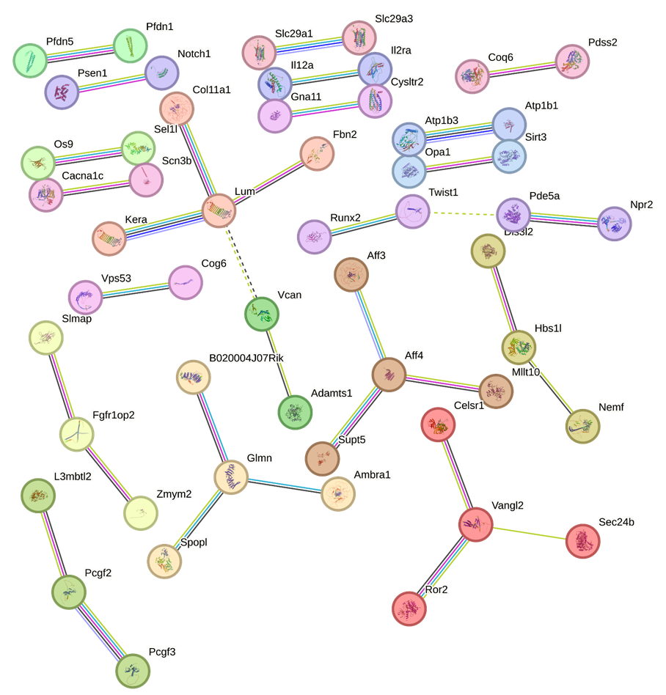

Supplemental figure S2. Analysis of protein:protein interactions within the 204 IMPC genes with a vertebral phenotype using the STRING biological database, with Markov Cluster Algorithm (MCL), showing the interactions with high (0.70–0.89) confidence.

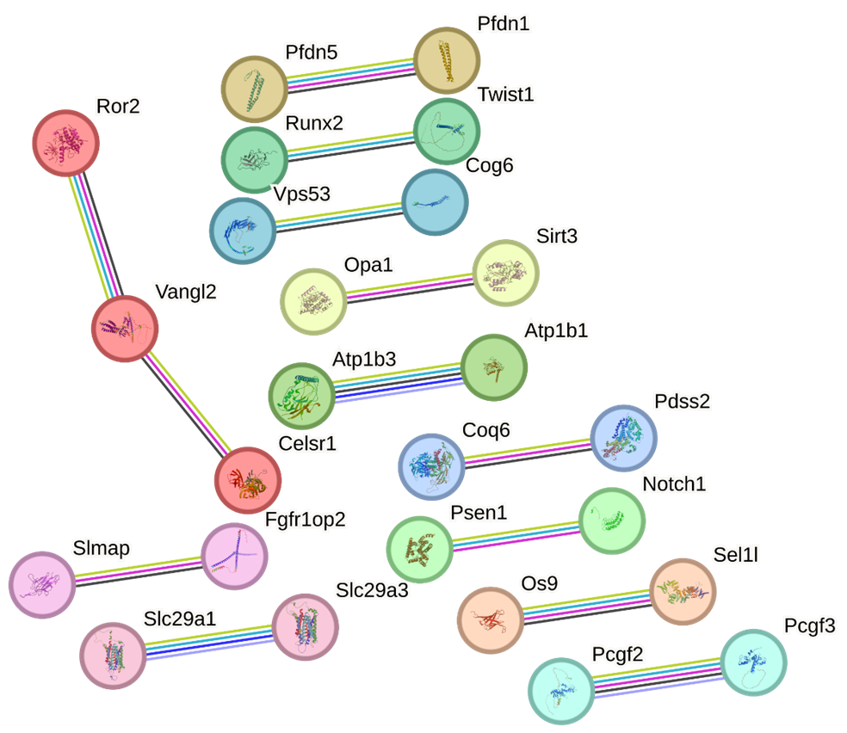

Supplemental figure S3. Analysis of protein:protein interactions within the 204 IMPC genes with a vertebral phenotype using the STRING biological database, with Markov Cluster Algorithm (MCL), showing the interactions with highest (0.90–1.0) confidence.

