SUPPLEMENTARY FILE

Supplementary Table S1. Databases queried for biological annotations for candidate gene prioritization.
Database (Abbreviation) | Annotation Type | URL | Reference
EBI Expression Atlas (EEA) | Expression | https://www.ebi.ac.uk/gxa/home/ | [1]
Gene eXpression Database (GXD) | Expression | http://www.informatics.jax.org/expression.shtml | [2]
Gene Ontology (GO) | Functional | http://www.geneontology.org/ | [3]
Mammalian Phenotype | Phenotypic | https://www.informatics.jax.org/vocab/mp_ontology | [4]
Disease Ontology (DO) | Phenotypic | https://disease-ontology.org/do | [5]

Supplementary Table S2. Descriptive statistics for cardiac GSH concentrations and redox status in male mice.
Cardiac concentrations of GSH (nmol/mg protein) and GSSG (nmol/mg protein) were quantified in samples collected from DO mice (100 males) by HPLC. Total glutathione concentrations were then calculated (GSH + 2GSSG), as were GSH/GSSG and E_{h} (mV).
Phenotype | N | x̄ | Median | SD | Min | Max
Total Glutathione (nmol/mg) | 100 | 8.49 | 7.71 | 3.27 | 3.72 | 20.41
GSH (nmol/mg) | 100 | 4.32 | 3.31 | 3.49 | 0.0007 | 15.99
GSSG (nmol/mg) | 100 | 2.08 | 1.98 | 0.78 | 1.02 | 5.80
GSH/GSSG | 100 | 2.54 | 1.84 | 2.30 | 0.002 | 11.25
E_{h} (mV) | 100 | -282.41 | -289.45 | 35.96 | -333.91 | -65.15

Supplementary Table S3. Descriptive statistics for cardiac GSH concentrations and redox status in female mice.
Cardiac concentrations of GSH (nmol/mg protein) and GSSG (nmol/mg protein) were quantified in samples collected from DO mice (108 females) by HPLC. Total glutathione concentrations were then calculated (GSH + 2GSSG), as were GSH/GSSG and E_{h} (mV).
Phenotype | N | x̄ | Median | SD | Min | Max
Total Glutathione (nmol/mg) | 108 | 7.71 | 7.48 | 2.24 | 3.78 | 14.01
GSH (nmol/mg) | 108 | 3.64 | 3.17 | 2.22 | 0.06 | 10.92
GSSG (nmol/mg) | 108 | 2.03 | 1.92 | 0.60 | 1.02 | 3.48
GSH/GSSG | 108 | 2.05 | 1.60 | 1.66 | 0.02 | 9.54
E_{h} (mV) | 108 | -283.37 | -285.16 | 23.95 | -326.55 | -172.10

Supplementary Table S4. Statistical correlations between markers of the cardiac GSH system.
Spearman’s rho (ρ) was calculated to understand relationships between cardiac GSH system markers. Cardiac GSH and GSSG concentrations were calculated using HPLC and standardized as nmol/mg protein. Concentrations were then used to calculate total glutathione (GSH + 2GSSG), GSH/GSSG, and E_{h} (expressed as mV).
Phenotype |  | ρ | p-value
GSH | GSSG | -0.39 | p < 0.001
GSH | Total Glutathione | 0.88 | p < 0.001
GSSG | Total Glutathione | 0.16 | p < 0.05
GSH | GSH/GSSG | 0.94 | p < 0.001
GSSG | GSH/GSSG | -0.65 | p < 0.001
Total Glutathione | GSH/GSSG | 0.59 | p < 0.001
GSH | E_{h} | -0.98 | p < 0.001
GSSG | E_{h} | 0.54 | p < 0.001
Total Glutathione | E_{h} | -0.69 | p < 0.001
GSH/GSSG | E_{h} | -0.99 | p < 0.001

Supplementary Table S5. Results of high-resolution association mapping of cardiac GSH redox system.
QTL peaks with LOD scores > 6 included within the table. Significant QTL position and respective Bayesian credible interval included in parentheses in Mbp. Total glutathione, GSH, and GSSG standardized to nmol/mg. E_{h} expressed in mV.
Phenotype | Chr | QTL Position (Mbp) | LOD | Genome-wide p-value
GSH | 14 | 54.240 (48.909 - 55.303) | 7.492 | 0.0905
E_{h} | 14 | 54.239 (48.905 - 55.226) | 6.969 | 0.2072
GSH | 16 | 96.736 (96.670 - 98.097) | 6.969 | 0.2076
GSH | 19 | 57.209 (57.981 - 57.523) | 6.596 | 0.3455
E_{h} | 16 | 96.736 (96.670 - 98.097) | 6.574 | 0.3555
GSSG | 10 | 124.104 (87.902 - 125.347) | 6.411 | 0.4318
GSH/GSSG | 14 | 54.239 (26.536 - 80.310) | 6.154 | 0.5654
E_{h} | 19 | 57.209 (3.2638 - 57.978) | 6.147 | 0.5689
GSH/GSSG | 5 | 38.839 (37.152 - 122.875) | 6.104 | 0.5923

Supplementary Table S6. Chr 16 GSH candidate genes and their relevant annotations (Chr16:96.670-98.097±1 Mbp; GRCm38/mm10)ª.
ªResource abbreviations: EEA, EBI Expression Atlas; DO, Disease Ontology; GO, Gene Ontology; GXD, Gene eXpression Database; MGI, Mouse Genome Informatics; MP, Mammalian Phenotype.
 |  |  |  | Expression |  | Functional | Phenotypic (cardiac-related)
MGI Gene/Marker ID | Symbol | Feature Type | Ensembl ID | MGI | EEA | GO | MP | Human
MGI:1310000 | Kcnj15 | protein coding gene | ENSMUSG00000062609 | x
MGI:95415 | Erg | protein coding gene | ENSMUSG00000040732 | x |  | x | x
MGI:95456 | Ets2 | protein coding gene | ENSMUSG00000022895 | x
MGI:1860263 | Psmg1 | protein coding gene | ENSMUSG00000022913 | x
MGI:1890651 | Brwd1 | protein coding gene | ENSMUSG00000022914 | x
MGI:96120 | Hmgn1 | protein coding gene | ENSMUSG00000040681 | x |  | x
MGI:2136882 | Get1 | protein coding gene | ENSMUSG00000023147 | x
MGI:1354740 | Sh3bgr | protein coding gene | ENSMUSG00000040666 | x
MGI:1354740 | Sh3bgr | protein coding gene | ENSMUSG00000040666 | x
MGI:97509 | Pcp4 | protein coding gene | ENSMUSG00000090223 | x
MGI:1860440 | Bace2 | protein coding gene | ENSMUSG00000040605 | x | x
MGI:1930121 | Prdm15 | protein coding gene | ENSMUSG00000014039 | x
MGI:1891883 | C2cd2 | protein coding gene | ENSMUSG00000045975 | x
MGI:1196281 | Dscam | protein coding gene | ENSMUSG00000050272 |  | x
MGI:97243 | Mx1 | polymorphic pseudogene | ENSMUSG00000000386 |  | x

 |  |  |  |  | Expression |  | Functional | Phenotypic (cardiac-related)
MGI Gene/Marker ID | Symbol | Name | Feature Type | Ensembl ID | MGI | EEA | GO | MP | Human
MGI:1098765 | Nrap | nebulin-related anchoring protein | protein coding gene | ENSMUSG00000049134 | x |  | x
MGI:87937 | Adrb1 | adrenergic receptor, beta 1 | protein coding gene | ENSMUSG00000035283 | x |  | x | x
MGI:1194500 | Ablim1 | actin-binding LIM protein 1 | protein coding gene | ENSMUSG00000025085 | x | x
MGI:2147749 | Atrnl1 | attractin like 1 | protein coding gene | ENSMUSG00000054843 | x
Supplementary Table S7. Chr 19 GSH candidate genes and their relevant annotations (Chr19:3.403-57.881±1 Mbp; GRCm38/mm10)ª.
ªResource abbreviations: EEA, EBI Expression Atlas; DO, Disease Ontology; GO, Gene Ontology; GXD, Gene eXpression Database; MGI, Mouse Genome Informatics; MP, Mammalian Phenotype.

Supplementary Table S8. Chr 10 GSSG candidate genes and their relevant annotations (Chr10:87.902-125.347±1 Mbp; GRCm38/mm10)ª.
ªResource abbreviations: EEA, EBI Expression Atlas; DO, Disease Ontology; GO, Gene Ontology; GXD, Gene eXpression Database; MGI, Mouse Genome Informatics; MP, Mammalian Phenotype.
 |  |  |  | Expression |  | Functional | Phenotypic (cardiac-related)
MGI Gene/Marker ID | Symbol | Feature Type | Ensembl ID | MGI | EEA | GO | MP | Human
MGI:1922567 | Parpbp | protein coding gene | ENSMUSG00000035365 | x | x
MGI:1919964 | Nup37 | protein coding gene | ENSMUSG00000035351 | x | x
MGI:2384841 | Chpt1 | protein coding gene | ENSMUSG00000060002 | x | x
MGI:1918780 | Gas2l3 | protein coding gene | ENSMUSG00000074802 | x | x
MGI:1916252 | 1500026H17Rik | lncRNA gene | ENSMUSG00000097383 | x | x
MGI:1306796 | Apaf1 | protein coding gene | ENSMUSG00000019979 | x | x | x
MGI:1353498 | Slc25a3 | protein coding gene | ENSMUSG00000061904 | x | x
MGI:106920 | Tmpo | protein coding gene | ENSMUSG00000019961 | x | x
MGI:97293 | Nedd1 | protein coding gene | ENSMUSG00000019988 | x | x
MGI:96836 | Lta4h | protein coding gene | ENSMUSG00000015889 | x | x
MGI:1888978 | Ntn4 | protein coding gene | ENSMUSG00000020019 | x | x
MGI:2143698 | Vezt | protein coding gene | ENSMUSG00000036099 | x | x
MGI:1336168 | Cradd | protein coding gene | ENSMUSG00000045867 | x | x
MGI:1333774 | Mrpl42 | protein coding gene | ENSMUSG00000062981 | x | x
MGI:3041208 | 4732465J04Rik | lncRNA gene | ENSMUSG00000101517 | x | x
MGI:2442192 | Eea1 | protein coding gene | ENSMUSG00000036499 | x | x
MGI:94872 | Dcn | protein coding gene | ENSMUSG00000019929 | x | x | x
MGI:109347 | Lum | protein coding gene | ENSMUSG00000036446 | x | x
MGI:104653 | Atp2b1 | protein coding gene | ENSMUSG00000019943 | x | x | x
MGI:1914853 | Dusp6 | protein coding gene | ENSMUSG00000019960 | x | x | x | x
MGI:3036255 | Tmtc3 | protein coding gene | ENSMUSG00000036676 | x | x
MGI:1202907 | Csrp2 | protein coding gene | ENSMUSG00000020186 | x | x
MGI:2443807 | Osbpl8 | protein coding gene | ENSMUSG00000020189 | x | x
MGI:1919019 | Bbs10 | protein coding gene | ENSMUSG00000035759 | x | x
MGI:1855693 | Nap1l1 | protein coding gene | ENSMUSG00000058799 | x | x
MGI:1096880 | Phlda1 | protein coding gene | ENSMUSG00000020205 | x | x
MGI:96668 | Kcnc2 | protein coding gene | ENSMUSG00000035681 | x | x | x
MGI:97809 | Ptprb | protein coding gene | ENSMUSG00000020154 | x | x
MGI:105933 | Rab3ip | protein coding gene | ENSMUSG00000064181 | x | x
MGI:2143561 | D630029K05Rik | lncRNA gene | ENSMUSG00000031294 | x | x
MGI:2448063 | Lrrc10 | protein coding gene | ENSMUSG00000060187 | x | x | x | x | x
MGI:1100860 | Frs2 | protein coding gene | ENSMUSG00000020170 | x | x | x | x
MGI:96952 | Mdm2 | protein coding gene | ENSMUSG00000020184 | x | x | x | x
MGI:1330301 | Dyrk2 | protein coding gene | ENSMUSG00000028630 | x | x
MGI:2443538 | Msrb3 | protein coding gene | ENSMUSG00000051236 | x | x | x
MGI:1859216 | Avpr1a | protein coding gene | ENSMUSG00000020123 | x | x | x | x
MGI:1914532 | Washc3 | protein coding gene | ENSMUSG00000020056 | x
MGI:1918962 | Dram1 | protein coding gene | ENSMUSG00000020057 |  | x
MGI:3643902 | Gnptab | protein coding gene | ENSMUSG00000035311 |  | x
MGI:3801878 | Gm16235 | lncRNA gene | ENSMUSG00000087429 |  | x
MGI:109542 | Sycp3 | protein coding gene | ENSMUSG00000020059 |  | x
MGI:1336213 | Mybpc1 | protein coding gene | ENSMUSG00000020061 |  | x
MGI:1341168 | Spic | protein coding gene | ENSMUSG00000004359 |  | x
MGI:3643371 | Gm4925 | pseudogene | ENSMUSG00000069540 |  | x
MGI:99436 | Arl1 | protein coding gene | ENSMUSG00000060904 |  | x
MGI:1917933 | Utp20 | protein coding gene | ENSMUSG00000004356 |  | x
MGI:2384916 | Slc5a8 | protein coding gene | ENSMUSG00000020062 |  | x
MGI:2443344 | Ano4 | protein coding gene | ENSMUSG00000035189 |  | x
MGI:1352464 | Nr1h4 | protein coding gene | ENSMUSG00000047638 |  | x
MGI:3039629 | Slc17a8 | protein coding gene | ENSMUSG00000019935 |  | x | x
MGI:1289172 | Scyl2 | protein coding gene | ENSMUSG00000069539 |  | x
MGI:1914269 | Actr6 | protein coding gene | ENSMUSG00000019948 |  | x
MGI:2442888 | Bltp3b | protein coding gene | ENSMUSG00000019951 |  | x
MGI:1924781 | Anks1b | protein coding gene | ENSMUSG00000058589 |  | x
MGI:1914704 | Ikbip | protein coding gene | ENSMUSG00000019975 |  | x
MGI:5453896 | Gm24119 | snoRNA gene | ENSMUSG00000077167 |  | x
MGI:5434113 | Gm20757 | lncRNA gene | ENSMUSG00000098040 |  | x
MGI:1922208 | Cfap54 | protein coding gene | ENSMUSG00000020014 |  | x
MGI:97517 | Cdk17 | protein coding gene | ENSMUSG00000020015 |  | x
MGI:101762 | Elk3 | protein coding gene | ENSMUSG00000008398 |  | x
MGI:96010 | Hal | protein coding gene | ENSMUSG00000020017 |  | x
MGI:1919011 | Amdhd1 | protein coding gene | ENSMUSG00000015890 |  | x
MGI:2444738 | Ccdc38 | protein coding gene | ENSMUSG00000036168 |  | x
MGI:1917128 | Snrpf | protein coding gene | ENSMUSG00000020018 |  | x
MGI:3801763 | Gm15915 | lncRNA gene | ENSMUSG00000085723 |  | x
MGI:3781748 | Gm3571 | pseudogene | ENSMUSG00000090610 |  | x
MGI:1929701 | Metap2 | protein coding gene | ENSMUSG00000036112 |  | x
MGI:1261419 | Fgd6 | protein coding gene | ENSMUSG00000020021 |  | x
MGI:1352465 | Nr2c1 | protein coding gene | ENSMUSG00000005897 |  | x
MGI:1913664 | Ndufa12 | protein coding gene | ENSMUSG00000020022 |  | x | x
MGI:2442900 | Tmcc3 | protein coding gene | ENSMUSG00000020023 |  | x
MGI:3801736 | Tmcc3os | antisense lncRNA gene | ENSMUSG00000086269 |  | x
MGI:5530918 | Mir7211 | miRNA gene | ENSMUSG00000098544 |  | x
MGI:1914973 | Cep83os | bidirectional promoter lncRNA gene | ENSMUSG00000097164 |  | x
MGI:1924298 | Cep83 | protein coding gene | ENSMUSG00000020024 |  | x
MGI:1890127 | Plxnc1 | protein coding gene | ENSMUSG00000074785 |  | x
MGI:1916879 | 2310039L15Rik | lncRNA gene | ENSMUSG00000100550 |  | x
MGI:1201787 | Socs2 | protein coding gene | ENSMUSG00000020027 |  | x
MGI:1917773 | 5730420D15Rik | lncRNA gene | ENSMUSG00000097766 |  | x
MGI:1934835 | Ube2n | protein coding gene | ENSMUSG00000074781 |  | x
MGI:1918457 | Nudt4 | protein coding gene | ENSMUSG00000020029 |  | x
MGI:4834226 | Mir3058 | miRNA gene | ENSMUSG00000092867 |  | x
MGI:3646302 | Anapc15-ps | pseudogene | ENSMUSG00000074780 |  | x
MGI:88215 | Btg1 | protein coding gene | ENSMUSG00000036478 |  | x
MGI:107942 | Epyc | protein coding gene | ENSMUSG00000019936 |  | x
MGI:1918511 | Poc1b | protein coding gene | ENSMUSG00000019952 |  | x
MGI:894692 | Galnt4 | protein coding gene | ENSMUSG00000090035 |  | x
MGI:96974 | Kitl | protein coding gene | ENSMUSG00000019966 |  | x
MGI:2384917 | Cep290 | protein coding gene | ENSMUSG00000019971 |  | x | x | x
MGI:1921197 | Rlig1 | protein coding gene | ENSMUSG00000046567 |  | x | x
MGI:1328351 | Nts | protein coding gene | ENSMUSG00000019890 |  | x
MGI:2384307 | Rassf9 | protein coding gene | ENSMUSG00000044921 |  | x
MGI:2143484 | Slc6a15 | protein coding gene | ENSMUSG00000019894 |  | x
MGI:1914057 | Tmtc2 | protein coding gene | ENSMUSG00000036019 |  | x
MGI:3783108 | Gm15666 | pseudogene | ENSMUSG00000084399 |  | x
MGI:3783105 | Gm15663 | lncRNA gene | ENSMUSG00000085282 |  | x
MGI:3041259 | Mettl25 | protein coding gene | ENSMUSG00000036009 |  | x
MGI:1289302 | Ccdc59 | protein coding gene | ENSMUSG00000019897 |  | x
MGI:2443834 | Ppfia2 | protein coding gene | ENSMUSG00000053825 |  | x
MGI:2685720 | Acss3 | protein coding gene | ENSMUSG00000035948 |  | x
MGI:2135609 | Lin7a | protein coding gene | ENSMUSG00000019906 |  | x
MGI:97253 | Myf6 | protein coding gene | ENSMUSG00000035923 |  | x
MGI:1096349 | Ptprq | protein coding gene | ENSMUSG00000035916 |  | x
MGI:3647600 | Otogl | protein coding gene | ENSMUSG00000091455 |  | x
MGI:1309528 | Ppp1r12a | protein coding gene | ENSMUSG00000019907 |  | x
MGI:2149961 | Pawr | protein coding gene | ENSMUSG00000035873 |  | x
MGI:99667 | Syt1 | protein coding gene | ENSMUSG00000035864 |  | x
MGI:2183703 | Nav3 | protein coding gene | ENSMUSG00000020181 |  | x
MGI:1289147 | E2f7 | protein coding gene | ENSMUSG00000020185 |  | x
MGI:2445110 | Zdhhc17 | protein coding gene | ENSMUSG00000035798 |  | x
MGI:5454894 | Gm25117 | snoRNA gene | ENSMUSG00000087819 |  | x
MGI:1918571 | 4933440J02Rik | lncRNA gene | ENSMUSG00000097082 |  | x
MGI:1289274 | Krr1 | protein coding gene | ENSMUSG00000063334 |  | x
MGI:1920940 | Glipr1 | protein coding gene | ENSMUSG00000056888 |  | x
MGI:3801764 | Gm15914 | pseudogene | ENSMUSG00000089667 |  | x
MGI:1914971 | Atxn7l3b | protein coding gene | ENSMUSG00000074748 |  | x
MGI:2384311 | Trhde | protein coding gene | ENSMUSG00000050663 |  | x
MGI:1913937 | Tbc1d15 | protein coding gene | ENSMUSG00000020130 |  | x
MGI:894308 | Rab21 | protein coding gene | ENSMUSG00000020132 |  | x
MGI:1914476 | Tmem19 | protein coding gene | ENSMUSG00000069520 |  | x
MGI:1914066 | Thap2 | protein coding gene | ENSMUSG00000020137 |  | x
MGI:2446143 | Zfc3h1 | protein coding gene | ENSMUSG00000034163 |  | x
MGI:1341817 | Lgr5 | protein coding gene | ENSMUSG00000020140 |  | x
MGI:2384918 | Tspan8 | protein coding gene | ENSMUSG00000034127 |  | x
MGI:109559 | Ptprr | protein coding gene | ENSMUSG00000020151 |  | x
MGI:1919318 | Cnot2 | protein coding gene | ENSMUSG00000020166 |  | x
MGI:3026931 | 5330438D12Rik | lncRNA gene | ENSMUSG00000052291 |  | x
MGI:2685085 | Myrfl | protein coding gene | ENSMUSG00000034057 |  | x
MGI:3580298 | Best3 | protein coding gene | ENSMUSG00000020169 |  | x
MGI:107186 | Cct2 | protein coding gene | ENSMUSG00000034024 |  | x
MGI:1927224 | Yeats4 | protein coding gene | ENSMUSG00000020171 |  | x
MGI:96897 | Lyz2 | protein coding gene | ENSMUSG00000069516 |  | x
MGI:96902 | Lyz1 | protein coding gene | ENSMUSG00000069515 |  | x
MGI:1913948 | Cpsf6 | protein coding gene | ENSMUSG00000055531 |  | x
MGI:1917824 | Cpm | protein coding gene | ENSMUSG00000020183 |  | x
MGI:2448489 | Slc35e3 | protein coding gene | ENSMUSG00000060181 |  | x
MGI:2143854 | Nup107 | protein coding gene | ENSMUSG00000052798 |  | x
MGI:894315 | Rap1b | protein coding gene | ENSMUSG00000052681 |  | x
MGI:96951 | Mdm1 | protein coding gene | ENSMUSG00000020212 |  | x
MGI:1921665 | 4932442E05Rik | protein coding gene | ENSMUSG00000104443 |  | x
MGI:1261820 | Cand1 | protein coding gene | ENSMUSG00000020114 |  | x
MGI:1921303 | Grip1 | protein coding gene | ENSMUSG00000034813 |  | x
MGI:1922226 | Grip1os1 | antisense lncRNA gene | ENSMUSG00000085418 |  | x
MGI:2152895 | Helb | protein coding gene | ENSMUSG00000020228 |  | x
MGI:1921164 | Irak3 | protein coding gene | ENSMUSG00000020227 |  | x
MGI:1915462 | Tmbim4 | protein coding gene | ENSMUSG00000020225 |  | x
MGI:1913475 | Llph | protein coding gene | ENSMUSG00000020224 |  | x
MGI:101761 | Hmga2 | protein coding gene | ENSMUSG00000056758 |  | x
MGI:2444388 | 9230105E05Rik | lncRNA gene | ENSMUSG00000090191 |  | x
MGI:1918124 | 4921513I03Rik | lncRNA gene | ENSMUSG00000044544 |  | x
MGI:3802142 | Gm15961 | lncRNA gene | ENSMUSG00000086444 |  | x
MGI:3802158 | Gm15910 | lncRNA gene | ENSMUSG00000087480 |  | x
MGI:3782657 | Gm4473 | lncRNA gene | ENSMUSG00000086522 |  | x
MGI:3580376 | Lemd3 | protein coding gene | ENSMUSG00000048661 |  | x
MGI:3801807 | Gm16166 | pseudogene | ENSMUSG00000082936 |  | x
MGI:1344332 | Wif1 | protein coding gene | ENSMUSG00000020218 |  | x | x
MGI:1921944 | Tbc1d30 | protein coding gene | ENSMUSG00000052302 |  | x
MGI:1922862 | Gns | protein coding gene | ENSMUSG00000034707 |  | x
MGI:2179722 | Rassf3 | protein coding gene | ENSMUSG00000025795 |  | x
MGI:1929658 | Tbk1 | protein coding gene | ENSMUSG00000020115 |  | x
MGI:1920442 | Xpot | protein coding gene | ENSMUSG00000034667 |  | x
MGI:2670984 | Kics2 | protein coding gene | ENSMUSG00000053684 |  | x
MGI:2152936 | Srgap1 | protein coding gene | ENSMUSG00000020121 |  | x
MGI:2384919 | Rxylt1 | protein coding gene | ENSMUSG00000034620 |  | x
MGI:3644454 | Gm9081 | pseudogene | ENSMUSG00000098138 |  | x
MGI:2442087 | Ppm1h | protein coding gene | ENSMUSG00000034613 |  | x
MGI:1914324 | Mon2 | protein coding gene | ENSMUSG00000034602 |  | x
MGI:101857 | Usp15 | protein coding gene | ENSMUSG00000020124 |  | x
MGI:2143691 | Tafa2 | protein coding gene | ENSMUSG00000044071 |  | x
MGI:1330284 | Slc16a7 | protein coding gene | ENSMUSG00000020102 |  | x
MGI:1913855 | 1700017N19Rik | protein coding gene | ENSMUSG00000056912 |  | x
MGI:1913272 | Kcnmb4 | protein coding gene | ENSMUSG00000054934 |  | x
MGI:6097756 | Gm48308 | unclassified gene | ENSMUSG00000112932 |  | x
MGI:5010165 | Gm17980 | pseudogene | ENSMUSG00000112259 |  | x
MGI:6097458 | Gm48106 | pseudogene | ENSMUSG00000112428 |  | x
MGI:5825829 | Gm46192 | pseudogene | ENSMUSG00000111919 |  | x
MGI:3645288 | Gm5780 | pseudogene | ENSMUSG00000112140 |  | x
MGI:1099806 | Rmst | lncRNA gene | ENSMUSG00000112117 |  | x
MGI:3648240 | Gm8512 | pseudogene | ENSMUSG00000111104 |  | x
MGI:3646193 | Gm4800 | pseudogene | ENSMUSG00000111759 |  | x
MGI:5454018 | Gm24241 | snoRNA gene | ENSMUSG00000088412 |  | x
MGI:6215303 | Gm49783 | unclassified gene | ENSMUSG00000111740 |  | x
MGI:3836967 | Mir1931 | miRNA gene | ENSMUSG00000089214 |  | x
MGI:5591847 | Gm32688 | lncRNA gene | ENSMUSG00000111531 |  | x
MGI:5009823 | Gm17745 | lncRNA gene | ENSMUSG00000110647 |  | x
MGI:1921704 | 4933408J17Rik | lncRNA gene | ENSMUSG00000097407 |  | x
MGI:3647055 | Gm8580 | pseudogene | ENSMUSG00000090159 |  | x
MGI:3802140 | Gm15963 | lncRNA gene | ENSMUSG00000086891 |  | x
MGI:3045318 | Usp44 | protein coding gene | ENSMUSG00000020020 |  | x
MGI:6215053 | Gm49628 | unclassified gene | ENSMUSG00000110869 |  | x
MGI:3801971 | Gm16155 | lncRNA gene | ENSMUSG00000085409 |  | x
MGI:6118596 | Gm49167 | unclassified gene | ENSMUSG00000112203 |  | x
MGI:6098317 | Gm48689 | lncRNA gene | ENSMUSG00000112669 |  | x
MGI:6098613 | Gm48868 | unclassified gene | ENSMUSG00000112677 |  | x
MGI:5588843 | Gm29684 | lncRNA gene | ENSMUSG00000112481 |  | x
MGI:6098634 | Gm48880 | unclassified gene | ENSMUSG00000112744 |  | x
MGI:6098637 | Gm48882 | lncRNA gene | ENSMUSG00000112593 |  | x
MGI:6096651 | Gm47599 | lncRNA gene | ENSMUSG00000112261 |  | x
MGI:6096827 | Gm47708 | lncRNA gene | ENSMUSG00000112188 |  | x
MGI:5592702 | Gm33543 | protein coding gene | ENSMUSG00000110353 |  | x
MGI:6097926 | Gm48427 | lncRNA gene | ENSMUSG00000112234 |  | x
MGI:6098057 | Gm48521 | lncRNA gene | ENSMUSG00000111912 |  | x
MGI:3648168 | Gm8613 | pseudogene | ENSMUSG00000112892 |  | x
MGI:4950405 | Mir3966 | miRNA gene | ENSMUSG00000105557 |  | x
MGI:5593456 | Gm34297 | lncRNA gene | ENSMUSG00000112874 |  | x
MGI:6098457 | Gm48768 | lncRNA gene | ENSMUSG00000112346 |  | x
MGI:3801746 | Gm16239 | lncRNA gene | ENSMUSG00000089994 |  | x
MGI:5593733 | Gm34574 | lncRNA gene | ENSMUSG00000112805 |  | x
MGI:5593936 | Gm34777 | lncRNA gene | ENSMUSG00000111923 |  | x
MGI:5594080 | Gm34921 | lncRNA gene | ENSMUSG00000112384 |  | x
MGI:6097430 | Gm48089 | lncRNA gene | ENSMUSG00000112544 |  | x
MGI:2445145 | B530045E10Rik | lncRNA gene | ENSMUSG00000044633 |  | x
MGI:95633 | Gad1-ps | pseudogene | ENSMUSG00000090665 |  | x
MGI:5594194 | Gm35035 | lncRNA gene | ENSMUSG00000112082 |  | x
MGI:1919082 | Csl | protein coding gene | ENSMUSG00000046934 |  | x
MGI:5594365 | Gm35206 | lncRNA gene | ENSMUSG00000112304 |  | x
MGI:5594692 | Gm35533 | lncRNA gene | ENSMUSG00000112831 |  | x
MGI:6096768 | Gm47673 | unclassified gene | ENSMUSG00000112580 |  | x
MGI:6097228 | Gm47956 | lncRNA gene | ENSMUSG00000112000 |  | x
MGI:6097597 | Gm48206 | unclassified gene | ENSMUSG00000112193 |  | x
MGI:6097591 | Gm48203 | unclassified gene | ENSMUSG00000112512 |  | x
MGI:6097599 | Gm48207 | unclassified gene | ENSMUSG00000112571 |  | x
MGI:6097740 | Gm48298 | unclassified gene | ENSMUSG00000112820 |  | x
MGI:3643034 | Rps15a-ps1 | pseudogene | ENSMUSG00000056877 |  | x
MGI:1923083 | 4930532I03Rik | lncRNA gene | ENSMUSG00000112201 |  | x
MGI:5595442 | Gm36283 | lncRNA gene | ENSMUSG00000112532 |  | x
MGI:6096432 | Gm47466 | pseudogene | ENSMUSG00000112065 |  | x
MGI:1925931 | 9230102K24Rik | lncRNA gene | ENSMUSG00000112398 |  | x
MGI:6098588 | Gm48851 | pseudogene | ENSMUSG00000112165 |  | x
MGI:3647789 | Rpl6l | pseudogene | ENSMUSG00000091086 |  | x
MGI:5010034 | Gm17849 | pseudogene | ENSMUSG00000112642 |  | x
MGI:3644450 | Gm5176 | pseudogene | ENSMUSG00000111997 |  | x
MGI:5589421 | Gm30262 | lncRNA gene | ENSMUSG00000112249 |  | x
MGI:5589783 | Gm30624 | lncRNA gene | ENSMUSG00000112430 |  | x
MGI:5011190 | Gm19005 | pseudogene | ENSMUSG00000112802 |  | x
MGI:5623650 | Gm40765 | lncRNA gene | ENSMUSG00000112087 |  | x
MGI:3783167 | Gm15723 | lncRNA gene | ENSMUSG00000084865 |  | x
MGI:2651811 | Tph2 | protein coding gene | ENSMUSG00000006764 |  | x | x
MGI:3645705 | Gm8942 | pseudogene | ENSMUSG00000111964 |  | x
MGI:3642645 | Gm10752 | unclassified gene | ENSMUSG00000112301 |  | x
MGI:2443640 | A130012E19Rik | lncRNA gene | ENSMUSG00000112822 |  | x
MGI:3642929 | Gm8960 | pseudogene | ENSMUSG00000112099 |  | x
MGI:6096692 | Gm47625 | unclassified gene | ENSMUSG00000112461 |  | x
MGI:6121539 | Gm49344 | unclassified gene | ENSMUSG00000112881 |  | x
MGI:5825840 | Gm46203 | pseudogene | ENSMUSG00000111937 |  | x
MGI:1918336 | 4933412E12Rik | lncRNA gene | ENSMUSG00000112627 |  | x
MGI:3646721 | Gm5781 | pseudogene | ENSMUSG00000111966 |  | x
MGI:3641810 | Gm10747 | lncRNA gene | ENSMUSG00000112242 |  | x
MGI:5591300 | Gm32141 | lncRNA gene | ENSMUSG00000112344 |  | x
MGI:1918317 | 4933411E08Rik | lncRNA gene | ENSMUSG00000112500 |  | x
MGI:5611080 | Gm37852 | unclassified gene | ENSMUSG00000102896 |  | x
MGI:6097232 | Gm47958 | lncRNA gene | ENSMUSG00000112684 |  | x
MGI:3646677 | Cdc5lrt3-ps | pseudogene | ENSMUSG00000112614 |  | x
MGI:5591961 | Cdc5lrt4 | protein coding gene | ENSMUSG00000112252 |  | x
MGI:3782240 | Gm4065 | lncRNA gene | ENSMUSG00000112198 |  | x
MGI:5621288 | Gm38403 | lncRNA gene | ENSMUSG00000112854 |  | x
MGI:5592836 | Gm33677 | lncRNA gene | ENSMUSG00000112778 |  | x
MGI:6096454 | Gm47480 | lncRNA gene | ENSMUSG00000112609 |  | x
MGI:6095713 | Gm47024 | unclassified gene | ENSMUSG00000112287 |  | x
MGI:6096236 | Gm47342 | lncRNA gene | ENSMUSG00000112243 |  | x
MGI:6095688 | Gm47009 | lncRNA gene | ENSMUSG00000112894 |  | x
MGI:6097469 | Gm48115 | unclassified gene | ENSMUSG00000112322 |  | x
MGI:2447818 | 1700006J14Rik | lncRNA gene | ENSMUSG00000034764 |  | x
MGI:3642299 | Gm10741 | lncRNA gene | ENSMUSG00000112431 |  | x
MGI:6098163 | Gm48591 | lncRNA gene | ENSMUSG00000112009 |  | x
MGI:5623672 | Gm40787 | lncRNA gene | ENSMUSG00000112539 |  | x
MGI:6098514 | Gm48804 | unclassified gene | ENSMUSG00000112596 |  | x
MGI:6098630 | Gm48878 | unclassified gene | ENSMUSG00000112794 |  | x
MGI:2441782 | Sros1 | lncRNA gene | ENSMUSG00000112095 |  | x
MGI:2444187 | A430028G04Rik | lncRNA gene | ENSMUSG00000112417 |  | x
MGI:5595367 | Gm36208 | lncRNA gene | ENSMUSG00000112220 |  | x
MGI:3028060 | D630033A02Rik | lncRNA gene | ENSMUSG00000112237 |  | x
MGI:3782305 | Gm4129 | lncRNA gene | ENSMUSG00000112294 |  | x
MGI:6097078 | Gm47862 | unclassified gene | ENSMUSG00000111943 |  | x

Supplementary Table S9. Cardiac GSH phenotypes exhibit mild to moderate heritability.
Heritability (H²) was estimated using R/qtl2 and kinship was accounted for using a linear mixed model.
Phenotype | Heritability
Cardiac GSH | 0.285
Cardiac GSSG | 0.205
Cardiac Total GSH | 0.094
Cardiac GSH/GSSG | 0.342
Cardiac redox potential | 0.464

Supplementary Table S10. Chr 14 GSH candidate genes and their relevant annotations (Chr14:48.909-55.303±1 Mbp; GRCm38/mm10)ª.
ªResource abbreviations: EEA, EBI Expression Atlas; DO, Disease Ontology; GO, Gene Ontology; GXD, Gene eXpression Database; MGI, Mouse Genome Informatics; MP, Mammalian Phenotype.
 |  |  |  | Expression |  | Functional | Phenotypic (cardiac-related)
MGI Gene/Marker ID | Symbol | Feature Type | Ensembl ID | GXD | EEA | GO | MP | DO
MGI:1914669 | Armh4 | protein coding gene | ENSMUSG00000036242 | x
MGI:2685134 | Ccnb1ip1 | protein coding gene | ENSMUSG00000071470 | x
MGI:1341112 | Parp2 | protein coding gene | ENSMUSG00000036023 | x |  | x
MGI:97919 | Rnase1 | protein coding gene | ENSMUSG00000035896 | x
MGI:1352498 | Ndrg2 | protein coding gene | ENSMUSG00000004558 | x |  | x
MGI:1917140 | Zfp219 | protein coding gene | ENSMUSG00000049295 | x
MGI:107795 | Hnrnpc | protein coding gene | ENSMUSG00000060373 | x
MGI:1915022 | Chd8 | protein coding gene | ENSMUSG00000053754 | x
MGI:1915389 | Tox4 | protein coding gene | ENSMUSG00000016831 | x
MGI:4439838 | Trac | gene segment | ENSMUSG00000076928 | x
MGI:101912 | Dad1 | protein coding gene | ENSMUSG00000022174 | x
MGI:1337120 | Slc7a7 | protein coding gene | ENSMUSG00000000958 | x |  | x | x
MGI:1916086 | Mrpl52 | protein coding gene | ENSMUSG00000010406 | x
MGI:101900 | Mmp14 | protein coding gene | ENSMUSG00000000957 | x
MGI:1929480 | Lrp10 | protein coding gene | ENSMUSG00000022175 | x
MGI:1355323 | Slc7a8 | protein coding gene | ENSMUSG00000022180 | x |  | x
MGI:105311 | Efs | protein coding gene | ENSMUSG00000022203 | x
MGI:97255 | Myh6 | protein coding gene | ENSMUSG00000040752 | x |  | x | x | x
MGI:2676883 | Mir208a | miRNA gene | ENSMUSG00000065432 | x |  | x | x
MGI:3642848 | Mhrt | lncRNA gene | ENSMUSG00000097652 | x
MGI:2155600 | Myh7 | protein coding gene | ENSMUSG00000053093 | x |  | x | x
MGI:3718461 | Mir208b | miRNA gene | ENSMUSG00000077928 | x |  | x
MGI:2686934 | Zfhx2 | protein coding gene | ENSMUSG00000040721 | x
MGI:1934682 | Emc9 | protein coding gene | ENSMUSG00000022217 | x
MGI:1096365 | Psme2 | protein coding gene | ENSMUSG00000079197 | x
MGI:1934704 | Rnf31 | protein coding gene | ENSMUSG00000047098 | x
MGI:107587 | Irf9 | protein coding gene | ENSMUSG00000002325 | x
MGI:1915131 | Mdp1 | protein coding gene | ENSMUSG00000002329 | x
MGI:97301 | Nedd8 | protein coding gene | ENSMUSG00000010376 | x
MGI:107246 | Tinf2 | protein coding gene | ENSMUSG00000007589 | x
MGI:99674 | Adcy4 | protein coding gene | ENSMUSG00000022220 | x
MGI:2154952 | Ripk3 | protein coding gene | ENSMUSG00000022221 | x |  | x
MGI:1920431 | Nfatc4 | protein coding gene | ENSMUSG00000023411 | x |  | x | x
MGI:3583292 | Otx2os1 | lincRNA | ENSMUSG00000098682 |  | x
MGI:1922538 | Slc35f4 | protein coding | ENSMUSG00000021852 |  | x
MGI:3650121 | Trav8d-1 | TR V gene | ENSMUSG00000076770 |  | x
MGI:3650631 | Trav9d-1 | TR V gene | ENSMUSG00000096478 |  | x
MGI:3649416 | Trav6d-5 | TR V gene | ENSMUSG00000095426 |  | x
MGI:3782037 | Trav4d-3 | TR V gene | ENSMUSG00000093939 |  | x
MGI:3647073 | Rps19-ps2 | Processed pseudogene | ENSMUSG00000094974 |  | x
MGI:2686335 | Trav6d-7 | TR V gene | ENSMUSG00000095756 |  | x
MGI:5293419 | Trav13d-3 | TR V gene | ENSMUSG00000095643 |  | x
MGI:3704436 | Trav16d-dv11 | TR V gene | ENSMUSG00000076796 |  | x
MGI:3647760 | Trav8d-2 | TR V gene | ENSMUSG00000076795 |  | x
MGI:4440515 | Trav13d-4 | TR V gene | ENSMUSG00000096329 |  | x
MGI:3822547 | Trav14d-3-dv8 | TR V gene | ENSMUSG00000094619 |  | x
MGI:3809200 | Trav9n-1 | TR V pseudogene | ENSMUSG00000092251 |  | x
MGI:3704437 | Trav6n-5 | TR V gene | ENSMUSG00000076800 |  | x

Supplementary Table S11. Top variants within +/- 1 Mbp of the 95% Bayesian credible interval for the Chr 14 GSH QTL.

snp | chr | pos | lod | ensembl_gene_id | consequence | description | chromosome_name | start_position | end_position | strand
rs51357179 | 14 | 48.02473 | 1.807696 |  | intergenic_variant | NA | NA | NA | NA | NA
rs31523260 | 14 | 48.55554 | 1.835033 |  | intergenic_variant | NA | NA | NA | NA | NA
rs50150098 | 14 | 48.77541 | 1.832831 | ENSMUSG00000098682 | ENSMUSG00000098682:intron_variant,ENSMUSG00000098682:non_coding_transcript_variant | orthodenticle homeobox 2 opposite strand 1 [Source:MGI Symbol;Acc:MGI:3583292] | 14 | 48906165 | 49109111 | 1
SV_14_48779257_48779275 | 14 | 48.77927 | 1.832831 | NA | NA | NA | NA | NA | NA | NA
SV_14_48828391_48828548 | 14 | 48.82847 | 1.79911 | NA | NA | NA | NA | NA | NA | NA
14:48881954_G/A | 14 | 48.88195 | 1.670297 |  | intergenic_variant | NA | NA | NA | NA | NA
SV_14_48956723_48956986 | 14 | 48.95685 | 1.737438 | NA | NA | NA | NA | NA | NA | NA
rs233172300 | 14 | 49.29198 | 1.676231 |  | intergenic_variant | NA | NA | NA | NA | NA
rs587249600 | 14 | 49.38534 | 3.154105 | ENSMUSG00000021852 | ENSMUSG00000021852:intron_variant,ENSMUSG00000021852:non_coding_transcript_variant | solute carrier family 35, member F4 [Source:MGI Symbol;Acc:MGI:1922538] | 14 | 49535976 | 49763503 | -1
SV_14_49396550_49396687 | 14 | 49.39662 | 2.277656 | NA | NA | NA | NA | NA | NA | NA
SV_14_49878403_49885148 | 14 | 49.88178 | 1.815075 | NA | NA | NA | NA | NA | NA | NA
SV_14_50306834_50307152 | 14 | 50.30699 | 2.270554 | NA | NA | NA | NA | NA | NA | NA
SV_14_52001626_52001848 | 14 | 52.00174 | 1.866519 | NA | NA | NA | NA | NA | NA | NA
14:52783834_C/T | 14 | 52.78383 | 1.824103 | ENSMUSG00000076770 | ENSMUSG00000076770:downstream_gene_variant | T cell receptor alpha variable 8D-1 [Source:MGI Symbol;Acc:MGI:3650121] | 14 | 53015904 | 53016452 | 1
14:52784086_T/A | 14 | 52.78409 | 1.824103 |  | intergenic_variant | NA | NA | NA | NA | NA
14:52784512_C/T | 14 | 52.78451 | 1.824103 |  | intergenic_variant | NA | NA | NA | NA | NA
14:52784536_T/A | 14 | 52.78454 | 1.824103 |  | intergenic_variant | NA | NA | NA | NA | NA
14:52785442_C/T | 14 | 52.78544 | 1.824103 |  | intergenic_variant | NA | NA | NA | NA | NA
14:52785448_T/C | 14 | 52.78545 | 1.824103 |  | intergenic_variant | NA | NA | NA | NA | NA
14:52785482_T/A | 14 | 52.78548 | 1.824103 |  | intergenic_variant | NA | NA | NA | NA | NA
14:52785490_A/C | 14 | 52.78549 | 1.824103 |  | intergenic_variant | NA | NA | NA | NA | NA
14:52785499_A/T | 14 | 52.7855 | 1.824103 |  | intergenic_variant | NA | NA | NA | NA | NA
14:52785638_A/G | 14 | 52.78564 | 1.824103 |  | intergenic_variant | NA | NA | NA | NA | NA
14:52785691_A/G | 14 | 52.78569 | 1.824103 |  | intergenic_variant | NA | NA | NA | NA | NA
14:52785714_T/C | 14 | 52.78571 | 1.824103 |  | intergenic_variant | NA | NA | NA | NA | NA
14:52785760_C/T | 14 | 52.78576 | 1.824103 |  | intergenic_variant | NA | NA | NA | NA | NA
14:52785892_A/T | 14 | 52.78589 | 1.824103 |  | intergenic_variant | NA | NA | NA | NA | NA
14:52785910_C/T | 14 | 52.78591 | 1.824103 |  | intergenic_variant | NA | NA | NA | NA | NA
14:52785977_G/A | 14 | 52.78598 | 1.824103 |  | intergenic_variant | NA | NA | NA | NA | NA
14:52786067_G/C | 14 | 52.78607 | 1.824103 |  | intergenic_variant | NA | NA | NA | NA | NA
14:52786112_G/C | 14 | 52.78611 | 1.824103 |  | intergenic_variant | NA | NA | NA | NA | NA
14:52786178_A/G | 14 | 52.78618 | 1.824103 |  | intergenic_variant | NA | NA | NA | NA | NA
14:52786288_G/A | 14 | 52.78629 | 1.824103 |  | intergenic_variant | NA | NA | NA | NA | NA
14:52786302_A/G | 14 | 52.7863 | 1.824103 |  | intergenic_variant | NA | NA | NA | NA | NA
14:52786513_G/A | 14 | 52.78651 | 1.824103 |  | intergenic_variant | NA | NA | NA | NA | NA
14:52786522_T/C | 14 | 52.78652 | 1.824103 |  | intergenic_variant | NA | NA | NA | NA | NA
14:52786724_C/T | 14 | 52.78672 | 1.824103 |  | intergenic_variant | NA | NA | NA | NA | NA
14:52786725_A/G | 14 | 52.78673 | 1.824103 |  | intergenic_variant | NA | NA | NA | NA | NA
14:52786739_G/C | 14 | 52.78674 | 1.824103 |  | intergenic_variant | NA | NA | NA | NA | NA
14:52786785_A/G | 14 | 52.78679 | 1.824103 |  | intergenic_variant | NA | NA | NA | NA | NA
14:52786820_G/A | 14 | 52.78682 | 1.824103 |  | intergenic_variant | NA | NA | NA | NA | NA
14:52786876_C/G | 14 | 52.78688 | 1.824103 |  | intergenic_variant | NA | NA | NA | NA | NA
14:52786966_A/G | 14 | 52.78697 | 1.824103 |  | intergenic_variant | NA | NA | NA | NA | NA
14:52787157_T/C | 14 | 52.78716 | 1.824103 |  | intergenic_variant | NA | NA | NA | NA | NA
14:52787176_C/T | 14 | 52.78718 | 1.824103 |  | intergenic_variant | NA | NA | NA | NA | NA
14:52787216_A/G | 14 | 52.78722 | 1.824103 | ENSMUSG00000096478 | ENSMUSG00000096478:upstream_gene_variant | T cell receptor alpha variable 9D-1 [Source:MGI Symbol;Acc:MGI:3650631] | 14 | 53029773 | 53030234 | 1
14:52787237_T/G | 14 | 52.78724 | 1.824103 | ENSMUSG00000096478 | ENSMUSG00000096478:upstream_gene_variant | T cell receptor alpha variable 9D-1 [Source:MGI Symbol;Acc:MGI:3650631] | 14 | 53029773 | 53030234 | 1
14:52787239_G/T | 14 | 52.78724 | 1.824103 | ENSMUSG00000096478 | ENSMUSG00000096478:upstream_gene_variant | T cell receptor alpha variable 9D-1 [Source:MGI Symbol;Acc:MGI:3650631] | 14 | 53029773 | 53030234 | 1
14:52787266_A/G | 14 | 52.78727 | 1.824103 | ENSMUSG00000096478 | ENSMUSG00000096478:upstream_gene_variant | T cell receptor alpha variable 9D-1 [Source:MGI Symbol;Acc:MGI:3650631] | 14 | 53029773 | 53030234 | 1
14:52787273_G/A | 14 | 52.78727 | 1.824103 | ENSMUSG00000096478 | ENSMUSG00000096478:upstream_gene_variant | T cell receptor alpha variable 9D-1 [Source:MGI Symbol;Acc:MGI:3650631] | 14 | 53029773 | 53030234 | 1
14:52787286_G/T | 14 | 52.78729 | 1.824103 | ENSMUSG00000096478 | ENSMUSG00000096478:upstream_gene_variant | T cell receptor alpha variable 9D-1 [Source:MGI Symbol;Acc:MGI:3650631] | 14 | 53029773 | 53030234 | 1
14:52788101_A/C | 14 | 52.7881 | 1.824103 | ENSMUSG00000096478 | ENSMUSG00000096478:upstream_gene_variant | T cell receptor alpha variable 9D-1 [Source:MGI Symbol;Acc:MGI:3650631] | 14 | 53029773 | 53030234 | 1
14:52788109_C/G | 14 | 52.78811 | 1.824103 | ENSMUSG00000096478 | ENSMUSG00000096478:upstream_gene_variant | T cell receptor alpha variable 9D-1 [Source:MGI Symbol;Acc:MGI:3650631] | 14 | 53029773 | 53030234 | 1
14:52789208_C/G | 14 | 52.78921 | 1.824103 | ENSMUSG00000096478 | ENSMUSG00000096478:upstream_gene_variant | T cell receptor alpha variable 9D-1 [Source:MGI Symbol;Acc:MGI:3650631] | 14 | 53029773 | 53030234 | 1
14:52789212_G/C | 14 | 52.78921 | 1.824103 | ENSMUSG00000096478 | ENSMUSG00000096478:upstream_gene_variant | T cell receptor alpha variable 9D-1 [Source:MGI Symbol;Acc:MGI:3650631] | 14 | 53029773 | 53030234 | 1
14:52789261_T/C | 14 | 52.78926 | 1.824103 | ENSMUSG00000096478 | ENSMUSG00000096478:upstream_gene_variant | T cell receptor alpha variable 9D-1 [Source:MGI Symbol;Acc:MGI:3650631] | 14 | 53029773 | 53030234 | 1
14:52789262_G/A | 14 | 52.78926 | 1.824103 | ENSMUSG00000096478 | ENSMUSG00000096478:upstream_gene_variant | T cell receptor alpha variable 9D-1 [Source:MGI Symbol;Acc:MGI:3650631] | 14 | 53029773 | 53030234 | 1
14:52789328_A/G | 14 | 52.78933 | 1.824103 | ENSMUSG00000096478 | ENSMUSG00000096478:upstream_gene_variant | T cell receptor alpha variable 9D-1 [Source:MGI Symbol;Acc:MGI:3650631] | 14 | 53029773 | 53030234 | 1
14:52790819_C/A | 14 | 52.79082 | 1.824103 | ENSMUSG00000095426,ENSMUSG00000096478 | ENSMUSG00000095426:upstream_gene_variant,ENSMUSG00000096478:upstream_gene_variant | NA | NA | NA | NA | NA
14:52790876_A/G | 14 | 52.79088 | 1.824103 | ENSMUSG00000095426,ENSMUSG00000096478 | ENSMUSG00000095426:upstream_gene_variant,ENSMUSG00000096478:upstream_gene_variant | NA | NA | NA | NA | NA
14:52790883_G/T | 14 | 52.79088 | 1.824103 | ENSMUSG00000095426,ENSMUSG00000096478 | ENSMUSG00000095426:upstream_gene_variant,ENSMUSG00000096478:upstream_gene_variant | NA | NA | NA | NA | NA
14:52790895_T/C | 14 | 52.7909 | 1.824103 | ENSMUSG00000095426,ENSMUSG00000096478 | ENSMUSG00000095426:upstream_gene_variant,ENSMUSG00000096478:upstream_gene_variant | NA | NA | NA | NA | NA
14:52790896_G/A | 14 | 52.7909 | 1.824103 | ENSMUSG00000095426,ENSMUSG00000096478 | ENSMUSG00000095426:upstream_gene_variant,ENSMUSG00000096478:upstream_gene_variant | NA | NA | NA | NA | NA
14:52790914_C/T | 14 | 52.79091 | 1.824103 | ENSMUSG00000095426,ENSMUSG00000096478 | ENSMUSG00000095426:upstream_gene_variant,ENSMUSG00000096478:upstream_gene_variant | NA | NA | NA | NA | NA
14:52790958_G/A | 14 | 52.79096 | 1.824103 | ENSMUSG00000095426,ENSMUSG00000096478 | ENSMUSG00000095426:upstream_gene_variant,ENSMUSG00000096478:upstream_gene_variant | NA | NA | NA | NA | NA
14:52791168_A/G | 14 | 52.79117 | 1.824103 | ENSMUSG00000095426,ENSMUSG00000096478 | ENSMUSG00000095426:upstream_gene_variant,ENSMUSG00000096478:upstream_gene_variant | NA | NA | NA | NA | NA
14:52791172_A/G | 14 | 52.79117 | 1.824103 | ENSMUSG00000095426,ENSMUSG00000096478 | ENSMUSG00000095426:upstream_gene_variant,ENSMUSG00000096478:upstream_gene_variant | NA | NA | NA | NA | NA
14:52791220_G/A | 14 | 52.79122 | 1.824103 | ENSMUSG00000095426,ENSMUSG00000096478 | ENSMUSG00000095426:upstream_gene_variant,ENSMUSG00000096478:upstream_gene_variant | NA | NA | NA | NA | NA
14:52791406_T/C | 14 | 52.79141 | 1.824103 | ENSMUSG00000095426,ENSMUSG00000096478 | ENSMUSG00000095426:upstream_gene_variant,ENSMUSG00000096478:upstream_gene_variant | NA | NA | NA | NA | NA
14:52791637_G/A | 14 | 52.79164 | 1.824103 | ENSMUSG00000095426,ENSMUSG00000096478 | ENSMUSG00000095426:upstream_gene_variant,ENSMUSG00000096478:upstream_gene_variant | NA | NA | NA | NA | NA
14:52791700_G/A | 14 | 52.7917 | 1.824103 | ENSMUSG00000095426,ENSMUSG00000096478 | ENSMUSG00000095426:upstream_gene_variant,ENSMUSG00000096478:upstream_gene_variant | NA | NA | NA | NA | NA
14:52791711_C/T | 14 | 52.79171 | 1.824103 | ENSMUSG00000095426,ENSMUSG00000096478 | ENSMUSG00000095426:upstream_gene_variant,ENSMUSG00000096478:upstream_gene_variant | NA | NA | NA | NA | NA
14:52791966_A/G | 14 | 52.79197 | 1.880665 | ENSMUSG00000095426,ENSMUSG00000096478 | ENSMUSG00000095426:upstream_gene_variant,ENSMUSG00000096478:upstream_gene_variant | NA | NA | NA | NA | NA
14:52792164_G/T | 14 | 52.79216 | 1.811398 | ENSMUSG00000095426,ENSMUSG00000096478 | ENSMUSG00000095426:upstream_gene_variant,ENSMUSG00000096478:upstream_gene_variant | NA | NA | NA | NA | NA
14:52793524_C/T | 14 | 52.79352 | 1.811398 | ENSMUSG00000095426,ENSMUSG00000096478 | ENSMUSG00000095426:upstream_gene_variant,ENSMUSG00000096478:downstream_gene_variant | NA | NA | NA | NA | NA
SV_14_52794325_52799325 | 14 | 52.79683 | 1.811398 | NA | NA | NA | NA | NA | NA | NA
14:52802543_C/T | 14 | 52.80254 | 1.811398 |  | intergenic_variant | NA | NA | NA | NA | NA
14:52802563_G/A | 14 | 52.80256 | 1.811398 |  | intergenic_variant | NA | NA | NA | NA | NA
14:52802736_C/T | 14 | 52.80274 | 1.811398 |  | intergenic_variant | NA | NA | NA | NA | NA
14:52803018_A/G | 14 | 52.80302 | 1.811398 |  | intergenic_variant | NA | NA | NA | NA | NA
14:52803166_G/A | 14 | 52.80317 | 1.811398 |  | intergenic_variant | NA | NA | NA | NA | NA
SV_14_52801325_52806325 | 14 | 52.80383 | 1.811398 | NA | NA | NA | NA | NA | NA | NA
SV_14_52816304_52818661 | 14 | 52.81748 | 1.811398 | NA | NA | NA | NA | NA | NA | NA
SV_14_52832325_52835325 | 14 | 52.83383 | 1.811398 | NA | NA | NA | NA | NA | NA | NA
14:52905435_T/C | 14 | 52.90544 | 1.811398 | ENSMUSG00000093939,ENSMUSG00000094974 | ENSMUSG00000093939:downstream_gene_variant,ENSMUSG00000094974:downstream_gene_variant | NA | NA | NA | NA | NA
SV_14_52913325_52930325 | 14 | 52.92183 | 1.811398 | NA | NA | NA | NA | NA | NA | NA
SV_14_52932325_52950325 | 14 | 52.94133 | 1.811398 | NA | NA | NA | NA | NA | NA | NA
SV_14_52947325_52950325 | 14 | 52.94883 | 1.811398 | NA | NA | NA | NA | NA | NA | NA
14:52959387_T/C | 14 | 52.95939 | 1.811398 | ENSMUSG00000096610 | ENSMUSG00000096610:downstream_gene_variant | NA | NA | NA | NA | NA
rs580173868 | 14 | 53.0116 | 1.811398 | ENSMUSG00000095756 | ENSMUSG00000095756:downstream_gene_variant | T cell receptor alpha variable 6D-7 [Source:MGI Symbol;Acc:MGI:2686335] | 14 | 53245069 | 53245555 | 1
14:53036863_A/C | 14 | 53.03686 | 1.811398 | ENSMUSG00000095643 | ENSMUSG00000095643:downstream_gene_variant | T cell receptor alpha variable 13D-3 [Source:MGI Symbol;Acc:MGI:5293419] | 14 | 53270305 | 53270876 | 1
14:53041864_G/A | 14 | 53.04186 | 1.728944 | ENSMUSG00000076795 | ENSMUSG00000076795:upstream_gene_variant | T cell receptor alpha variable 8D-2 [Source:MGI Symbol;Acc:MGI:3647760] | 14 | 53279885 | 53280348 | 1
14:53041929_A/T | 14 | 53.04193 | 1.728944 | ENSMUSG00000076795 | ENSMUSG00000076795:upstream_gene_variant | T cell receptor alpha variable 8D-2 [Source:MGI Symbol;Acc:MGI:3647760] | 14 | 53279885 | 53280348 | 1
14:53041942_A/G | 14 | 53.04194 | 1.728944 | ENSMUSG00000076795 | ENSMUSG00000076795:upstream_gene_variant | T cell receptor alpha variable 8D-2 [Source:MGI Symbol;Acc:MGI:3647760] | 14 | 53279885 | 53280348 | 1
14:53041947_C/T | 14 | 53.04195 | 1.728944 | ENSMUSG00000076795 | ENSMUSG00000076795:upstream_gene_variant | T cell receptor alpha variable 8D-2 [Source:MGI Symbol;Acc:MGI:3647760] | 14 | 53279885 | 53280348 | 1
14:53042136_A/C | 14 | 53.04214 | 1.728944 | ENSMUSG00000076795 | ENSMUSG00000076795:upstream_gene_variant | T cell receptor alpha variable 8D-2 [Source:MGI Symbol;Acc:MGI:3647760] | 14 | 53279885 | 53280348 | 1
14:53042862_A/T | 14 | 53.04286 | 1.728944 | ENSMUSG00000076796,ENSMUSG00000076795 | ENSMUSG00000076796:upstream_gene_variant,ENSMUSG00000076795:missense_variant | NA | NA | NA | NA | NA
14:53044919_G/A | 14 | 53.04492 | 1.728944 | ENSMUSG00000076796,ENSMUSG00000076795 | ENSMUSG00000076796:upstream_gene_variant,ENSMUSG00000076795:downstream_gene_variant | NA | NA | NA | NA | NA
14:53045000_A/G | 14 | 53.045 | 1.728944 | ENSMUSG00000076796,ENSMUSG00000076795 | ENSMUSG00000076796:upstream_gene_variant,ENSMUSG00000076795:downstream_gene_variant | NA | NA | NA | NA | NA
14:53045097_A/C | 14 | 53.0451 | 1.728944 | ENSMUSG00000076796,ENSMUSG00000076795 | ENSMUSG00000076796:upstream_gene_variant,ENSMUSG00000076795:downstream_gene_variant | NA | NA | NA | NA | NA
14:53045159_A/G | 14 | 53.04516 | 1.728944 | ENSMUSG00000076796,ENSMUSG00000076795 | ENSMUSG00000076796:upstream_gene_variant,ENSMUSG00000076795:downstream_gene_variant | NA | NA | NA | NA | NA
14:53045161_C/A | 14 | 53.04516 | 1.728944 | ENSMUSG00000076796,ENSMUSG00000076795 | ENSMUSG00000076796:upstream_gene_variant,ENSMUSG00000076795:downstream_gene_variant | NA | NA | NA | NA | NA
14:53045182_T/G | 14 | 53.04518 | 1.728944 | ENSMUSG00000076796,ENSMUSG00000076795 | ENSMUSG00000076796:upstream_gene_variant,ENSMUSG00000076795:downstream_gene_variant | NA | NA | NA | NA | NA
14:53045192_C/T | 14 | 53.04519 | 1.728944 | ENSMUSG00000076796,ENSMUSG00000076795 | ENSMUSG00000076796:upstream_gene_variant,ENSMUSG00000076795:downstream_gene_variant | NA | NA | NA | NA | NA
14:53045411_C/G | 14 | 53.04541 | 1.728944 | ENSMUSG00000076796,ENSMUSG00000076795 | ENSMUSG00000076796:upstream_gene_variant,ENSMUSG00000076795:downstream_gene_variant | NA | NA | NA | NA | NA
14:53073124_G/A | 14 | 53.07312 | 1.728944 | ENSMUSG00000096329 | ENSMUSG00000096329:missense_variant | T cell receptor alpha variable 13D-4 [Source:MGI Symbol;Acc:MGI:4440515] | 14 | 53310220 | 53310731 | 1
14:53073138_C/A | 14 | 53.07314 | 1.728944 | ENSMUSG00000096329 | ENSMUSG00000096329:missense_variant | T cell receptor alpha variable 13D-4 [Source:MGI Symbol;Acc:MGI:4440515] | 14 | 53310220 | 53310731 | 1
14:53073141_G/A | 14 | 53.07314 | 1.728944 | ENSMUSG00000096329 | ENSMUSG00000096329:synonymous_variant | T cell receptor alpha variable 13D-4 [Source:MGI Symbol;Acc:MGI:4440515] | 14 | 53310220 | 53310731 | 1
14:53073144_G/C | 14 | 53.07314 | 1.728944 | ENSMUSG00000096329 | ENSMUSG00000096329:missense_variant | T cell receptor alpha variable 13D-4 [Source:MGI Symbol;Acc:MGI:4440515] | 14 | 53310220 | 53310731 | 1
14:53073499_T/G | 14 | 53.0735 | 1.728944 | ENSMUSG00000096329 | ENSMUSG00000096329:downstream_gene_variant | T cell receptor alpha variable 13D-4 [Source:MGI Symbol;Acc:MGI:4440515] | 14 | 53310220 | 53310731 | 1
14:53079883_A/C | 14 | 53.07988 | 1.728944 | ENSMUSG00000094619 | ENSMUSG00000094619:downstream_gene_variant | T cell receptor alpha variable 14D-3-DV8 [Source:MGI Symbol;Acc:MGI:3822547] | 14 | 53315909 | 53316502 | 1
14:53080779_C/T | 14 | 53.08078 | 1.728944 | ENSMUSG00000094619 | ENSMUSG00000094619:downstream_gene_variant | T cell receptor alpha variable 14D-3-DV8 [Source:MGI Symbol;Acc:MGI:3822547] | 14 | 53315909 | 53316502 | 1
rs581643538 | 14 | 53.086 | 1.712135 |  | intergenic_variant | NA | NA | NA | NA | NA
rs583568686 | 14 | 53.0861 | 1.712135 |  | intergenic_variant | NA | NA | NA | NA | NA
rs581595096 | 14 | 53.10345 | 1.704822 | ENSMUSG00000092251,ENSMUSG00000076800 | ENSMUSG00000092251:downstream_gene_variant,ENSMUSG00000076800:upstream_gene_variant | NA | NA | NA | NA | NA
rs579329102 | 14 | 53.1035 | 1.704822 | ENSMUSG00000092251,ENSMUSG00000076800 | ENSMUSG00000092251:downstream_gene_variant,ENSMUSG00000076800:upstream_gene_variant | NA | NA | NA | NA | NA
rs581826557 | 14 | 53.10395 | 1.704822 | ENSMUSG00000092251,ENSMUSG00000076800 | ENSMUSG00000092251:downstream_gene_variant,ENSMUSG00000076800:upstream_gene_variant | NA | NA | NA | NA | NA
SV_14_53475156_53479681 | 14 | 53.47742 | 2.602466 | NA | NA | NA | NA | NA | NA | NA
SV_14_54091931_54091933 | 14 | 54.09193 | 2.232443 | NA | NA | NA | NA | NA | NA | NA
SV_14_54279758_54279776 | 14 | 54.27977 | 2.491346 | NA | NA | NA | NA | NA | NA | NA
SV_14_54342903_54343261 | 14 | 54.34308 | 2.523437 | NA | NA | NA | NA | NA | NA | NA
SV_14_54437885_54438132 | 14 | 54.43801 | 1.828878 | NA | NA | NA | NA | NA | NA | NA
SV_14_54500801_54501021 | 14 | 54.50091 | 1.827889 | NA | NA | NA | NA | NA | NA | NA
SV_14_54676272_54676274 | 14 | 54.67627 | 1.665028 | NA | NA | NA | NA | NA | NA | NA

Supplementary Table S12. Compilation of renal, hepatic, and cardiac GSH system QTL intervals.
 | Phenotype | LOD | Chr | QTL Position (Mbp) | QTL Position (cM)
Renal | Total Glutathione | 6.298 | 2 | 52.657 (19.817 – 61.128) | 30.193 (14.085 – 35.317)
Renal | Total Glutathione | 6.428 | 11 | 100.804 (100.059 – 101.369) | 63.671 (63.395 – 64.832)
Renal | Total Glutathione | 7.105 | X | 51.602 (49.234 – 51.892) | 28.205 (25.870 – 28.316)
Renal | GSH | 6.249 | 2 | 52.657 (19.817 – 64.003) | 30.193 (14.085 – 37.364)
Renal | GSH | 6.664 | 11 | 100.810 (100.059 – 101.369) | 63.682 (63.395 – 64.832)
Renal | GSH | 6.962 | X | 51.602 (49.234 – 51.892) | 28.205 (25.870 – 28.316)
Renal | GSSG | 6.044 | 1 | 144.970 (143.603 – 148.590) | 63.069 (62.513 – 63.371)
Renal | GSSG | 6.048 | 16 | 62.938 (61.291 – 72.202) | 36.457 (36.121 – 40.793)
Renal | GSH/GSSG | 6.032 | 13 | 71.522 (71.458 – 72.209) | 38.009 (37.975 – 38.731)
Renal | E_{h} | 6.258 | 14 | 22.959 (22.359 – 23.926) | 12.791 (12.204 – 14.152)
Renal | BUN | 6.06 | 6 | 127.602 (125.386 – 128.618) | 62.438 (59.395 – 63.065)
Hepatic | Total Glutathione | 6.748 | 14 | 22.506 (22.058 – 22.528) | 12.355 (12.035 – 12.377)
Hepatic | Total Glutathione | 6.011 | 18 | 51.537 (35.120 – 76.532) | 28.097 (18.887 – 51.726)
Hepatic | GSH | 6.755 | 14 | 22.506 (22.058 – 22.528) | 12.355 (12.035 – 12.377)
Hepatic | GSSG | 6.283 | 1 | 21.043 (18.793 – 22.050) | 6.502 (5.847 – 8.186)
Hepatic | GSSG | 6.178 | 2 | 91.523 (78.897 – 91.656) | 50.598 (47.166 – 50.641)
Hepatic | GSSG | 6.149 | 18 | 53.075 (50.199 – 82.487) | 28.328 (27.234 – 55.913)
Hepatic | GSH/GSSG | 6.407 | 11 | 6.017 (5.568 – 7.583) | 3.906 (3.664 – 4.782)
Hepatic | GSH/GSSG | 8.224 | 16 | 8.998 (8.865 – 10.077) | 4.779 (4.433 – 5.470)
Hepatic | E_{h} | 6.48 | 16 | 6.997 (3.526 – 8.225) | 3.373 (2.074 – 3.621)
Hepatic | E_{h} | 8.598 | 16 | 8.998 (8.865 – 10.324) | 4.779 (4.433 – 5.579)
Hepatic | NADPH | 6.352 | 2 | 173.408 (173.133 – 174.508) | 96.424 (95.769 – 97.976)
Hepatic | NADPH | 6.612 | 12 | 28.626 (28.578 – 29.450) | 10.987 (10.975 – 11.927)
Hepatic | NADPH | 6.287 | 17 | 51.366 (50.164 – 52.542) | 26.684 (25.861 – 27.425)
Hepatic | NADP⁺ | 7.032 | 3 | 110.517 (109.677 – 115.729) | 48.547 (48.380 – 50.024)
Hepatic | NADP⁺ | 6.59 | 8 | 61.237 (60.722 – 65.378) | 30.937 (30.901 – 32.757)
Hepatic | NADP⁺/NADPH | 7.637 | 12 | 28.626 (28.562 – 29.394) | 10.987 (10.972 – 11.864)
Hepatic | NADH | 6.062 | 14 | 100.731 (99.320 – 102.809) | 50.508 (49.350 – 52.844)

Cardiac | GSH | 7.4922555 | 14 | 54.23953 (48.909 - 55.303) | 27.551 (25.407 - 27.966)
Cardiac | E_{h} | 6.96993055 | 14 | 54.23953 (48.905271 - 55.226142) | 27.551 (25.405 - 27.936)
Cardiac | GSH | 6.96857156 | 16 | 96.735776 (96.670 - 98.097) | 57.035 (57.016 - 57.841)
Cardiac | GSH | 6.59622423 | 19 | 57.209308 (57.981 - 57.523) | 52.157 (3.158 - 53.747)
Cardiac | E_{h} | 6.57350903 | 16 | 96.735776 (96.670035 - 98.096875) | 57.035 (57.016 - 57.841)
Cardiac | GSSG | 6.41088918 | 10 | 124.103853 (87.902 - 125.347) | 72.222 (43.709 - 72.548)
Cardiac | GSH/GSSG | 6.15378124 | 14 | 54.23953 (26.536 - 80.310) | 27.551 (11.224 - 42.809)
Cardiac | E_{h} | 6.14726648 | 19 | 57.209308 (3.263752 - 57.978364) | 52.157 (3.097 - 53.882)
Cardiac | GSH/GSSG | 6.10393796 | 5 | 38.838612 (37.152 - 122.875) | 20.787 (17.501 - 82.49)

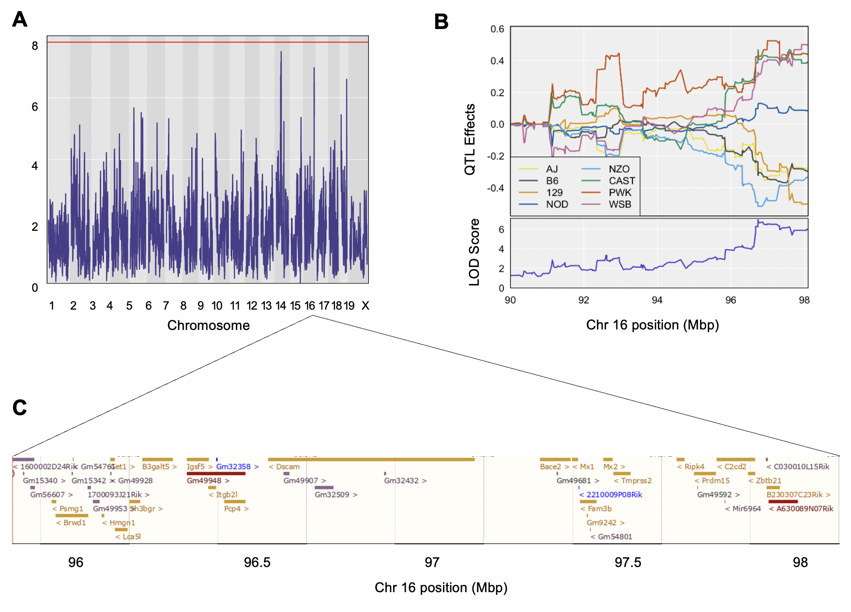
Supplementary Figure S1. High-resolution QTL mapping of cardiac GSH reveals a suggestive peak on murine chromosome 16. A. Genome-wide scan of cardiac GSH (nmol/μg) contains a QTL with LOD score 6.969 located at 96.735776 Mbp. The permutation-derived threshold is indicated by the red colored line at significance (α) level 0.05. B. Founder allele QTL effects for this locus. Each colored line represents one of eight DO founder alleles as indicated in the legend. The differences between strains are considered significant when the LOD score (bottom plot) crosses the significance thresholds established in panel A. C. Candidate genes found within the QTL interval extracted from the Ensembl genome browser.
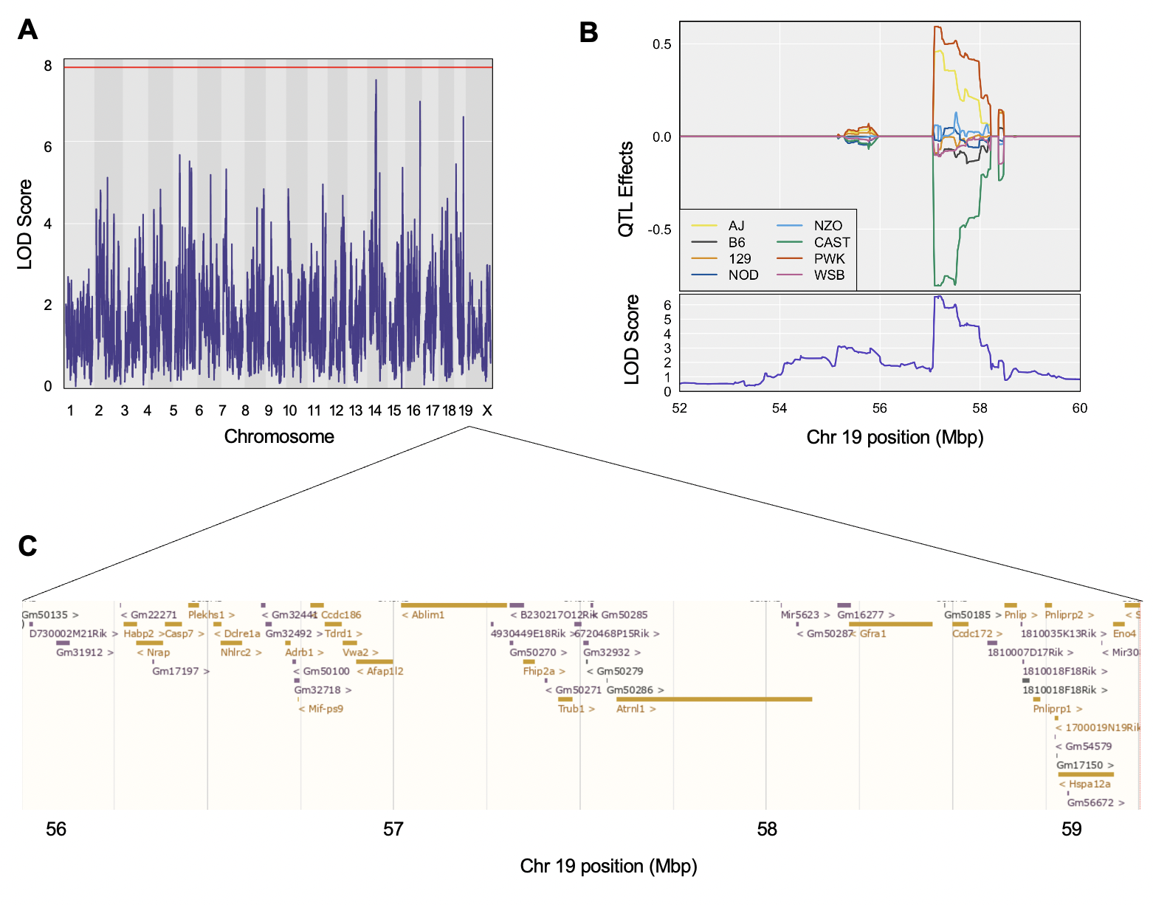
Supplementary Figure S2. High-resolution QTL mapping of cardiac GSH reveals a suggestive peak on murine chromosome 19. A. Genome-wide scan of cardiac GSH (nmol/μg) contains a QTL with LOD score 6.596 located at 57.209 Mbp. The permutation-derived threshold is indicated by the red colored line at significance (α) level 0.05. B. Founder allele QTL effects for this locus. Each colored line represents one of eight DO founder alleles as indicated in the legend. The differences between strains are considered significant when the LOD score (bottom plot) crosses the significance thresholds established in panel A. C. Candidate genes found within the QTL interval extracted from tbe Ensembl genome browser.

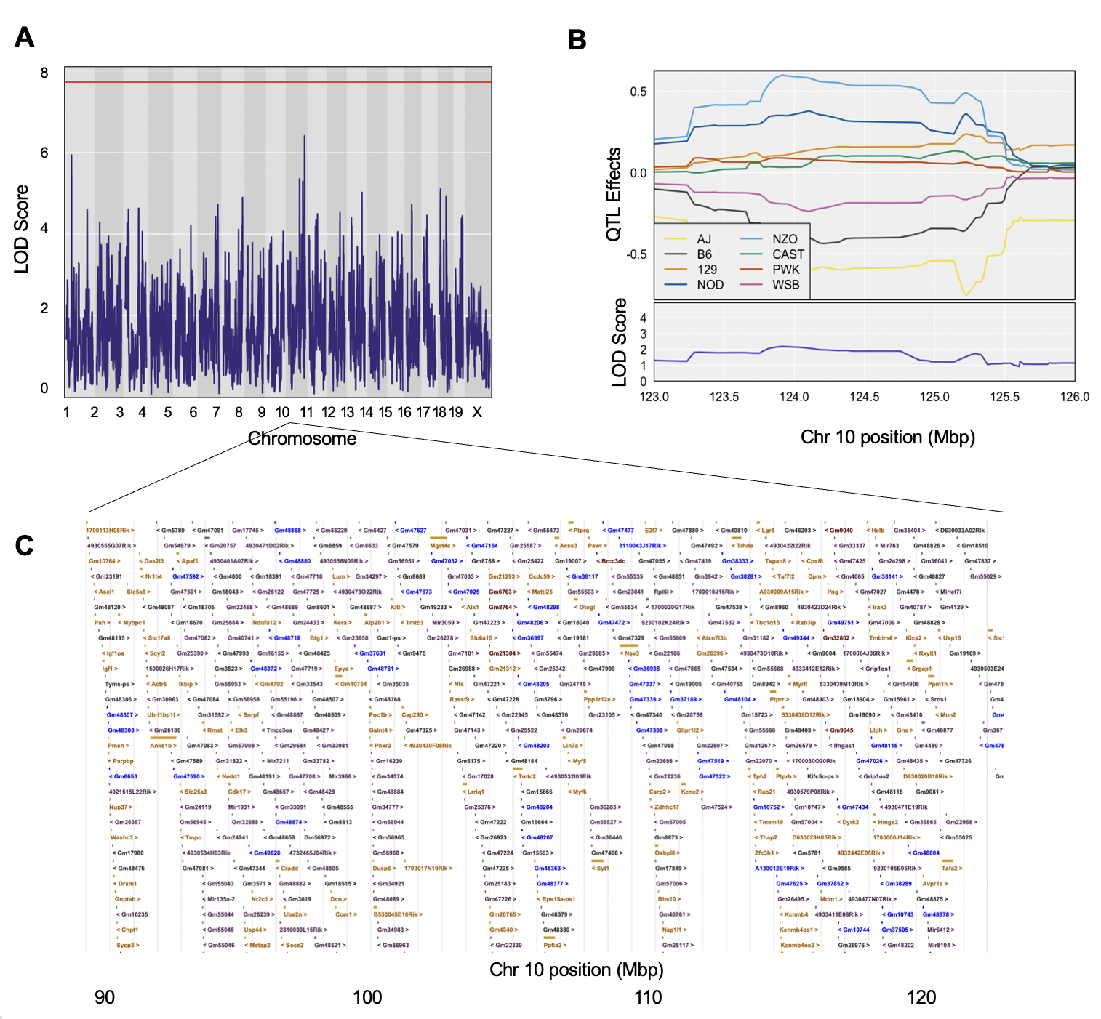
Supplementary Figure S3. High-resolution QTL mapping of cardiac GSSG reveals a suggestive peak on murine chromosome 10. A. Genome-wide scan of cardiac GSSG (nmol/μg) contains a QTL with LOD score 6.411 located at 124.11 Mbp. The permutation-derived threshold is indicated by the red colored line at significance (α) level 0.05. B. Founder allele QTL effects for this locus. Each colored line represents one of eight DO founder alleles as indicated in the legend. The differences between strains are considered significant when the LOD score (bottom plot) crosses the significance thresholds established in panel A. C. Candidate genes found within the QTL interval extracted from tbe Ensembl genome browser.

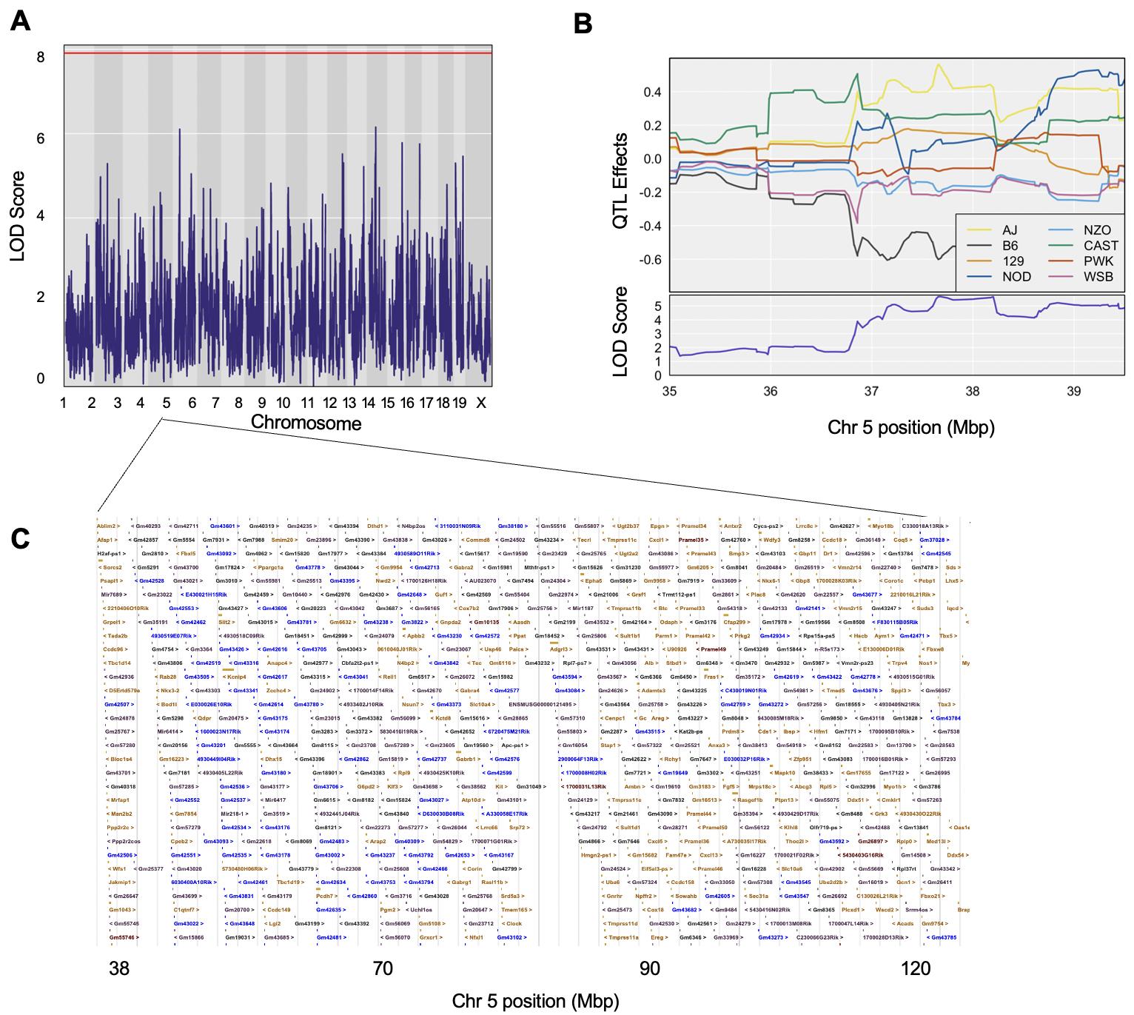

Supplementary Figure S4. High-resolution QTL mapping of cardiac GSH/GSSG reveals a suggestive peak on murine chromosome 5. A. Genome-wide scan of cardiac GSSG/GSSG contains a QTL with LOD score 6.103 located at 38.839 Mbp. The permutation-derived threshold is indicated by the red colored line at significance (α) level 0.05. B. Founder allele QTL effects for this locus. Each colored line represents one of eight DO founder alleles as indicated in the legend. The differences between strains are considered significant when the LOD score (bottom plot) crosses the significance thresholds established in panel A. C. Candidate genes found within the QTL interval extracted from tbe Ensembl genome browser.

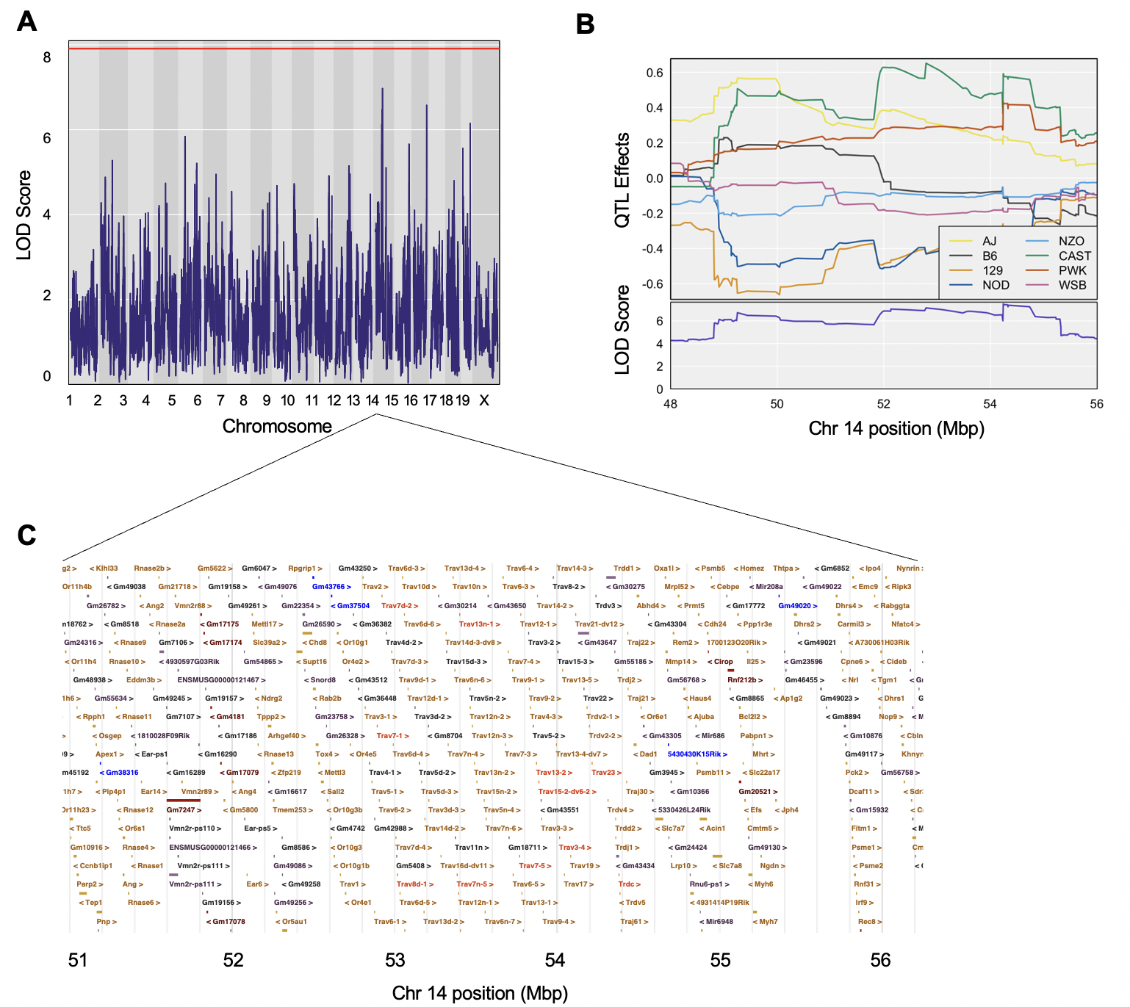
Supplementary Figure S5. High-resolution QTL mapping of cardiac redox potential reveals a suggestive peak on murine chromosome 14. A. Genome-wide scan of cardiac redox potential contains a QTL with LOD score 6.969 located at 54.240 Mbp. The permutation-derived threshold is indicated by the red colored line at significance (α) level 0.05. B. Founder allele QTL effects for this locus. Each colored line represents one of eight DO founder alleles as indicated in the legend. The differences between strains are considered significant when the LOD score (bottom plot) crosses the significance thresholds established in panel A. C. Candidate genes found within the QTL interval extracted from tbe Ensembl genome browser.

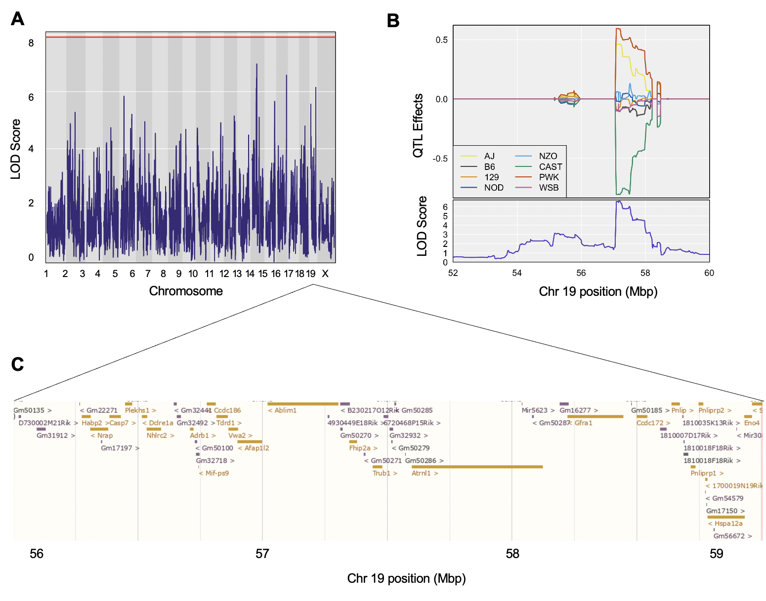
Supplementary Figure S6. High-resolution QTL mapping of cardiac redox potential reveals a suggestive peak on murine chromosome 19. A. Genome-wide scan of cardiac redox potential contains a QTL with LOD score 6.147 located at 57.209 Mbp. The permutation-derived threshold is indicated by the red colored line at significance (α) level 0.05. B. Founder allele QTL effects for this locus. Each colored line represents one of eight DO founder alleles as indicated in the legend. The differences between strains are considered significant when the LOD score (bottom plot) crosses the significance thresholds established in panel A. C. Candidate genes found within the QTL interval extracted from tbe Ensembl genome browser.

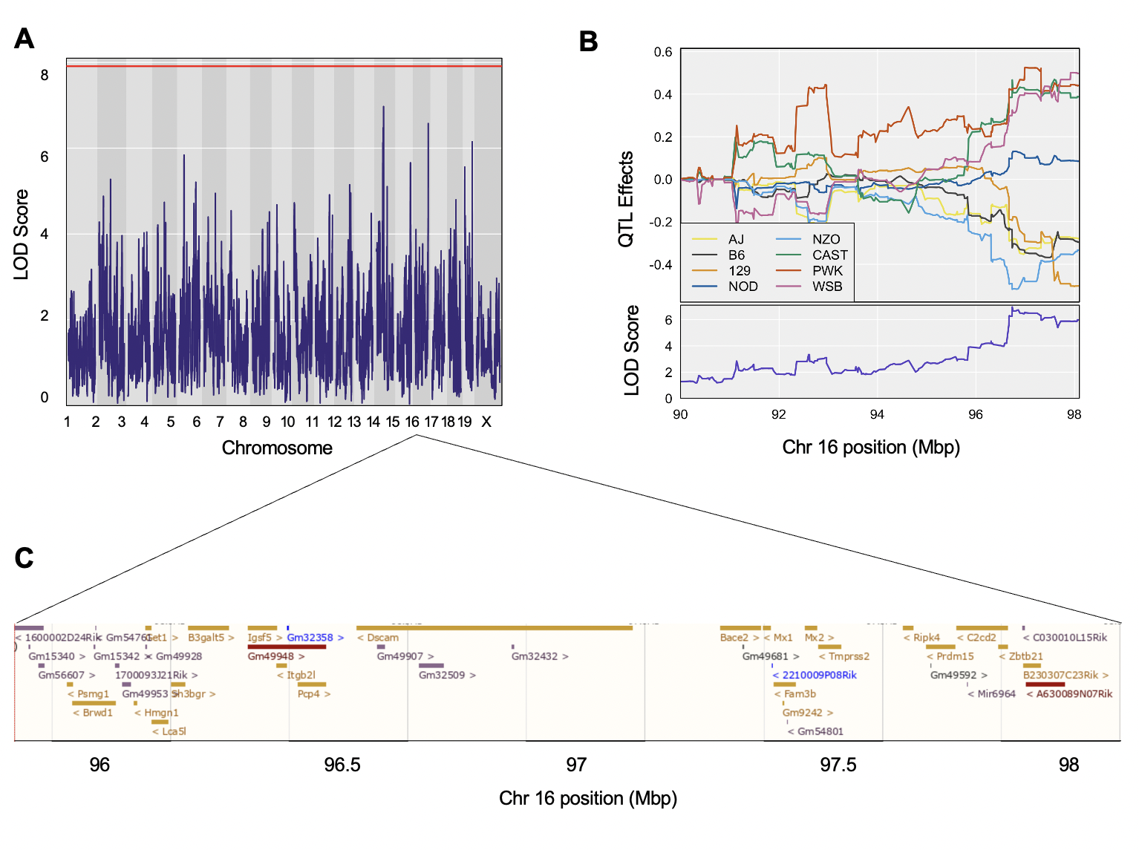
Supplementary Figure S7. High-resolution QTL mapping of cardiac redox potential reveals a suggestive peak on murine chromosome 16. A. Genome-wide scan of cardiac redox potential contains a QTL with LOD score 6.574 located at 96.736 Mbp. The permutation-derived threshold is indicated by the red colored line at significance (α) level 0.05. B. Founder allele QTL effects for this locus. Each colored line represents one of eight DO founder alleles as indicated in the legend. The differences between strains are considered significant when the LOD score (bottom plot) crosses the significance thresholds established in panel A. C. Candidate genes found within the QTL interval extracted from tbe Ensembl genome browser.

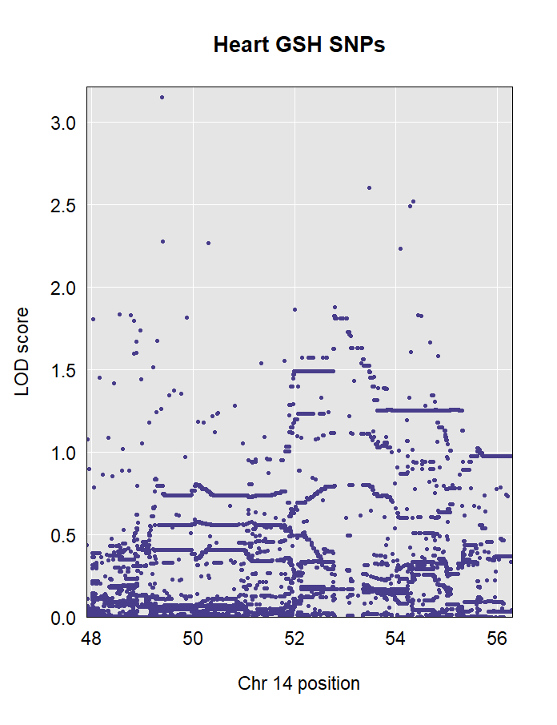
Supplementary Figure S8. All known variants within +/- 1 Mbp of the 95% Bayesian credible interval for the Chr 14 GSH QTL.

1. Petryszak, R., et al., Expression Atlas update--an integrated database of gene and protein expression in humans, animals and plants. Nucleic Acids Res, 2016. 44(D1): p. D746-52.
2. Baldarelli, R.M., et al., The mouse Gene Expression Database (GXD): 2021 update. Nucleic Acids Research, 2020. 49(D1): p. D924-D931.
3. Ashburner, M., et al., Gene ontology: tool for the unification of biology. The Gene Ontology Consortium. Nat Genet, 2000. 25(1): p. 25-9.
4. Smith, C.L., C.-A.W. Goldsmith, and J.T. Eppig, The Mammalian Phenotype Ontology as a tool for annotating, analyzing and comparing phenotypic information. Genome Biology, 2004. 6(1): p. R7.
5. Schriml, L.M., et al., The Human Disease Ontology 2022 update. Nucleic Acids Res, 2022. 50(D1): p. D1255-d1261.

