Electronic Supplementary Material

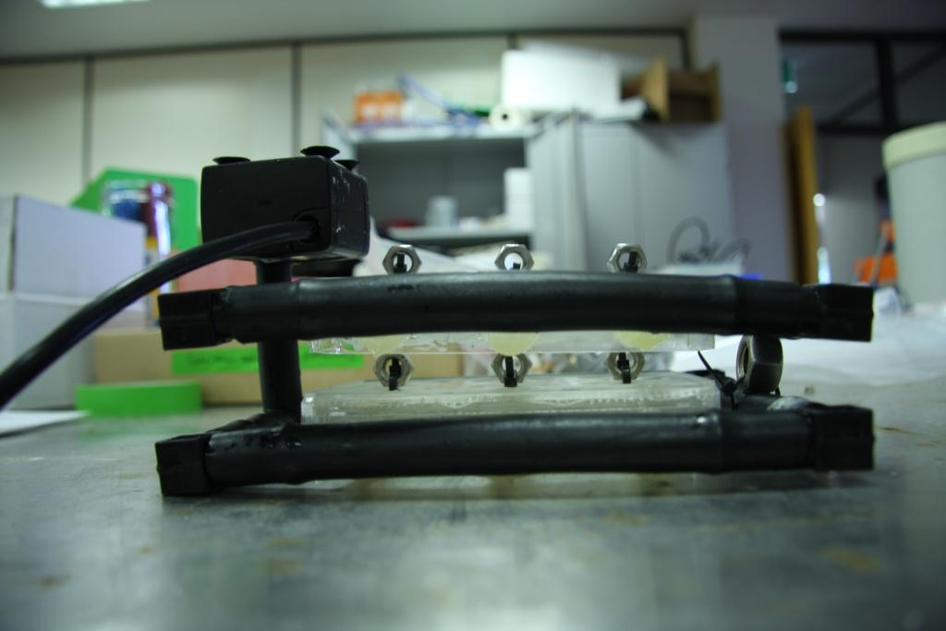
Figure S1. Side-view of housings for Foraminifera which was inserted inside the aquaria, Top level: Marginopora vertebralis, lower level: Heterostegina depressa. A small aquaria pump delivers active inflow.
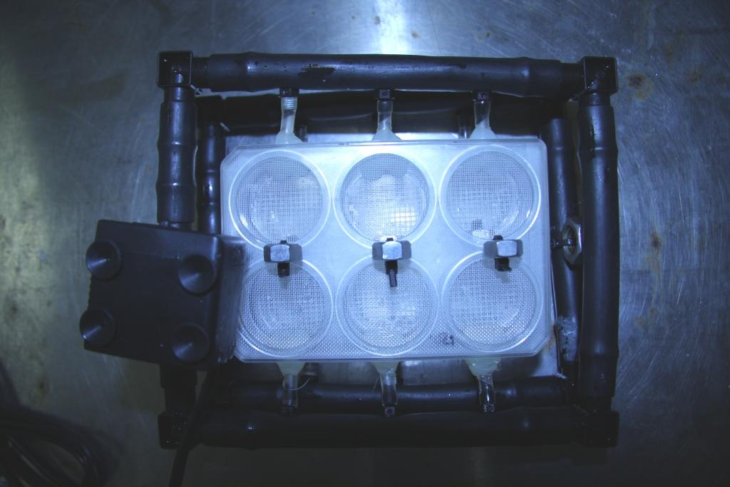
Figure S2. Top-view of Foraminifera housings outside of the aquaria, plankton mesh is used to separate the Foraminifera (image does not show shade cloth types used).

