Supplementary information

Figure S1: Time needed to reach T_{50%} (in days). Blue or green bars represent the compounds for which no decrease could be estimated for 90 days. Orange bars represent the compounds which induced a decrease in F_{v}/F_{m} to T_{50%} or below after 20 days.
Figure S2: Time needed to reach T_{50%} (in days). Blue or green bars represent the compounds for which no decrease could be estimated for 90 days. Orange bars represent the compounds which induced a decrease in F_{v}/F_{m} to T_{50%} or below after 20 days.

Figure S1
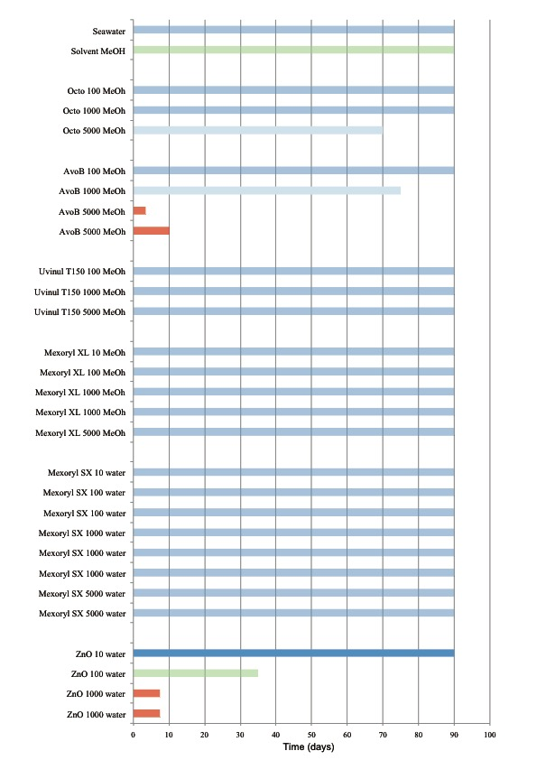

Figure S2