Supplementary Material

Photo-movement in the sea anemone Aiptasia influenced by light quality and symbiotic association

Shawna A. Foo^{1, 2}, Lauren Liddell³, Arthur Grossman⁴, and Ken Caldeira¹

¹ Department of Global Ecology, Carnegie Institution for Science, Stanford, CA, USA
² Center for Global Discovery and Conservation Science, Arizona State University, Tempe, Arizona USA 85287
³ Space Biosciences, NASA Ames Research Center, Moffett Field, CA, USA
⁴ Department of Plant Biology, Carnegie Institution for Science, Stanford, CA, USA

Corresponding author: sfoo@asu.edu

Supplementary Figure 1. Tank set up with the LED light strip placed on the front end of the tank (large black arrow) where the long white arrow indicates the direction of increasing light intensity. The thick, short white arrow marks the positions of the anemones along the width of the tank that received a light intensity of 2 µmol photons m⁻²s⁻¹. Anemones were photographed daily over a period of 11 days. The y-distance between the start and end x, y position for individual anemones was measured.

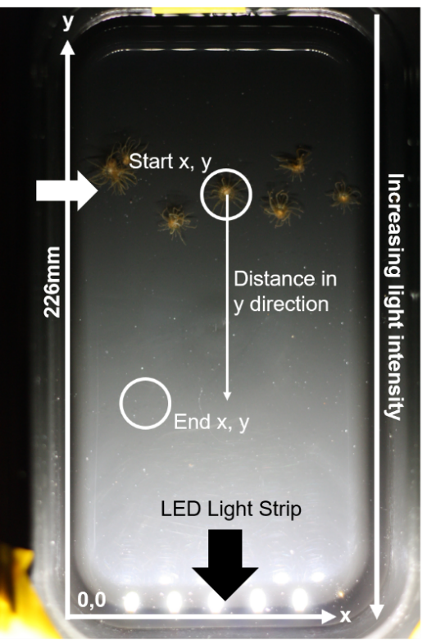

Supplementary Table 1. Results of binomial regression analyses for proportion of symbiotic versus aposymbiotic anemones that were bent towards the light over the 11 days of the experiment. Significant values are indicated in bold.
Independent variable | Estimate | Std. Error | Z value | Probability
White light
Presence of symbiont | 1.594 | 0.585 | 2.723 | 0.007
Day | 0.134 | 0.084 | 1.583 | 0.113
Blue light
Presence of symbiont | 1.450 | 0.607 | 2.390 | 0.017
Day | 0.225 | 0.089 | 2.521 | 0.012
Red light
Presence of symbiont | 0.441 | 0.676 | 0.652 | 0.514
Day | 0.124 | 0.096 | 1.295 | 0.195

Supplementary Figure 2. Examples of phototropism from one set of experiments with H2-SSB01, displaying a birds-eye view of the anemones in the same tank over the 11-day experimental period. The position of the light source is at the bottom edge of each photograph (the black arrows point toward the light source and increasing light intensity). At day 11, the 360-degree circle and check mark indicate an example of an anemone scored as bent towards the light; the anemone’s tentacles and body length are bent within the third quadrant facing the light. If the anemone was bent in the first or second quadrant, it would not have been considered bent towards the light. After Time 0, very few anemones did not exhibit column bending.

