Environmental flexibility in Oulastrea crispata in a highly urbanised environment – a microbial perspective

Till Röthig^{1,2}, Henrique Bravo^{1,3,#}, Alison Corley^{1,#}, Tracey-Leigh Prigge^{1,#}, Arthur Chung¹, Vriko Yu¹, Shelby E. McIlroy¹, Mark Bulling², Michael Sweet², David M. Baker¹

¹ The Swire Institute of Marine Science and School of Biological Sciences, The University of Hong Kong, Hong Kong, SAR
² Aquatic Research Facility, Environmental Sustainability Research Centre, University of Derby, United Kingdom
³ Groningen Institute for Evolutionary Life Sciences, University of Groningen, Groningen, The Netherlands
# contributed equally

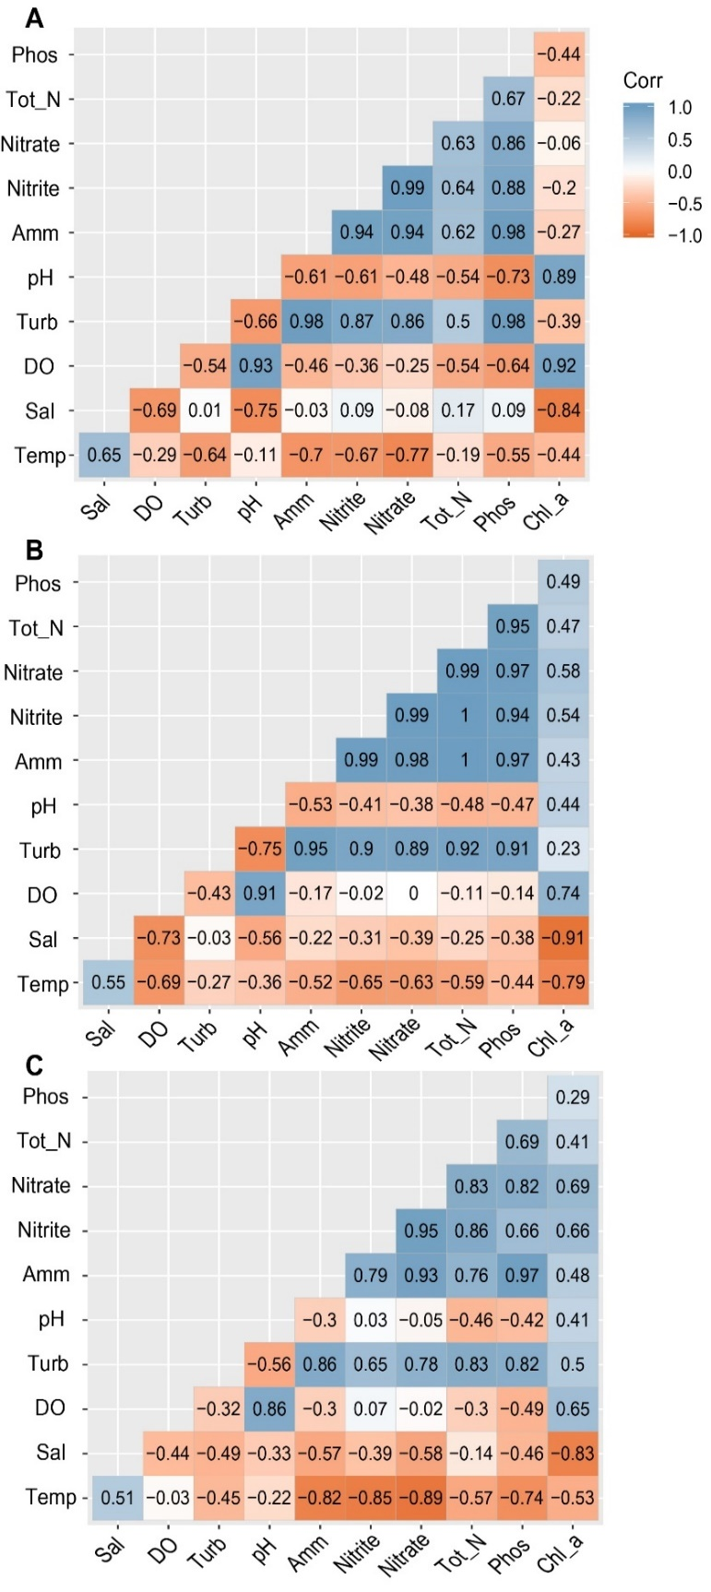

Supplementary Figure 1. Correlation analysis for environmental parameters during summer 2018. Depicted are correlations between A) environmental parameters for August, B) averaged parameters from July and August, and C) averaged parameters from June, July, and August 2018. (Temp, temperature; Sal, salinity; DO, dissolved oxygen; Turb, turbidity; Amm, ammonia; TN, total nitrogen; Phos, phosphate; Chl_a, chlorophyll a).

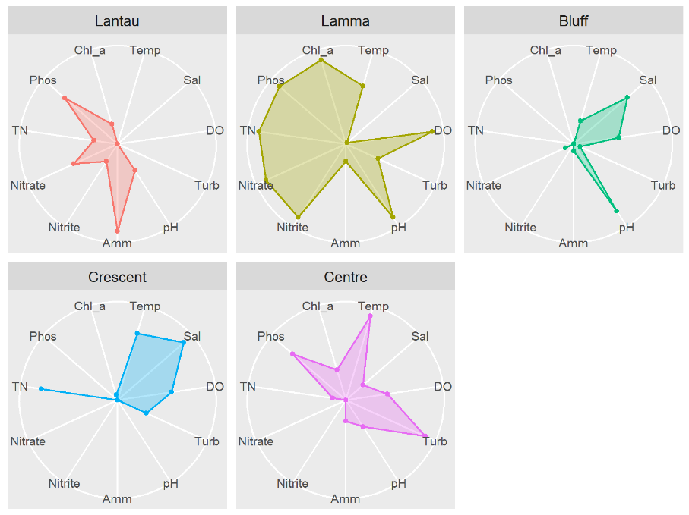
June

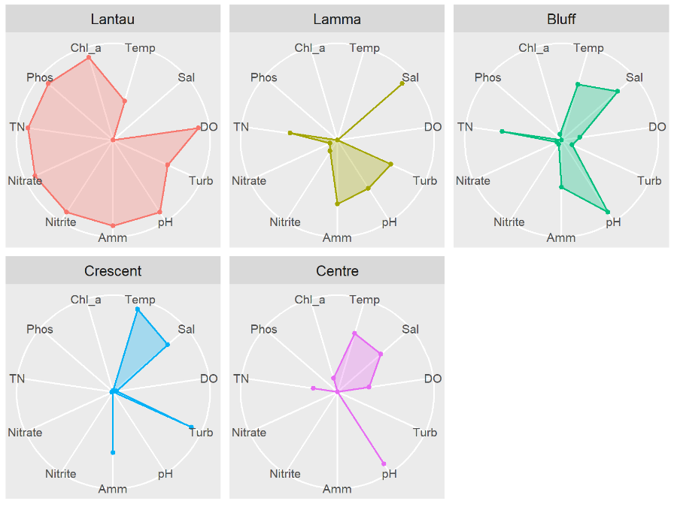
July

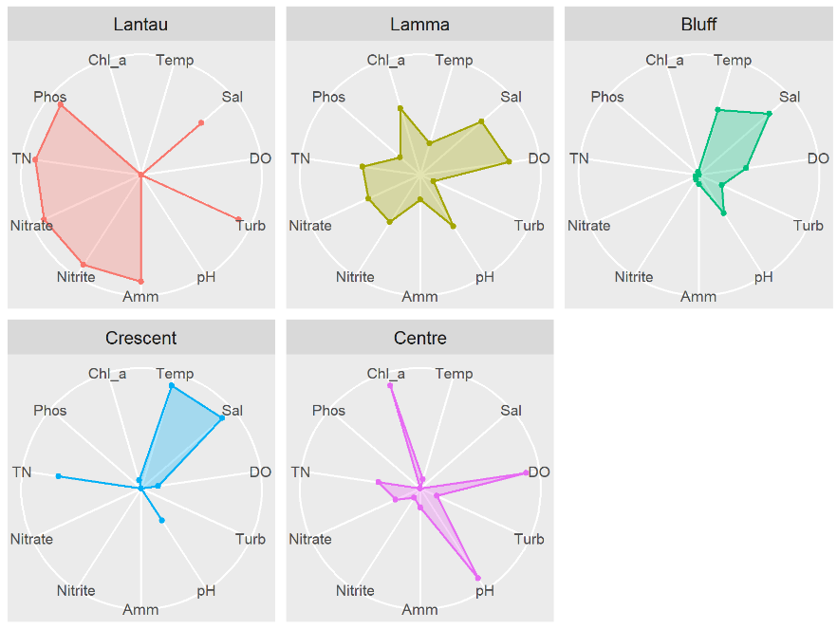
August

Supplementary Figure 2. Radar plots of environmental conditions between June and August 2018. Radial axes for each environmental variable have been scaled so that their ranges are the same for each station. For any particular station, points closer to the centre of the plots represent values that are near the minimum value for the particular environmental variable across all stations, and points that are further from the plot centre represent values nearer the maximum value. (Temp, temperature; Sal, salinity; DO, dissolved oxygen; Turb, turbidity; Amm, ammonia; TN, total nitrogen; Phos, phosphate; Chl_a, chlorophyll a)

