Supplementary Information
Title:

Sub-annual fluorescence measurements of coral skeleton: relationship between skeletal luminescence and terrestrial humic-like substances

Authors, Affiliations and Addresses:

Nikita Kaushal^{1*#}, Liudongqing Yang ^{1,2#}, Patrick Martin^{1*}, Jani T. I. Tanzil^{2,3,4}, Jen Nie Lee⁵, Nathalie F. Goodkin^{1,2,6}

¹Asian School of the Environment, Nanyang Technological University, Singapore

²Earth Observatory of Singapore, Nanyang Technological University, Singapore

³St. John’s Island National Marine Laboratory, National University of Singapore, Singapore

⁴Tropical Marine Science Institute, National University of Singapore, Singapore

⁵Faculty of Science and Marine Environment, Universiti Malaysia Terengganu, Kuala Nerus, Malaysia

⁶Department of Earth and Planetary Sciences, American Museum of Natural History, New York, U.S.A.

*Corresponding authors: nkaushal@ntu.edu.sg or pmartin@ntu.edu.sg

#Equal contributions from the authors.

Keywords:

Fluorescence, luminescence, humic, EEM, coral

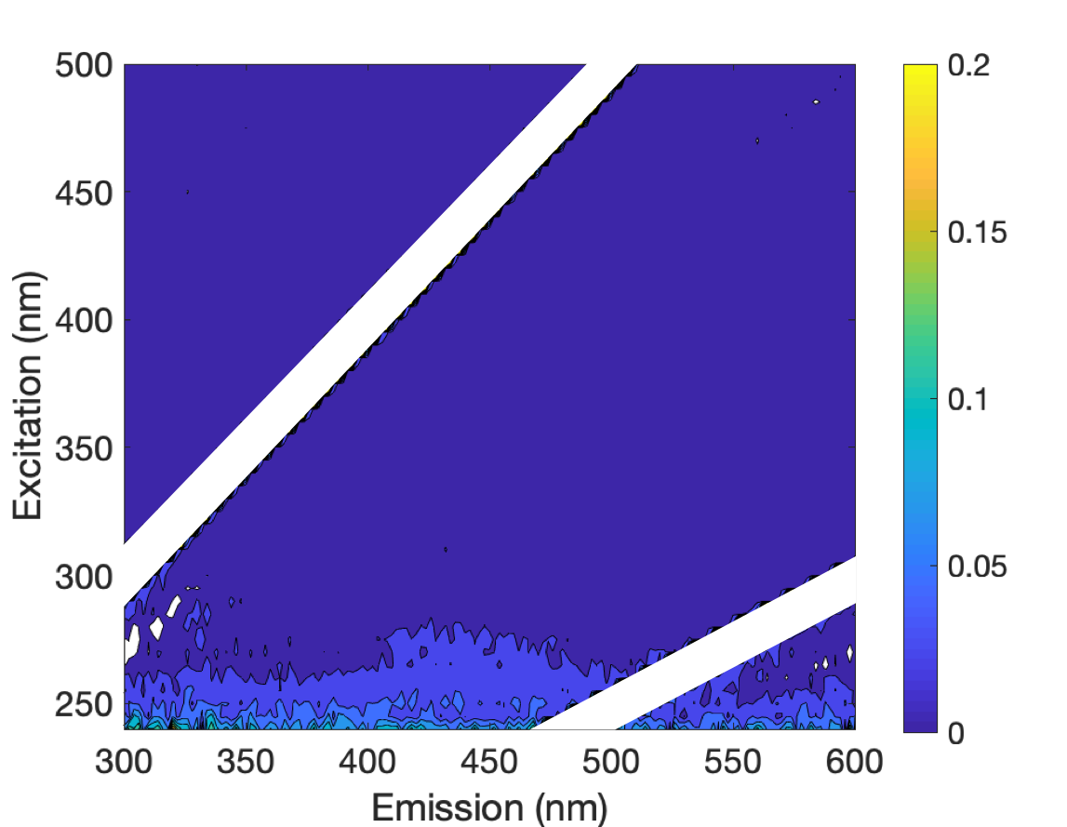

Fig. S1. Fluorescence EEM spectra of aragonite precipitated from artificial seawater made from Sigma sea salts and deionized water without addition of any type of organic matter. The color bar represents fluorescence intensity in Raman Units.

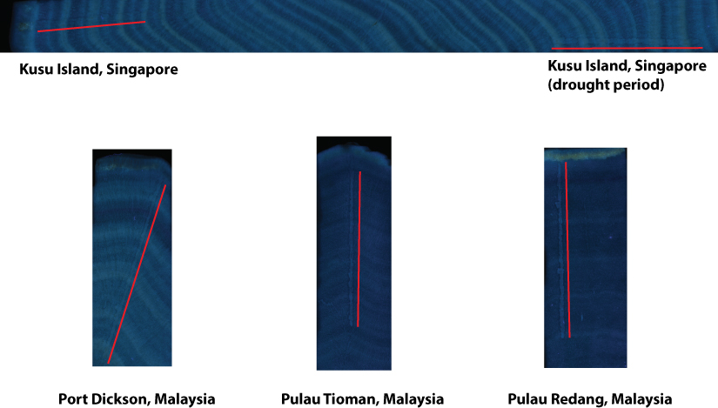

Fig. S2. Images of the coral slices showing variation in luminescence intensity and drilling tracks (highlighted by red lines) of fluorescence measurements. Brightness of all the images were increased by 60% in Adobe Photoshop CS6.
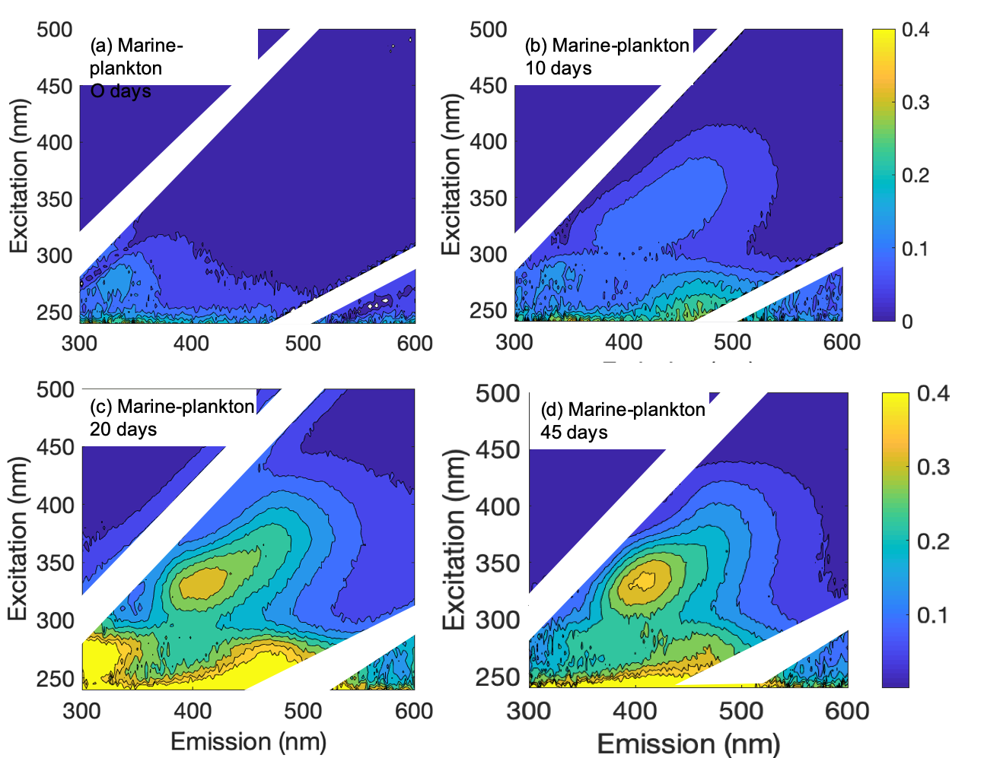
Fig. S3. Fluorescence EEM spectra of water samples from the marine plankton culture experiment. Figures a, b and c were measured during the growth phase. Figure d was measured after keeping the sample in the dark for 25 days to allow partial degradation and reprocessing of the DOC by heterotrophic microbes. The color bar represents fluorescence intensity in Raman Units.
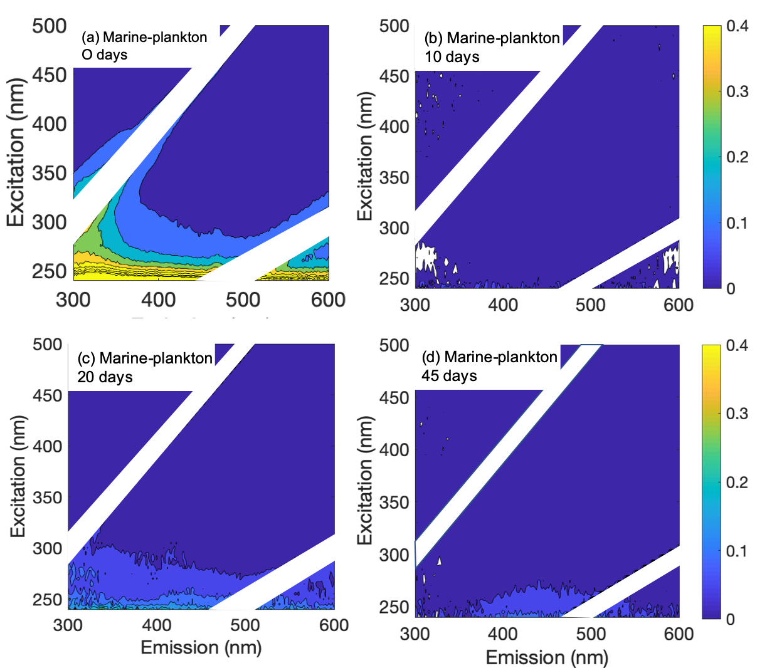
Fig. S4. Fluorescence EEM spectra of aragonite samples precipitated from the marine plankton culture experiment. Figures a, b and c were measured during the growth phase. Figure d was measured after keeping the sample in the dark for 25 days to allow partial degradation and reprocessing of the DOC by heterotrophic microbes. The color bar represents fluorescence intensity in Raman Units.

