Appendices
Appendix1. Total number of site-level benthic and fish surveys from 2000 to 2011, inside and outside of all eight Marine Protected Areas (MPAs). All years surveyed except for 2007 (all sites), 2008 (sites 3, 7 and 8), and 2009 (sites 1, 2, 4 and 5).
 | Site 1 |  | Site 2 |  | Site 3 |  | Site 4 |  | Site 5 |  | Site 6 |  | Site 7 |  | Site 8
Survey years | 2000 -2011 |  | 2000 -2011 |  | 2000 -2011 |  | 2000 -2011 |  | 2003 -2011 |  | 2000 -2011 |  | 2002 -2011 |  | 2004 -2011
MPA | In | Out | In | Out | In | Out | In | Out | In | Out | In | Out | In | Out | In | Out
Total benthic  transects | 51 | 34 | 36 | 36 | 34 | 17 | 34 | 17 | 24 | 23 | 37 | 39 | 26 | 24 | 20 | 20
Total  fish  transects | 63 | 41 | 45 | 46 | 42 | 22 | 40 | 20 | 28 | 28 | 44 | 44 | 30 | 29 | 24 | 24

Appendix 2. Broad classification of fish families by commercial value for food, whether generally valued for the aquaria trade, their typical trophic group, and level of reef association. Categories based on (Samoilys et al. 2007; McClanahan 2014; Froese and Pauly 2018).
Family | Commercial food value | Aquaria species | Primary typical feeding trait | Reef-association
Acanthuridae (Surgeonfish) | Medium | Yes | Herbivore | Medium
Apogonidae (Cardinalfish) | Low | Yes | Planktivore | High
Balistidae (Triggerfish) | Medium | No | Invertivore | Medium
Blenniidae (Blennies) | Low | No | Herbivore | High
Caesionidae (Fusiliers) | Low | No | Planktivore | Medium
Carangidae (Jacks) | High | No | Piscivore | Low
Centriscidae (Shrimpfish | Low | Yes | Planktivore | Medium
Chaetodontidae (Butterflyfish) | Low | Yes | Corallivore | High
Cirrhitidae (Hawkfish) | Low | No | Invertivore | High
Gerreidae (Silver biddies) | Low | No | Invertivore | High
Gobiesocidae (Clingfish) | Low | No | Invertivore | High
Gobiidae (Gobies) | Low | No | Invertivore | High
Haemulidae (Sweetlips/grunts) | High | Yes | Scavengers | Medium
Holocentridae (Soldierfish) | Medium | No | Invertivore | Medium
Labridae (Wrasses) | Medium | No | Scavengers | Medium
Lethrinidae (Emperors) | High | No | Piscivore | Medium
Lutjanidae (Snappers) | High | No | Piscivore | Medium
Monacanthidae (Filefish) | Low | Yes | Invertivore | Medium
Muglidae (Mullet) | Medium | No | Detritivore | Medium
Mullidae (Goatfish) | Medium | No | Scavengers | Medium
Nemipteridae (Breams) | High | No | Piscivore | Medium
Pinguipedidae (Sandperch) | Low | No | Piscivore | Medium
Plotosidae (Eeltail Catfish | Low | Yes | Detritivore | Medium
Pomacanthidae (Angelfish) | Medium | Yes | Spongivore | Medium
Pomacentridae (Damselfish) | Low | Yes | Herbivore | High
Scaridae (Parrotfish) | Medium | No | Herbivore | Medium
Scorpaenidae (Scorpionfish) | Low | Yes | Piscivore | High
Serranidae (grouper) | High | No | Piscivore | Medium
Siganidae (Rabbitfish | Medium | No | herbivore | Medium
Sphyraenidae (Barracudas) | High | No | Piscivore | Low
Syngnathidae (Pipefish) | Low | Yes | Planktivore | High
Synodontidae (Lizardfish) | Low | No | Piscivore | High
Tetraodontidae (Pufferfish) | Low | Yes | Piscivore | High
Zanclidae (Moorish Idol) | Low | No | Spongivore | Medium

Appendix 3. Model estimates from a linear mixed effects model of log-transformed fish biomass against the interacting effects of Years Since Designation (YSD) and whether in / out of Marine Protected Area (MPA). Table separated to individual sites to illustrate site-level random effects within the model. *** p < 0.001; ** p < 0.01; * p < 0.05
Site | Parameters | Intercept (Inside) | YSD | Management | YSD x Management
Asinan | Estimate | 8.14 | 0.15 | -0.23 | -0.07
 | t value | 34.96 *** | 3.73 *** | -0.59 | -1.06
Bantigui-an Saguise | Estimate | 8.11 | 0.00 | -0.05 | 0.06
 | t value | 28.38 *** | 0.02 | -0.13 | 0.59
Batasan | Estimate | 10.64 | -0.15 | -1.18 | 0.03
 | t value | 44.79 *** | -3.95 *** | -3.53 *** | 0.48
Bilangbilangan | Estimate | 9.34 | -0.02 | 0.14 | -0.06
 | t value | 42.89 *** | -0.61 | 0.41 | -1.08
Handumon | Estimate | 10.38 | -0.14 | -0.87 | -0.07
 | t value | 28.19 *** | -3.78 *** | -1.68 | -1.27
Jandayan Norte | Estimate | 8.50 | -0.23 | -0.51 | 0.07
 | t value | 26.52 *** | -3.65 *** | -1.13 | 0.83
Pandanon | Estimate | 9.08 | 0.01 | 0.12 | -0.07
 | t value | 51.44 *** | 0.36 | 0.38 | -0.96
Pinamgo | Estimate | 8.79 | -0.14 | -1.47 | 0.04
 | t value | 23.01 *** | -2.43 * | -2.63 ** | 0.44

Appendix 4. Fish total length kernal distributions for all fish species surveyed inside and outside of eight Marine Protected Areas (MPAs) along the Danajon Bank, Philippines during 1999 – 2011. Years since designation shown A) 0 years, B) 5 years, and c) 10 years. The grey-shaded area indicates one standard error either side of the null model of no difference in length distribution based on protection.
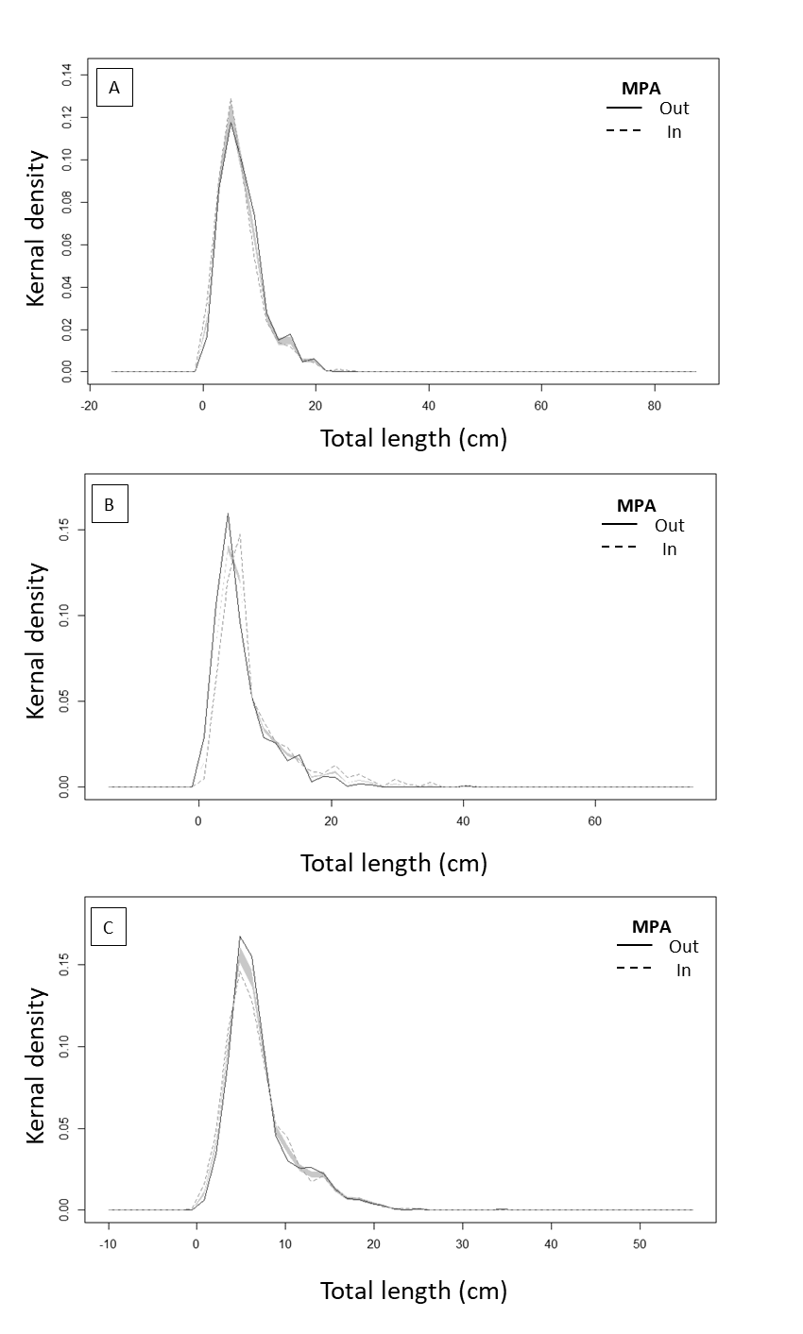

Appendix 5. Linear mixed effects model estimates of fish density, investigating the interacting effects of Management – whether in / out of Marine Protected Areas (MPAs), and Years Since Designation (YSD) for all eight sites in the Danajon Bank. Analyses separated into five (10 cm) Total Length size class bins. Site is a random factor. *** p < 0.001, ** p < 0.01, * p < 0.05, † p < 0.1 .
Parameters | Estimate | t value | 95% Confidence interval | R² (fixed) | R² (total)
0 - <10 cm
(Intercept) | 5.22 *** | 19.64, p = 0.00 | [4.70, 5.74] | 0.05 | 0.63
YSD | -0.03 | -0.87, p = 0.20 | [-0.10, 0.04]
Management(Out) | 0.47 *** | 3.89, p = 0.00 | [0.23, 0.70]
YSD:Management(Out) | -0.07 *** | -4.16, p = 0.00 | [-0.11, -0.04]
N (transects) | 570.00
≥10 - < 20 cm
(Intercept) | 3.87 *** | 20.01, p = 0.00 | [3.49 - 4.25] | 0.04 | 0.37
YSD | -0.01 | -0.16, p = 0.44 | [-0.07, 0.06]
Management(Out) | -0.07 | -0.47, p = 0.32 | [-0.34, 0.21]
YSD:Management(Out) | -0.05 ** | -2.61, p = 0.00 | [-0.09, -0.01]
N (transects) | 569.00
≥ 20 - < 30 cm
(Intercept) | 2.23 *** | 6.78, p = 0.00 | [1.59, 2.88] | 0.13 | 0.36
YSD | -0.08 * | -2.46, p = 0.02 | [-0.14, -0.02]
Management(Out) | -0.37 * | -1.85, p = 0.03 | [-0.75, 0.02]
YSD:Management(Out) | -0.05 * | -1.76, p = 0.04 | [-0.12, 0.01]
N (transects) | 395.00
≥ 30 - < 40 cm
(Intercept) | 1.49 *** | 4.79, p = 0.00 | [0.92, 2.06] | 0.07 | 0.20
YSD | -0.08† | -1.65, p = 0.09 | [-0.14, -0.01]
Management(Out) | -0.71 * | -1.79, p = 0.04 | [-1.47, 0.06]
YSD:Management(Out) | 0.03 | 0.51, p = 0.31 | [-0.09, 0.16]
N (transects) | 155.00
≥ 40 cm
(Intercept) | 1.16 * | 2.52, p = 0.02 | [0.37, 1.95] | 0.03 | 0.12
YSD | -0.03 | -0.40, p = 0.36 | [-0.16, 0.09]
Management(Out) | -0.77 | -1.40, p = 0.08 | [-1.81, 0.27]
YSD:Management(Out) | 0.10 | 0.93, p = 0.18 | [-0.10, 0.29]
N (transects) | 72.00

Appendix 6. Linear mixed effects model outputs for logged fish biomass (g) for each of eight fish trophic groups in the Danajon bank. The model investigates the interacting fixed effects of Management (whether in / out of Marine Protected Areas), and Years Since Designation (YSD), with ‘site’ as a random effect. Data pooled across eight MPA sitess monitored between 2000 and 2011.
Parameters | Estimate | t value | 95% Confidence interval | R² (fixed) | R² (total)
Corallivore
(Intercept) | 7.17 *** | 16.66, p = 0.00 | [6.33, 8.01] | 0.12 | 0.44
YSD | -0.06 | -1.16, p = 0.14 | [-0.15, 0.04]
Management (Out) | -1.16 *** | -3.30, p = 0.00 | [-1.85, -0.47]
YSD: Management (Out) | 0.02 | 0.40, p = 0.34 | [-0.08, 0.12]
N (Transects) | 164.00
Detritivore
(Intercept) | 5.74 *** | 7.81, p = 0.00 | [4.41, 7.07], | 0.11 | 0.11
YSD | -0.06 | -0.30, p = 0.39 | [-0.44, 0.31]
Management (Out) | 1.18 | 1.05, p = 0.15 | [-0.71, 3.07]
YSD: Management (Out) | -0.26 | -0.83, p = 0.21 | [-0.74, 0.23]
N (Transects) | 37.00
Herbivore
(Intercept) | 9.13 *** | 15.35, p = 0.00 | [7.97, 10.30] | 0.17 | 0.71
YSD | -0.07 | -1.26, p = 0.12 | [-0.17, 0.04]
Management (Out) | -1.25 *** | -4.20, p = 0.00 | [-1.83, -0.66]
YSD: Management (Out) | -0.04 | -0.87, p = 0.19 | [-0.12, 0.04]
N (Transects) | 174.00
Invertivore
(Intercept) | 7.22 *** | 12.85, p = 0.00 | [6.12, 8.32] | 0.24 | 0.64
YSD | -0.24 * | -2.75, p = 0.01 | [-0.41, -0.07]
Management (Out) | -0.51 | -1.24, p = 0.11 | [-1.32, 0.30]
YSD: Management (Out) | -0.07 | -1.05, p = 0.15 | [-0.19, 0.06]
N (Transects) | 132.00
Piscivore
(Intercept) | 9.04 *** | 21.34, p = 0.00 | [8.21, 9.87] | 0.30 | 0.66
YSD | -0.18 ** | -4.07, p = 0.00 | [-0.26, -0.09]
Management (Out) | -0.64 ** | -2.52, p = 0.01 | [-1.14, -0.14
YSD: Management (Out) | -0.03 | -0.83, p = 0.20 | [-0.10, 0.04]
N (Transects) | 172.00
Planktivore
(Intercept) | 7.90 *** | 9.72, p = 0.00 | [6.32, 9.48] | 0.09 | 0.46
YSD | -0.13 | -1.66, p = 0.06 | [-0.28, 0.01]
Management (Out) | -0.41 | -0.80, p = 0.21 | [-1.39, 0.58]
YSD: Management (Out) | -0.05 | -0.61, p = 0.27 | [-0.19, 0.10]
N (Transects) | 134.00
Scavengers
(Intercept) | 9.61 *** | 18.68, p = 0.00 | [8.60, 10.62] | 0.22 | 0.71
YSD | -0.10 * | -2.19, p = 0.03 | [-0.20, -0.01]
Management (Out) | -0.46 * | -1.93, p = 0.03 | [-0.94, -0.01]
YSD: Management (Out) | -0.08 ** | -2.40, p = 0.01 | [-0.15, -0.01
N (Transects) | 174.00
Spongivore
(Intercept) | 5.22 *** | 7.71, p = 0.00 | [3.91, 6.54] | 0.04 | 0.37
YSD | 0.04 | 0.61, p = 0.28 | [-0.08, 0.16]
Management (Out) | -0.23 | -0.40, p = 0.34 | [-1.31, 0.85]
YSD: Management (Out) | -0.08 | -0.88, p = 0.19 | [-0.23, 0.08]
N (Transects) | 110.00

Appendix 7. Linear model outputs for percentage cover change since Marine Protected Area (MPA) designation for surveys within eight sites, both inside (I) and outside (O) of MPA protection, within the Danajon Bank, Philippines. Outputs grouped by benthic type with SE shown in grey.
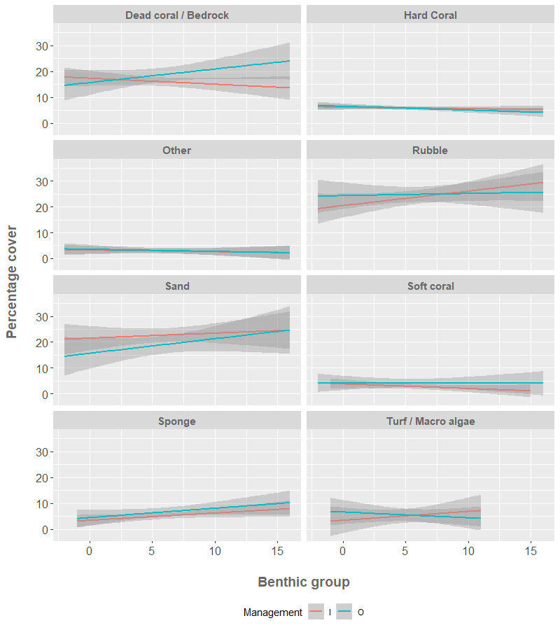
Appendix 8. Model estimates from a linear mixed effects model of (square-root transformed) coral cover against time (years) and management (in / out of eight Marine Protected Area sites within the Danajon Bank), separated to illustrate site-level random effects within the model. *** p < 0.001; ** p < 0.01; * p < 0.05.
Site | Parameter | Intercept (Inside) | Year | Management | Year x Management
Asinan | Estimate | 6.50 | -0.04 | 0.76 | -0.17
 | t value | 16.16 *** | -0.65 | 1.10 | -1.43
Bantigui-an Saguise | Estimate | 5.57 | 0.00 | -0.48 | 0.13
 | t value | 12.17 *** | 0.01 | -0.75 | 0.79
Batasan | Estimate | 6.04 | -0.11 | 0.31 | 0.15
 | t value | 14.16 *** | -1.72 | 0.51 | 1.61
Bilangbilangan | Estimate | 6.03 | 0.13 | 0.30 | -0.26
 | t value | 15.94 *** | 2.35 * | 0.51 | -2.90 **
Handumon | Estimate | 4.71 | -0.06 | 0.47 | -0.02
 | t value | 7.01 *** | -0.93 | 0.51 | -0.19
Jandayan Norte | Estimate | 3.40 | 0.06 | -0.35 | -0.05
 | t value | 6.73 *** | 0.62 | -0.48 | -0.36
Pandanon | Estimate | 5.82 | -0.34 | -0.16 | 0.14
 | t value | 19.46 *** | -4.80 *** | -0.30 | 1.16
Pinamgo | Estimate | 3.07 | 0.12 | -0.51 | -0.09
 | t value | 5.13 *** | 1.31 | -0.58 | -0.69

Appendix 9. Principal Component Analysis (PCA) of A) broad substrate types within each site through time, and B) Coral growth form composition through time. YSD = Years since designation), inside MPA = circles, outside MPA = squares. Results shown for eight sites in the Danajon bank, monitored between 2000 and 2011
