Supplementary materials

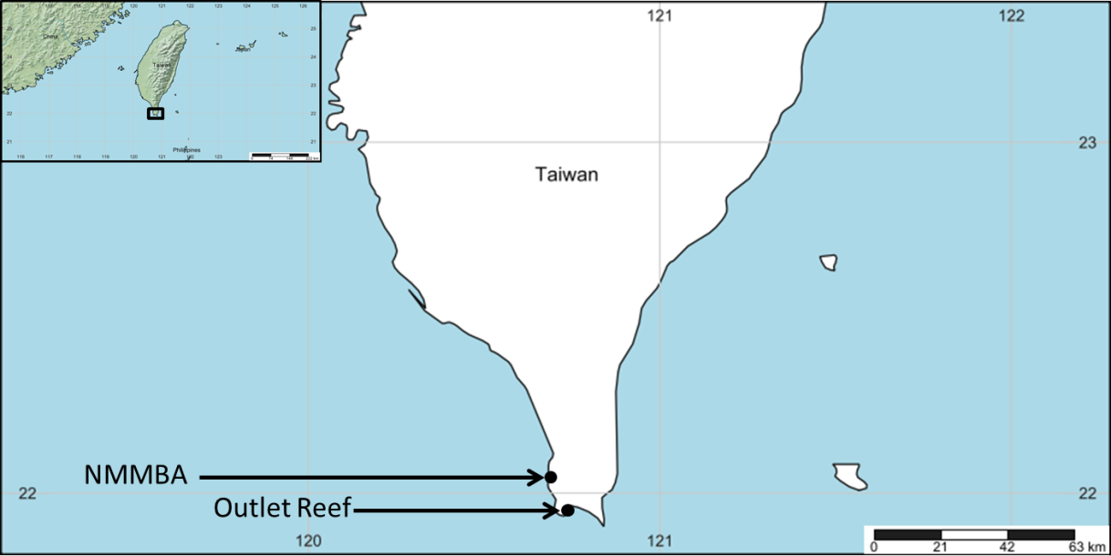
Figure S1: Colony collection site (Outlet Reef) and research center site (National Museum of Marine Biology & Aquarium; NMMBA) in southern Taiwan.

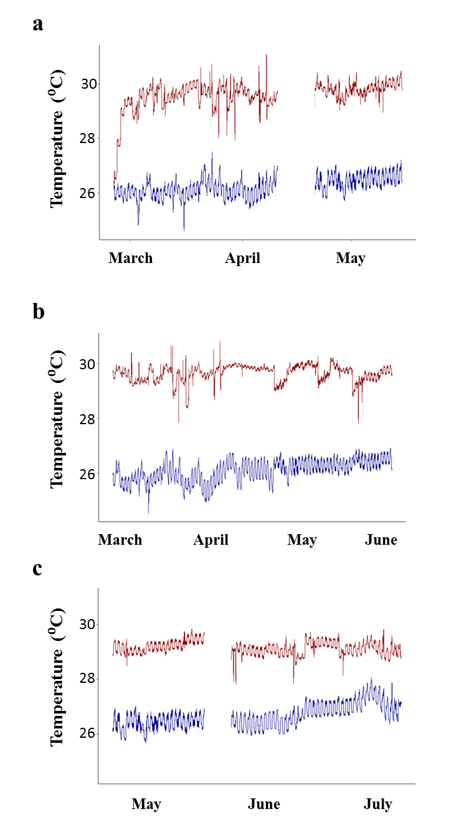

Figure S2: Mean temperature in the control (blue lines) and heated (red lines) treatments for the (a) parent colony tanks (heated: 29.7°C ± 0.3; control: 26.3°C ± 0.4), (b) April recruit recruitment tanks (heated: 29.7°C ± 0.3; control: 26.1°C ± 0.4), and (c) May recruit recruitment tanks (heated: 29.2°C ± 0.2; control: 26.7°C ± 0.4). No temperature data are available from 10-20 April for the parent colony tanks, and 13-19 May in the May recruit tanks due technical issues.
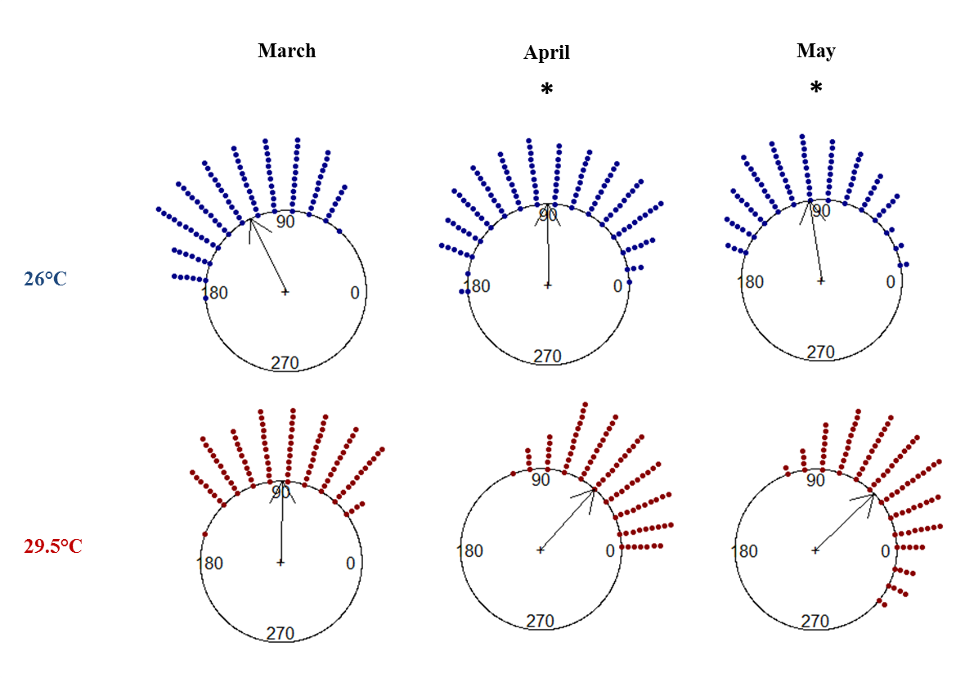
Figure S3. Circular plots of reproductive timing of Pocillopora acuta across three reproductive cycles when held at either 26°C or 29.5°C from March to May 2017. Approximate cumulative duration of treatment exposure was 5 days (March), 30 days (April), and 60 days (May). Asterisks indicate significant differences between treatments (Watson’s tests, p<0.001).

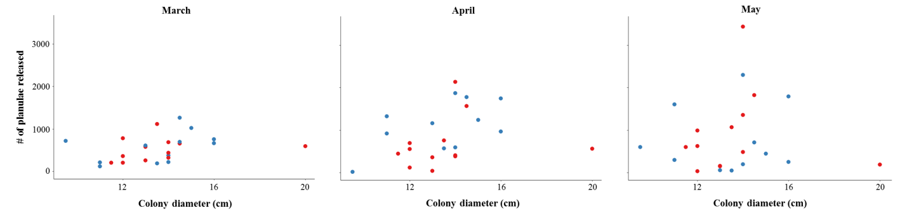
Figure S4: Relationship between total number of planulae released and colony diameter for adult Pocillopora acuta corals exposed to control (26°C; blue dots) and heated (29.5°C; red dots) treatments from March to May 2017.

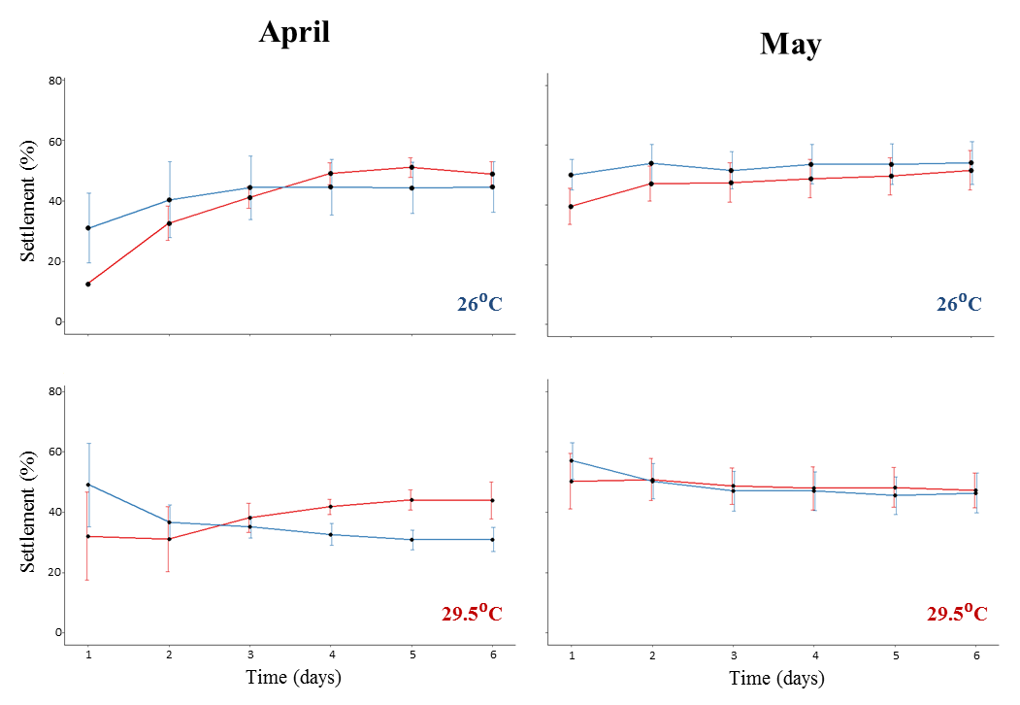

Figure S5. Percentage of Pocillopora acuta planulae (mean ± SE) released that settled within control (26°C) and heated (29.5°C) recruitment tanks within the first 6 days post-release. Planulae were sourced from colonies held within the control treatment (blue lines) and heated treatment (red lines); independent recruitment was conducted for the April and May planulation.

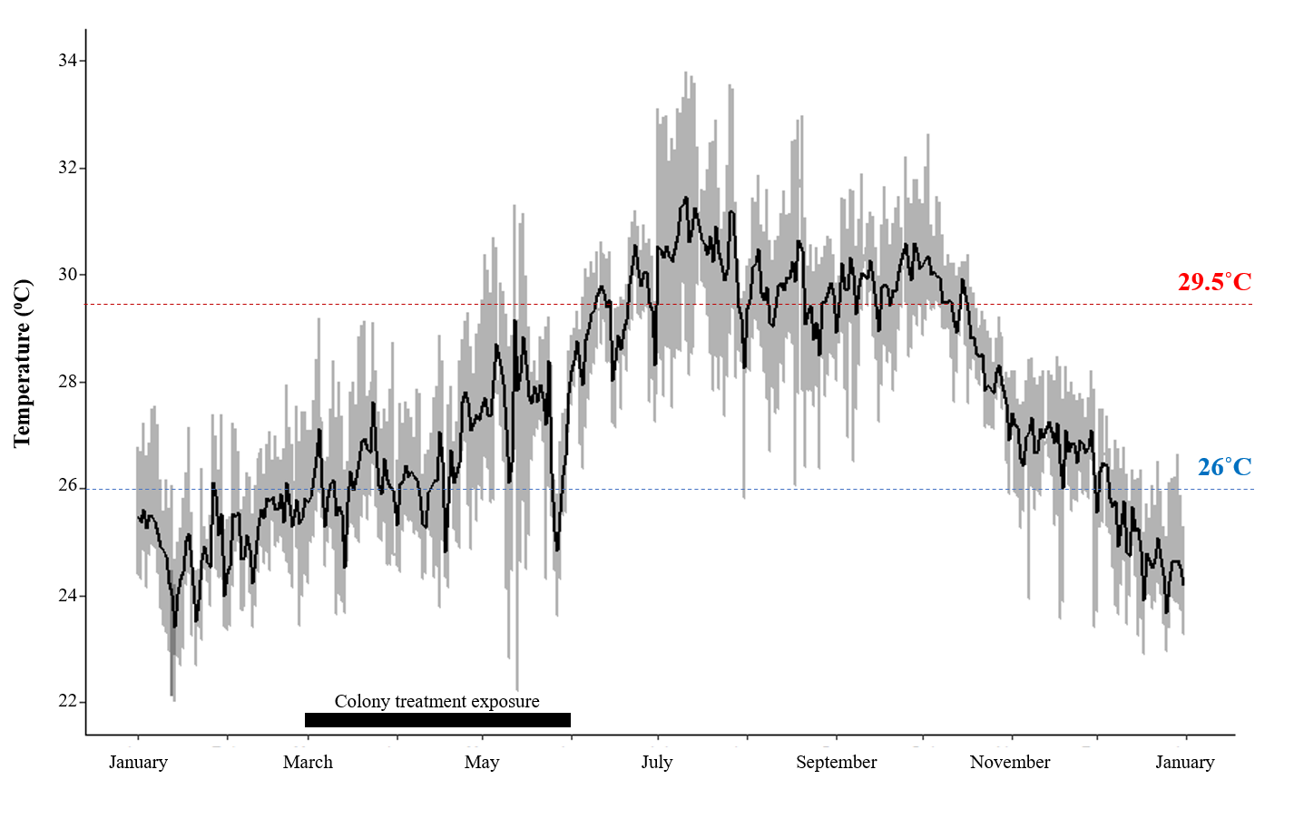

Figure S6. Temperature at Outlet reef from January 2017- January2018; temperature recorded every 10 minutes (grey line), experimental treatment temperatures (blue: control; red: heated) and daily mean temperature (black line).

Table S1. Number of days of planula release by Pocillopora acuta from March to May 2017 within treatments (control: 26°C; heated: 29.5°C), and proportion of release occurring in the 4 peak days each month. Lunar day 1 refers to the new moon.

Treatment | Number of reproductive days each month | Proportion of reproduction within the 4 peak days
March
26°C  29.5°C | 8.75 ± 1.7  7.92 ± 1.3 | 0.71 ± 0.14  0.65 ± 0.07
April
26°C  29.5°C | 10.45 ± 3.6  6.92 ± 2.1 | 0.51 ± 0.24  0.85 ± 0.10
May
26°C  29.5°C | 8.09 ± 3.0  7.75 ± 3.1 | 0.75 ± 0.13  0.84 ± 0.11

Table S2. Results of Watson’s tests for homogeneity of Pocillopora acuta reproductive timing within parent treatments across three reproductive cycles (March to May 2017).

Treatment | N | F | P
Control (26°C)
March vs. April  April vs. May  March vs. May | 12, 11  11, 11  12, 11 | 0.30  0.23  0.06 | <0.01  <0.05  >0.10
Heated (29.5°C)
March vs. April  April vs. May  March vs. May | 12, 12  12, 12  12, 12 | 0.52  0.12  0.58 | <0.001  >0.10  <0.001

Table S3. Effect of coral colony size and experimental temperature on the number of Pocillopora acuta planulae released per month from March to May 2017. Parameters were obtained from a generalized linear model (with Poisson distribution). Experimental temperatures were 26°C (control) and 29.5°C (heated).

Fixed effects | Estimate | Standard  error | z | Lower  CI | Upper  CI | P
March
Intercept  Treatment  Colony size | 5.204  -0.116  0.084 | 0.056  0.018  0.004 | 92.866  -6.586  21.134 | 5.094  -0.150  0.076 | 5.314  -0.081  0.092 | <0.001  <0.001  <0.001
April
Intercept  Treatment  Colony size | 5.685  -0.531  0.097 | 0.045  0.014  0.003 | 127.244  -36.852  30.748 | 5.597  -0.559  0.091 | 5.772  -0.503  0.104 | <0.001  <0.001  <0.001
May
Intercept  Treatment  Colony size | 6.345  0.178  0.021 | 0.047  0.015  0.003 | 135.54  12.237  6.258 | 6.253  0.150  0.014 | 6.436  0.207  0.028 | <0.001  <0.001  <0.001
May (outlier removed)
Intercept  Treatment  Colony size | 6.483  -0.109  0.011 | 0.052  0.016  0.004 | 126.87  -6.890  2.298 | 6.382  -0.141  0.004 | 6.583  -0.079  0.018 | <0.001  <0.001  0.003
Model: Reproductive abundance ~ treatment + colony size

Table S4. The effect of experimental temperatures (26°C; control and 29.5°C; heated) on colony Fv/Fm over time. Parameters were obtained from a linear mixed effect model, with colony as a random effect. Measurements were taken at 43, 60, 74, and 90 days of treatment exposure; no earlier time points were included due to equipment malfunction.

Fixed effects | Estimate | Standard  error | t | Lower  CI | Upper  CI | P
Intercept  Treatment  Time | 0.676  -0.031  -0.048 | 0.007  0.010  0.005 | 97.647  -3.067  -9.367 | 0.663  -0.050  -0.058 | 0.690  -0.011  -0.038 | <0.001  0.006  <0.001
Model: Colony Fv/Fm ~ treatment + scale (time) + (1| colony)

Table S5. Linear mixed effect model output for Pocillopora acuta planulae length for March to May 2017; fixed effect was parent temperature, and random effect was parent colony (n = 12 colonies/treatment). The number of individual planulae measured each month were: March: n = 893, April: n = 761, and May: n = 734.

Fixed effects | Estimate | Standard  error | t | Lower  CI | Upper  CI | P
March
Intercept  Parent temp. | 1.601  -0.002 | 0.042  0.060 | 37.822  -0.032 | 1.518  -0.119 | 1.684  0.115 | <0.001  0.975
April
Intercept  Parent temp. | 1.600  -0.140 | 0.037  0.051 | 43.435  -2.765 | 1.525  -0.239 | 1.670  -0.041 | <0.001  0.013
May
Intercept  Parent temp. | 1.682  -0.308 | 0.038  0.054 | 44.365  -5.711 | 1.608  -0.414 | 1.757  -0.202 | <0.001  <0.001
Model: Planulae length ~ parent treatment + (1| colony)

Table S6. Generalized linear model output for Pocillopora acuta planulae Fv/Fm for April and May 2017 (no data available for March due to equipment malfunction).

Fixed effects | Estimate | Standard  error | t | Lower  CI | Upper  CI | P
April
Intercept  Parent temp. | 0.715  -0.019 | 0.007  0.010 | 105.507  -1.944 | 0.702  -0.374 | 0.729  0.0002 | <0.001  0.057
May
Intercept  Parent temp. | 0.738  -0.001 | 0.004  0.006 | 166.153  -0.091 | 0.730  -0.013 | 0.747  0.012 | <0.001  0.927
Model: Planulae Fv/Fm ~ parent treatment

Table S7. Linear mixed effect model output for the proportion of Pocillopora acuta planulae that settled after 6 days in April and May 2017. Fixed effects were parent temperature, recruitment temperature (and parent: recruitment temperature interaction). A random effect of tank was included; 12 tanks were used each month.

Fixed effects | Estimate | Standard  error | t | Lower  CI | Upper  CI | P
April
Intercept  Parent temp.  Recruitment temp.  Parent:Recruitment temp. | 0.479  0.010  -0.169  0.119 | 0.051  0.066  0.072  0.094 | 9.379  0.146  -2.345  1.272 | 0.379  -0.120  -0.311  -0.065 | 0.579  0.140  -0.028  0.303 | <0.001  0.88  0.026  0.21
May
Intercept  Parent treatment  Recruitment treatment  Parent:Recruitment temp. | 0.541  -0.025  -0.077  0.033 | 0.045  0.063  0.063  0.089 | 12.088  -0.395  -1.219  0.373 | 0.453  -0.149  -0.201  -0.142 | 0.628  0.100  0.047  0.209 | <0.001  0.69  0.22  0.71
Model: Recruitment ~ parent treatment * recruitment treatment + (1| tank)

Table S8. Cox mixed effects model output for the survival of Pocillopora acuta recruits in April and May 2017. Fixed effects were parent temperature, recruitment temperature (and parent: recruitment temperature interaction). Random effects of tile nested within tank was included; 96 tiles within 12 tanks were used each month.

Fixed effects | Coefficient | Coefficient (Exponentiated) | Coefficient (SE) | z | P
April
Parent temp.  Recruitment temp.  Parent:Recruitment temp. | -0.39  -0.11  0.57 | 0.67  0.98  1.76 | 0.22  0.46  0.31 | -1.81  -0.25  1.82 | 0.07  0.80  0.07
May
Parent treatment  Recruitment treatment  Parent:Recruitment temp. | -0.26  -0.13  0.88 | 0.77  0.88  2.42 | 0.22  0.36  0.31 | -1.18  -0.37  2.86 | 0.24  0.71  <0.01
Model: Survival ~ parent treatment * recruitment treatment + (1| tank) + (1| tile)

Table S9. Linear mixed-effect model output for diameter of Pocillopora acuta recruit in April and May 2017. Fixed effects were parent temperature, recruitment temperature (and parent: recruitment temperature interaction), and time. A random effect of tile nested within tank was included; 96 tiles within 12 tanks were used each month. The number of individual recruits measured across time points each month were: April: n =1275, and May: n = 1939. Data for week 9 in May was not included due to small sample size.

Fixed effects | Estimate | Standard  error | t | Lower  CI | Upper  CI | P
April
Intercept  Parent temp.  Recruitment temp.  Parent:Recruitment temp.  Time | 1.938  -0.163  0.017  -0.004  0.072 | 0.034  0.032  0.047  0.047  0.002 | 57.070  -5.081  0.364  -0.090  35.223 | 1.871  -0.225  -0.076  -0.096  0.068 | 2.004  -0.100  0.110  0.088  0.076 | <0.001  <0.001  0.72  0.93  <0.001
May
Intercept  Parent treatment  Recruitment treatment  Parent:Recruitment temp.  Time | 2.253  -0.502  -0.039  0.142  0.042 | 0.034  0.035  0.047  0.050  0.003 | 65.389  -14.137  -0.821  2.832  16.005 | 2.185  -0.571  -0.132  0.044  0.037 | 2.320  -0.432  0.054  0.241  0.037 | <0.001  <0.001  0.42  0.006  <0.001
Model: Recruit diameter ~ parent treatment * recruitment treatment + time + (1| tank) + (1| tile)

Table S10. Linear mixed-effect model output for Fv/Fm of Pocillopora acuta recruits in April and May. Fixed effects were parent temperature, recruitment temperature (and parent: recruitment temperature interaction), and time. A random effect of tile nested within tank was included; 96 tiles within 12 tanks were used each month. The number of individual recruits measured across time points each month were: April: n = 1275, and May: n = 1939. Data for week 9 in May was not included due to small sample size.

Fixed effects | Estimate | Standard  error | t-value | Lower  CI | Upper  CI | P-value
April
Intercept  Parent temp.  Recruitment temp.  Parent:Recruitment temp.  Time | 0.733  -0.018  -0.004  -0.007  -0.006 | 0.005  0.004  0.007  0.006  0.0003 | 149.516  -4.229  -0.569  -1.031  -19.971 | 0.724  -0.027  -0.017  -0.019  -0.007 | 0.743  -0.010  0.010  0.006  -0.006 | <0.001  <0.001  0.577  0.306  <0.001
May
Intercept  Parent treatment  Recruitment treatment  Parent:Recruitment temp.  Time | 0.695  -0.013  -0.004  -0.002  -0.003 | 0.004  0.004  0.005  0.005  0.0004 | 191.323  -3.646  -0.893  -0.420  -9.983 | 0.688  -0.020  -0.014  -0.012  -0.004 | 0.702  -0.006  0.005  0.008  -0.003 | <0.001  <0.001  0.38  0.68  <0.001
Model: Recruit Fv/Fm ~ parent treatment * recruitment treatment + time + (1| tank) + (1| tile)

Table S11: Linear model output of Pocillopora acuta colony Fv/Fm held under heated (29.5°C) or control (26°C) conditions as assessed at individual time points; 43, 60, 74 and 90 days at treatment conditions.

Fixed effects | Estimate | Standard  error | t-value | Lower  CI | Upper  CI | P
Day 43
Intercept  Parent temp. | 0.724  -0.008 | 0.008  0.011 | 90.97  -0.768 | 0.708  -0.030 | 0.739  0.013 | <0.001  0.45
Day 60
Intercept  Parent temp. | 0.723  -0.042 | 0.010  0.014 | 73.185  -3.077 | 0.704  -0.069 | 0.742  -0.015 | <0.001  0.006
Day 74
Intercept  Parent temp. | 0.649  -0.060 | 0.017  0.024 | 37.495  -2.470 | 0.615  -0.108 | 0.683  -0.012 | <0.001  0.025
Day 90
Intercept  Parent temp. | 0.609  0.0002 | 0.014  0.022 | 45.142  0.011 | 0.583  -0.043 | 0.636  0.043 | <0.001  0.99
Model for each timepoint: Colony Fv/Fm ~ treatment

Table S12: Linear mixed model output for Pocillopora acuta recruit size as assessed at each time point in our study for the recruits settled in April.

Fixed effects | Estimate | Standard  error | t-value | Lower  CI | Upper  CI |  | P
Week 1
Intercept  Parent temp.  Recruitment temp.  Parent:Recruitment temp. | 1.867  -0.136  0.061  -0.007 | 0.046  0.047  0.068  0.070 | 40.246  -2.867  0.910  -0.101 | 1.777  -0.228  -0.071  -0.143 | 1.958  -0.429  0.194  0.129 | <0.001  0.005  0.37  0.92
Week 3
Intercept  Parent temp.  Recruitment temp.  Parent:Recruitment temp. | 2.301  -1.582  6.380  -2.528 | 0.033  0.028  0.049  0.045 | 69.954  -5.700  1.296  -0.001 | 2.236  -0.213  -0.033  -0.088 | 2.365  -0.104  0.160  0.088 | <0.001  <0.001  0.21  0.99
Week 7
Intercept  Parent temp.  Recruitment temp.  Parent:Recruitment temp. | 2.463  -0.167  -0.015  0.054 | 0.034  0.038  0.050  0.057 | 72.058  -4.410  -0.297  0.944 | 2.396  -0.241  -0.113  -0.058 | 2.530  -0.093  0.083  0.165 | <0.001  <0.001  0.77  0.35
Week 9
Intercept  Parent temp.  Recruitment temp.  Parent:Recruitment temp. | 2.567  -0.199  -0.054  0.026 | 0.053  0.054  0.074  0.079 | 48.826  -3.692  -0.729  0.329 | 2.464  -0.305  -0.198  -0.129 | 2.970  -0.093  0.091  0.181 | <0.001  <0.001  0.46  0.74
Model for each time point: Recruit diameter ~ parent treatment * recruitment treatment + (1| tank) + (1| tile)

Table S13. Linear mixed model output for Pocillopora acuta recruit size as assessed at each time point in our study for the recruits settled in May.

Fixed effects | Estimate | Standard  error | t-value | Lower  CI | Upper  CI | P
Week 1
Intercept  Parent temp.  Recruitment temp.  Parent:Recruitment temp. | 2.233  -0.513  -0.027  0.171 | 0.036  0.041  0.051  0.058 | 62.247  -12.647  -0.524  2.953 | 2.162  -0.592  -0.127  0.057 | 2.303  -0.433  0.073  0.283 |  | <0.001  <0.001  0.61  0.004
Week 3
Intercept  Parent temp.  Recruitment temp.  Parent:Recruitment temp. | 2.477  -0.506  -0.050  0.110 | 0.041  0.042  0.058  0.060 | 60.141  -12.172  -0.857  1.842 | 2.396  -0.587  -0.165  -0.007 | 2.558  -0.425  0.064  0.228 |  | <0.001  <0.001  0.40  0.07
Week 7
Intercept  Parent temp.  Recruitment temp.  Parent:Recruitment temp. | 2.481  -0.482  -0.010  0.097 | 0.035  0.040  0.049  0.060 | 70.952  -12.007  -0.205  1.624 | 0.069  0.079  0.096  0.117 | 2.550  -0.403  0.086  0.215 |  | <0.001  <0.001  0.84  0.11
Model for each time point: Recruit diameter ~ parent treatment * recruitment treatment + (1| tank) + (1| tile)

Table S14. Linear mixed model output for Pocillopora acuta recruit Fv/Fm as assessed at each time point in our study for the recruits settled in April.

Fixed effects | Estimate | Standard  error | t-value | Lower  CI | Upper  CI |  | P
Week 1
Intercept  Parent temp.  Recruitment temp.  Parent:Recruitment temp. | 0.717  -0.011  0.011  -0.020 | 0.008  0.006  0.011  0.009 | 14.161  58.888  15.944  69.028 | 0.703  -0.023  -0.010  -0.038 | 0.732  0.0007  0.033  -0.002 | <0.001  0.07  0.33  0.03
Week 3
Intercept  Parent temp.  Recruitment temp.  Parent:Recruitment temp. | 0.719  -0.011  -0.020  -0.004 | 0.007  0.010  0.011  0.016 | 87.300  -1.038  -1.805  -0.266 | 0.704  -0.032  -0.042  -0.035 | 0.735  0.010  0.002  0.027 | <0.001  0.30  0.07  0.79
Week 7
Intercept  Parent temp.  Recruitment temp.  Parent:Recruitment temp. | 0.681  -0.011  0.001  -0.004 | 0.008  0.008  0.012  0.011 | 84.637  -1.377  0.081  -0.325 | 0.666  -0.026  -0.022  -0.026 | 0.671  0.005  0.024  0.019 | <0.001  0.17  0.94  0.75
Week 9
Intercept  Parent temp.  Recruitment temp.  Parent:Recruitment temp. | 0.699  -0.055  -0.118  0.010 | 0.008  0.009  0.012  0.013 | 83.344  -6.056  -1.017  0.768 | 0.682  -0.073  -0.034  -0.415 | 0.715  -0.037  0.011  0.035 | <0.001  <0.001  0.32  0.77
Model for each time point: Recruit Fv/Fm~ parent treatment * recruitment treatment + (1| tank) + (1| tile)

Table S15. Linear mixed model output for Pocillopora acuta recruit Fv/Fm as assessed at each time point in our study for the recruits settled in May.

Fixed effects | Estimate | Standard  error | t-value | Lower  CI | Upper  CI |  | P
Week 1
Intercept  Parent temp.  Recruitment temp.  Parent:Recruitment temp. | 0.675  0.013  -0.006  -0.012 | 0.006  0.006  0.008  0.009 | 116.806  2.083  -0.771  -1.390 | 0.664  0.001  -0.022  -0.029 | 0.686  0.024  0.010  0.005 | <0.001  0.04  0.45  0.17
Week 3
Intercept  Parent temp.  Recruitment temp.  Parent:Recruitment temp. | 0.700  -0.024  -0.006  0.003 | 0.005  0.006  0.007  0.009 | 151.202  -3.893  -0.886  0.286 | 0.691  -0.036  -0.017  -0.015 | 0.709  -0.012  0.007  0.020 | <0.001  <0.001  0.38  0.78
Week 7
Intercept  Parent temp.  Recruitment temp.  Parent:Recruitment temp. | 0.647  -0.043  0.001  0.006 | 0.005  0.007  0.007  0.010 | 127.544  -5.970  0.090  0.621 | 0.664 0.057  -0.014  -0.014 | 0.685  -0.029  0.015  0.027 | <0.001  <0.001  0.93  0.54
Model for each time point: Recruit Fv/Fm ~ parent treatment * recruitment treatment + (1| tank) + (1| tile)

