Supplementary Materials

Coral Reefs

Crystallographic and chemical signatures in coral skeletal aragonite

Gabriela A. Farfan,^{1,2,3*} Amy Apprill,³ Anne Cohen,⁴ Thomas M. DeCarlo,^{5,6} Jeffrey E. Post,¹ Rhian G. Waller,⁷ Colleen M. Hansel^{3*}

¹Department of Mineral Sciences, National Museum of Natural History, Smithsonian Institution, Washington, DC, United States, ²MIT-WHOI Joint Program in Oceanography/Applied Ocean Science & Engineering, Woods Hole Oceanographic Institution, Woods Hole, MA, United States, ³Department of Marine Chemistry & Geochemistry, Woods Hole Oceanographic Institution, Woods Hole, MA, United States, ⁴Department of Marine Geology & Geophysics, Woods Hole Oceanographic Institution, Woods Hole, MA, United States, ⁵Oceans Institute, School of Earth Sciences, The University of Western Australia, Crawley, WA, Australia, ⁶College of Natural and Computational Science, Hawaiʻi Pacific University, Honolulu, HI, Unites States, ⁷Darling Marine Center, The University of Maine, Walpole, ME, United States
*Corresponding Authors: Gabriela A. Farfan and Colleen M. Hansel.

Emails: farfang@si.edu, chansel@whoi.edu

ORCIDs: 0000-0001-5204-7044, 0000-0002-3506-7710

Table of contents:
Extended Materials and Methods
Supplementary Figures 1–3
Supplementary Tables 1–6 (included as a spreadsheet)

Extended Materials and Methods

Coral aragonite sampling
An assumption that we make in our bulk chemical measurements is that the tips of the septa that we sampled across the many coral species represented in this study have consistent ratios of COC:fiber aragonite. This is important to note because coral skeletal metal/Ca ratios may vary widely across the ultrastructure of the skeleton, particularly comparing the centers of calcification (COC) versus the fibers (Meibom et al. 2006; 2008; Sowa et al. 2008). This is similarly the case in synthetic aragonite spherulites (Holcomb et al. 2009; Boon et al. 2020). Since we do observe that STZCs and DSACs group by composition in this study (Fig. 6), we assume that the chemical trends described here extend beyond ultrastructure and reflect differences in seawater composition and temperature, which in turn drive the observed shifts in crystallography.

Meibom A, Yurimoto H, Cuif JP, Domart‐Coulon I, Houlbreque F, Constantz B, Dauphin
Y, Tambutté E, Tambutté S, Allemand D, Wooden J (2006) Vital effects in coral skeletal composition display strict three‐dimensional control. Geophys Res Lett 33

Geological aragonites
The aragonite sample from Buchanan, VA (VT-M1010) came in powdered form and likely originates from solution cavities which occur on the faces of the James River Hydrate Quarry of the Cambrian Age Shady dolomite formation (Gooch et al. 1960). The Washington Co., UT aragonite (MGMH-116162) occurs in a massive habit and likely originates from re-precipitated dolomotized Pennsylvania Callville limestone, which occurs adjacent to germanium and copper mineral deposits at the Apex Mine (Berstein 1986). The aragonite from West Goshen, PA (MGMH-129393) also occurs in a massive habit and was mined from Marshall’s Quarry, which is known for serpentine and other metamorphic minerals formed at higher pressures (Rand et al. 1892). The Tsumeb Mine, Namibia known for Cu and precious metal minerals is hosted by the Neoproterozoic Otavi dolomite formation and produced transparent euhedral crystals of sample MGMH-143853 (Weber and Wilson 1977).

Berstein LR (1986) Geology and mineralogy of the Apex germanium-gallium mine,
Washington County, Utah. U.S. Geological Survey Bulletin 1577
Gooch EO, Wood RS, Parrott WT (1960) Sources of aggregate used in Virginia highway construction: Virginia Division of Mineral Resources. Mineral Resources Rept 1
Rand TD, Jefferis WW, Cardeza, JTM (1892) Mineral Localities of Philadelphia and Vicinity. Proc Acad Nat Sci Philadelphia 44:174–202
Weber D, Wilson WE (1977) Tsumeb IV. Geology. Mineralogical Record, 8:14–16

X-ray diffraction
The two marine mollusk samples were run on a similar Rigaku D/MAX Rapid micro X-ray diffractometer with the same Debye-Scherrer geometry and experimental set up at the Smithsonian National Museum of Natural History, Department of Mineral Sciences, Washington, DC. A NIST SRM 660a LaB6 standard (Cline et al. 2000) was measured with the same experimental setup on both instruments to verify data quality and consistency.
We tested the effects of no griding versus gentle grinding and heavy grinding to ensure that the grinding did not introduce any artifacts or induce any phase changes. A subset of samples were loaded into 0.8mm Kapton capillaries and compared to results from Kapton tips to assure that results did not vary due to sample mounting methods. As proof of reproducibility, aragonite samples measured at different times of year, for different amounts of time, as well as on different instruments, produced consistent crystallographic signatures explored via Rietveld refinements.
Full-width at half-maximum (FWHM) measurements were performed on the main (111) peak of the coral aragonite diffraction pattern using PDXL 2 Rigaku software by referencing aragonite (Caspi et al. 2005).

Caspi EN, Pokroy B, Lee PL, Quintana JP, Zolotoyabko E (2005) On the structure of aragonite. Acta Cryst B 61:129–132
Cline JP, Von Dreele RB, Winburn R, Stephens PW, Filliben JJ (2000) Certificate Srm
660a. NIST, Gaithersburg, MD, USA

Rietveld analysis
Based on the LaB₆ standard results and systematic Rietveld refinement shifts observed in representative aragonite samples (JCp-1 reference coral, VT-M1010 geological, and ArgSyn freshwater synthetic) measured on both instruments, final Hansel Lab Rietveld refinements were adjusted to match the Smithsonian instrument values. These systematic shifts did not affect the relative differences between samples.
While we did measure calcite phase contributions via Rietveld Refinements, we did not observe any clear relationships between unit-cell volumes as a function of calcite contents across all of the samples measured.
Crystallite sizes determined by Rietveld analyses were consistently between 0.08–0.4 µm, indicating that these larger crystallite sizes were not responsible for significant Gaussian peak broadening often observed in samples with smaller crystallite sizes. This size range was also consistent with the ~100 nm crystallite domains observed in corals via SEM (Benzerara et al. 2011).
The Rietveld refinement values for DSACs presented in Farfan et al. (2018) have been re-shifted according to new, more thorough, calibrations between Woods Hole Oceanographic Institution and Smithsonian Institution XRD instruments.

Farfan GA, Cordes EE, Waller RG, DeCarlo TM, Hansel CM (2018) Mineralogy of deep-sea
coral aragonites as a function of aragonite saturation state. Front Mar Sci 5:473
Benzerara K, Menguy N, Obst M, Stolarski J, Mazur M, Tylisczak T, Brown Jr GE, Meibom A (2011) Study of the crystallographic architecture of corals at the nanoscale by scanning transmission X-ray microscopy and transmission electron microscopy. Ultramicroscopy 111:1268–1275

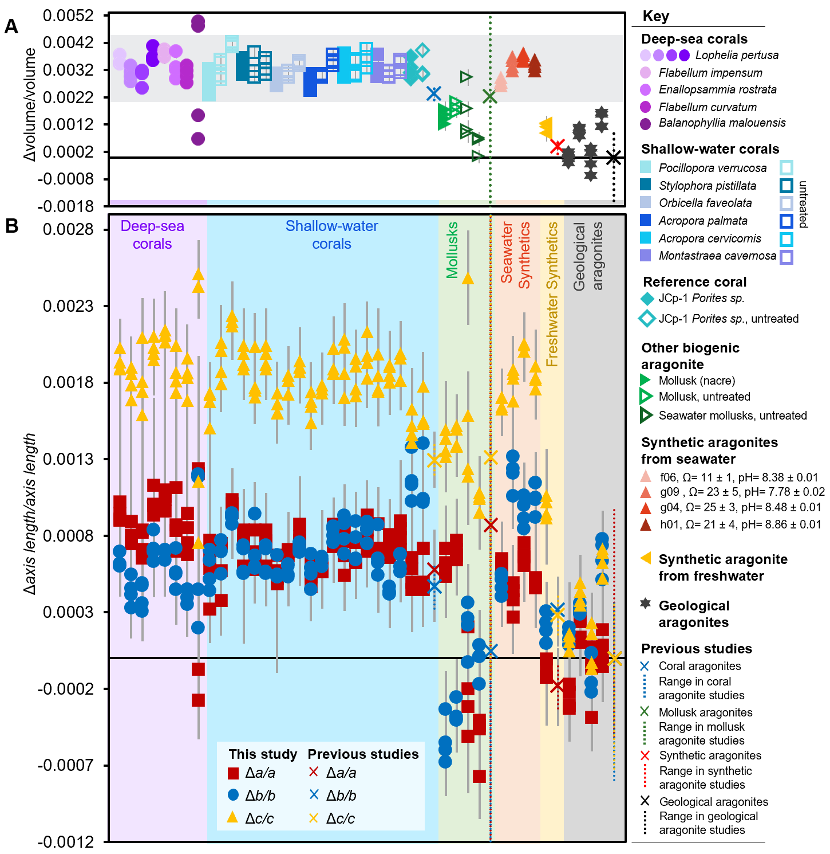
Supplementary Figure 1. Unit-cell parameters for all aragonites calculated in this study by whole pattern Rietveld refinements are plotted highlight the similarities and differences between aragonites formed by different methods (corals, synthetics, etc.). Unit-cell parameters are expressed as A) the ratio of the difference in unit-cell volume between the sample and the mean unit cell volume for previously-studied geological aragonites over the geological aragonite unit-cell volume. B) anisotropic differences in a-axis (red squares), b-axis (blue circles), and c-axis (yellow triangles) lengths as ratios of the difference in axis length between the sample and previously-studied geological aragonites over the geological aragonite axis length. Error bars are based on estimated standard deviations calculated by Rietveld refinements.

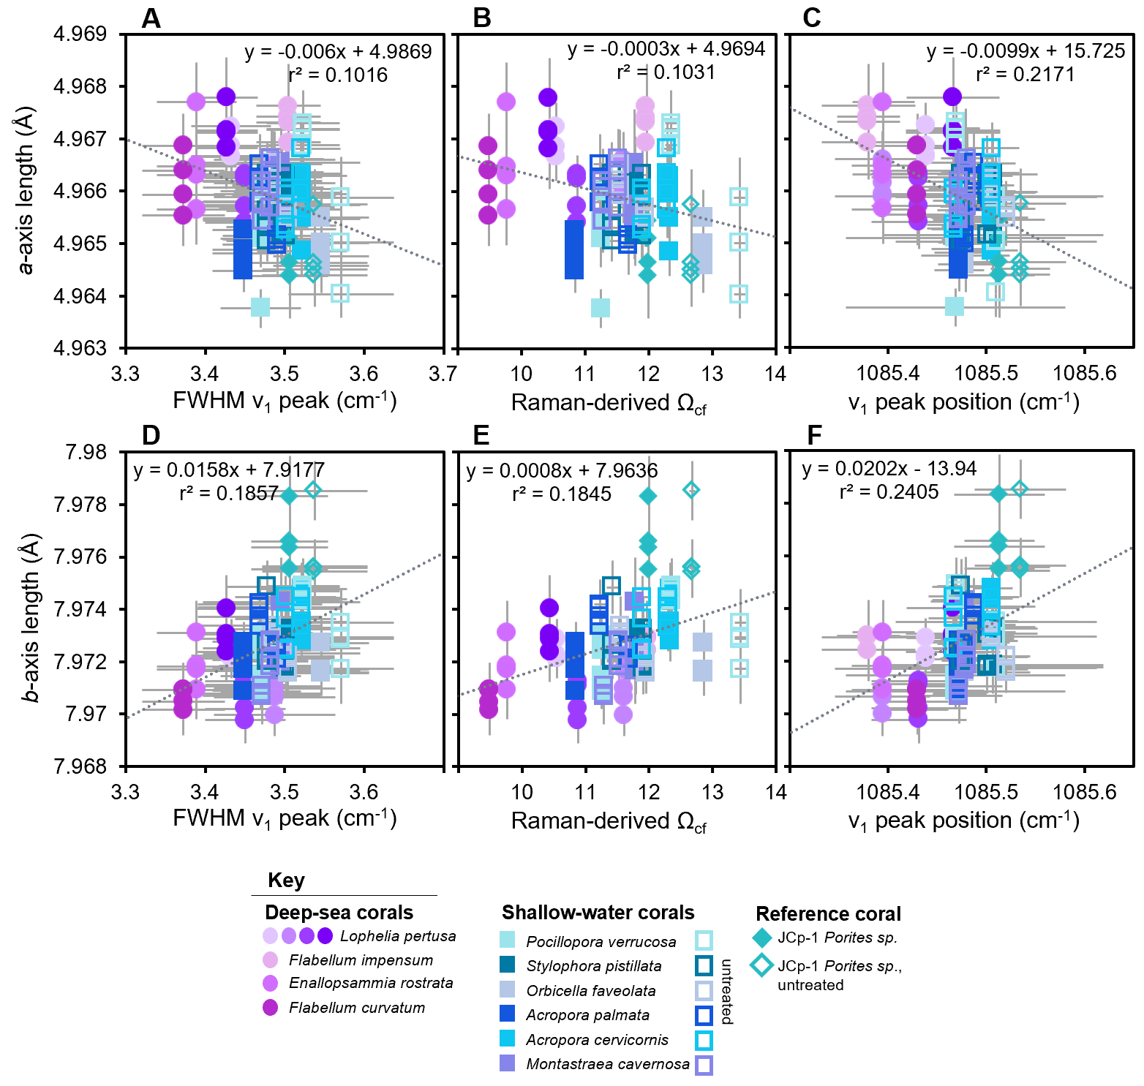
Supplementary Figure 2. Coral aragonite unit-cell A-C) a-axis, D-F) b-axis lengths as functions of Raman spectroscopy data for FWHM v₁ peak, Raman-derived Ω_{cf}, and v₁ peak positions, respectively. Error bars represent estimated standard deviations calculated by Rietveld refinements for unit-cell parameters and standard errors for Raman data.
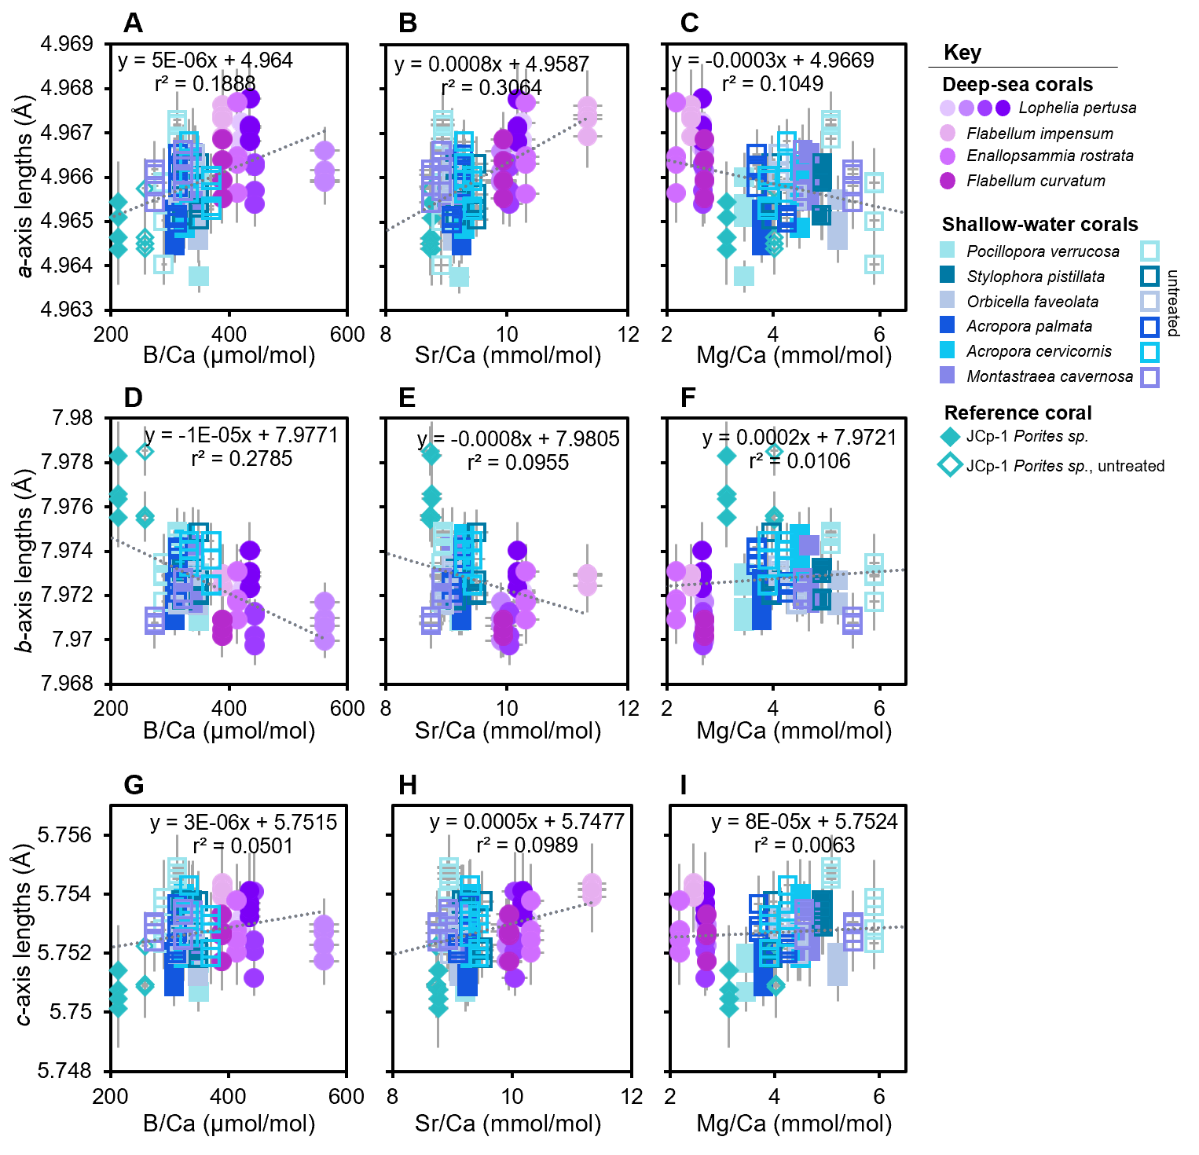
Supplementary Figure 3. Coral aragonite unit-cell A-C) a-axis, D-F) b-axis, and G-I) c-axis lengths as functions of B/Ca, Sr/Ca, and Mg/Ca ratios, respectively. Error bars represent estimated standard deviations.

