The role of parapodia and lack of photoacclimation in kleptoplasts of the sacoglossan sea slug Plakobranchus ocellatus

Angela Richards Donà^{1*}, Jussi Evertsen², Geir Johnsen³

¹Hawai‘i Institute of Marine Biology, University of Hawai‘i at Mānoa, HI 96822, USA
²Department of Natural History, NTNU University Museum, Norwegian University of Science and Technology
³Centre of Autonomous Marine Operations and Systems, Trondhjem Biological Station, Department of Biology, Norwegian University of Science and Technology

Supplementary Material
Table S1. Specimen ID, date, depth, and habitat for the sacoglossan specimens collected at LIRS. The photosynthetic parameters rETR_{max}, α, and E_{k} are presented for most specimens (n/a indicates saturation did not occur and n/a* denotes lack of α with subsequent inability to calculate other parameters). TG = Thuridilla gracilis, PO = Plakobranchus ocellatus, EO = Elysia ornata, CB = Casuarina Beach, BI = Bird Islet, CC = Coconut Beach, OT = One Tree Coconut Beach, PL = Palfrey Island, HR = Horseshoe Reef, TB = Trawler Beach, LG = Lagoon, Group 1 (grey highlight) = June collection, Group 2 = January collection. Only Group 2 was used for pigment extractions and HPLC.

ID | Group | Depth (m) | Habitat |  | E_{k} | rETR_{max} | 𝛼
Thuridilla gracilis
TG_CB_1 | 1 | 1 | Bedrock |  | 694 | 347 | 0.5
TG_CB_2 | 1 | 1 | Bedrock |  | n/a | n/a | 0.35
TG_CC_1 | 1 | 1-2 | Reef flat, sand |  | 456 | 356 | 0.78
TG_BI_1 | 2 | 2-8 | Coral rubble |  | n/a | n/a | 0.33
TG_BI_2 | 2 | 2-8 | Coral rubble |  | 72 | 53 | 0.74
TG_BI_3 | 2 | 2-8 | Coral rubble |  | 81 | 51 | 0.63
TG_CC_2 | 2 | 1-2 | Reef flat, sand |  | n/a* | n/a* | n/a*
TG_CC_3 | 2 | 1-2 | Reef flat, sand |  | n/a* | n/a* | n/a*
TG_CC_4 | 2 | 1-2 | Reef flat, sand |  | 2082 | 812 | 0.39
TG_CC_5 | 2 | 1-2 | Reef flat, sand |  | n/a | n/a | 0.48
TG_CC_6 | 2 | 1-2 | Reef flat, sand |  | 778 | 397 | 0.51
TG_CC_7 | 2 | 1-2 | Reef flat, sand |  | n/a* | n/a* | n/a*
TG_CC_8 | 2 | 1-2 | Reef flat, sand |  | 2230 | 1115 | 0.5
TG_CC_9 | 2 | 1-2 | Reef flat, sand |  | 1028 | 514 | 0.5
Plakobranchus ocellatus
PO_CB_1 | 1 | 1 | Sand |  | n/a | n/a | 0.49
PO_CB_2 | 1 | 1 | Sand |  | 2219 | 1509 | 0.68
PO_CB_3 | 1 | 1 | Sand |  | n/a | n/a | 0.48
PO_OT_1 | 1 | 1 | Sand |  | 1222 | 1014 | 0.83
PO_OT_2 | 1 | 1 | Sand |  | 675 | 574 | 0.85
PO_OT_3 | 1 | 1 | Sand |  | 837 | 879 | 1.05
PO_PL_1 | 1 | 2 | Sand, rubble |  | 592 | 355 | 0.6
PO_PL_2 | 2 | 3 | Sand, rubble |  | 221 | 128 | 0.58
PO_HR_1 | 2 | 2 | Sand |  | 490 | 196 | 0.4
PO_TB_1 | 2 | 3 | Sand |  | 410 | 172 | 0.42
PO_TB_2 | 2 | 3 | Sand |  | 100 | 104 | 1.04
PO_CC_1 | 2 | 1-2 | Reef flat, sand |  | n/a* | n/a* | n/a*
PO_CC_2 | 2 | 1-2 | Reef flat, sand |  | n/a* | n/a* | n/a*
PO_CC_3 | 2 | 1-2 | Reef flat, sand |  | n/a* | n/a* | n/a*
Elysia ornata
EO_PL_1 | 1 | 1 | Boulders |  | 450 | 288 | 0.64
EO_PL_2 | 1 | 1 | Boulders |  | n/a | n/a | 0.58
EO_PL_3 | 1 | 1 | Boulders |  | 556 | 250 | 0.45
EO_LG_1 | 2 | x | Sand |  | n/a* | n/a* | n/a*
EO_CC_1 | 2 | 1-2 | Reef flat, sand |  | n/a | n/a | 0.21
EO_CC_2 | 1 | 1-2 | Reef flat, sand |  | 597 | 400 | 0.67

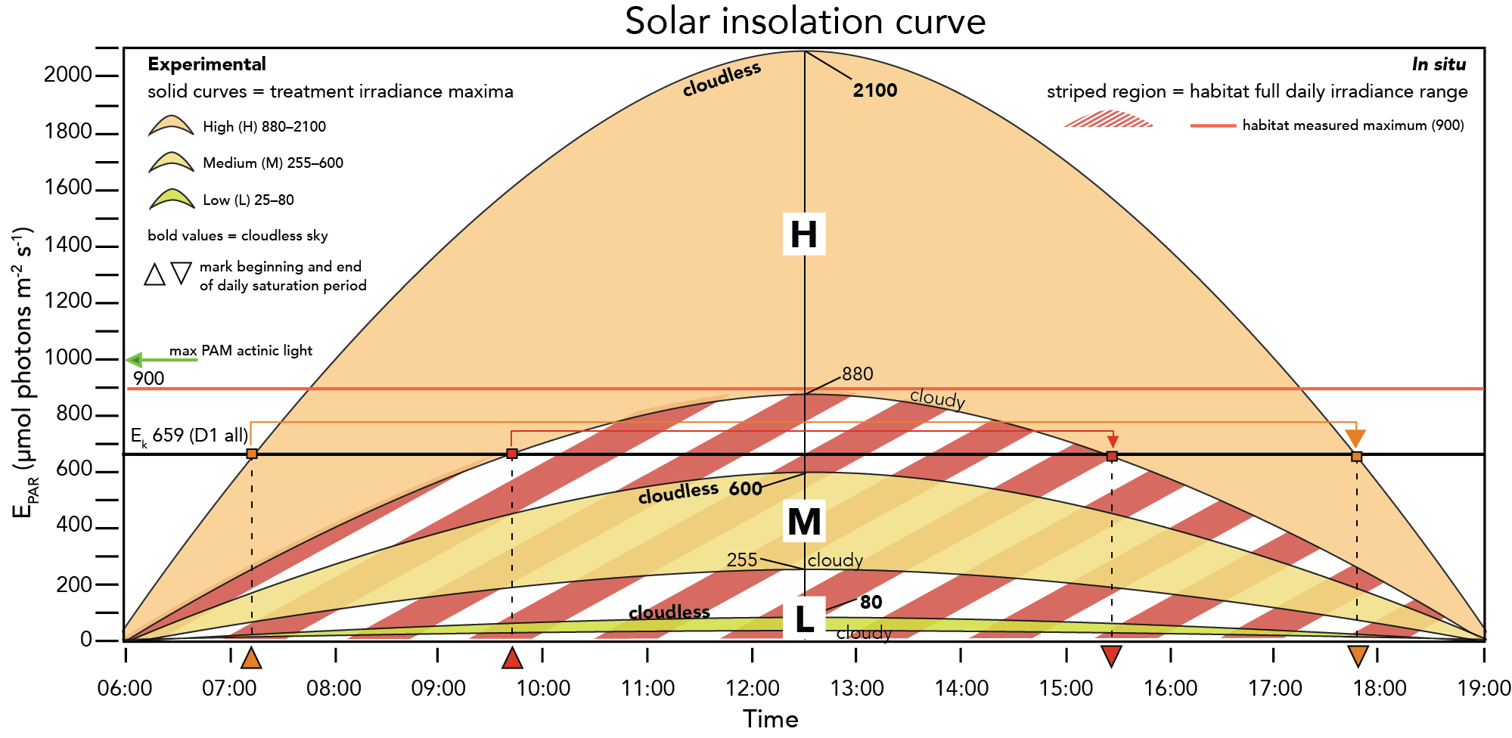
Figure S1. Solar insolation curve depicting approximate daily light habitats for the experimental treatments (solid) and collection reef habitat (striped) based on measured maxima at ~solar noon in May. Habitat maximum (red line) measured on a cloudless day whereas experimental treatment ranges were derived from several measurements on cloudy and cloudless (bold) days. E_{k} is the mean for kleptoplasts of all specimens at time of collection. Arrows with dotted vertical lines indicate approximate times of day the high light treatment entered and exited saturation conditions on cloudless (orange arrows) and cloudy (red arrows) days. L = low, M = medium, H = high.

