The following supplement accompanies the article
Empirically derived thermal thresholds of four coral species along the Red Sea using a portable and standardized experimental approach
Nicolas R. Evensen, Christian R. Voolstra*, Maoz Fine, Gabriela Perna, Carol Buitrago-López, Anny Cárdenas, Guilhem Banc-Prandi, Katherine Rowe, Daniel J. Barshis*
*Corresponding authors: christian.voolstra@uni-konstanz.de, dbarshis@odu.edu

SUPPLEMENTARY MATERIAL
Methods
Sample collection and experimental timelines
Collections at each site came from exposed fore reef sites at ~ 5-m depth. The reefs were at least 8-km off the coast to avoid potential land-based influences as much as possible, except for Eilat, where corals were collected from the research nursery at the Interuniversity Institute of Marine Sciences, and Obock, where corals were collected from a coastal fringing reef. Eight fragments (~ 2–3 cm long branch tips for branching species and ~ 2 cm in diameter cores for mounding species) were collected per colony at each site, with colonies sampled at least 5-m apart from each other to minimize the potential of sampling clones. Sampled specimens were stored in plastic bags and transported to port in a cooler filled with seawater from the collection site. Only a single species, P. lobata was abundant enough to sample at the southernmost site within the Red Sea, Al Qunfudhah, though this species was not sampled in Eilat due to permitting restrictions. In turn, A. hemprichii was not sampled in Obock as this species was not found at that site. Corals were collected under permits from the Israeli Minister of the Environment (for Eilat), the Saudi Coastguard Authority (for the other four sites in the Red Sea), and Djibouti’s Ministry of Urban Affairs, Environment, and Tourism (for Obock).
Sample collection and short-term heat stress assays were conducted in parallel at the Eilat site, by a team of three researchers, and at the four central/southern Red Sea sites (Al Wajh, Yanbu, Al Fahal, and Al Qunfudhah), by a team of six researchers, both in August 2018. In turn, the Djibouti site was sampled in a separate expedition in February 2020 by a team of three researchers. Experiments at each of the six research sites were conducted over two days, totalling 12 days of experiment time, though the actual data collection occurred over a longer time span. Despite being ship-based for the sites in the central/southern Red Sea, boats were not permitted to stay out at sea overnight for the duration of the experiments, thus the boats returned to port following sample collections.

Technical details of the short-term heat stress assays (CBASS)
The temperature in each tank was controlled by IceProbe Thermoelectric chillers (Nova Tec, San Rafael, California, USA) and 200W titanium aquarium heaters (Schego, Offenbach, Germany) linked to a custom-built controller (Arduino MEGA 2560). HOBO Pendant Temperature Data Loggers (Onset Computer Corp.) were used to record the temperature of each tank for the duration of the experiment. Tanks were illuminated following a 12:12h day/night cycle by 165W full spectrum LED aquarium lights (Galaxyhydro), representing the average day length in the tropics. Lights were adjusted to photosynthetic active radiation levels of ~ 600 µmol photons m⁻² s⁻¹ using a LI-193 Spherical Underwater Quantum Sensor (LI-COR, Lincoln, Nebraska USA) to produce light levels above the minimum light levels suggested by Grottoli et al. (2020), but below light levels that may cause photodamage to the corals and within the daily range expected from these reef systems. All tanks were continuously supplied with local seawater at a rate of ~ 2 L h⁻¹. The full experimental metadata are summarized in Table S6 below.

Physiological measurements
Symbiodiniaceae cell counts were obtained via flow cytometry (BD LSRFortessa, BD Biosciences, San Jose, CA, USA). The aliquoted homogenate (see main text) was thawed on ice and diluted with 400 µl of FSW, vortexed, and passed through a cell strainer (5 mL polystyrene round-bottom tube with cell-strainer cap; Corning Life Sciences, NY, USA). Then, 6 µl of 1% SDS was added to the strained sample, vortexed, and 300 µl transferred into a 96-well round bottom plate (three technical replicates per well; Corning Life Sciences, NY, USA), and directly used for flow cytometry analysis. Symbiodiniaceae cells were discriminated from host cells and debris by a combination of their forward scatter (size) and red fluorescence (chlorophyll) using the FlowJo V 10.5.3 software (TreeStar, Ashland, OR, USA). All samples were measured in triplicate.
Chlorophyll a (chl a) content was determined using the SpectraMax Paradigm Multi-Mode Microplate Reader (Molecular Devices, San Jose, CA, USA). The aliquoted homogenate (see main text) was thawed on ice and centrifuged to separate host and symbiont tissues (5000 x g for 5 min at 4°C). The supernatant was removed, and symbiont chlorophyll was extracted via incubation in 100% acetone for 24h at 4°C in the dark, at which point samples were visually inspected to ensure full chlorophyll extraction. Extracted samples were centrifuged (2000 x g for 5 mins at 4°C) and 200 µl were transferred (three replicates per sample) to a 96-well flat bottom plate (Greiner, Bio-One, Kremsmünster, Austria). The absorbance was determined at 664, 630, and 750 nm, and chl a content calculated following the equations of Jeffrey and Humphrey (1975) for acetone extracted dinoflagellates and corrected for the different optical path length of the cuvette used (0.555 cm).
Supplementary Tables
Table S1. Location of research sites. GPS coordinates, country, region, and species sampled at each site.
Table S2. Summary of heat-hold temperatures during the CBASS acute thermal assays. Temperature measurements at all sites were obtained using built-in temperature sensors that logged temperatures at 1-minute intervals (n = 180; see GitHub repository for raw data), except in Eilat where temperatures were measured at regular intervals using a handheld temperature sensor (n = 6). 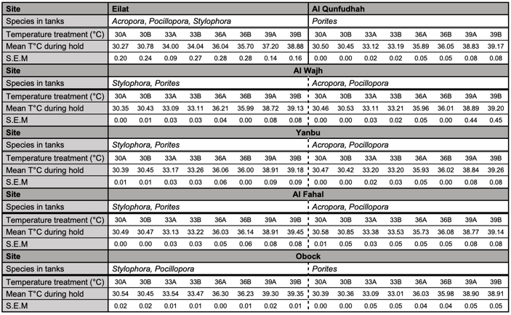
Table S3. Results of the Generalized linear mixed models (GLMMs) comparing F_{v} /F_{m} and visual bleaching ED50s for each coral species across sites.
Physiological measurement | Species | Source | df | MS | F | P
F_{v} /F_{m} ED50s | S. pistillata | Site | 4 | 7.32 | 30.5 | < 0.001
F_{v} /F_{m} ED50s | S. pistillata | Residuals | 30 | 0.240
F_{v} /F_{m} ED50s | P. lobata | Site | 4 | 11.8 | 9.42 | < 0.001
F_{v} /F_{m} ED50s | P. lobata | Residuals | 30 | 0.313
F_{v} /F_{m} ED50s | A. hemprichii | Site | 4 | 1.44 | 26.9 | < 0.001
F_{v} /F_{m} ED50s | A. hemprichii | Residuals | 30 | 0.054
F_{v} /F_{m} ED50s | P. verrucosa | Site | 4 | 2.38 | 5.18 | 0.003
F_{v} /F_{m} ED50s | P. verrucosa | Residuals | 30 | 0.460
Visual bleaching ED50s | S. pistillata | Site | 4 | 44.1 | 6.66 | < 0.001
Visual bleaching ED50s | S. pistillata | Residuals | 30 | 6.62
Visual bleaching ED50s | P. lobata | Site | 4 | 18.9 | 5.25 | 0.003
Visual bleaching ED50s | P. lobata | Residuals | 26 | 3.61
Visual bleaching ED50s | A. hemprichii | Site | 2 | 1.79 | 1.10 | 0.355
Visual bleaching ED50s | A. hemprichii | Residuals | 18 | 1.631
Visual bleaching ED50s | P. verrucosa | Site | 4 | 13.9 | 4.26 | 0.008
Visual bleaching ED50s | P. verrucosa | Residuals | 29 | 3.27

Table S4. Results of the Generalized linear mixed models (GLMMs) comparing symbiont densities and chlorophyll a (chl a) concentrations for each coral species across sites and temperature treatments. Coral colony was included in the models as random effect nested within sites.
Physiological measurement | Species | Source | df | MS | F | P
Symbiont densities  (cm⁻²) | S. pistillata | Temperature | 3 | 5.01 | 18.9 | < 0.001
Symbiont densities  (cm⁻²) | S. pistillata | Site | 2 | 1.67 | 6.30 | 0.007
Symbiont densities  (cm⁻²) | S. pistillata | Temperature × Site | 6 | 3.40 | 12.8 | < 0.001
Symbiont densities  (cm⁻²) | P. lobata | Temperature | 3 | 1.81 | 5.13 | 0.003
Symbiont densities  (cm⁻²) | P. lobata | Site | 2 | 2.44 | 6.90 | 0.006
Symbiont densities  (cm⁻²) | P. lobata | Temperature × Site | 6 | 0.417 | 1.18 | 0.330
Symbiont densities  (cm⁻²) | A. hemprichii | Temperature | 3 | 4.35 | 20.9 | < 0.001
Symbiont densities  (cm⁻²) | A. hemprichii | Site | 2 | 55.6 | 267 | < 0.001
Symbiont densities  (cm⁻²) | A. hemprichii | Temperature × Site | 6 | 1.69 | 8.14 | < 0.001
Symbiont densities  (cm⁻²) | P. verrucosa | Temperature | 3 | 37.0 | 69.8 | < 0.001
Symbiont densities  (cm⁻²) | P. verrucosa | Site | 2 | 62.8 | 119 | < 0.001
Symbiont densities  (cm⁻²) | P. verrucosa | Temperature × Site | 6 | 8.06 | 15.2 | < 0.001
Chl a  (µg cm⁻²) | S. pistillata | Temperature | 3 | 1.37 | 6.22 | 0.001
Chl a  (µg cm⁻²) | S. pistillata | Site | 2 | 8.21 | 37.3 | < 0.001
Chl a  (µg cm⁻²) | S. pistillata | Temperature × Site | 6 | 0.935 | 4.25 | 0.001
Chl a  (µg cm⁻²) | P. lobata | Temperature | 3 | 0.539 | 5.26 | 0.003
Chl a  (µg cm⁻²) | P. lobata | Site | 2 | 0.848 | 8.27 | 0.006
Chl a  (µg cm⁻²) | P. lobata | Temperature × Site | 6 | 0.083 | 0.808 | 0.568
Chl a  (µg cm⁻²) | A. hemprichii | Temperature | 3 | 0.383 | 6.09 | 0.001
Chl a  (µg cm⁻²) | A. hemprichii | Site | 2 | 15.5 | 246 | < 0.001
Chl a  (µg cm⁻²) | A. hemprichii | Temperature × Site | 6 | 0.123 | 1.96 | 0.085
Chl a  (µg cm⁻²) | P. verrucosa | Temperature | 3 | 13.4 | 64.6 | < 0.001
Chl a  (µg cm⁻²) | P. verrucosa | Site | 2 | 45.3 | 218 | < 0.001
Chl a  (µg cm⁻²) | P. verrucosa | Temperature × Site | 6 | 2.98 | 14.4 | < 0.001

Table S5. Results of the Generalized linear mixed models (GLMMs) comparing F_{v} /F_{m} ED50s relative to local maximum monthly mean (MMM) seawater temperatures at each site, comparing thresholds relative to local MMMs between sites and species.
Source | df | MS | F | P
Site | 5 | 31.3 | 113 | < 0.001
Species | 3 | 9.58 | 34.5 | < 0.001
Site × Species | 10 | 2.32 | 8.34 | < 0.001
Residuals | 114 | 0.278

Table S6. Summary of project metadata produced to increase cross-study comparisons across coral bleaching experiments (modified from Grottoli et al. 2020).
Metadata type | Data type | Conditions/methods, and units
Coral collection | Latitude and longitude at collection site  Collection depth  Collection dates  Coral morphology  Symbiodiniaceae for all coral colonies  Acclimation post collection prior to experiment | See Table S1 (in Decimal degrees)  ~ 5 m  August 2018 (all but Obock), and February 2020  Branching, corymbose, and massive  Unknown  2-3 hours
Experimental design | Name of location  Bleaching stress temperature period  System type  No. tanks per treatment  No. coral genets (colonies) per treatment  No. coral genets (colonies) per tank within treatments  No. recovery days post heat-stress | See Table S1  18 hours  Flow-through, outdoor  2  7  1  < 1 (11 hours)
Experimental temperature conditions | Control temperature  Baseline temperature (MMM)  Temperature ramp-up rate  Duration at heat stress temperature  Temperature modulation | 30°C  27.01-31.56°C  1-3°C / h  7 hours  Static
Other experimental conditions | Light conditions  Light cycle  Tank turnover  Tank size  Seawater filtration  Seawater source  Feeding | 600 μmol photons m^{–2} s^{–1} (measured via LiCor Li192)  12:12 hour day:night cycle  2 L / h  10 L  None  Natural (direct from local reef)  Not fed

Supplementary Figures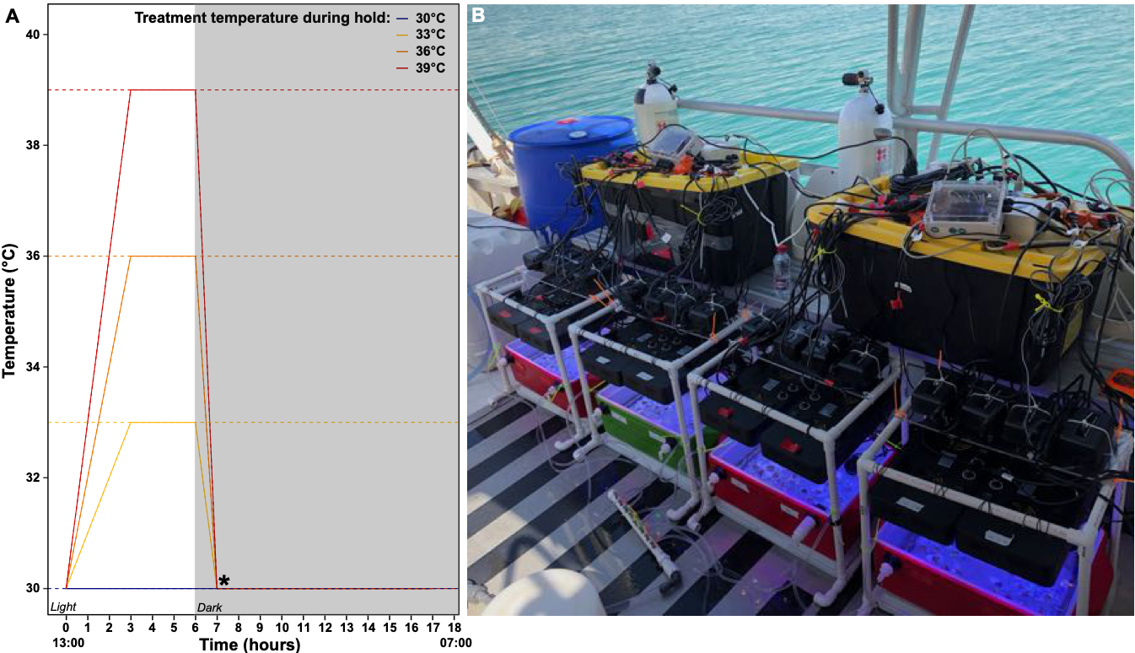
Figure S1. (A) Target temperature profiles for 18-hour acute thermal stress assays in the Coral Bleaching Automated Stress System (CBASS), with the four temperature profiles designed to encompass the full range of the thermal stress response in corals. Standard start and end times for the assays are indicated below the x-axis. Asterisk indicates the time point of dark-adapted photosynthetic efficiency measurement (F_{m}/F_{m}), with symbiont densities, chl a content, and visual bleaching assessments conducted at the end of the 18 h assays. (B) Overview of the CBASS setup on a small research vessel, showing 4 light- and temperature-independent, flow-through tanks with 2 replicate units per temperature treatment. Photo credit: Christian R. Voolstra.
Figure S2. Example of the photographs taken used for visual bleaching assessments, displaying the appearance of A. hemprichii fragments in the four temperature treatments at the end of the 18-hour thermal assays. Prior to assessments, photos were corrected for color and exposure using a monochromatic grayscale reference (Kodak Color Separation Guide and Gray Scale Q-13) in each photograph following the method of Winters et al. (2009). Severity of bleaching then was scored on a 6-category scale of 0-100% bleached (0%, 20%, 40%, 60%, 80%, and 100%; labelled above each fragment) by three independent people, with the median bleaching score selected for each colony (sensu Morikawa and Palumbi 2019).

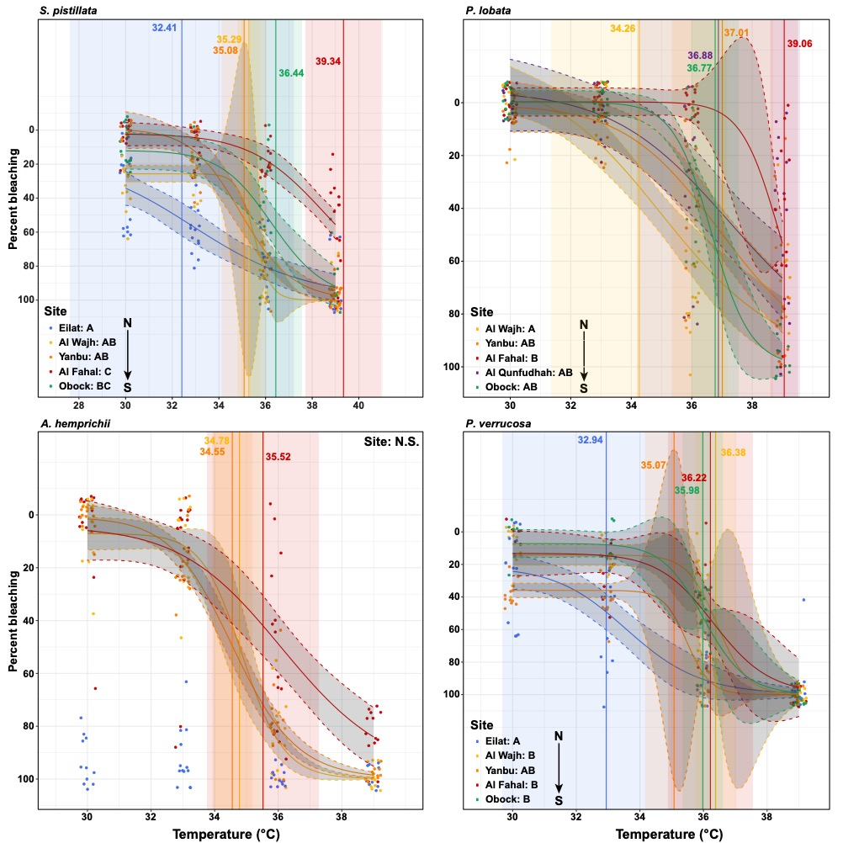
Figure S3. Visual bleaching assessments based on photographs taken at the end of the 18-hour thermal assays (described in Figure S2). Three-parameter log-logistic curves were fit to each population, which are plotted with 95% confidence intervals. Vertical lines indicate the mean effective dose 50 (ED50) for each population, along with the standard error indicated by the shaded regions (each n = 7), based on individual curve fits and ED50s for each colony. Letters in the bottom-left corner of the panels represent statistical differences between sites based on Tukey’s post hoc comparisons. Note: low visual bleaching scores for A. hemprichii corals across all temperature treatments meant that no curve could be fit for Eilat.

Figure S4. Symbiont densities (10⁶ individuals cm⁻²) for each species at the end of the 18-h thermal stress assays. Boxplot lines represent the median, with boxes showing the 25th to the 75th percentile, lines are whiskers showing 1.5x the Interquartile Range, and open circles displaying outliers (n = 7 per treatment). Overall results of the GLMM are denoted in the text at the bottom/top left of each panel. For interactive effects of temperature and site, differences among temperatures within sites are denoted by colour-coded lowercase letters above the boxes, while differences among sites within temperatures are denoted by uppercase letters below the boxes. For P. lobata, letters above the boxes denote differences between temperature treatments, pooling sites, with differences between sites indicated in italics in the lower left corner of the panel.

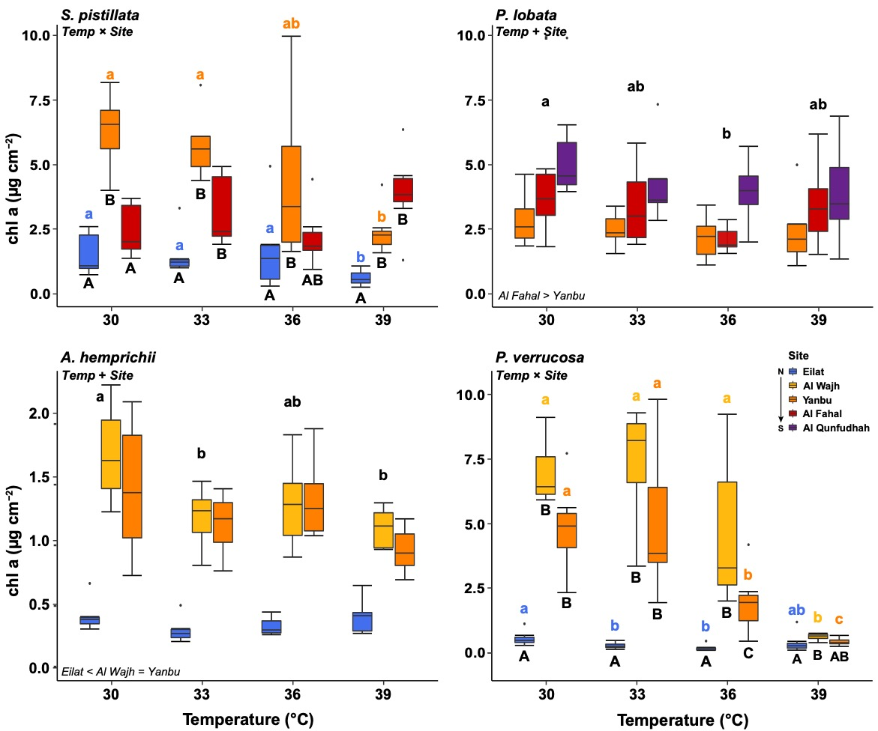

Figure S5. Chl a content (µg cm⁻²) for each species at the end of the 18-h thermal stress assays. Boxplot lines represent the median, with boxes showing the 25th to the 75th percentile, lines are whiskers showing 1.5x the Interquartile Range, and open circles displaying outliers (n = 7 per treatment). Overall results of the GLMM are denoted in the text at the bottom/top left of each panel. For interactive effects of temperature and site, differences among temperatures within sites are denoted by colour-coded lowercase letters above the boxes, while differences among sites within temperatures are denoted by uppercase letters below the boxes.
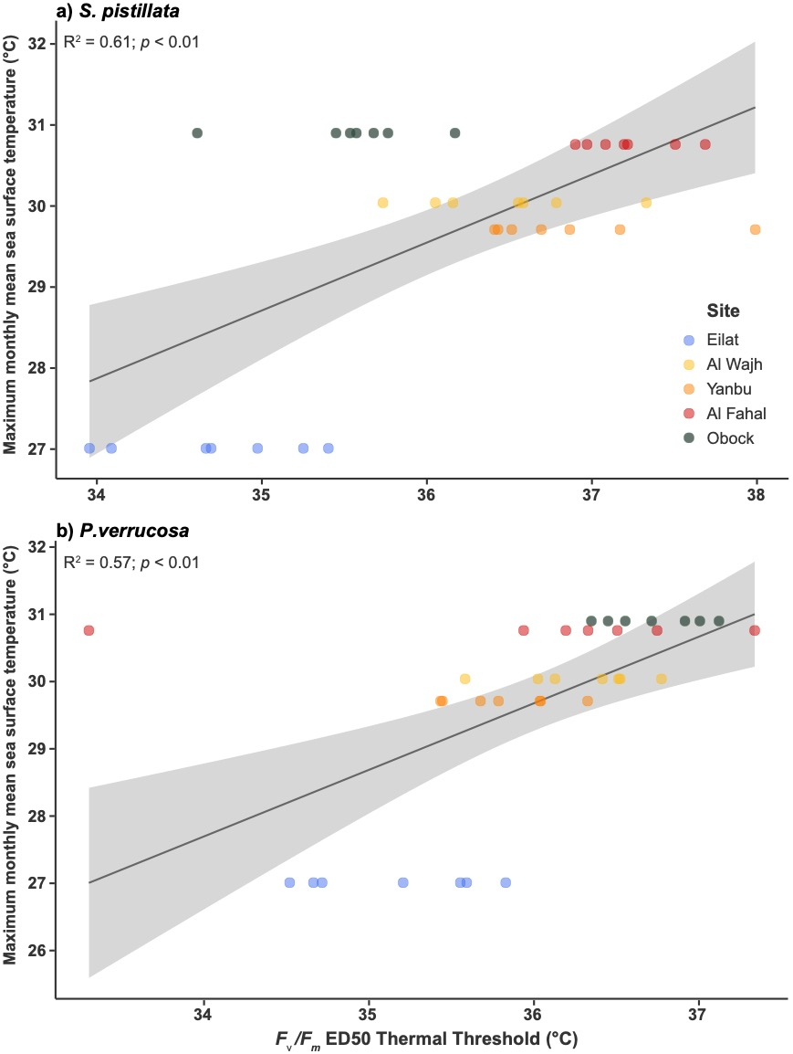
Figure S6. Correlations between F_{v}/F_{m} ED50 thermal thresholds and Maximum monthly mean (MMM) sea surface temperatures for a) Stylophora pistillata and b) Pocillopora verrucosa, across the five sites (color-coded) from which these species were sampled (7 colonies per site, n = 35). Black lines represent the linear regression, with grey-shaded areas indicating the 95% confidence intervals.

REFERENCES
Grottoli AG, Toonen RJ, Woesik R van, Thurber RV, Warner ME, McLachlan RH, Price JT, Bahr KD, Baums IB, Castillo K, Coffroth MA, Cunning R, Dobson K, Donahue M, Hench JL, Iglesias‐Prieto R, Kemp DW, Kenkel CD, Kline DI, Kuffner IB, Matthews JL, Mayfield A, Padilla‐Gamino J, Palumbi S, Voolstra CR, Weis VM, Wu HC (2020) Increasing comparability among coral bleaching experiments. Ecological Applications e2262
Jeffrey SW, Humphrey GF (1975) New spectrophotometric equations for determining chlorophylls a, b, c1 and c2 in higher plants, algae and natural phytoplankton. Biochemie und Physiologie der Pflanzen 167:191–194
Morikawa MK, Palumbi SR (2019) Using naturally occurring climate resilient corals to construct bleaching-resistant nurseries. Proceedings of the National Academy of Sciences 116:10586–10591
Winters G, Holzman R, Blekhman A, Beer S, Loya Y (2009) Photographic assessment of coral chlorophyll contents: Implications for ecophysiological studies and coral monitoring. Journal of Experimental Marine Biology and Ecology 380:25–35

