Supplementary Information for Growth responses of mixotrophic giant clams on nearshore turbid coral reefs
Kimberley Mills¹, Eleanor H. John¹, Duncan D. Muir ¹, Nadia Santodomingo², Kenneth Johnson², Muhammad Ali Syed Hussein ³, Sindia Sosdian^{1, 1}Cardiff University, School of Earth and Environmental Sciences, United Kingdom; ²Natural History Museum, London, United Kingdom; ³Borneo Marine Research Institute, Universiti Malaysia Sabah; millsk3@cardiff.ac.uk
List of Tridacna squamosa samples used in this study
Table S1. Thirteen Tridacna squamosa specimens used in this study from Darvel Bay and Semporna reefs. BA = Baik; TR = Triangle; BL = Blue Lagoon; TH = THalu; MI = Misan; SA = Sakar; SEM = Semporna reefs. L = live collected shells; D = dead collected shells; U = unknown collection status of shells.
Site | Sample | Collection Status
TR | SSct | L 2019
BA | SSbaik | L 2019
TR | ZW156 | L 2020
BA | NS207 | L 2020
BL | SS01ABH | D
BA | SS01BBT | D
TR | SS03BCT | D
TR | SS02BCT | D
TH | SS01ATH | D
MI | SS01ASM | D
SA | SS02ASN | D
SEM | SEMA | U
SEM | SEMB | U

Diagenetic screening
Dead shells of T. squamosa collected from the seafloor were screened under scanning electron microscopy (SEM) for signs of diagenetic alteration. We scanned across the inner layer of shell surfaces (etched with 0.5 % HCL for 15 sec) where counting of growth increments took place and investigated visual characteristics that indicate original aragonite arrangements (Taylor et al. 1969) (Fig. S1). The following characteristics that may indicate alteration were searched for: irregular shaped crystals with irregular intercrystalline boundaries, coarsening of crystal size (Hou et al. 2020); fusion of platelets (Hou et al., 2020); lack of consistency in size of lamellae (supplemental in Killam et al. 2021). The detection of original aragonite structures was recorded in all shells (Fig. S1).
Preservation of dead collected shells was further supported with Raman spectroscopic analysis, carried out on a Renishaw inVia Raman microscopy with green argon laser (λ = 540). Raman spectra were acquired for three areas across shells in the same position as acquired images for chronologies. For each spectrum, 20 accumulations were integrated with 5 s exposure time at 10% laser power. Focus was placed on the calcium carbonate “lattice mode” (100-400 cm⁻¹) and the in-plane bend (v₄) internal mode (700–720 cm⁻¹), effective for discrimination of aragonite and calcite (e.g. Urmos et al. 1991; Parker et al. 2010). We found aragonite defining peaks at the v4 in-plane bending mode at ~701 and 705 cm⁻¹ across the shells of all samples (Urmos et al. 1991) (Fig. S2). The lattice mode showed characteristic low frequency measurements at 150 and 210 cm⁻¹ (DeCarlo 2018) and the strongest v1 peaks (Urmos et al. 1991) near 1085 cm⁻¹ were displayed, indicating that shells were aragonitic and showed no alteration to calcite.

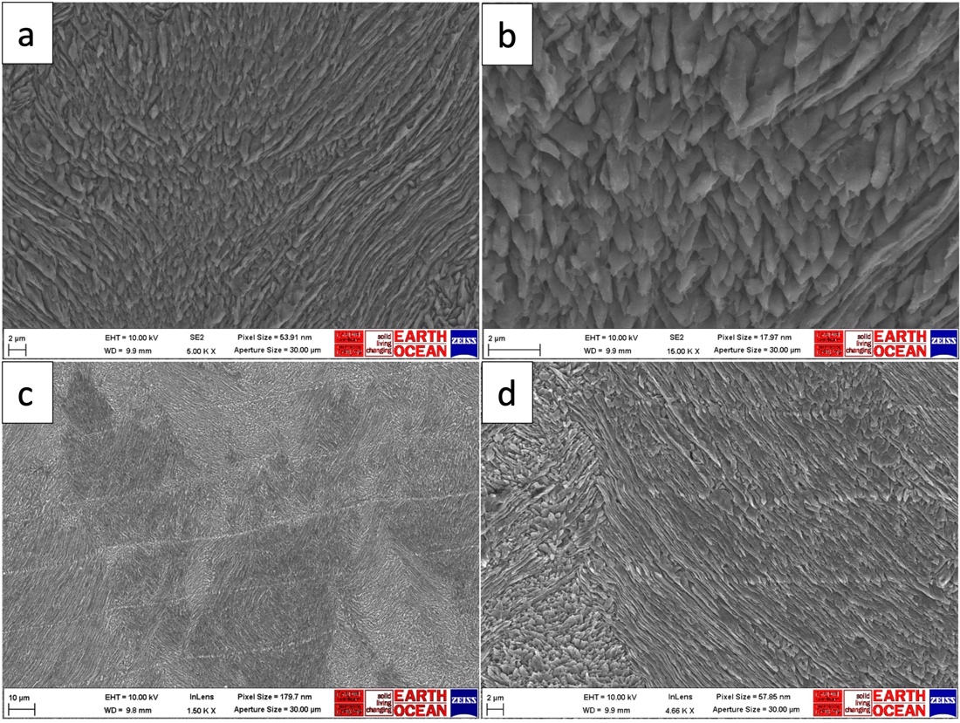
Figure S1. Scanning electron microscopy (SEM) images of Tridacna squamosa thin sections showing evidence for original aragonite microstructures: (a, b) strong crystallization boundaries in size and shape of third-order laths (i.e. individual aragonitic crystals) (SS03BCT); (c, d) well-defined angles between each first-order lamellar in the inner shell growth layer (SEMA and SEMB respectively).

Figure S2. Raman spectra of ten Tridacna squamosa shell samples collected dead from Darvel Bay and unknown collection status from Semporna reefs, showing aragonite defining peaks and a lack of calcite defining peaks. (a) IIL = inner layer, representing region of last growth; (b) MIL = middle inner layer, representing region of mid to first growth; (c); OL = outer layer.

Environmental Data
Table S2. In situ and remote sensed derived products used in this study. BA = Baik; TR = Triangle; BL = Blue Lagoon; TH = THalu; MI = Misan; SA = Sakar. GEE = Google Earth Engine; NOAA = National Oceanic and Atmospheric Administration database. NOAA CDR PATMOSX = Cloud Properties, Reflectance, and Brightness Temperatures, Version 5.3; HYCOM = Hybrid Coordinate Ocean Model, Water Temperature and Salinity; MODIS Aqua = Ocean Color SMI: Standard Mapped Image MODIS Aqua; VIIRS = NOAA Visible Infrared Imaging Radiometer Suite; CHIRPS = Climate Hazards Group InfraRed Precipitation with Station data.
Environmental Factor | Site | Data Period | Data Type | Source | Spatial Resolution | Temporal Resolution
SST | BA, TR | 2019–2020 | In situ | This study | NA | 10–15 min
Lux | BA, TR | 2019–2020 | In situ | This study | NA | 10–15 min
Cloud Cover | BA, TR | 2018–2020 | Remote sense | GEE; NOAA CDR PATMOSX | 0.08° x 0.08° | Daily
Salinity | BA, TR | 2018–2020 | Remote sense | GEE; HYCOM | 0.08° x 0.08° | Daily
SST | BA, TR | 2018–2019 | Remote sense | GEE; MODIS Aqua | 0.05° x 0.05° | Daily
K_{d}(490) | BA, TR, BL, TH, MI, SA | 2018–2020 | Remote sense | NOAA; VIIRS | 0.05° x 0.05° | Daily
Chlorophyll-a | BA, TR | 2018–2020 | Remote sense | NOAA; VIIRS | 0.05° x 0.05° | Daily
Rainfall | BA, TR | 2018–2020 | Remote sense | NOAA; CHIRPS | 0.05° x 0.05° | Daily

Construction of mean shell growth chronologies
Overall visibility of growth increments from across the inner layer of each shell obtained with SEM and petrography were accessed and rated from very low (VL) (> 30% of increments clear), low (L) (> 60% of increments clear), medium (M) (> 75% of increments clear), high (H) (> 90% of increments clear) or very high (VH) (> 95% of increments clear) and estimated days alive and mean daily growth (µm) noted (Table S2). To compile final mean shell growth chronologies, combined chronologies that were rated L or higher were fitted with Locally Weighted Least Squares Regression (loess line). Mean lifespan and growth (mm/yr) were calculated from final chronologies (Table S3).
For some counts, an autoplace tool was used in the dendrochronological software Coorecorder 9.8 (Cybis) (Maxwell and Larsson 2021), which automatically places points at growth line borders (denoted as ‘automated’ or ‘A’ as opposed to ‘manual’ or ‘M’ in Table S2). Yet, due to the highly topographic microstructure of most samples, this tool was deemed unreliable in most cases and created large offsets. For this reason, we only incorporated these measurements into final mean chronologies in samples whose daily growth lines were highly identifiable across the whole inner layer region of the shell. Large offsets in some samples between light microscopy and SEM (particularly SSbaik) are discussed further in the main body of text.
Table S3. Raw count data of individual shell growth chronologies for Tridacna squamosa. Shell sample, reef site, collection status, counting method, technique used to acquire images, image source, estimated lifespan, daily growth statistics, increment visibility are shown. BA = Baik; TR = Triangle; BL = Blue Lagoon; TH = THalu; MI = Misan; SA = Sakar; SEM = Semporna region. L = live collected shells; D = dead collected shells; U = unknown collection status of shells. PM = primary counter manual; SM = second counter manual; PA = primary counter automated. R = reflected light; T = transmitted light, SE = secondary electron. LM = light microscopy; SEM = scanning electron microscopy. VH = very high; H = high; M = medium; L = low; VL = very low.
Sample | Site | Collection | Counting Method | Technique | Image Source | Estimated Days Alive | Mean daily growth (μm) | SD | SE | Range (μm) | Visibility
SSct | TR | L 2019 | PM | LM | R | 1144 | 14.28 | 3.78 | 0.11 | 21.92 | H
SSct | TR | L 2019 | PA | LM | R | 1336 | 13.88 | 4.16 | 0.11 | 28.00 | H
SSct | TR | L 2019 | PM | SEM | SE | 1127 | 12.86 | 3.02 | 0.09 | 20.03 | H
SSct | TR | L 2019 | SM | LM | R | 1107 | 15.91 | 4.44 | 0.13 | 27.62 | H
SSbaik | BA | L 2019 | PM | LM | R | 1186 | 15.79 | 6.03 | 0.18 | 38.50 | M
SSbaik | BA | L 2019 | PA | LM | R | 1081 | 15.46 | 6.09 | 0.18 | 38.50 | M
SSbaik | BA | L 2019 | PM | SEM | SE | 1961 | 11.86 | 5.85 | 0.13 | 37.25 | M
SSbaik | BA | L 2019 | SM | LM | R | 1141 | 16.70 | 7.63 | 0.23 | 51.79 | M
ZW156 | TR | L 2020 | PM | LM | R | 689 | 21.79 | 6.37 | 0.26 | 43.52 | VH
ZW156 | TR | L 2020 | PA | LM | R | 662 | 25.02 | 10.21 | 0.40 | 49.58 | VH
ZW156 | TR | L 2020 | PM | SEM | SE | 684 | 20.00 | 7.84 | 0.30 | 37.04 | VH
ZW156 | TR | L 2020 | SM | LM | R | 681 | 21.72 | 8.85 | 0.34 | 42.06 | VH
NS207 | BA | L 2020 | PM | LM | R | 2508 | 12.08 | 5.20 | 0.10 | 32.70 | L
NS207 | BA | L 2020 | PM | SEM | SE | 2702 | 9.94 | 4.46 | 0.08 | 21.39 | L
NS207 | BA | L 2020 | SM | LM | R | 2441 | 12.89 | 5.93 | 0.12 | 35.36 | L
SS01ABH | BL | D | PM | LM | T | 1093 | 15.35 | 7.12 | 0.21 | 34.57 | H
SS01ABH | BL | D | PA | LM | T | 1055 | 16.99 | 7.27 | 0.22 | 45.00 | H
SS01ABH | BL | D | PM | SEM | SE | 1649 | 15.68 | 6.15 | 0.15 | 34.72 | VL
SS01BBT | BA | D | PM | LM | T | 1899 | 11.93 | 3.53 | 0.12 | 26.90 | L
SS01BBT | BA | D | PA | LM | T | 1518 | 12.90 | 4.22 | 0.11 | 29.00 | L
SS01BBT | BA | D | PM | SEM | SE | 2016 | 11.75 | 3.86 | 0.09 | 32.70 | M
SS03BCT | TR | D | PM | LM | T | 541 | 20.34 | 5.62 | 0.24 | 31.27 | VH
SS03BCT | TR | D | PA | LM | T | 540 | 19.56 | 5.37 | 0.23 | 28.26 | VH
SS03BCT | TR | D | PM | SEM | SE | 537 | 16.86 | 6.50 | 0.28 | 28.30 | VH
SS02BCT | TR | D | PM | LM | T | 1261 | 12.06 | 4.63 | 0.13 | 22.20 | H
SS02BCT | TR | D | PA | LM | T | 1204 | 11.97 | 4.78 | 0.14 | 25.00 | H
SS02BCT | TR | D | PM | SEM | SE | 1251 | 12.39 | 4.80 | 0.14 | 24.46 | H
SS01ATH | TH | D | PM | LM | T | 345 | 10.46 | 3.72 | 0.20 | 17.62 | M
SS01ATH | TH | D | PA | LM | T | 357 | 10.27 | 4.09 | 0.22 | 19.00 | M
SS01ATH | TH | D | PM | SEM | SE | 472 | 10.90 | 3.85 | 0.18 | 22.81 | H
SS01ASM | MI | D | PM | LM | T | 1246 | 16.13 | 6.64 | 0.19 | 30.56 | M/H
SS01ASM | MI | D | PA | LM | T | 1081 | 16.61 | 7.28 | 0.22 | 39.03 | M/H
SS01ASM | MI | D | PM | SEM | SE | 1330 | 13.87 | 6.13 | 0.17 | 27.55 | H
SS02ASN | SA | D | PM | LM | T | 370 | 10.11 | 3.41 | 0.18 | 16.93 | VL
SS02ASN | SA | D | PM | SEM | SE | 284 | 12.08 | 3.69 | 0.22 | 17.42 | L/M
SS02ASN | SA | D | PM | SEM | SE | 262 | 11.24 | 3.30 | 0.21 | 17.87 | L/M
SEMA | SEM | U | SM | LM | R | 371 | 22.88 | 4.37 | 0.23 | 24.79 | M
SEMA | SEM | U | PA | LM | R | 387 | 23.56 | 5.37 | 0.27 | 28.24 | M
SEMA | SEM | U | SM | SEM | SE | 447 | 20.46 | 6.12 | 0.29 | 28.80 | H
SEMB | SEM | U | SM | LM | R | 153 | 21.38 | 6.07 | 0.49 | 30.23 | VL
SEMB | SEM | U | PA | LM | R | 278 | 20.73 | 7.69 | 0.46 | 34.79 | VL
SEMB | SEM | U | SM | SEM | SE | 263 | 19.27 | 8.15 | 0.50 | 32.89 | L

Figure S3. Relationship between days alive and daily growth rate (µm) for individual counts incorporated into final mean shell growth chronologies from dead collected Tridacna squamosa shells for samples SS01BBT (Baik) (a), SS02BCT (Triangle) (b), SS03BCT (Triangle) (c), SS01ABH (Blue Lagoon) (d), SS01ASM (Misan) (e), SS01ATH (THalu) (f), SS02ASN (Sakar) (g), SEMA (Semporna) (h), SEMB (Semporna) (i). PM-LM = primary counter, measurement tool (ImageJ), light microscopy images; PA-LM = primary counter, autoplace function (CooRecorder), light microscopy images; PM-SEM = primary counter, measurement tool (ImageJ), SEM images; SM-LM = secondary counter, measurement tool (ImageJ), light microscopy images.

Figure S4. Relationship between days alive and daily growth rate (µm) for individual counts incorporated into final mean shell growth chronologies from live collected Tridacna squamosa shells for samples SSbaik (Baik, 2019 collected) (a), SSct (Triangle, 2019 collected) (b), NS207 (Baik, 2020 collected) (c), ZW156 (Triangle, 2020 collected) (d). PM-LM = primary counter, measurement tool (ImageJ), light microscopy images; PA-LM = primary counter, autoplace function (CooRecorder), light microscopy images; PM-SEM = primary counter, measurement tool (ImageJ), SEM images; SM-LM = secondary counter, measurement tool (ImageJ), light microscopy images.

Table S4. Individual growth chronologies incorporated into combined final growth chronologies, approximate age (yr) and annual mean growth rate (mm/yr) for Tridacna squamosa shells. BA = Baik; TR = Triangle; BL = Blue Lagoon; TH = THalu; MI = Misan; SA = Sakar; SEM = Semporna reefs. N = number of counts incorporated into final chronologies. PM-LM = primary counter, measurement tool (ImageJ), light microscopy images; PA-LM = primary counter, autoplace function (CooRecorder), light microscopy images; PM-SEM = primary counter, measurement tool (ImageJ), SEM images; SM-LM = secondary counter, measurement tool (ImageJ), light microscopy images.
Sample | Site | N | Incorporated chronologies | Age (yr) | Overall mean growth (mm/yr) | Mean growth 0–1 yr (mm/yr) | Mean growth 0–2 yr (mm/yr) | Mean growth 2–4 yr (mm/yr) | Mean growth 4–6 yr (mm/yr)
SSbaik | BA | 3 | PM-LM (1), PM-SEM (1), SM-LM (1) | 3.40 | 5.20 ± 2.48 | 6.01 ± 2.63 | 5.48 ± 0.006 | - | -
SSct | TR | 3 | PM-LM (1), PM-SEM (1), SM-LM (1) | 3.10 | 5.24 ± 1.46 | 4.91 ± 1.35 | 5.40 ± 1.43 | - | -
NS207 | BA | 3 | PM-LM (1), PM-SEM (1), SM-LM (1) | 7.23 | 4.21 ± 1.95 | 4.66 ± 2.05 | 4.30 ± 1.73 | 5.82 ± 1.81 | 3.58 ± 1.46
ZW156 | TR | 4 | PM-LM (1), PM-SEM (1), SM-LM (1) PA-LM (1) | 1.86 | 8.13 ± 3.37 | 6.51 ± 3.09 | - | - | -
SS01ABH | BL | 2 | PM-LM (1), PA-LM (1) | 2.95 | 5.90 ± 2.66 | 6.31 ± 1.97 | 7.14 ± 2.15
SS01BBT | BA | 2 | PM-LM (1), PM-SEM (1) | 5.23 | 4.43 ± 1.40 | 5.06 ± 1.40 | 5.01 ± 1.31 | 4.53 ± 1.31 | -
SS03BCT | TR | 3 | PA-LM (1), PM-LM (1), PM-SEM (1 | 1.48 | 6.82 ± 2.21 | 6.02 ± 2.05 | - | - | -
SS02BCT | TR | 2 | PM-LM (1), PM-SEM (1) | 3.41 | 4.44 ± 1.72 | 4.68 ± 1.86 | 5.01 ± 1.62 | - | -
SS01ATH | TH | 2 | PM-LM (1), PM-SEM (1) | 1.19 | 3.91 ± 1.39 | 4.00 ± 1.43 | - | - | -
SS01ASM | MI | 2 | PM-LM (1), PM-SEM (1) | 3.53 | 5.41 ± 2.36 | 6.94 ± 2.53 | 6.22 ± 2.46 | - | -
SS02ASN | SA | 2 | PM-SEM (2) | 0.74 | 4.26 ± 1.29 | - | - | - | -
SEMA | SEM | 2 | SM-LM (1), SM-SEM (1) | 1.11 | 7.87 ± 2.02 | 7.73 ± 2.02 | - | - | -
SEMB | SEM | 1 | SM-SEM (1) | 0.72 | 7.04 ± 2.98 | - | - | - | -

Salinity Data for Darvel Bay

Figure S5. Monthly variation of sea surface salinity (SSS) in Darvel Bay for 2018–2020. Data are for period of last year of growth (LYOG) for 2019 and 2020 live collected shells.

Last Year of Growth (LYOG) for Live and Dead collected shells from Key Sites Baik and Triangle

Figure S6. SGI chronologies for last year of growth (LYOG) for Tridacna squamosa shells collected alive and dead from the key reef sites Baik (NS207; SSbaik; SS01BBT) and Triangle (ZW156; SSct; SS02BCT) in Darvel Bay. NS207 (a), ZW156 (b), SSbaik (c) and SSct (d) are live collected shells and the x-axis correspond to dates. SS01BBT (e) and SS02BCT (f) are dead collected shells from the seafloor and the x-axis correspond to approximate days alive.

Shell Growth Chronologies for Dead Collected Shells from Darvel Bay and Semporna

Figure S7. Floating SGI chronologies for dead collected Tridacna squamosa shells from Darvel Bay at Blue Lagoon (a; SS01ABH), Baik (b; SS01BBT), THalu (c; SS01ATH), Misan (d; SS01ASM), Triangle (e, f; SS03BCT, SS02BCT) and Semporna (g; SEMA) showing growth in relation to approximate days alive. Shells younger than 365 days are excluded from analysis. Red dashed vertical lines represent one year of growth.

Analysis of Variance for Shell SGI Values

Table S5. Tukey HSD test for differences in SGI growth rate between pooled shells from different sites in Darvel Bay and Semporna. Upper matrix reports p-values between sites. Lower matrix is the difference (lower-upper values).
 | Sakar | Triangle | THalu | Misan | Baik | Blue Lagoon | Semporna
Sakar |  | 0.54 | 0.89 | 0.76 | 0.36 | 0.82 | 0.90
Triangle | -1.27  (-3.65-1.12) |  | 0.99 | 0.97 | 0.99 | 0.99 | 0.99
THalu | -0.97  (-3.89-1.95) | -0.29  (-2.68-2.09) |  | 0.99 | 0.99 | 0.99 | 0.98
Misan | 0.99  (-1.39-3.37) | -0.28 (-1.96-1.41) | 0.02  (-2.36-2.40) |  | 0.36 | 0.99 | 0.99
Baik | 1.38  (-0.80- 3.57) | 0.12  (-1.28-1.51) | 0.41  (-1.77-2.60) | 1.38  (-0.80-3.57) |  | 0.97 | 0.99
Blue Lagoon | 0.97 (-1.55-3.50) | -0.29  (-2.18-1.59) | 0.01  (-2.53-2.53) | -0.02  (-1.90-1.87) | 0.41  (-1.22-2.04) |  | 0.82
Semporna | -0.95  (-3.87-1.97) | -0.32  (-2.70- 2.07) | -0.02  (-2.94-2.90) | 0.04  (-2.34-2.42) | 0.43  (-1.76-3.57) | 0.02  (-2.50-2.55)

Environmental Data and Shell Standardized Growth Index (SGI)

Figure S8. Added-variable plots of individual explanatory variables versus dependent shell SGI for period corresponding to last year of growth (LYOG) for sample ssBaik (Baik, 2019).

Figure S9. Added-variable plots of individual explanatory variables versus dependent shell SGI for period corresponding to last year of growth (LYOG) for sample NS207 (Baik, 2020).

Figure S10. Added-variable plots of individual explanatory variables versus dependent shell SGI for period corresponding to last year of growth (LYOG) for sample ssCT (Triangle, 2019).

Figure S11. Added-variable plots of individual explanatory variables versus dependent shell SGI for period corresponding to last year of growth (LYOG) for sample ZW156 (Triangle, 2020).

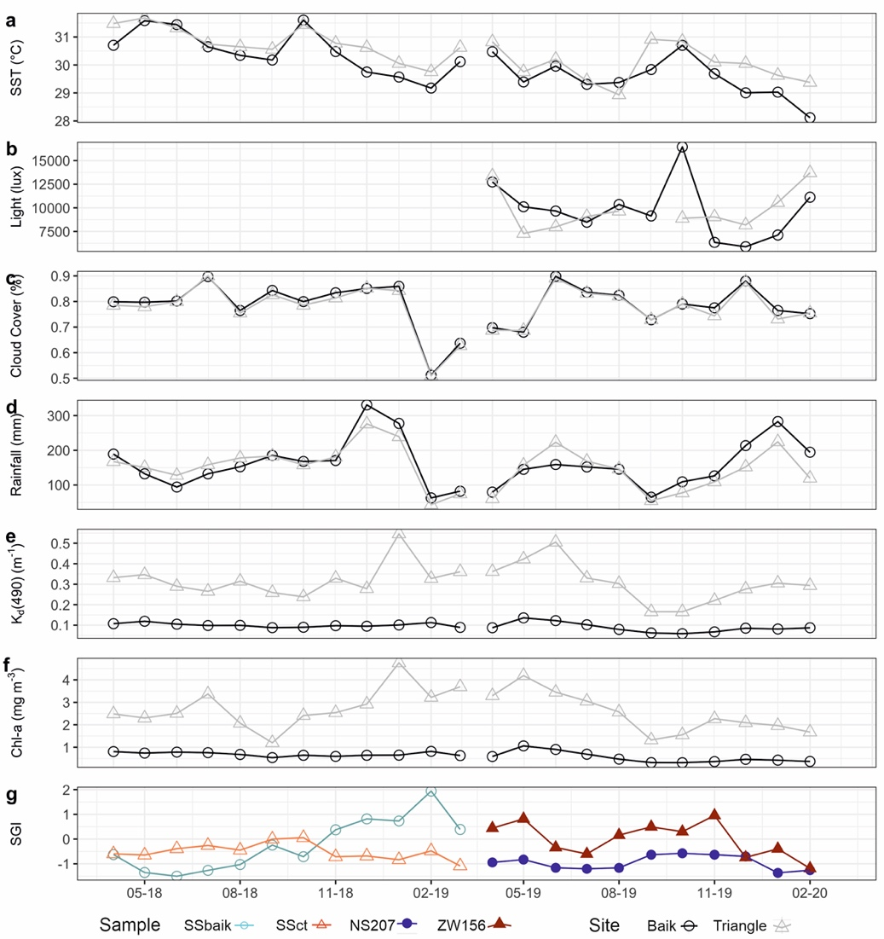
Figure S12. Comparison of monthly growth pattern for last year of growth (LYOG) in shells collected alive from the Baik (ssBaik, NS207) and Triangle (ssCT, ZW156) reefs, with monthly sea surface temperature (SST) (a), light (lux) (b), cloud cover (%) (c), rainfall (mm) (d), K_{d}490 (m⁻¹) (e), chlorophyll-a (mg m⁻³) (f) and monthly SGI (g).

Figure S13. Multitaper method (MTM) power spectra of daily SGI chronologies a) ssCT, b) NS207, c) ssBaik and d) daily max tide (m) in frequency space. AR(1) significance peaks are set to 95 and 99% and represented in respect to red noise background. Significant peaks are labelled with arrows and/or horizontal bars and identified in approximate days in relation to frequency (1/day).

Shell Microstructure

Figure S14. SEM image of the outer- (right) and inner shell layer (left) of Tridacna squamosa (SSbaik), clearly demarcated by the pallial line running vertically down the middle of the image.

References
DeCarlo, T.M., 2018. Characterizing coral skeleton mineralogy with Raman spectroscopy. Nat Commun 9, 5325. https://doi.org/10.1038/s41467-018-07601-3
Hou, X., Yu, H., Hou, Z., Li, J., Chen, Y., Luo, L., Chen, X., Li, W., Yang, H., Zeng, W., 2020. Structural and mechanical evolution of Tridacna gigas during permineralization. Journal of the Mechanical Behavior of Biomedical Materials 103, 103609. https://doi.org/10.1016/j.jmbbm.2019.103609
Killam, D., Al-Najjar, T., Clapham, M., 2021. Giant clam growth in the Gulf of Aqaba is accelerated compared to fossil populations. Proc. R. Soc. B. 288, 20210991. https://doi.org/10.1098/rspb.2021.0991
Maxwell, R.S., Larsson, L.A., 2021. Measuring tree-ring widths using the CooRecorder software application. Dendrochronologia 67, 125841. https://doi.org/10.1016/j.dendro.2021.125841
Parker, J.E., Thompson, S.P., Lennie, A.R., Potter, J., Tang, C.C., 2010. A study of the aragonite-calcite transformation using Raman spectroscopy, synchrotron powder diffraction and scanning electron microscopy. CrystEngComm 12, 1590. https://doi.org/10.1039/b921487a
Taylor, J.D., Kennedy, W.J, Hall, A., 1969. The shell structure and mineralogy of the Bivalvia: introduction
Nuculacea-Trigonacea. Bull. Br. Mus. Nat. Hist. Zool., 3, pp. 1–125.
Urmos, J., Sharma, S.K., Mackenzie, F.T., 1991. Characterization of some biogenic carbonates with Raman spectroscopy. Am. Miner. 76, pp. 641–646.

